Dear Editor,

We are pleased to submit our manuscript "PREDICT-AML: Personalized REsponse via Drug Interaction with Cellular Traits for Acute Myeloid Leukemia" for consideration in Wiley Advanced Science. PREDICT-AML is a multi-omics machine learning framework for personalized drug response prediction in AML, developed on the BeatAML cohort and externally validated on two independent patient cohorts.

Prior approaches have been limited by single-cohort evaluation, inflated benchmarks from random cross-validation, and restricted drug coverage. PREDICT-AML addresses all three gaps. The key contributions are:

- State-of-the-art performance with rigorous evaluation. TabPFN with Knowledge-Distilled drug embeddings achieves r_{pc} = 0.690 (MAE = 37.712) on the held-out BeatAML test set -- surpassing the best published ElasticNet approach (r_{pc} = 0.360) and the MDREAM ensemble (r_{sc} = 0.685 vs. 0.680) across all 150 test drugs. Here r_{pc} and r_{sc} stand for Pearson and Spearman correlations. We demonstrate that standard random cross-validation inflates apparent performance by ~13% relative to patient-stratified CV and establish the latter as the clinically appropriate benchmark.

- Simultaneous multi-cohort external validation. PREDICT-AML is validated on LeeAML (r_{pc} = 0.597; 30 patients, 49 drugs) and FIMM-AML (|r_{pc}| = 0.557; 187 patients, 78 drugs), spanning distinct institutions, geographic sites, and drug sensitivity platforms (AUC vs. DSS).

- Four complementary drug representations (physicochemical, Knowledge-Distilled embeddings, ChemBERTa, MolFormer) augmented by patient-specific drug-pathway proximity scores derived from network propagation on the STRING protein-protein interaction network.

- Novel reduced-panel finding. Somatic mutations combined with cell-state enrichment scores alone -- without gene expression -- recapitulate full multi-omics performance (r_{sc} = 0.685), offering a practical alternative for resource-limited clinical settings.

- Novel biological discoveries. Across the top-10 predicted drugs, BCL6 expression is significant in all ten compounds across mechanistically distinct drug classes, extending beyond its established role in FLT3 inhibitor resistance. Immunogenic cell death (ICD) pathway activity emerges as a novel multi-drug transcriptional biomarker of AML sensitivity. Monocyte-like cell-state enrichment confers Venetoclax resistance (β = 0.77, R² = 0.87) while predicting MEK-inhibitor sensitivity, consistent with MCL-1 dependence in monocytic blasts.

- SHAP interpretability recovers established mechanisms (IDH2/BCL-2 synthetic lethality) and identifies POU4F1 transcriptional state as a novel candidate sensitivity biomarker without explicit pathway supervision.

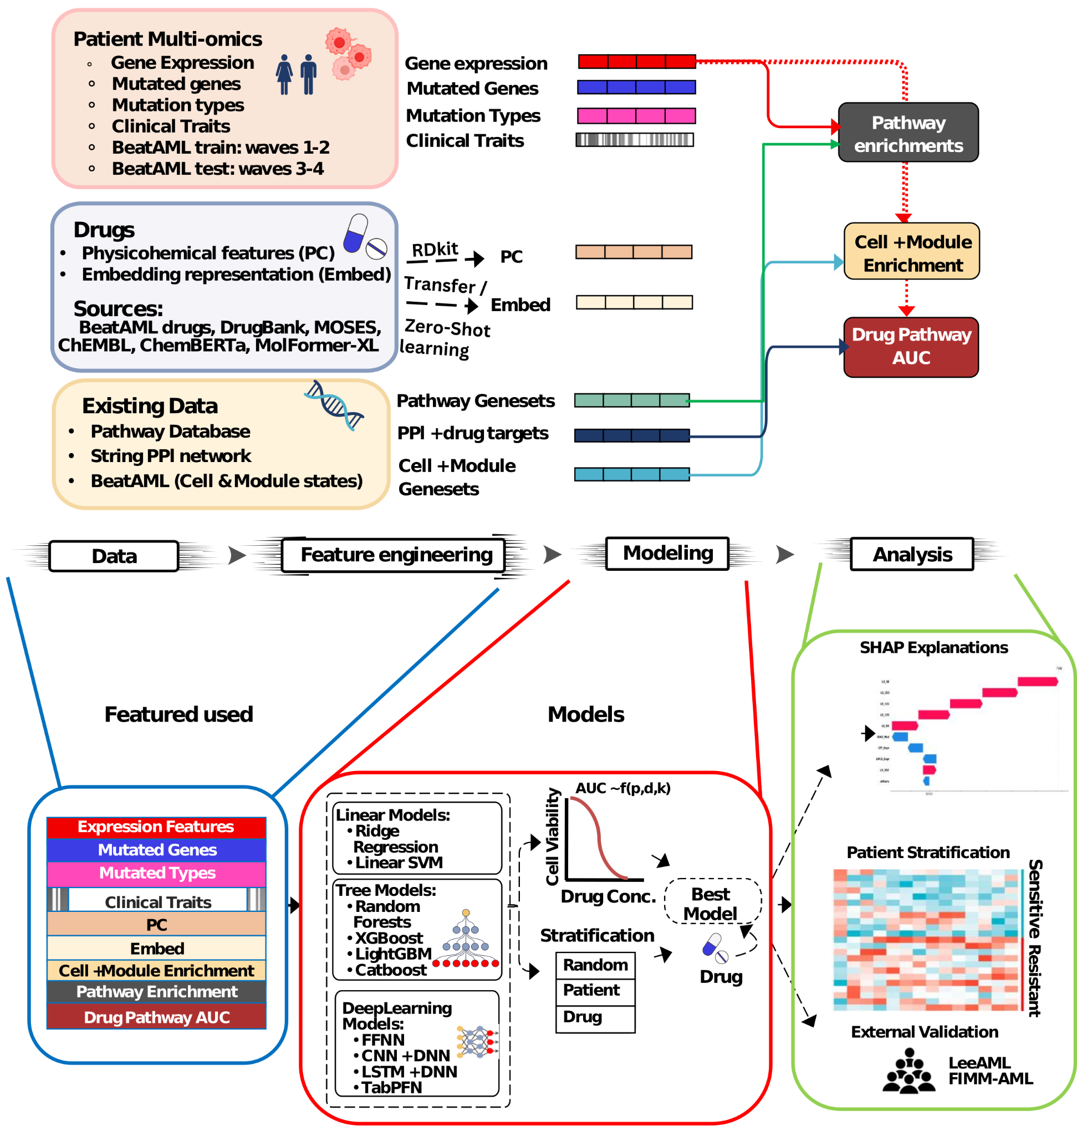
Figure: Overview of the PREDICT-AML framework. Starting from the BeatAML cohort, multi-omics patient features (somatic mutations, gene expression, pathway activity, and cell-state enrichment scores) are combined with four molecular representations (PC, KD-Embed, ChemBERTa, and MolFormer) augmented by patient-specific drug-pathway proximity scores. The merged patient-drug feature matrices are used to train and evaluate a panel of machine learning models, including gradient-boosted trees, deep learning architectures, and TabPFN as the primary model. Models are evaluated under three cross-validation strategies (patient-stratified, drug-stratified, and random). The best-performing configuration is subsequently externally validated on the independent LeeAML and FIMM-AML cohorts to assess generalizability and combined with SHAP interpretability.

All data, code and workflows are publicly available at: https://github.com/raghvendra5688/PT-AML2.0.

None of this work has been published or is under consideration elsewhere. Please contact us at raghvendramall@ieee.org, ramall@hbku.edu.qa with any queries.

With Regards,

Dr. Raghvendra Mall
Qatar Center for Artificial Intelligence, Qatar Computing Research Institute, Hamad Bin Khalifa University, Doha, Qatar

Suggested Reviewers

1. Prof. Michele Ceccarelli
Department of Public Health Sciences, University of Miami
Miller School of Medicine, Coral Gables, FL 33146, U.S.A.
mxc2982@miami.edu

2. Prof. Jiangning Song
Biochemistry & Molecular Biology, Monash Biomedicine Discovery Institute
Monash University, Australia
Jiangning.Song@monash.edu

3. Prof. Hamid R. Arabnia
Department of Computer Science, University of Georgia
Athens, GA 30602, U.S.A.
hra@uga.edu

4. Prof. Yundong Zhou
Dual-Appointed Professor
The Second Department of Oncology, Cancer Center, Huizhou First Hospital,Huizhou, Guangdong, China
Email: zyundongss@foxmail.com

