──────────────────────────────────────────────────────────────────────────────

BRIDGESTONE IT ENGINEERING
Platform Engineering — AI & Automation

ENTERPRISE SOLUTION ARCHITECTURE DOCUMENT
Bridgestone IT AI Assistant
Enterprise AI-Powered IT Service Management Platform

──────────────────────────────────────────────────────────────────────────────

Document ID | BST-ESAD-2026-001
Version | 1.0.0
Status | Released
Date | July 2026
Owner | Platform Engineering — AI & Automation
Audience | Engineering Leadership · Principal Engineers · Enterprise Architects
Classification | Internal — Engineering Leadership

Revision History
Version | Date | Author | Description
0.1 | May 2026 | Platform Engineering | Initial draft — AI pipeline and integration architecture
0.5 | June 2026 | Platform Engineering | Security, database and deployment chapters added
0.9 | July 2026 | Platform Engineering | Full review; ADR, observability and roadmap added
1.0 | July 2026 | Platform Engineering | Final release for engineering leadership review

Table of Contents
NOTE Open this document in Microsoft Word, then press Ctrl+A followed by F9 to populate the Table of Contents with page numbers.

3. Executive Summary
The Bridgestone IT AI Assistant is an enterprise-grade, AI-augmented IT Service Desk platform designed to reduce Level-1 support load, improve Mean Time To Resolution (MTTR), and preserve ServiceNow as the authoritative system of record.
The platform routes employee IT issues through a 23-node LangGraph agentic pipeline before escalating to human intervention. The AI agent conducts structured interviews, retrieves enterprise knowledge, executes diagnostic tools (VPN, Active Directory, Network), performs root-cause reflection, and — where self-service resolution is impossible — creates a properly enriched, validated ServiceNow Incident automatically.
A dual-approval workflow governs privileged software installation requests, routing through Manager approval and IT Admin grant operations without human triage. Four-role JWT-secured RBAC separates employee, manager, admin and superadmin concerns across dedicated portal surfaces.

IMPORTANT Platform Impact:
• Eliminates manual first-line triage for common IT issue categories
• Removes classification errors through AI-validated, schema-driven ServiceNow field mapping
• Provides real-time SLA visibility with automated seven-state escalation
• Delivers complete auditability through an append-only immutable audit trail

4. Business Problem

4.1 Context
Enterprise IT helpdesks operating at scale face a structural imbalance: ticket volume grows linearly with headcount, while Level-1 staffing is constrained by cost. At Bridgestone, this produces five measurable failure modes.

4.2 Failure Modes
Failure Mode | Root Cause | Business Impact
High L1 ticket volume | Manual triage of repetitive issues | Increased cost per ticket, slow MTTR
Incorrect ServiceNow classification | Human error in category / assignment group selection | Mis-routed tickets, SLA breach
Approval process latency | Manual manager notification for privileged requests | Delayed productivity recovery
SLA breach detection lag | Reactive monitoring; no automated escalation | SLA compliance risk, degraded experience
Lack of self-service resolution | No intelligent guidance before ticket creation | Unnecessary L1 escalation for solvable issues

Table 1 — Business Failure Modes

4.3 Architectural Constraints
- ServiceNow must remain the system of record — no parallel ticket stores.
- Existing Microsoft ecosystem (Active Directory, Microsoft Graph, Outlook) must be respected.
- The solution must be deployable inside the Bridgestone network perimeter.
- AI output must never directly create side effects without deterministic validation.

5. Business Objectives
# | Objective | Measurement
O-1 | Reduce L1 ticket volume | Percentage of issues resolved without ticket creation
O-2 | Reduce MTTR | Average time from report to resolution
O-3 | Improve ticket classification accuracy | ServiceNow field validation pass rate
O-4 | Automate privileged software approval workflow | End-to-end time: request to access grant
O-5 | Improve employee self-service experience | First-contact resolution rate
O-6 | Maintain complete auditability | Audit log coverage across all state transitions
O-7 | Preserve ServiceNow as system of record | All incidents traceable to a ServiceNow INC number
O-8 | Enforce SLA compliance with automated escalation | Percentage of tickets escalated before SLA breach

Table 2 — Business Objectives

6. Solution Overview

6.1 Architecture Pattern
The platform is built on a Hybrid AI + Deterministic architecture. AI reasoning handles ambiguous, contextual decisions — intent detection, diagnostic planning, root-cause analysis, reflection and classification. Deterministic services handle all outcomes governed by business rules — approval routing, SLA computation, ServiceNow field mapping and state machine transitions.
This separation is deliberate. AI output is non-deterministic by nature. Every AI decision that produces a side effect (ticket creation, approval, access grant) is gated by deterministic validation before execution.

6.2 Platform Layers
Layer | Technology | Responsibility
Presentation Layer | Next.js 16 / React 19 | Four role-separated portal surfaces (Employee · Manager · Admin · SuperAdmin)
API Gateway Layer | FastAPI + Uvicorn | Authentication, RBAC, rate limiting, security headers, PromptGuard
AI Orchestration | LangGraph StateGraph | 23-node conditional AI pipeline with multi-step diagnostic loops
Deterministic Logic | Classification & SLA Services | Business-rule enforcement on all AI outcomes before system mutation
Integration Layer | ServiceNow, Graph, AD, VPN Adapters | Adapter-pattern enterprise system connectors with mock/live toggle
Data Tier | PostgreSQL 14 & Redis | ACID relational storage and metadata / session caching

Table 3 — Platform Architecture Layers

6.3 Platform Scope
In Scope | Out of Scope
L1 AI-driven issue diagnosis | L2/L3 deep infrastructure troubleshooting
ServiceNow incident creation and lifecycle | ServiceNow configuration and CMDB management
Privileged software request approval workflow | Software licensing management
SLA monitoring and automated escalation | ITSM capacity planning
RBAC-separated portal surfaces | HR and payroll integration
Audit logging for compliance | SOC/SIEM integration (roadmap)

Table 4 — Platform Scope

7. Functional Capabilities

7.1 Core Capabilities
Capability | Description
Conversational AI Triage | Employees describe issues in natural language; the agent conducts a structured diagnostic interview before escalating
Multi-Step Troubleshooting | The agent iteratively executes tool chains (VPN, AD, network) and loops until resolution or escalation
Automatic ServiceNow Incident Creation | Issues that cannot be self-resolved are classified, enriched, validated and submitted to ServiceNow via OAuth2
Dual-Approval Workflow | Privileged requests route through Manager approval, then Admin access grant, tracked in DB and ServiceNow
SLA Engine | APScheduler job evaluates open tickets every 60 seconds, progressing through seven escalation states
Role-Separated Portals | Four purpose-built surfaces for Employee, Manager, IT Admin and SuperAdmin roles
Analytics Dashboard | Ticket volume by category and team, priority breakdown, SLA compliance trend
Knowledge Base | Admin-managed KB articles with AI-assisted article suggestion from resolved ticket context

7.2 Platform-Level Capabilities
Capability | Implementation
Prompt Injection Protection | Three-tier risk classifier (HIGH → reject, MEDIUM → sanitise, LOW → warn) on every user message
Rate Limiting | Per-user/per-IP sliding-window limiter on /chat, /auth/login, /upload — no external dependencies
Immutable Audit Log | Append-only RBAC audit trail: SHA-256 payload hash, correlation ID, actor, ISO-8601 timestamp
Distributed Tracing | OpenTelemetry-compatible trace_span context manager instruments every pipeline node and LLM call
Structured JSON Logging | Per-request correlation ID propagated via Python contextvars through every log statement
Auto Schema Migration | Missing database columns detected and added on startup — no manual migration tooling required

8. Enterprise Business Workflow

8.1 Employee Issue Resolution Flow
The interaction sequence below details how an employee request moves from raw chat input through the security gateway, diagnostic graph, tool execution, and optional ServiceNow incident creation.
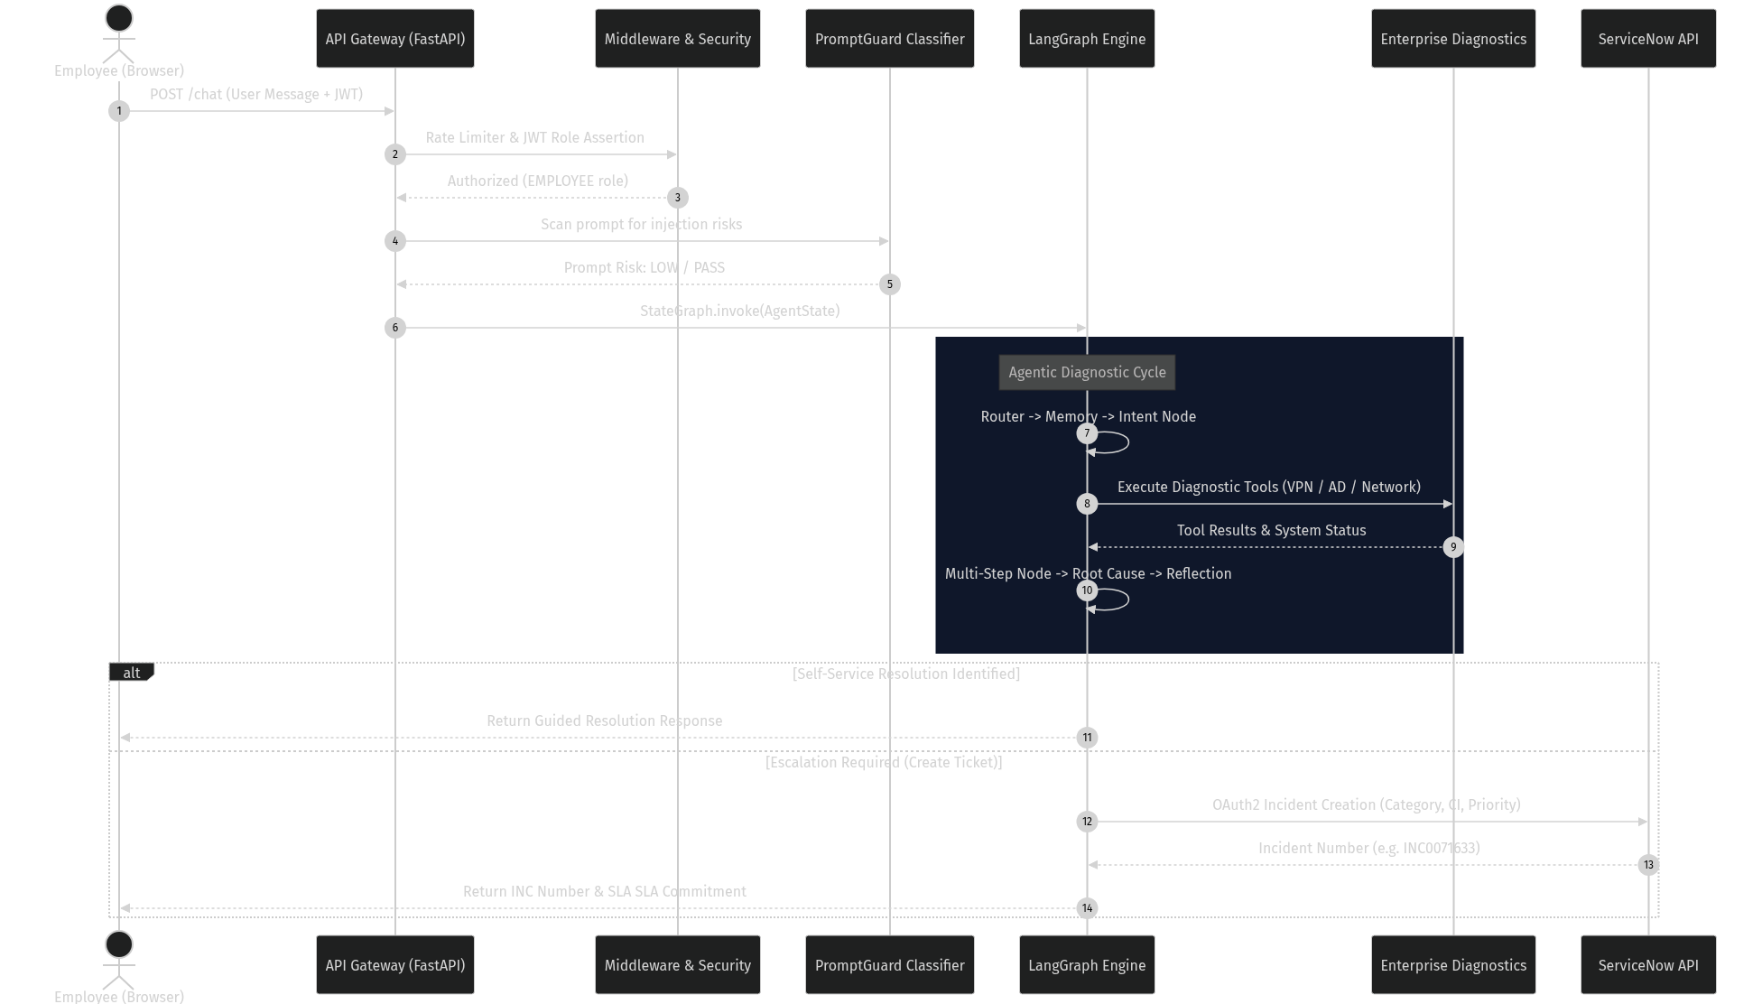
Figure 1 — Employee Issue Resolution — End-to-End Sequence Diagram
Figure 1 illustrates the end-to-end processing sequence for employee IT support interactions. Inbound HTTP requests traverse a mandatory FastAPI middleware security chain (Rate Limiter, JWT Auth, RBAC, and PromptGuard) before reaching the LangGraph StateGraph engine. Within the pipeline, diagnostic tools are invoked iteratively to gather evidence; if self-service resolution fails, an enriched ServiceNow incident is created via OAuth2 REST APIs, returning an official ticket number to the user.

8.2 Privileged Software Approval Workflow
Requests for privileged software (e.g. VS Code, SAP GUI, Adobe CC) follow a strict two-stage human-in-the-loop approval workflow before local access is granted.
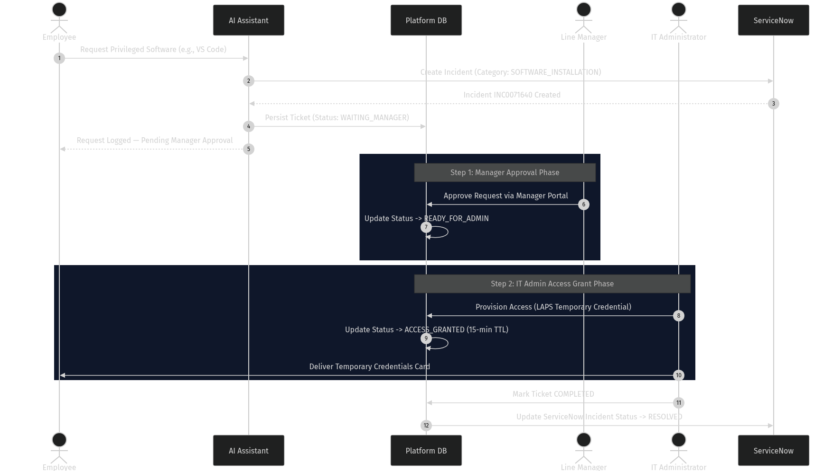
Figure 2 — Privileged Software Dual-Approval Workflow Sequence
Figure 2 depicts the state synchronization across the platform database, ServiceNow, Manager portal, and IT Admin queue for privileged requests. When an employee requests restricted software, the AI classifies the intent as a software installation requiring approval and immediately persists a ticket in WAITING_MANAGER status while notifying ServiceNow. Following Manager approval, the status transitions to READY_FOR_ADMIN, whereupon an IT Administrator issues temporary credentials (LAPS) and completes the ticket in ServiceNow.

8.3 SLA Escalation State Machine
The platform SLA engine evaluates open incidents every 60 seconds against defined operational level agreements.
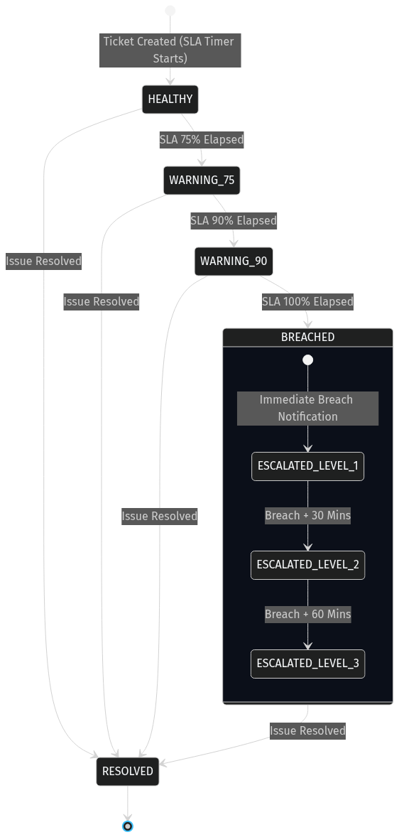
Figure 3 — SLA Escalation State Machine — Workflow States
Figure 3 details the seven-state SLA lifecycle transition matrix enforced by the background scheduler. Tickets originate in the HEALTHY state and progress through WARNING_75 (75% elapsed) and WARNING_90 (90% elapsed) triggers, notifying Managers and IT Administrators accordingly. If 100% of the SLA window elapses before resolution, the ticket transitions to BREACHED and automatically initiates Level-1, Level-2, and Level-3 management escalations at 30-minute intervals.

9. High-Level System Architecture

9.1 Architecture Overview
The Bridgestone IT AI Assistant platform is structured into clean architectural tiers ensuring complete isolation between presentation, gateway, agentic reasoning, deterministic logic, and persistent storage.
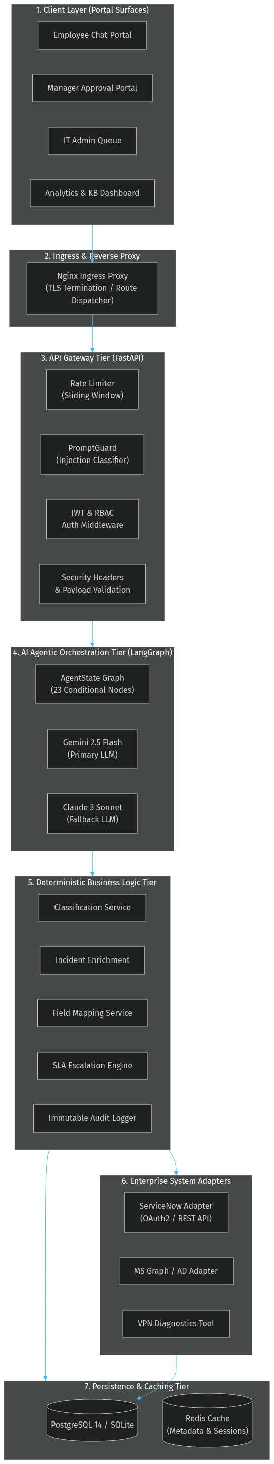
Figure 4 — High-Level System Architecture — Component Topology
Figure 4 presents the macro architectural topology of the platform across seven isolated layers. Nginx handles intranet ingress and TLS termination, routing web traffic to Next.js portal surfaces and API requests to FastAPI gateway middleware. Business logic is cleanly segmented between LangGraph agentic reasoning, deterministic validation services, enterprise integration adapters (ServiceNow, Active Directory, VPN), and persistent data stores (PostgreSQL, Redis).

9.2 Architectural Zones
Zone | Responsibility | Key Design Decision
Client Layer | Role-separated portal surfaces | Single Next.js app; portal views gated by JWT role
API Gateway | Auth, authorisation, rate limiting, injection guard | All cross-cutting concerns resolved before business logic executes
AI Orchestration | Multi-step reasoning, planning, tool execution | LangGraph StateGraph provides deterministic routing between AI nodes
Deterministic Services | Classification, enrichment, SLA, approval | AI output is never directly submitted to external systems — always validated first
Integration Layer | Enterprise system adapters | Adapter pattern with mock/live toggle per environment variable
Data Layer | Persistence and caching | SQLAlchemy ORM; database-agnostic for dev/prod parity

10. AI Architecture

10.1 Purpose & AI System Responsibilities
The AI subsystem performs four distinct functions: natural language intent recognition, diagnostic interview planning, root-cause hypothesis reflection, and ITSM taxonomy classification. To eliminate non-deterministic failure modes, AI components operate within strict boundaries.

10.2 AI Provider Fallback Architecture
To prevent platform outage during primary LLM rate-limiting or provider failure, the AI abstraction layer implements a three-tier resilient fallback model.
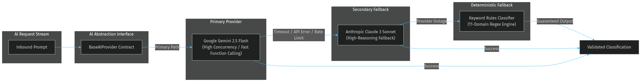
Figure 5 — AI Provider Three-Tier Fallback Architecture
Figure 5 illustrates the multi-provider failover strategy implemented behind the BaseAIProvider abstraction. Inbound requests are first routed to Google Gemini 2.5 Flash for high-speed intent detection and tool planning; upon API timeout or rate-limit exceptions, traffic seamlessly fails over to Anthropic Claude 3 Sonnet. If all external LLM services become unavailable, the pipeline falls back to a deterministic 11-domain keyword regular expression engine to maintain triage availability.

10.3 AI Responsibilities by Node
Node | AI Role | Deterministic Gate
Router | Classify message as CHAT or TROUBLESHOOT | Exact string match on output
Context Router | Route to correct pipeline branch | Output constrained to four enum values
Intent | Classify IT issue category | Validated against valid_categories from incident_config.json
Diagnostic Interview | Determine information sufficiency; generate targeted questions | Short-circuit to END if questions are pending
Planner | Generate ordered tool execution plan | Plan validated against registered tool registry
Knowledge | Retrieve and rank relevant KB articles | Top-N selected by relevance score
Tool | Select and execute enterprise tool | Tool result validated before state update
Multi-Step | Evaluate tool results; decide whether to loop or escalate | troubleshooting_complete boolean controls loop exit
Root Cause | Synthesise hypothesis from tool chain results | Structured JSON output validated by Pydantic
Reflection | Evaluate reasoning quality; flag low-confidence decisions | Reflection score used by Decision node
Decision | Choose: CREATE_TICKET, EXECUTE_ACTION, or ASK_MORE_INFO | Enum output; unknown values default to ASK_MORE_INFO
Approval | Evaluate whether action requires approval | Approval status: PENDING, APPROVED, REJECTED
Classification | Assign ITSM category, subcategory, assignment group, CI | Validated against live ServiceNow metadata before submission

Table 5 — AI Node Responsibilities and Deterministic Gates

10.4 Classification Service Design
The ClassificationService acts as the boundary between AI output and ServiceNow incident creation. It enforces confidence thresholds (HIGH >= 0.90, MEDIUM 0.70-0.89, LOW < 0.70) and routes responses through Pydantic schema validation before payload construction.

11. LangGraph Workflow

11.1 StateGraph Architecture
The core AI reasoning pipeline is implemented as a 23-node LangGraph StateGraph (`backend/app/graph/graph.py`). The state graph enforces TypedDict schema validation across every turn and decouples node logic from graph routing.

11.2 AgentState Schema & Field Groups
Field Group | Fields
Session Context | session_id, username, user_role, user_message
Routing | decision, route, intent
AI Outputs | root_cause_analysis, reflection, plan, knowledge_context, tool_result
Approval | approval_required, approval_status, approval_action
Ticket | ticket, ticket_lifecycle, assigned_team
Multi-Step | tool_chain, hypothesis_tracker, troubleshooting_iterations, troubleshooting_complete, next_tool
Diagnostic | diagnostic_interview, conversation_goal, active_issue
SLA | sla, notifications

Table 6 — AgentState TypedDict — Field Groups

11.3 23-Node StateGraph Topology
The 23-node state graph controls execution flow through conditional edge routing based on conversation state, intent classification, and diagnostic completion.
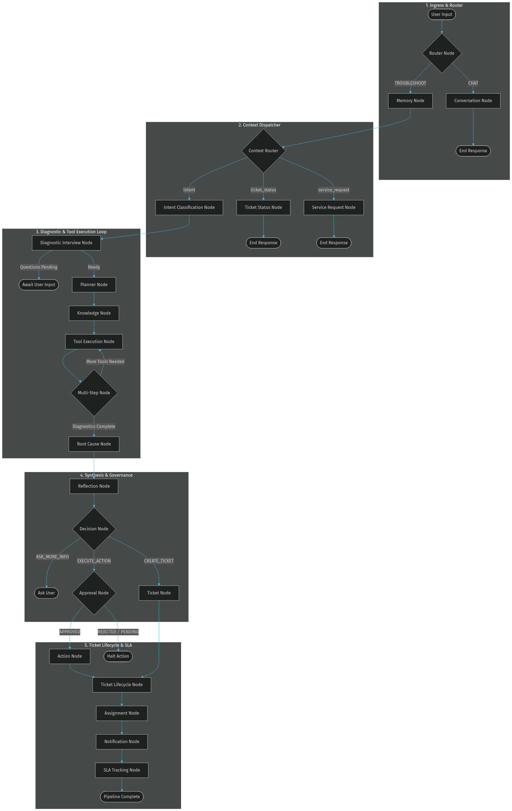
Figure 6 — LangGraph 23-Node Workflow — Conditional State Graph Topology
Figure 6 details the full 23-node state machine governing the AI agent execution lifecycle. Inbound interactions enter through the Router node, which separates conversational chat from diagnostic troubleshooting. The multi-step diagnostic loop iteratively invokes system tools (VPN, Active Directory, Ping) and routes through Root Cause and Reflection nodes before rendering terminal decisions (Ticket Creation, Action Execution, or User Clarification).

11.4 Conditional Routing Logic
Conditional Edge | Routing Logic
route_after_router | decision == 'CHAT' → conversation; otherwise → memory
context_router | Lambda on state['route']: ticket_lifecycle | ticket_status | service_request | intent
route_after_diagnostic_interview | decision_response populated → END; else → planner
route_after_multi_step | troubleshooting_complete is False and next_tool is not None → tool; else → root_cause
route_decision | CREATE_TICKET → ticket; EXECUTE_ACTION → approval; else → END
route_after_approval | approval_status == 'APPROVED' → action; else → END
route_after_lifecycle | ticket['ticket_id'] exists → assignment; else → notification

Table 7 — LangGraph Conditional Edge Routing Logic

12. Conversation Lifecycle

12.1 Session State & Memory Persistence
Conversations are keyed by session_id in the platform database (`conversations` and `conversation_events` tables). The Memory node fetches dialogue history prior to pipeline execution and serializes updated state context upon completion.

12.2 Diagnostic Interview & Information Sufficiency
The Diagnostic Interview node evaluates whether sufficient contextual details (device ID, error codes, network location) are present before diagnostic planning begins. If required fields are missing, targeted clarification questions are rendered to the employee, pausing pipeline execution until the next turn.

13. ServiceNow Integration Architecture

13.1 Adapter Pattern & ServiceNow Client
Enterprise integrations implement an adapter design pattern with explicit mock/live environment toggles. `ServiceNowClient` manages OAuth2 Password Grant tokens with thread-safe RLock refresh protection.
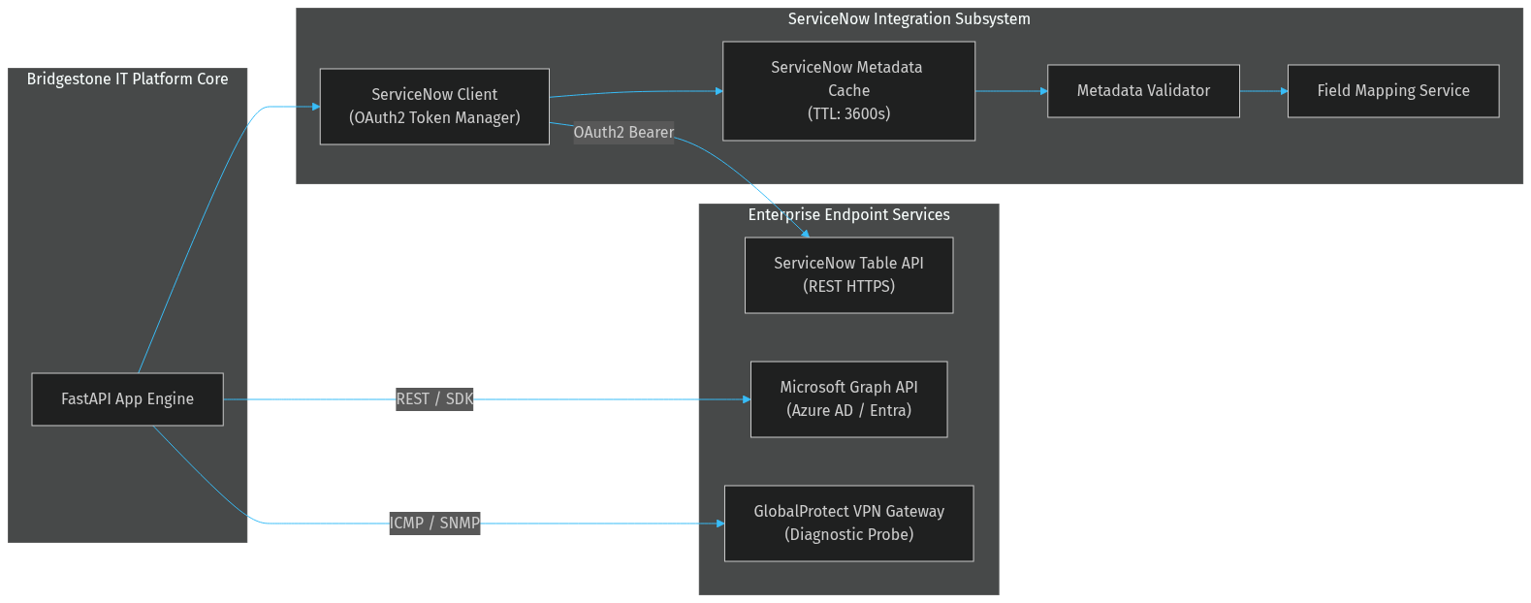
Figure 7 — Enterprise Integration Adapter Topology
Figure 7 illustrates the system integration topology connecting the core FastAPI backend with enterprise endpoints. ServiceNow interactions pass through a thread-safe token manager and a 3600-second metadata cache. External API calls to ServiceNow Table API, Microsoft Graph (Entra ID), and GlobalProtect VPN gateways are abstracted behind unified interfaces that toggle between live HTTPS calls and mock fixtures based on environment settings.

13.2 ServiceNow Metadata Validation Pipeline
To prevent invalid field submission errors when creating incidents, the platform routes AI outputs through a rigorous 4-stage validation pipeline.
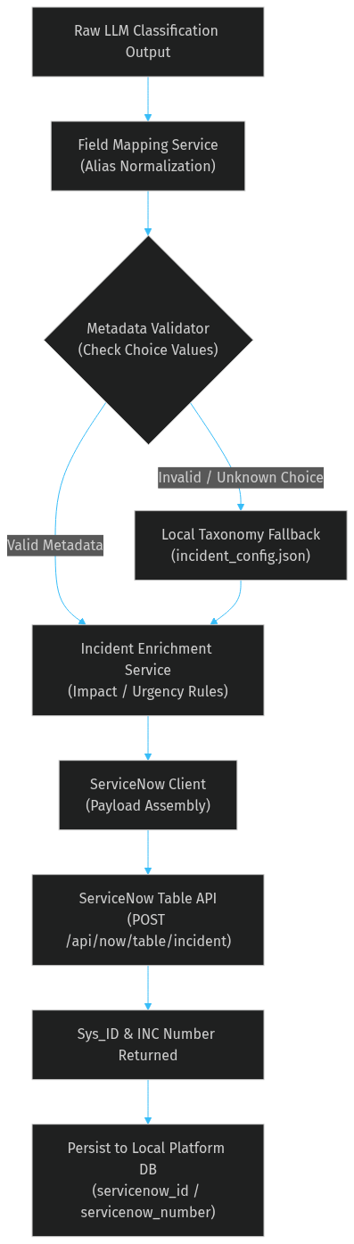
Figure 8 — ServiceNow Metadata Validation Pipeline
Figure 8 outlines the deterministic validation chain applied to LLM classification outputs before invoking ServiceNow REST APIs. Raw AI predictions are first mapped to canonical ServiceNow choice values by the FieldMappingService using `incident_config.json`. The MetadataValidator checks choice existence against cached instance choices; if an invalid choice is detected, local taxonomy defaults apply before IncidentEnrichmentService computes impact, urgency, and priority values.

13.3 ServiceNow Incident Lifecycle
Platform Status | ServiceNow Trigger / Action | Valid Next Status
NEW | Platform creates INC via OAuth2 | IN_PROGRESS or WAITING_MANAGER
WAITING_MANAGER | SOFTWARE_INSTALLATION / privileged request | READY_FOR_ADMIN or REJECTED
READY_FOR_ADMIN | Manager approves | ACCESS_GRANTED
ACCESS_GRANTED | Admin grants LAPS credentials | COMPLETED
IN_PROGRESS | Assigned to team | RESOLVED
RESOLVED | Engineer resolves | CLOSED (auto)
CLOSED | Final state | —
REJECTED | Manager rejects request | CLOSED

Table 8 — ServiceNow Incident Lifecycle — Platform Status States

14. Security Architecture

14.1 Defence-in-Depth Layer Stack
The security model implements strict defence-in-depth across perimeter, transport, application, and compliance audit layers.
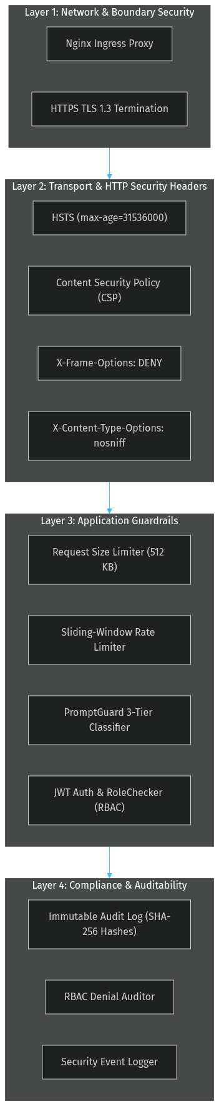
Figure 9 — Security Defence-in-Depth Layered Architecture
Figure 9 details the 4-layer security architecture enforcing corporate data protection standards. Perimeter TLS 1.3 termination at Nginx is fortified by transport-layer HTTP security headers (HSTS, CSP, X-Frame-Options, X-Content-Type-Options). Application middleware enforces 512 KB request payload limits, sliding-window rate limiting, PromptGuard injection scanning, and JWT RBAC checks, while all state modifications append to an immutable SHA-256 audit log.

14.2 Authentication & Authorization Flow
User authentication utilizes bcrypt password hashing and PyJWT HS256 token issuance. Every endpoint verifies token claims and role authorization via `RoleChecker` dependencies.
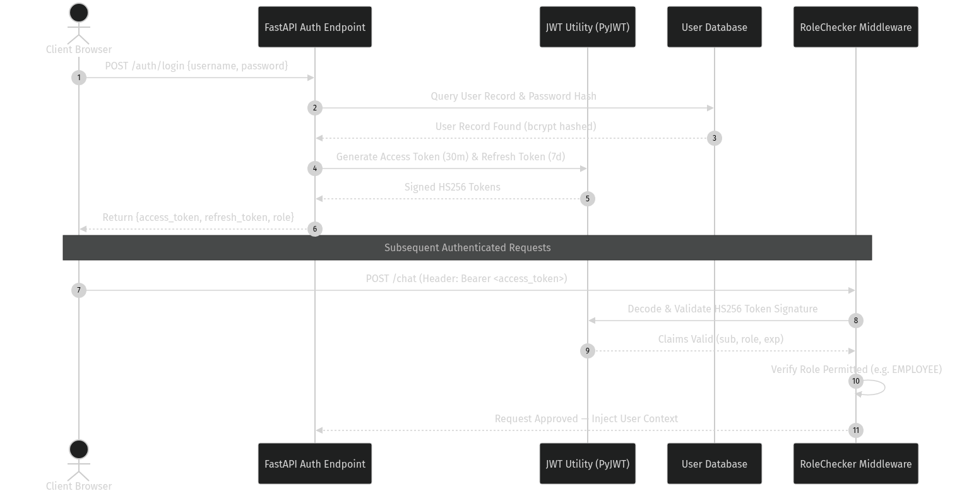
Figure 10 — Authentication and Authorisation Sequence Flow
Figure 10 demonstrates the credential verification and Bearer token lifecycle. Upon successful `/auth/login` authentication against bcrypt password hashes in the database, the API issues a 30-minute access token and a 7-day refresh token. Subsequent request headers are parsed by FastAPI `oauth2_scheme`, verifying HS256 signatures, token expiry, and user role entitlements prior to pipeline invocation.

14.3 Role-Based Access Control (RBAC)
Role | Permitted Endpoints
EMPLOYEE | /chat, /my-tickets, /auth/me
MANAGER | /chat, /manager/tickets/*, /analytics/*, /auth/me
ADMIN | /tickets/*, /admin/queue, /admin/tickets/*, /analytics/*, /knowledge/*, /auth/me
SUPERADMIN | All endpoints

Table 9 — Role-Based Access Control Model

14.4 PromptGuard Injection Classifier
PromptGuard protects the LLM pipeline against prompt injection attacks using full-phrase anchored regular expressions.
Risk Level | Action | Pattern Examples
HIGH | HTTP 400 + ImmutableAuditLog entry | 'ignore all instructions', 'you are now DAN', 'forget your previous instructions'
MEDIUM | Sanitise fragment — pipeline continues | 'act as X without restrictions', 'from now on you must', [INST] markers
LOW | Allow — emit structured warning log | Ambiguous phrasing partially matching medium patterns

Table 10 — PromptGuard Three-Tier Injection Classification

14.5 Immutable Audit Logging
Compliance auditability is maintained by `ImmutableAuditLog`, which exposes only an append-only `record()` method. Every entry captures correlation ID, actor identity, action type, timestamp, and a SHA-256 hash of the JSON payload.

15. Database Architecture

15.1 Data Model Overview
The database tier encompasses 19 SQLAlchemy ORM models organized across Identity, ITSM Workflow, AI Pipeline, Compliance Audit, SLA Tracking, and Platform Operations domains.

15.2 Core Entity Relationship Diagram
Primary data models maintain relational integrity across user identities, tickets, approval records, and SLA event histories.
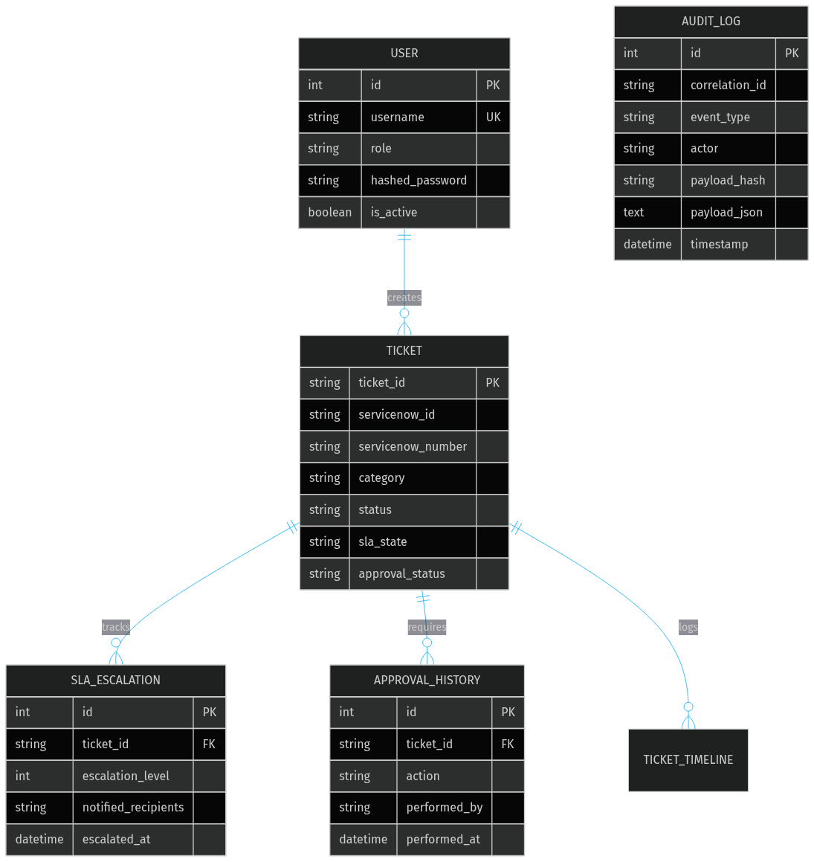
Figure 11 — Core Database Entity Relationship Diagram
Figure 11 defines the core entity relationship schema governing the relational database. User records maintain 1-to-many relationships with Ticket entities. Each Ticket tracks historical lifecycle changes across SlaEscalationHistory, SlaAuditEvent, ApprovalHistory, TicketTimeline, and TicketComment tables, while AuditLog and RbacAuditLog maintain unconstrained append-only audit structures.

15.3 Core Entities Table
Entity | Table | Key Fields
User | users | id, username (UK), role, hashed_password, is_active
Ticket | tickets | ticket_id (UK), category, status, request_type, servicenow_id, servicenow_number, sla_state, approval_status, laps_*
AuditLog | audit_logs | correlation_id, event_type, actor, payload_hash, payload_json, timestamp
SlaEscalationHistory | sla_escalation_history | ticket_id (FK), escalation_level, notified_recipients, escalated_at
SlaAuditEvent | sla_audit_events | ticket_id (FK), event_type, sla_pct, sla_state, event_at
RbacAuditLog | rbac_audit_logs | username, role, action, resource, outcome, correlation_id, timestamp
ApprovalHistory | approval_history | ticket_id (FK), action, performed_by, notes, performed_at
Conversation | conversations | session_id (UK), username, history_json, created_at, updated_at
KnowledgeDraft | knowledge_drafts | title, root_cause, resolution, category, confidence, status, source_ticket_id (FK)

Table 11 — Core Database Entities — Key Fields

16. API Request Lifecycle

16.1 End-to-End Chat API Request Lifecycle
Inbound HTTP requests to `/chat` traverse sequential middleware components prior to AI state graph invocation.
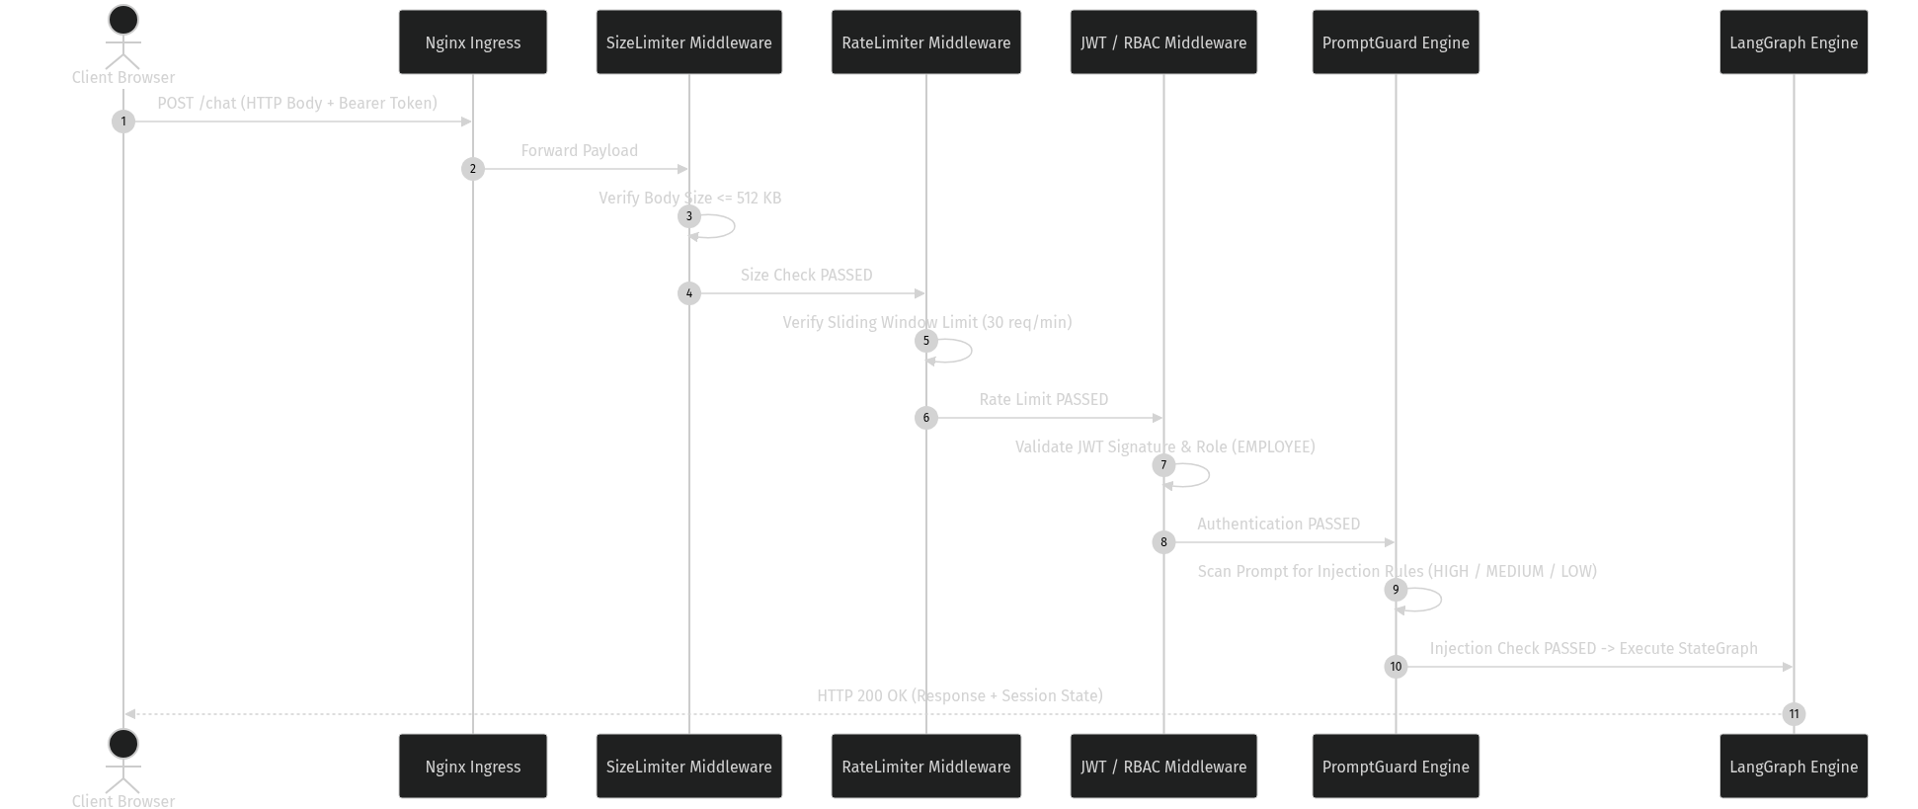
Figure 12 — Chat Endpoint API Request Lifecycle Sequence
Figure 12 traces the multi-layered execution path of an incoming POST `/chat` payload. Request execution begins at Nginx, moving sequentially through RequestSizeLimitMiddleware (<=512 KB), RateLimiter (30 req/min sliding window), JWT Auth & RoleChecker dependencies (EMPLOYEE role verification), and PromptGuard injection scanning. Only payloads successfully clearing all validation gates enter the LangGraph execution engine.

16.2 Middleware Failure Handling
Layer | Failure Response | Audit Action
Request Size Limit | HTTP 413 | Warning log
Rate Limiter | HTTP 429 + Retry-After header | Warning log
JWT Auth | HTTP 401 | SECURITY_UNAUTHORIZED_TOTAL metric incremented
Role Checker | HTTP 403 | RBAC audit log entry + SECURITY_PERMISSION_DENIED_TOTAL
PromptGuard HIGH | HTTP 400 | ImmutableAuditLog entry with matched pattern
PromptGuard MEDIUM | Request sanitised — pipeline continues | Structured warning log emitted

Table 12 — Middleware Chain Failure Responses

16.3 Full API Surface
Method | Endpoint | Role | Description
POST | /auth/login | Public | Issue JWT access + refresh tokens
GET | /auth/me | Authenticated | Return current user identity and role
POST | /chat | EMPLOYEE | Submit message to AI pipeline
GET | /my-tickets | EMPLOYEE | List user's own tickets
GET | /tickets | ADMIN, MANAGER | List all tickets
GET | /tickets/{id} | ADMIN, MANAGER | Get full ticket detail
PUT | /tickets/{id}/status | ADMIN | Update ticket status
GET | /manager/tickets | MANAGER, ADMIN | Pending approval queue
POST | /manager/tickets/{id}/approve | MANAGER | Approve privileged request
POST | /manager/tickets/{id}/reject | MANAGER | Reject privileged request
GET | /admin/queue | ADMIN | Admin action queue
POST | /admin/tickets/{id}/grant-access | ADMIN | Grant temporary admin access (LAPS)
POST | /admin/tickets/{id}/complete | ADMIN | Mark ticket complete
GET | /analytics/* | ADMIN, MANAGER | Analytics and reporting endpoints
GET | /knowledge/* | ADMIN | Knowledge base management
GET | /health | Public | Liveness probe
GET | /metrics | Internal | Prometheus metrics scrape endpoint

Table 13 — Full API Surface

17. Deployment Architecture

17.1 Production Docker Topology
Production deployment utilizes Docker Compose with isolated container networks, persistent named volumes, and container health check dependencies.
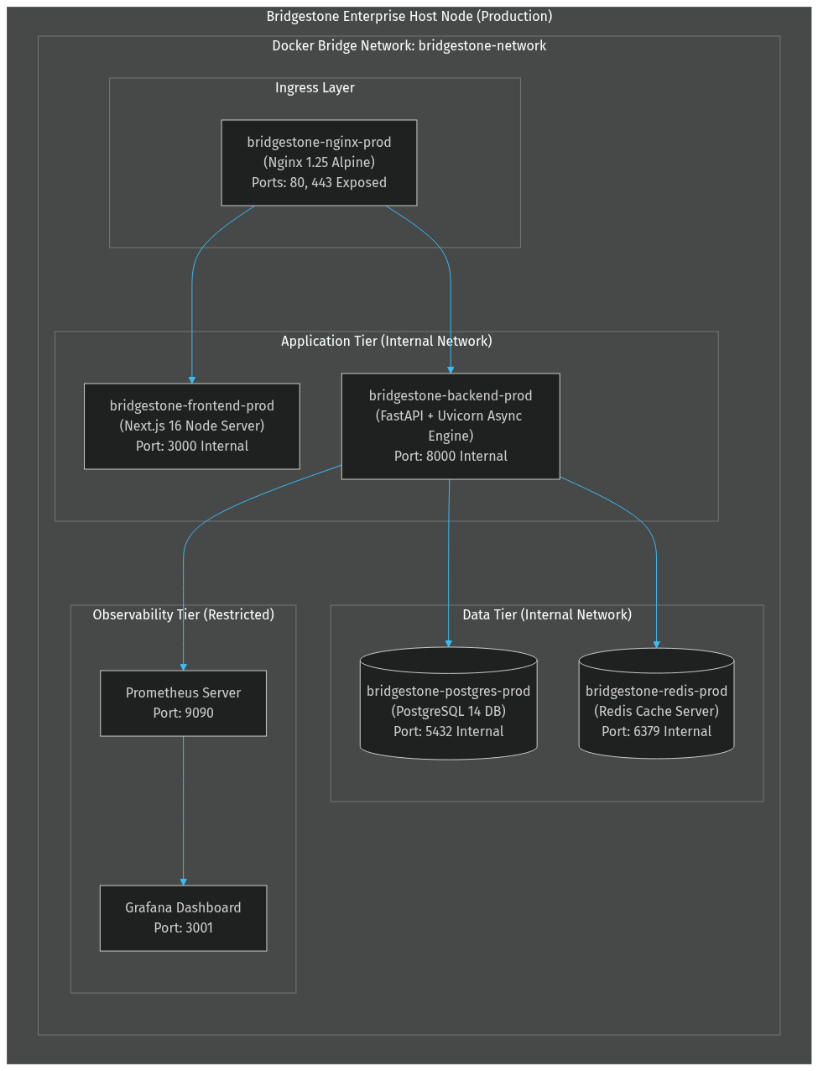
Figure 13 — Docker Compose Production Deployment Topology
Figure 13 illustrates the containerized service composition operating within the isolated `bridgestone-network` bridge. Nginx acts as the single external gateway exposing ports 80 and 443. Next.js frontend and FastAPI backend containers communicate over internal ports, depending on PostgreSQL and Redis health checks before accepting incoming connections.

17.2 Environment Matrix
Environment | Database | ServiceNow | Graph / AD | Compose File
Development | SQLite (local) | Mock | Mock | docker-compose.dev.yml
QA | PostgreSQL (container) | Mock | Mock | docker-compose.qa.yml
Backend-only | SQLite (local) | Mock | Mock | docker-compose.backend-only.yml
Production | PostgreSQL (container, persistent volume) | Live | Live | docker-compose.prod.yml

Table 14 — Environment Matrix

18. Monitoring & Observability Architecture

18.1 Observability Architecture & Metrics
The observability framework integrates Prometheus metric scraping (`/metrics`), Grafana dashboards, structured JSON logging, and OpenTelemetry-compatible tracing spans.

18.2 Prometheus Metric Categories
Category | Key Metrics
HTTP | http_requests_total, http_failures_total, http_request_duration_seconds
Security | security_logins_total, security_failed_logins_total, security_permission_denied_total, security_jwt_expired_total
LLM | llm_requests_total, llm_success_total, llm_failure_total, llm_latency_seconds
AI Agent | agent_execution_duration_seconds [label: agent_name]
Pipeline | pipeline_span_duration_seconds [labels: service, provider, status]
Database | db_connections_active
SLA | sla_escalation_total, sla_breaches_total
ServiceNow | servicenow_api_calls_total, servicenow_api_errors_total

Table 15 — Prometheus Metric Categories

18.3 Background Jobs & APScheduler
Job | Schedule | Responsibility
sla_monitor_job | Every 60 seconds | Evaluate open tickets against SLA thresholds; transition SLA state machine
notification_job | Every 30 seconds | Dispatch pending notifications to recipients
auto_close_job | Every 60 seconds | Auto-close tickets in PENDING state beyond hold period
cleanup_job | Daily at midnight (0 0 * * *) | Purge expired sessions and stale temporary records

Table 16 — APScheduler Background Jobs

19. Technology Stack

19.1 Backend Stack
Component | Technology | Version | Justification
Runtime | Python | 3.12 | Latest stable; required by LangGraph and google-genai SDK
API Framework | FastAPI + Uvicorn | 0.115 | Async-native, OpenAPI auto-documentation, Pydantic v2 integration
AI Orchestration | LangGraph StateGraph | Latest | Deterministic, testable AI pipeline control flow with conditional edges
Primary AI | Google Gemini | gemini-2.5-flash | Large context window, function calling, developer free-tier access
Fallback AI | Anthropic Claude | Claude 3 Sonnet | Independent provider for resilience against Gemini outages
ORM | SQLAlchemy | 2.x | Database-agnostic; SQLite and PostgreSQL parity
Auth | PyJWT + bcrypt | — | HS256 token issuance; bcrypt password hashing
HTTP Client | requests | — | Synchronous HTTP for ServiceNow REST API calls
Scheduling | APScheduler | — | In-process job scheduler with interval and cron triggers
Metrics | prometheus-client | — | Standard Prometheus Counter, Gauge, Histogram instrumentation
Validation | Pydantic v2 | — | Schema enforcement on all AI outputs and API models

19.2 Frontend Stack
Component | Technology | Version | Justification
Framework | Next.js | 16.2 | App Router, SSR, API route proxying to backend
Runtime | React | 19 | Server Components, concurrent rendering
Language | TypeScript | 5 | Type safety across all four portal surfaces
Styling | Tailwind CSS | 4 | Utility-first; design system consistency
Animation | Framer Motion | 12 | Micro-animations for portal interactions
Charts | Recharts | 3 | Analytics dashboard visualisations
Icons | Lucide React | Latest | Consistent enterprise iconography

19.3 Infrastructure Stack
Component | Technology | Justification
Reverse Proxy | Nginx stable-alpine | TLS termination, path-based routing, upstream proxy
Database (prod) | PostgreSQL 14 | ACID compliance, persistent volume, health check support
Cache | Redis | Session cache and ServiceNow metadata cache (production)
Containerisation | Docker + Compose | Environment-consistent deployment across dev, QA and production
Metrics Collection | Prometheus | Industry-standard scrape-based metrics
Dashboards | Grafana | Prometheus datasource; provisioning-as-code via volume mounts

20. Architecture Decision Records
Architecture Decision Records (ADRs) capture major architectural choices, design rationale, and accepted technical trade-offs.

ADR-001 — LangGraph StateGraph for AI Pipeline Orchestration
Field | Content
Status | Accepted
Context | The AI pipeline requires conditional branching, state persistence across nodes and multi-step tool-execution loops.
Decision | Use LangGraph StateGraph with typed AgentState TypedDict and conditional edge routing functions.
Consequences | Nodes are independently testable; routing logic is centralised in edge functions.

ADR-002 — Three-Tier AI Provider Fallback
Field | Content
Status | Accepted
Context | A single AI provider dependency creates a single point of failure.
Decision | Implement BaseAIProvider abstraction: Gemini (primary) → Claude (fallback) → keyword-rules deterministic engine.
Consequences | Guarantees operational continuity during provider outages.

ADR-003 — Configuration-Driven ITSM Taxonomy
Field | Content
Status | Accepted
Context | ServiceNow field values change when the instance is reconfigured.
Decision | All ITSM taxonomy externalised to incident_config.json, loaded at startup by ConfigurationService.
Consequences | Taxonomy changes require only JSON updates without Python code edits.

ADR-004 — In-Process Sliding-Window Rate Limiter
Field | Content
Status | Accepted
Context | External rate limiting dependencies add complexity for single-process setups.
Decision | Implement pure-Python _SlidingWindowStore using threading.Lock and collections.deque.
Consequences | Zero external dependencies for single-instance deployments.

ADR-005 — Adapter Pattern with Mock/Live Toggle
Field | Content
Status | Accepted
Context | Enterprise integrations require live credentials unavailable in dev/CI.
Decision | All integrations implement a BaseAdapter interface with mock toggles via env vars.
Consequences | Enables complete local offline pipeline testing.

ADR-006 — ServiceNow as Authoritative System of Record
Field | Content
Status | Accepted
Context | Without clear authority boundaries, ticket state could diverge.
Decision | Every platform ticket carries servicenow_id and servicenow_number. ServiceNow is authoritative.
Consequences | All incidents remain fully traceable to a ServiceNow INC number.

ADR-007 — Append-Only Immutable Audit Log
Field | Content
Status | Accepted
Context | Enterprise compliance requires tamper-evident audit logs.
Decision | ImmutableAuditLog exposes only record(). SHA-256 payload hashes stored alongside JSON payloads.
Consequences | Audit trail is non-repudiable under normal operation.

ADR-008 — Auto Schema Migration on Startup
Field | Content
Status | Accepted
Context | Maintaining Alembic migration chains adds friction during rapid POC iteration.
Decision | On startup, inspect schema and add missing columns via ALTER TABLE idempotently.
Consequences | Zero-friction schema evolution during development phases.

21. Engineering Challenges

21.1 AI Non-Determinism at ITSM Boundaries
Challenge | LLM outputs are stochastic. Category values produced by AI may fail ServiceNow validation.
Resolution | Four-stage validation chain: AI output → FieldMappingService → MetadataValidator → IncidentEnrichmentService before submitting API payloads.

21.2 Multi-Step Troubleshooting Loop Termination
Challenge | Tool execution loops must terminate deterministically without token budget exhaustion.
Resolution | AgentState tracks troubleshooting_iterations and troubleshooting_complete flag, enforcing loop exit conditions.

21.3 Concurrent ServiceNow OAuth2 Token Refresh
Challenge | Multiple concurrent requests could trigger duplicate token refresh calls.
Resolution | ServiceNowClient uses a threading.RLock gating refresh calls with a 60-second safety buffer.

21.4 ServiceNow Metadata Cache Consistency
Challenge | Instance reconfiguration can render choice values stale.
Resolution | TTL-based cache with graceful fallback to incident_config.json on API downtime.

21.5 Approval Workflow State Race Conditions
Challenge | Concurrent manager approval and admin access grants could cause inconsistent state.
Resolution | Strict pre-condition state checks in ApprovalService with full audit trail logging.

21.6 Prompt Injection Without Over-Blocking
Challenge | Keyword guards risk blocking valid IT prompts containing words like 'system' or 'act'.
Resolution | Full-phrase anchored regex patterns in PromptGuard ensuring accurate classification.

22. Future Roadmap

22.1 Near-Term (0–6 Months)
Initiative | Architectural Impact
Alembic Migration Chain | Replace auto-migration with versioned schema migrations
Redis-Backed Rate Limiter | Replace in-process store with Redis to support multi-replica scaling
Bi-Directional ServiceNow Sync | Webhook receiver for ServiceNow state alignment
Entra ID Live Integration | Replace mock AD adapter with production MS Graph OAuth2 flow
Knowledge Base Vector Search | Upgrade keyword retrieval to vector embeddings (pgvector)

22.2 Medium-Term (6–18 Months)
Initiative | Architectural Impact
Windows LAPS / CyberArk PAM | Replace mock credentials with live LAPS / PAM integration
Kubernetes Deployment | Multi-replica deployment with Redis shared state
OpenTelemetry Integration | Export traces to Jaeger, Datadog or Azure Monitor
Multi-Model AI Routing | Route requests to domain-optimised AI models

22.3 Long-Term (18+ Months)
Initiative | Architectural Impact
Predictive SLA Management | ML breach risk prediction model
Incident Pattern Clustering | Automated grouping of incidents into ServiceNow Problems
Multi-Tenant Architecture | Isolated data and AI contexts for subsidiaries

23. Conclusion
The Bridgestone IT AI Assistant establishes a production-credible architecture combining AI reasoning with deterministic enterprise controls, minimal operational complexity, and complete compliance auditability.

24. Appendix

24.1 ServiceNow Field Mapping Reference
Platform Concept | ServiceNow Field | Resolution Method
Category | category | AI → FieldMappingService → MetadataValidator
Subcategory | subcategory | AI → subcategory_map in incident_config.json
Assignment Group | assignment_group | assignment_group_map in incident_config.json
CMDB CI | cmdb_ci | ci_map in incident_config.json
Impact | impact | category_impact rules in incident_config.json
Urgency | urgency | category_urgency rules in incident_config.json
Priority | priority | Priority matrix derived from impact × urgency
Contact Type | contact_type | Static: 'Virtual Agent'
Caller | caller_id | Authenticated username from JWT

Table 17 — ServiceNow Field Mapping Reference

24.2 Environment Variables Reference
Variable | Default | Description
SECRET_KEY | dev default | JWT signing secret
DATABASE_URL | sqlite:///./bridgestone.db | SQLAlchemy connection string
REDIS_URL | redis://redis:6379/0 | Redis connection (prod)
GEMINI_API_KEY | — | Google Gemini API key
ANTHROPIC_API_KEY | — | Anthropic Claude API key
SERVICENOW_INSTANCE_URL | — | ServiceNow instance base URL
SERVICENOW_USERNAME | — | ServiceNow API username
SERVICENOW_CLIENT_ID | — | OAuth2 client ID
SERVICENOW_CLIENT_SECRET | — | OAuth2 client secret
SERVICENOW_AUTH_TYPE | basic | Auth mode: basic or oauth2
SERVICENOW_METADATA_CACHE_TTL_SECONDS | 3600 | Metadata cache TTL
USE_MOCK_SERVICENOW | true | Disable live ServiceNow calls
USE_MOCK_GRAPH | true | Disable live MS Graph calls
USE_MOCK_AD | true | Disable live Active Directory calls
RATE_LIMIT_CHAT | 30 | Max chat requests per window
RATE_LIMIT_CHAT_WINDOW | 60 | Chat rate limit window in seconds
RATE_LIMIT_LOGIN | 10 | Max login attempts per window
RATE_LIMIT_ENABLED | true | Enable rate limiting
HSTS_ENABLED | false | Enable HSTS headers
MAX_REQUEST_SIZE_KB | 512 | Max request body size in KB

Table 18 — Environment Variables Reference

24.3 LangGraph Node Inventory — All 23 Nodes
# | Node | Source File | Responsibility
1 | router | router_node.py | Classify message as CHAT or TROUBLESHOOT
2 | conversation | conversation_node.py | Handle general conversational messages; end immediately
3 | memory | memory_node.py | Load conversation history and active context into state
4 | context_router | context_router_node.py | Route to appropriate pipeline based on conversation context
5 | intent | intent_node.py | Classify IT issue into a diagnostic category
6 | diagnostic_interview | diagnostic_interview_node.py | Conduct structured diagnostic questioning; short-circuit if questions pending
7 | planner | planner_node.py | Generate ordered tool execution plan
8 | knowledge | knowledge_node.py | Retrieve relevant KB articles and resolution precedents
9 | tool | tool_node.py | Execute selected enterprise tool (VPN, AD, network, printer)
10 | multi_step | multi_step_node.py | Evaluate tool results; decide whether to loop or proceed to root cause
11 | root_cause | root_cause_node.py | Synthesise root cause from tool chain results
12 | reflection | reflection_node.py | Evaluate reasoning quality and flag low-confidence decisions
13 | decision | decision_node.py | Choose terminal action: CREATE_TICKET, EXECUTE_ACTION, or ASK_MORE_INFO
14 | approval | approval_node.py | Evaluate approval requirement; set approval_status
15 | action | action_node.py | Execute approved enterprise action
16 | ticket | ticket_node.py | Classify, enrich, validate, create ServiceNow incident
17 | ticket_lifecycle | ticket_lifecycle_node.py | Drive ticket state machine transitions (shared path)
18 | ticket_status | ticket_status_node.py | Return current ticket status to employee
19 | service_request | service_request_node.py | Handle service catalogue requests
20 | assignment | assignment_node.py | Assign ticket to appropriate team based on category
21 | notification | notification_node.py | Dispatch notifications to assigned recipients
22 | sla | sla_node.py | Initialise or update SLA tracking state
23 | context_router | context_router_node.py | Shared entry into ticket_lifecycle from standalone context path

Table 19 — LangGraph Node Inventory — All 23 Nodes

24.4 Database Model Inventory — All 19 Models
# | Model | Table | Domain
1 | User | users | Identity
2 | Session | sessions | Identity
3 | Ticket | tickets | ITSM Workflow
4 | ApprovalHistory | approval_history | ITSM Workflow
5 | ActionHistory | action_history | ITSM Workflow
6 | ServiceRequest | service_requests | ITSM Workflow
7 | ServiceCatalog | service_catalog | ITSM Workflow
8 | Conversation | conversations | AI Pipeline
9 | ConversationEvent | conversation_events | AI Pipeline
10 | AgentTrace | agent_traces | AI Pipeline
11 | AuditLog | audit_logs | Compliance
12 | RbacAuditLog | rbac_audit_logs | Compliance
13 | SecurityEvent | security_events | Compliance
14 | SlaAuditEvent | sla_audit_events | SLA
15 | SlaEscalationHistory | sla_escalation_history | SLA
16 | Notification | notifications | Operations
17 | ScheduledJob | scheduled_jobs | Operations
18 | KnowledgeDraft | knowledge_drafts | Knowledge
19 | IncidentCluster | incident_clusters | Analytics

Table 20 — Database Model Inventory — All 19 Models

End of Document — BST-ESAD-2026-001 v1.0.0
Bridgestone IT Engineering — Platform Engineering — AI & Automation
This document is intended for internal engineering review. Distribution restricted to engineering leadership, principal engineers and enterprise architects.

