|  |  |
| --- | --- |
|  |  |
|  |  |
|  |  |
|  |  |
|  |  |
|  | |
|  |  |
|  |  |
|  |  |
|  |  |
|  |  |
| **SCM Build & Deploy Procedures** | |
|  |  |
| Findlaw | |
|  |  |
| **Rework Capability Process** | |
|  |  |
|  |  |
|  |  |
|  |  |
| DD00048_ | |
|  |  |
|  |  |
|  |  |
|  |  |
|  |  |
|  |  |
|  |  |
|  |  |
|  |  |
|  |  |
|  |  |
| **Document Author(s) :** | Ragini Bamezai |
| **Document Version Date:** | **01/21/2016** |

**Table of Contents**

[1. Project Identification 4](#_Toc111871481)

[2. Component General Information 4](#_Toc111871482)

[3. Build & Deploy Procedures 4](#_Toc111871483)

[3.1. SCM AHP Build Procedures 5](#_Toc111871484)

3.2 SCM AHP Deploy Procedure.................................................................................6

Document History

|  |  |  |  |
| --- | --- | --- | --- |
| ***Version*** | ***Status / Change*** | ***Date*** | ***Author*** |
| *1.0* | *Initial Document Creation* | *01/21/2016* | *Ragini Bamezai* |

# Project Identification

|  |  |
| --- | --- |
| **Dev. Team:** | FindLaw |
| **Dev. Contact:** | Dhurendra Veer Singh (0155001) |

# Component General Information

|  |  |
| --- | --- |
| **Component Name** | ReworkCapabilityProcess |
| **Component Language(s)** | Java |
| **Component Description** |  |
| **Source Code Location for Dev** |  |
| **Documentation Location** | <https://theshare.thomsonreuters.com/sites/apptechqed/SCM/Shared%20Documents/Forms/AllItems.aspx?RootFolder=%2Fsites%2Fapptechqed%2FSCM%2FShared%20Documents%2FProjects%2FFindlaw> |
| **Landing Strip** | AHP repository |
| **Example Service Centre Ticket** | SCM supported |
| **Default SCMAS Build Server** | Any SCM-FINDLAW Build Machine |
| **Third Party Dependencies needed for build and deploy** | Perforce, Tomcat – 7.0.52; Java – jdk1.7.0\_07 |

# 

# Build & Deploy Procedures

Include all procedures needed for building this component, including:

* AHP/Build Tool Access and Steps.
* Manual build and deployment access
* How to pull down source
* What to compile
* Order to compile
* Listing of shared files/components or network components or services to be included
* Location of output binaries
* Notification
* Other special directions for completing the build.

## AHP Build Procedures

AHP location <http://anthillpro:8080/>

1. Build Run Instructions

SCM -> Prod -> Findlaw-> ReworkCapabilityProcess -> ReworkCapabilityProcess\_Build

1. **Description of Anthillpro Workflows :**

**ReworkCapabilityProcess\_Build workflow copies the below files from perforce into different**

**folders which we create before copying the files into them. Then tar it up and that tar file is**

**then stored in AHP artifacts :**

1. **ReworkCapabilityProcess.bpmn from “//eng-mn/MAIN/BPM/Projects/source/Activiti-Projects/ReworkCapabilityProcess/src/main/resources/diagrams/ReworkCapabilityProcess.bpmn” location in perforce is copied to “IN/PROCESS” folder and “OUT/PROCESS" folder.**
2. **create-activiti-process-sql-script.xslt from “eng-mn\MAIN\BPM\Projects\etc\process-sql-script\xslt\create-activiti-process-sql-script.xslt” location in perforce to “IN/XSL” folder.**
3. **xsltproc from “//eng-mn/MAIN/BPM/Projects/etc/process-sql-script/xsltproc” location in perforce to “IN/LIB” folder.**
4. **ReworkCapabilityProcess.sql file is generated by the output of running xsltproc file, create-activiti-process-sql-script.xslt file and xsltproc file and .sql file is stored in “OUT/SQL” folder.**

**NOTE : In the AHP artifacts, we will have an OUT.tar which will consists of two folders SQL and PROCESS. Under SQL folder, you will see ReworkCapabilityProcess.sql file and under PROCESS folder, you will see ReworkCapabilityProcess.bpmn file.**

1. Notification –> Findlaw

**For Dev Build:**

SCM -> Prod -> Findlaw-> ReworkCapabilityProcess -> ReworkCapabilityProcess\_Build

Select ReworkCapabilityProcess\_Build to do a build as per the below screen;



Now select **Build** option to trigger the Dev build

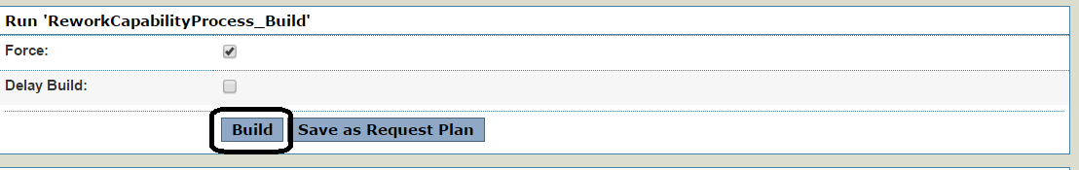

Once the **Build** got triggered you will be able to see the below page;

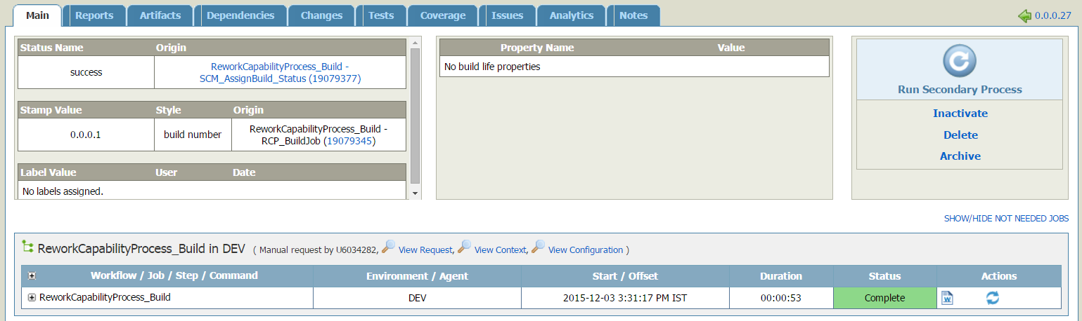

## AHP Deployment Procedures

**For this deploy, we will first untar OUT.tar and then will run the following SQL command :**

* **Java –jar <AHP>/OUT/LIB/ActivitiProcessDeployer.jar <Environment> <ProcessFilePath> <IsSQLExecutionRequired> <sqlFilePath>**

where

* **Environment to select will be Dev,QA.Stage or PROD**
* **ProcessFilePath will come from OUT/PROCESS/<ProcessFileName>.bpmn**
* **Is SQLExecutionRequired to select will be either Yes or No.**
* **sqlFilePath will come from OUT/SQL/<ProcessFileName>.sql**

SCM->Prod -> Findlaw -> ReworkCapabilityProcess -> ReworkCapabilityProcess\_Build , click on the latest successful build life from dashboard then secondary process from the build life, select the deploy workflow and run.

To Deploy select ReworkCapabilityProcess\_Build and click on the latest successful build as shown below :

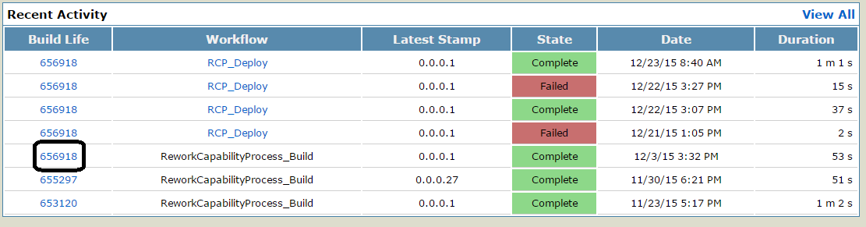

After clicking on **Build life** Id the below page will open;



To deploy the same version in Dev environment click on **Run Secondary Process** as below;

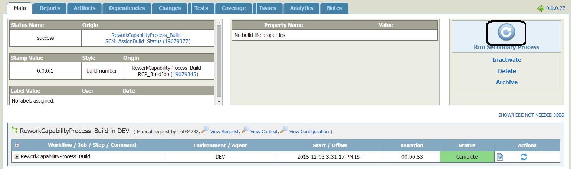

Select [**RCP\_Deploy**](http://anthillpro.int.thomson.com:8080/tasks/admin/project/workflow/WorkflowTasks/viewWorkflow?workflowId=40198) and the below page will open as below ;

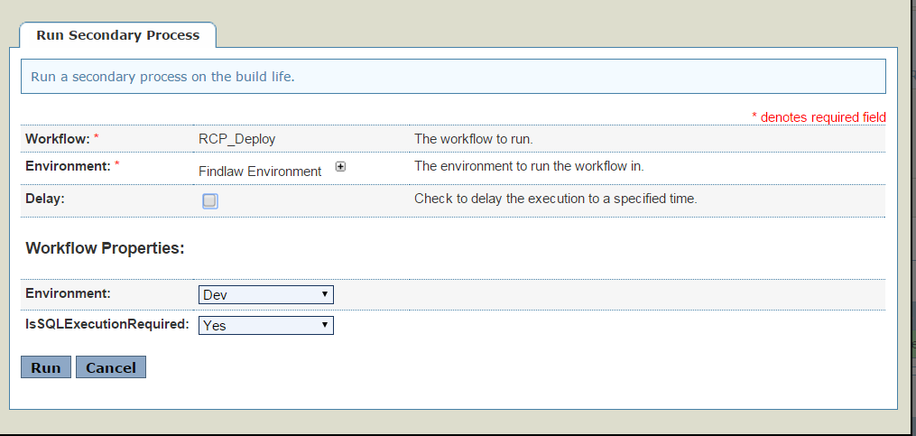

Now Select the Environment to deploy to and select if IsSQLExecutionRequired or not and select **Run** option :

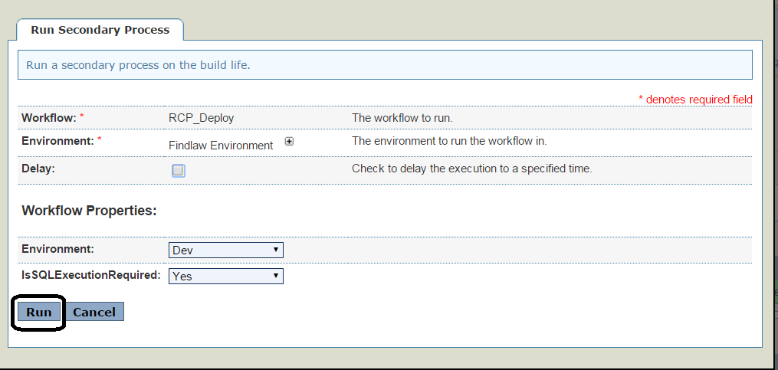

After this is completed, you will be able to see the below screenshot :

