

Cover Sheet for Term Paper

Name(s): 1. Utsha Basak  2. Khandoker Md. Ragib Ahsan  3. Maruf Hossain  4. MD.Labib Reza Joarder  5. Alfaz Uddin Ahmed | Student ID(s): 1. 22301205  2. 22301202  3. 23101051  4. 23301418  5. 24104135
Course name: Business – Basics, Ethics and Environment
Section: 27
Lecturer name: Noshin Anjum Chaiti (NAC)
Word Count (tables, charts, pictures references appendices and group learning report are not included): 3087

PLAGIARISM

Plagiarism is the presentation by a student of an assignment that has been copied in whole or in part from another student’s work, or from any other source (e.g. published books or periodicals or internet sites) without proper Acknowledgement in the text.
CONSEQUENCES OF PLAGIARISM AND COLLUSION

In any case where a student has been involved in plagiarism or collusion, this will be reported to the Dean. Their assignments will not be checked and they will fail to be evaluated. It may be reported to Student Administration and recorded on the student’s academic file.

DECLARATION

By submitting this assignment to the BRAC Business School, BRAC University, we declare that this submission is our own work and does not involve plagiarism or collusion. We give permission for our assignment to be scanned for electronic checking of plagiarism.



Business Plan
for
PixelPerfect3D

[Date: April 22, 2024]

Contact Information:

Email: contact@pixelperfect3d.com
Phone: (555) 789-0123
Address: 43 Mohakhali C/A, Dhaka 1212
Website: www.pixelperfect3d.com

Confidentiality Notice:

The information in this document is highly confidential and should only be used by the person or organization to whom it is addressed. It is strictly prohibited to review, use, disclose, or distribute anything without proper authorization.

22 April 2024
Noshin Anjum Chaiti
Lecturer
Brac Business School
Kha 224 Bir Uttam Rafiqul Islam Avenue,
Merul Badda, Dhaka 1212, Bangladesh

Dear Madam,
I want to thank you for the opportunity given by you to present our new business initiative.
PixelPerfect3D is looking for investors to further grow in the business market. Our company is one-of-a-kind in the fully-customizable plastic product category and our vision is to expand the business in the metal products category. We believe that we can give you long-term sustainable benefits in return to your investment. We have the potential to work in pretty much every sector in Bangladesh and your investment will be a great asset in advancing our business to that extent.
We have included our business plan and would very much appreciate your engagement with our company.
Thank you very much for your time and contact us for any further information you may need.

Sincerely,
PixelPerfect3D
Email: contact@pixelperfect3d.com
Phone: (555) 789-0123
Address: 43 Mohakhali C/A, Dhaka 1212
Website: www.pixelperfect3d.com

Table of Contents
Introduction ……………………………………………………………. 07
Background of the company…………………………………………….08
Business Environment…………………………………………………..09
SWOT Analysis…………………………………………………………10
Human side of the business……………………………………………...12

Marketing and E-Commerce……………………………………………..14
Accounting and Finance………………………………………………….17
Conclusion ……………………………………………………………... 19
Reference(s) ……………………………………………………………... 20

Introduction

In Bangladesh, getting a personalized product is very much time consuming and costly. In many cases, customers don't even get their desired product after spending hours searching for it and/or spending a large sum of money for it. We, PixelPerfect3D, offer bespoke creations from high quality plastic materials tailored for customer’s individual needs. We are a pioneering startup in this business sector that can revolutionize the landscape of manufacturing in our country. In 2023, USD 20.37 billion was the market size of the global 3D printing business and its expected ‘Compound Annual Growth Rate’ is 23.5% from 2024 to 2023 (3D printing market, 2022). At PixelPerfect3D, we think of a future where our capabilities spread beyond plastic by using metal 3D printing machines to offer more customizability in our line of products. While the dream is yet to become a reality due to financial capabilities, we are actively searching for the investors to be a part of us and grow together to make the vision a reality. Aside from the customizability, we also offer fixed-design products and have a subsidiary business of wood and metal carving which are highly interconnected to each other. Although currently we only operate on our online platform for customer engagement and sales, we are open for all the future possibilities as we are getting overwhelming positive responses from our customers, indicating a strong demand for 3D printed products in the market. As we go forward, PixelPerfect3D remains committed to delivering premium quality products through cutting-edge technology, customer-friendly service and dedication towards growth and excellence.

Background of the company

Launched in January 2024, PixelPerfect3D originated from a collective vision shared by five creative minds. Understanding the true potential for customizable products in the local market, the founders thought of a service from where people could buy their personalized products. Having backgrounds containing various fields such as engineering, business and economics, the whole team is well prepared to adopt and learn about the future prospects of the field we are working on.
The idea took place in a modest rented warehouse to have ample amount of space for operating the state-of-the-art 3D printing machines as well as storing raw materials and finished products. The founders pawned their resources to secure loans and invested from their personal funds to buy necessary equipment and arrange the proper setup for the business. Regardless of the financial strain, we worked tirelessly for days and nights to give our best to satisfy customers by creating them something unique and special.
The early days were very challenging times. From doing the market analysis to know about the complexities of the business and act accordingly, setting up an e-commerce platform to represent our ‘artwork’, going through strategic marketing to do the publicity of our work to finally streamlining the production process has taken us through some remarkable experiences and introduced us to the reality of conducting a business. However, the team’s perseverance and hard work paid off as we successfully launched our website (www.pixelperfect3d.com), offering a wide range of fixed and fully-customizable plastic based premium products. Within this very short time, the response from customers are overwhelmingly positive as they have never got the chance of having this much personalized products. Whether a fully finished product or just a part of it, many of the customers claimed that those have eased their life to a great extent.
As PixelPerfect3D continues to grow, the founders maintain a hands-on approach by managing key operational areas while the workers handle the product building site, manage the inventory and deliver the products. We have also expanded our creative horizon by opening a subsidiary venture in wood and metal carving which works in both ways: producing products completely on its own or producing a part of the product that merges with 3D printed objects to complete the whole product. This step further solidifies our presence in the market while fostering a culture of innovation and excellence. With a keen eye towards the future, the company is eager to get into the realm of metal 3D printing to broaden and tighten its grip in the market; and for that, PixelPerfect3D is actively exploring opportunities to collaborate with the ideal investors.

Business Environment

- The introduction emphasizes the growing need for individualized items and how 3D printing technology may meet this requirement. It acknowledges the difficulties customers encounter while purchasing personalized items in Bangladesh, suggesting a market need that PixelPerfect3D intends to solve.
- PixelPerfect3D is a leading firm that uses cutting-edge 3D printing technology to provide personalized masterpieces. The mention of future ambitions to expand into metal 3D printing suggests a willingness to innovate and remain ahead of industry trends.
- The introduction highlights PixelPerfect3D's huge market opportunity by providing statistics on the worldwide 3D printing market size and growth rate. This emphasizes the company's potential to scale and be viable in the long run.
- The mention of financial restrictions and the quest for investors suggests a recognition of the need of obtaining capital to fuel growth and achieve the company's goals. It also provides an opportunity for potential investors to profit from the tremendous possibilities of the 3D printing sector.
- PixelPerfect3D aims to go outside its online platform and explore more sales channels in the future. This adaptability demonstrates a proactive commitment to fulfilling customer demands and increasing market penetration.
- PixelPerfect3D's introduction emphasizes their commitment to offering high-quality products and courteous service. This emphasis on quality and perfection is vital for creating brand recognition and fostering consumer loyalty in a competitive industry.

SWOT Analysis

Strengths:
- PixelPerfect3D is a pioneer in 3D printing technology, providing customers with individualized products in such a unique way that a traditional method can’t replicate.
- Our ability to create personalized designs for particular customers fills a market gap and gives us a competitive advantage over standard production processes.
- We offer a diverse product portfolio, including personalized 3D printing, fixed-design objects, and additional services like wood and metal carving. This diverse portfolio strengthens the company's capacity to cater to various client demands and broaden its market reach.
- Strong demand for 3D printed products validates the company's business strategy and indicates potential for expansion.

Weaknesses:
- Financial constraints may hinder future goals, including expanding into metal 3D printing. This may limit the company's capacity to invest in technical advancements and scaled-up operations.
- The limited space inside our warehouse may hinder the company’s ability to scale up quickly to meet potential surges in demand.
- PixelPerfect3D's online platform may not appeal to customers who prefer offline buying or alternative sales channels.

Opportunities:
- PixelPerfect3D can extend its market presence by capitalizing on the growing demand for personalized items in the worldwide 3D printing market.
- Using metal 3D printing technology in the future will allow PixelPerfect3D to create more types of premium personalized products and that will allow us to expand more deeply into the market.
- We can use recycled raw materials to build products that are sustainable and good for the environment.

Threats:
- Problems may arise regarding design patents; so, we have to be very careful on choosing copyrighted products.
- Technology is advancing rapidly everyday; so, the technical innovations in our industry may leave our machineries outdated very quickly.
- Economic fallout can leave people without excess money to spend on non-essential products which will hamper our sales.

Human side of the business

We are creating a business based on technical skills and a business where analytical skills matters a lot. Besides, we will need business strategies and market analysis. In our startup we are finding people to give a better start of the company and total stability. With a proper manpower those who manage a company and it interaction with people could be our customers, employees, workers and all over persons who are implemented with us is way more easier and undoubtedly an important thing .The way we are going to give shape to this reality is called HRM or another words its called Human Resource Management or human sides of the business. Human side of the business is a total workforce of those who manage the company, recruiting employees and workers in all over sectors in order to give a good and sustainable support to the company. Their main target is to fulfill the needs,targets and ambition of a company. A company not only sells products but also gives services to its people. They could be employees and customers both. There are a lot of duties to perform from human sides of the business or HRM.HRM not only recruit employees but also arranges it also works for the following:
- Maximizes employees performance
- Human capital management
- Schedule employees and focus on labor relations.
- Training for new employees
- Taking proper steps to survive in a competitive environment through recruiting talented employees
As our company is a new startup in a new market and we have limited capital to start our business. We have to implement our ideas carefully so that we recruit people in low numbers but at least we can generate the best output. After making profit or any sort of balance we can enlarge our business field and can create more job designations for our new posts.
First of all, to run this company successfully we need to divide our company's job designations for all of the employees. For doing this particular work perfectly and to give a best output to our 3D printing related work we have to recruit these below employees and worker:
- Project manager and customer relation officer: A project manager is always needed in any small to biggest company in order to complete a task within time given from the customers side. Again, in our startup as we don't have enough capital to open so many job posts our project manager will be the same person for customer relation officer.He will basically deal with customers and contact them in further process. Not only that he will also take care of a customers need in after sales services. Suppose, a customer has ordered us a prototype design. First of all that design will go to the project manager and then he will first register that work, create a schedule for that work and lastly he would transfer that particular work to the 3D modeler and 3D machine operator. And this is how it will climb further steps.
- 3D modeler: A 3D modeler could be anyone if that person has sufficient training and experience over 3D designing. This is basically a part of digital art and illustration. Besides, a designers’ expertise matters here a lot. A 3D modeler deals with daily tasks filled with challenges and he covers the customers requirement according to their given design. Once he makes the design he hands over the task to the machine operator.
- 3D Machine operator: A 3D printer machine operator deals with the further process of the work. A machine operator could be anyone who has proper training over a 3D printer operating from any polytechnic institute. Or otherwise from a short training over this. For the first few month we will start with only one operator as our initial startup capital is low
- Account,sales and market analyzer: A company needs its accounts and finance management team for better count of their net expenses and income of the whole company. They will collect the data of every income and outcome of the company . Again, the same person will analyze the market and seek for the competitors as well as will analyze the demand of the customers.
- Warehouse and inventory management: At a very finishing stage of a product we will need a warehouse and inventory and a person who will manage our products and other things in a storage compartment. In simple words he will manage the products.
- Delivery man :We have to buy a vehicle for our delivery purpose. The delivery man will deliver all the products within the due date.

Marketing and E-Commerce

Product Mix:
PixelPerfect3D offers a truly different and broad item blend that takes care of the dynamic and shifting requirements of clients looking for modified and customized items. The item blend incorporates:

Fully Customizable 3D Printed Products:
These are customized manifestations produced using extremely great plastic materials, permitting clients to customize their items as per their singular requirements and inclinations. Cool models incorporate customized phone cases, puppets, home stylistic theme things, and adornments.

Fixed-Plan 3D Printed Items:
Notwithstanding completely adaptable items, PixelPerfect3D likewise offers a scope of fixed-plan 3D printed items. These items highlight pre-planned layouts and examples, furnishing clients with prepared to-arrange choices for different purposes.

Wood and Metal Carving:
PixelPerfect3D's auxiliary endeavor truly has some expertise in wood and metal cutting, offering items that supplement its 3D printed contributions. This incorporates independent wood and metal cut things as well as parts that coordinate consistently with 3D printed objects to make truly interesting cross breed items.

Segmentation, Targeting, and Positioning (STP) Strategy:

Segmentation:
PixelPerfect3D sections its market in view of socio economics, psychographics, and conduct. Demographically, the objective market incorporates truly educated people, youthful experts, and innovative lovers. Psychographically, the organization targets clients who esteem personalization, uniqueness, and advancement. Typically, PixelPerfect3D centers around clients who are early adopters of innovation and are truly ready to pay a premium for modified items.

Targeting:
The really primary target segments for PixelPerfect3D include:

* Millennials and Generation Z consumers who value individuality and self-expression.
* Professionals seeking unique gifts, promotional items, or personalized accessories.
* Hobbyists and collectors interested in customized figurines, sculptures, and memorabilia.

Positioning:
PixelPerfect3D positions itself as a spearheading startup changing the assembling scene in Bangladesh. The organization stresses its obligation to conveying premium quality items through state of the art innovation, client amicable assistance, and devotion towards development and greatness. PixelPerfect3D's situation rotates around offering completely adaptable, top notch 3D printed items that take care of the novel necessities and inclinations of its clients.

Promotional Activities and Pricing:

PixelPerfect3D employs a real mix of promotional activities to raise awareness, generate interest, and drive sales. These activities really include:

Online Advertising: Utilizing digital channels such as social media platforms, search engines, and display networks to target relevant audiences with engaging advertisements showcasing the customization options and product range.
Content Marketing: Creating informative and really visually appealing content, including blog posts, videos, and tutorials, to educate consumers about the benefits of 3D printing and personalized products.
Social Media Marketing: Leveraging platforms like Instagram, Facebook, and Pinterest to showcase product photos, customer testimonials, and really behind-the-scenes content, fostering community engagement and driving traffic to the website.
Influencer Partnerships: Collaborating with influencers and brand ambassadors in really relevant niches (e.g., tech, design, lifestyle) to reach new audiences and enhance brand credibility.
Email Marketing: Sending personalized newsletters, promotional offers, and product updates to subscribers, nurturing customer relationships and encouraging repeat purchases.
Pricing: PixelPerfect3D adopts a value-based pricing strategy, charging premium prices for its fully customizable products really based on the perceived value and uniqueness they offer. Fixed-design products are priced competitively to appeal to a broader customer base. The company also offers discounts and promotions during special occasions and holidays to incentivize purchases and drive sales.

E-commerce Strategies:

PixelPerfect3D's e-commerce strategies focus on optimizing the online shopping experience and maximizing customer satisfaction. Key strategies include:
User-Friendly Website Design:Planning an outwardly engaging and instinctive site with simple route, clear item classification, and consistent checkout cycle to upgrade convenience and energize transformations.
Mobile Optimization: Ensuring that the website is really fully optimized for mobile devices, allowing customers to browse and make purchases conveniently from their smartphones or tablets.
Secure Payment Gateway: Integrating a secure payment gateway to provide customers with a safe and really hassle-free transaction experience, building trust and confidence in the brand.
Personalized Recommendations:Executing calculations and AI procedures to give customized item suggestions in light of clients' perusing history,preferences, and purchase behavior, enhancing the relevance of product suggestions and driving cross-selling opportunities.
Customer Support and Feedback: Offering responsive customer support via live chat, email, and social media channels to address inquiries, resolve issues, and gather feedback for continuous improvement.
Order Tracking and Fulfillment:Offering clients the ability to monitor their orders and receive regular updates on their status will help to improve customer happiness and transparency by keeping them informed and ensuring prompt product delivery.

Customer Engagement and Sales Strategies:

PixelPerfect3D employs various strategies to engage customers and drive sales:

Interactive Product Customization Tools: Offering user-friendly customization tools on the website, allowing customers to personalize their products in real-time by choosing colors, textures, designs, and adding text or images.
Social Media Engagement: Actively engaging with customers on social media platforms by responding to comments, reposting user-generated content, and running interactive contests or challenges to encourage participation and brand advocacy.
Email Campaigns: Sending targeted email campaigns with exclusive offers, product updates, and personalized recommendations to subscribers, nurturing relationships and prompting repeat purchases.
Educational Content: Creating informative content such as tutorials, how-to guides, and case studies to educate customers about the benefits of 3D printing, inspire creativity, and showcase the versatility of really customized products.
Referral Program: Implementing a referral program that rewards customers for referring friends and family, incentivizing word-of-mouth marketing and customer acquisition.

Accounting and Finance

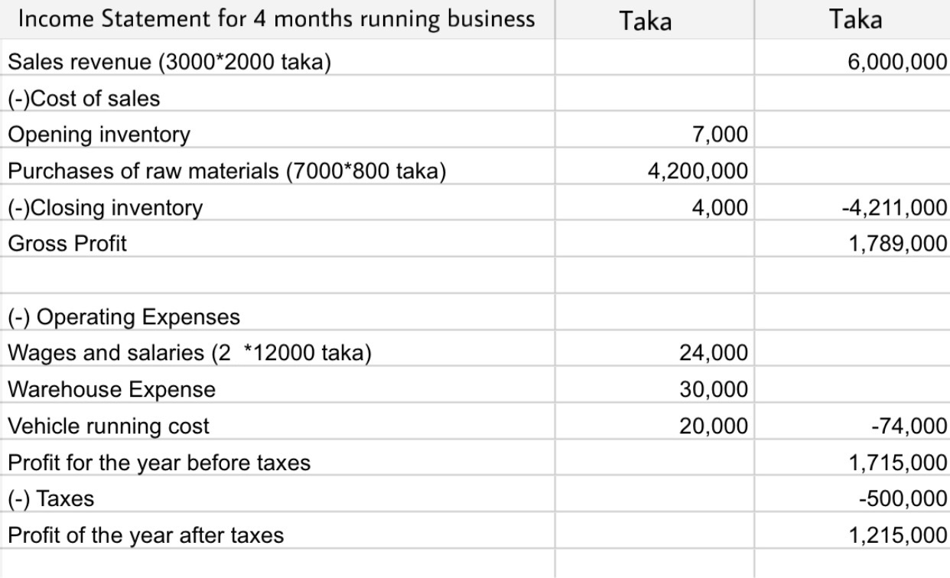
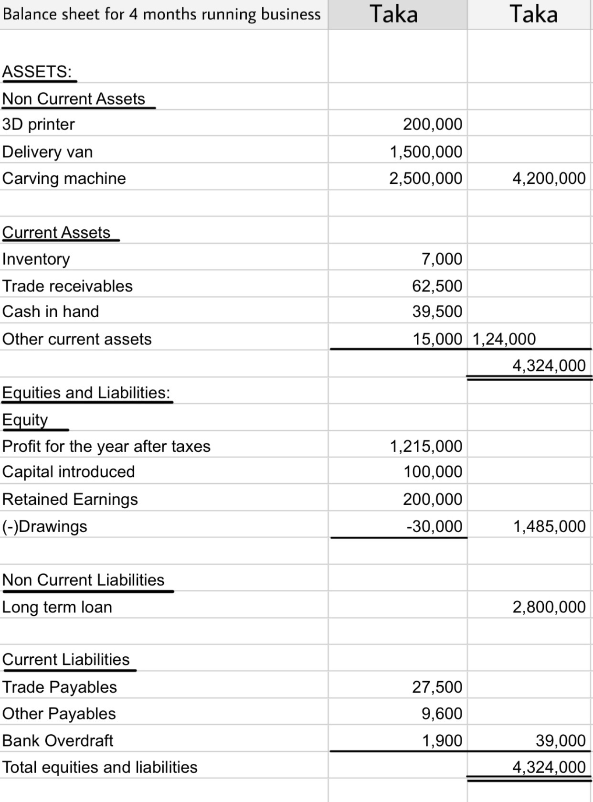
Conclusion

Our company's total architecture of every step is prepared. We have hired workers ,going to start managing our expenses and obviously we are going to implement these steps one by one. Which will help us eventually to build our motive. Besides, We are supposed to take analytical marketing strategies and will try to build a sustainable network between workers, clients and customers. Our profit margin and arranged works will guide us how to improve day by day. To be clear, dealing with customers and publicity of our company and services will be in top priority for our company. In a 3D printing company our printers and machine support should be of top notch quality so that it could give us a long term service and we have also implemented this stage. Furthermore, our goal is to build a 3D printing farm that has been a new idea throughout the country and if any company or their business which totally depends on 3D printing or they need any prototype for their business they could come to us. Their reliance over us will be appreciated and they can easily trust us for any project or any manufacturing process. We can guarantee that our product’s quality is top notch. With this belief and strategy we hope we will stand as a countrywise recognized 3D printing company.

Reference(s)
3D Printing Market Size, share & Trends analysis Report by component (Hardware, software, services), by printer type, by technology, by software, by application, by vertical, by region, and segment Forecasts, 2024 - 2030. (2022, April 8). https://www.grandviewresearch.com/industry-analysis/3d-printing-industry-analysis#:~:text=The%20global%203D%20printing%20market%20size%20was%20estimated%20at%20USD,USD%2088%2C281.2%20million%20by%202030

