

Name: Khandoker Md. Ragib Ahsan
Id: 22301202
Section: 03
Serial No- 36
Submitted to: Nowrin Hossian
Course code: Bio101
Course title: Introduction to Biology
Biology Lab report- ABO Blood group test

- Name of the experiment: to determine a person’s blood group
- Group determination: There were four groups. Each group had to test someone’s blood group so that anyone could select the appropriate blood transfusion. During the test, three drops of blood were collected to check the ABO blood group. As a result, one can learn about his blood group as the blood testing procedure.
- Purpose: The purpose is to identify one’s blood group.
- Principle: As we know there are 4 distinct types of blood groups (A, B, AB & O). Karl Landsteiner, an Austrian-American immunologist, and pathologist, in 1901, and for this discovery he got a Nobel Prize in medicine in 1940. After that, Alexander Weiner and Landsteiner. Discovered The Rh factor. The four classified blood groups - A, B, AB & O are based on the presence and absence of antibodies and inherited antigenic substances on the surface of RBC is the basis of the blood grouping test. The ABO and Rh blood grouping system is based on the agglutination reaction of the blood. Every blood cell contains an antigen with its corresponding antibody. For example, blood groups AB and A both include Antigen A and Antibody B but no Antibody, but blood groups A and B both have Antigen A and Antibody B. The O blood type, on the other hand, possesses both A and B antibodies but no antigen.The RBC contain every antigen, and the serum has all antibodies. Additionally, the Rhesus system, or Rh, is a type of antigen present on the surface of RBCs; its presence or absence defines whether an antigen is Rh+ or Rh-, and RhD is the most important Rhesus antigen.
- Apparatus:
  - Hexasol (Alcohol swabs)
  - Toothpicks
  - Lancet
  - Cotton
  - Clean glass slide
  - Disposal container
  - Marker
  - Tissue paper
- Reagents: Monoclonal Antibodies (Anti-A, Anti-B, Anti-RhD)
- Procedure:

- A clean glass slide was used for the blood test, and it was divided into three sections and labeled with the letters A, B, and D before being carefully placed on tissue paper (Note: During the procedure, one should not touch the flat side of the slide). In addition, the marker was used to write the person's name on the tissue paper. The person's fingertip was also thoroughly cleaned with Hexasol (alcohol swabs). Additionally, the fingertip was pricked with a clean, intact lancet needle before being wiped with an alcohol swab. The blood of a person was then obtained by gently pressing the fingertip. Three droplets of blood from the fingertip were then applied to the slide that had already been labeled. Before the blood sample started to dry out, three distinct drops of the antiserum were quickly but carefully dropped onto it. Drops of anti-A, anti-B, and anti-RhD were gradually applied to the labeled blood sample, A, B, and D. Finally, the blood and antiserum were combined in each region of the glass slide using three different unused toothpicks.
- Discussion :
  - On the surface of RBCs, there are two different protein types that are also referred to as antigens and Rh factor. Any person's blood type was determined by these two proteins. The specific blood group is identified by the presence of an antigen on RBC. The A blood group is indicated by the presence of the A antigen on the surface of the RBC. The A antigen is found on the surface of RBCs, which is a blood group A indicator. Similarly, to this, a person's blood type is B if they have the b antigen on the surface of their RBCs. A person with blood that has both A and B antigens on the surface of RBC has blood type AB, while a person with blood that has neither A nor B antigens on the surface of RBC has blood type O.

  - On the other hand, there are corresponding antibodies for every blood type. People who belong to blood group A, for instance, have A antigens on their RBC and anti-B in their serum. People with the blood group B have B antigens on their RBCs and anti-A in their serum. Individuals with blood group AB have both A and B antigens on their RBCs but none of the antibodies in their serum.
  - Additionally, the entire ABO and Rh blood grouping systems rely on the agglutination of blood samples. Because neither the A nor the B antigens were present in the blood sample on the glass slide, there was no agglutination on either sample. However, due to the presence of Rh+ in the D section, the blood began to agglutinate.
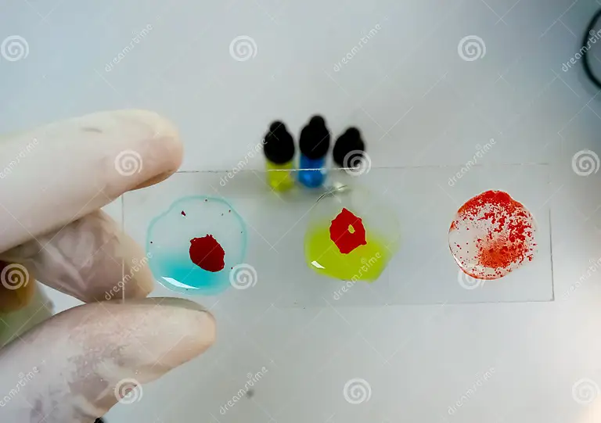

Ragib(O-positive)

- Precautions:
  - Labelling and Identification: To avoid mix-ups and maintain correct patient identification, ensure that blood samples are labeled accurately and clearly.
  - Aseptic Technique: Maintain sterile conditions and handle samples with care to avoid contamination and preserve sample integrity.
  - Quality Control: To validate the accuracy of testing techniques, do quality checks on a regular basis using known blood samples.
  - Temperature Control: Store samples and reagents at the correct temperature to preserve antigen and antibody integrity for accurate results.
  - Personal Training: Ensure that all people involved in testing have received adequate training in order to reduce errors and get consistent and trustworthy results.

References:
- https://www.webmd.com/a-to-z-guides/blood-types-what-to-know
- https://en.wikipedia.org/wiki/ABO_blood_group_system
- https://www.ncbi.nlm.nih.gov/pmc/articles/PMC8873177/

