Name: Ragib Ahsan

Eco602: Week10_Using_Models1

**Q1_Answer:**

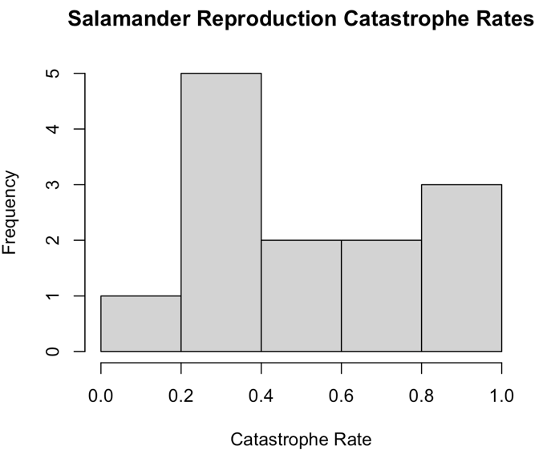

**Q2_Answer:**

p-value = 0.04097

#R Code- *shapiro.test(catrate$cat.rate)*

**Q3_Answer:**

Hypothesis- Collected data was from distributed data set.

**Q4_Answer:**

Lower p-value indicates that the data is from non-normally distributed population.

**Q5_Answer:**

#R Code-t.test(catrate$cat.rate, mu = 0.2857143)

**Q6_Answer:**

Hypothesis- salamander catastrophic reproduction rate is the same as the pond late filling rate.

**Q7_Answer:**

Because of the main interest in non-directionality of the data, it’s a two-tailed test.

**Q8_Answer:**

p-value = 0.01193, which is below the range of 0.05. Because of that a notable difference is expected between the two data sets (salamander reproductive catastrophic rate and pond late filling rate), which could be the false positive rate of 1.20%, suggests- no difference in the groups of 1.20% of the time.

**Q9_Answer:**

Confidence interval= 0.3526250 to 0.7261295, without zero.

**Q10_Answer:**

There could be a strong evidence to reject the null-hypothesis, because the p-value is lower.

**Q11_Answer:**

#R Code-wilcox.test(x= catrate$cat.rat, mu = 0.2857143)

**Q12_Answer:**

P-value from the Wilcoxon test is 0.006275, which is lower compared to the previous p-value- 0.01193.

**Q13_Answer:**

Yes, Wilcoxon test p-value could lead to reject the null hypothesis and suggests about the difference between the two datasets (reproductive catastrophic rate and pond late-filling rate). So, the rejection of null-hypothesis is possible based on this.

**Q14_Answer:**

Both tests indicate the lower p-values, which discourage the accept the null-hypothesis. Specifically, the p-value from Wilcoxon test, suggests to reject the null-hypothesis.

**Q15_Answer:**

I would choose the Wilcoxon test because, the data distribution type is more appropriate for this Wilcoxon test here.

**Q16_Answer:**

#R Code-shapiro.test(dat_adelie$flipper_length_mm)

**Q17_Answer:**

Both data sets are normally distributed. Because, their p-value is high enough to be the normally distributed data (for both Adelie and Chinstrap penguins- 0.72, and 0.8106). Here, these p-values supports the null-hypothesis.

**Q18_Answer:**

I had an issue, to get a combined image file with specific width and length.

**Q19_Answer:**

The alternative hypothesis- the flipper lengths are different in the Adelie penguins and Chinstrap penguins.

**Q20_Answer:**

t.test(flipper_length_mm ~ species, data = penguin_dat)