EsemkaTourism

**EsemkaTourism**

Software Requirement:

IDE: **Android Studio**

Programming Language: **Java or Kotlin**

Target Android: **SDK API 27**

Project Description and Task:

**EsemkaTourism** is a travel application designed for explorers and culture enthusiasts. With a vast collection of tourist attractions, events, and unique destinations, this app takes users on an exciting journey to discover the beauty of various places. From breathtaking natural landscapes to vibrant cultural festivals, **EsemkaTourism** is the perfect guide for travelers seeking unforgettable experiences.

**EsemkaTourism** wants you, as a talented developer, to create an Android mobile application that connects seamlessly to its Backend API. The API is already available, and you can access its documentation by running "EsemkaTourism.exe" and navigating to <http://localhost:5000/swagger> in your web browser. This will provide all the necessary details to integrate your application with the backend.

Ensure your application follows the recommended UI design and color style to create an immersive and user-friendly travel experience.

1. **Login Screen**

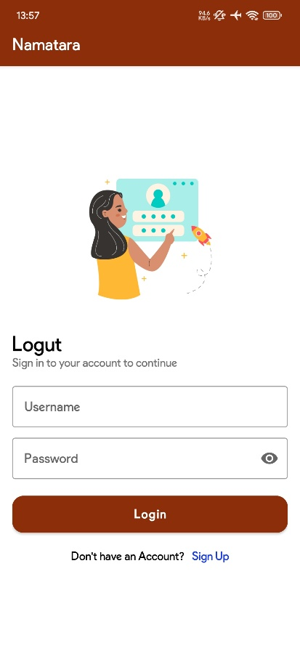This screen will be shown at first when the user opens the app. The user must fill out the Username and Password to login the applications.

When the user taps the **Login Button**:

* Ensure the Username and Password are filled out.
* The application must be validated based on the Backend API.
* Give a proper message if the login process fails. If the Login is successful, it redirects the user to **3. Main Screen**.

When the user taps the Sign-Up label, the user will be redirected to the **2. Sign-Up Screen**.

1. **Sign Up Screen**

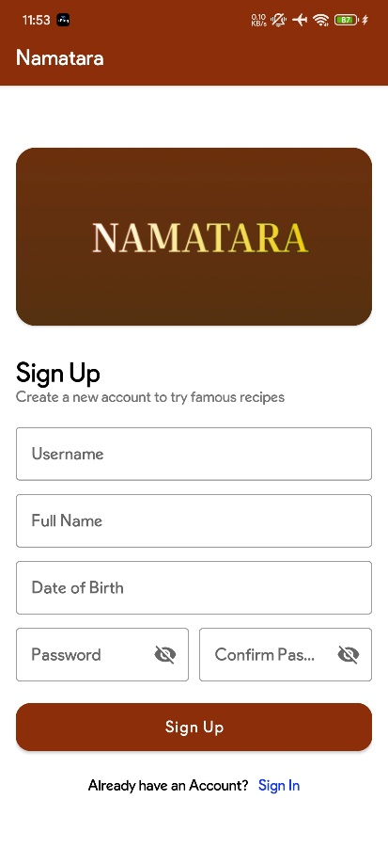This screen will be used by the user to create a new account.

When the user taps the **Sign-Up Button**:

* Ensure that all fields are filled out.
* Password and Confirm password must be the same.
* The application must validate based on Backend API.
* Give a proper message if the sign-up process fails. If the Sign-Up is successful, it redirects the user to **1. Login Screen.**

When the user taps the Sign-In label, the user will be redirected to the **Sign-In Screen**.

1. **Main Screen**

On the Main Screen, there is a BottomNavigationView. When the user presses the Navigation Button, the screen will change according to the Navigation that is selected.

1. **Navigation Home Screen**

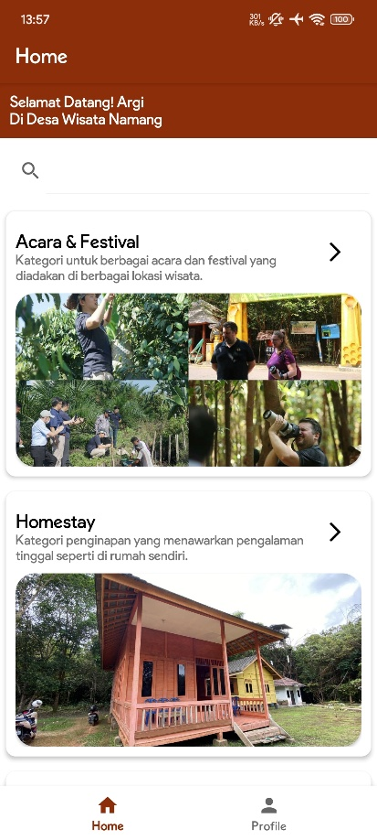

On the Home Screen, there is a bottom navigation view and a list of tourism categories. The category layout must be two columns and can be scrolled. When the user taps the category, the application will be redirected to the **4.** **Tourism Screen**.

1. **Navigation My Profile Screen**

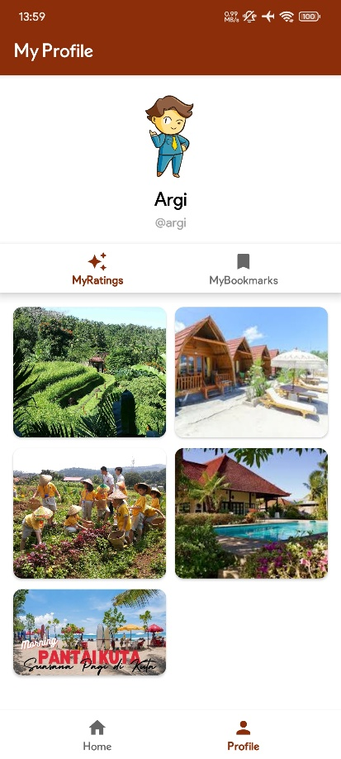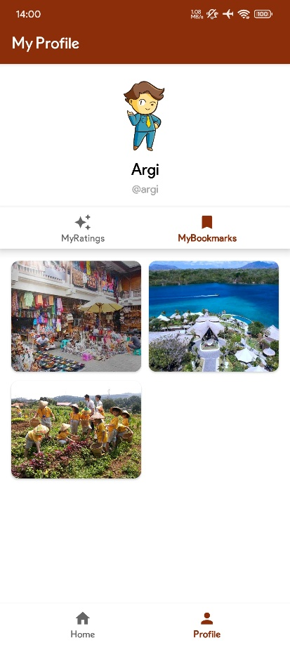

On the navigation My Profile screen, it will show the user profile, full name, and list of ratings and bookmarks. The image on the left shows that the user is already rated the places and the right image shows that the user is already bookmarked. The layout must be two columns and can be scrolled. When the user taps the images, the application will be redirected to the **5. Tourism Detail Screen**.

1. **Tourism Screen**

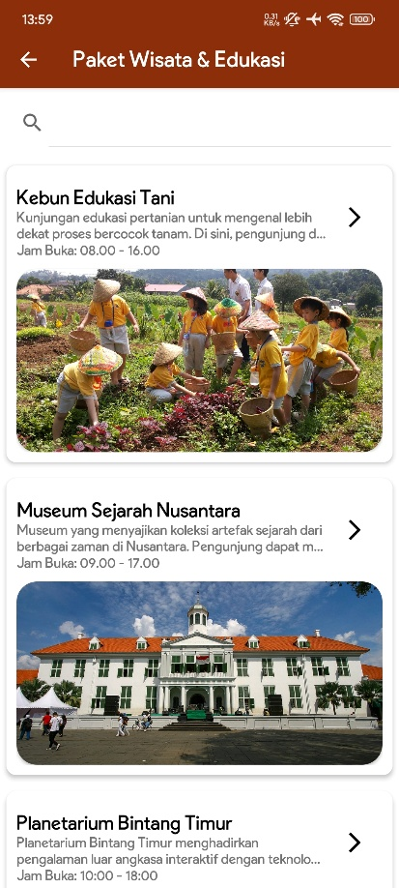

On the Tourism Screen, it will show a search box and a list of recipes based on the selected category. On the list, there is a image, title, icon and description. The user can search for recipes by using the title name as a keyword. When the user taps the data, the application will be redirected to the **Recipe Detail Screen**.

1. **Tourism Detail Screen**

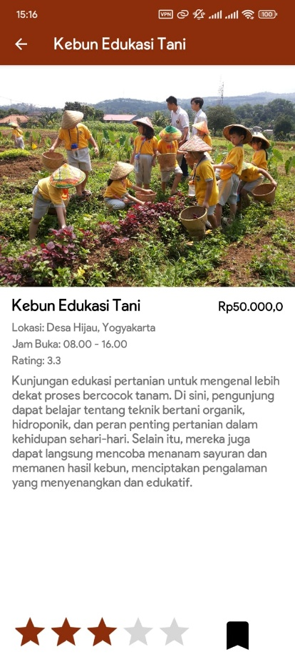

On this screen, there are image, title, and other general information. There are several conditions to which you need to pay attention:

* The rating bar and bookmark icon is load and changed by conditions.

**~ Good Luck ~**