Backend – 1

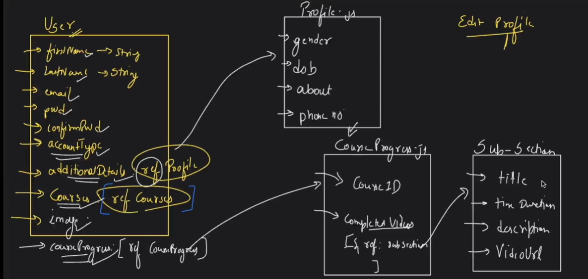
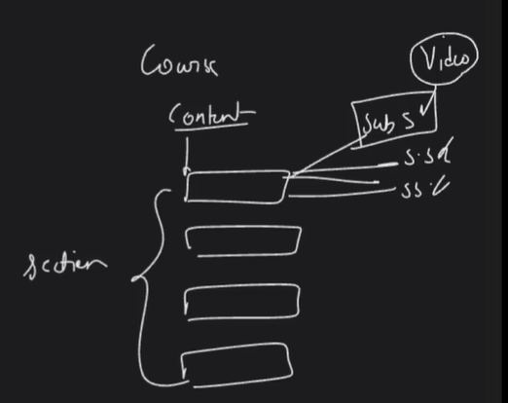
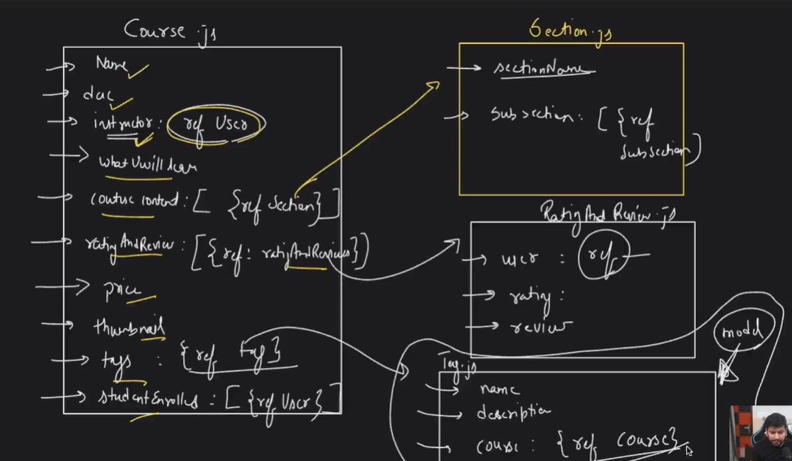
Starting with model creation:
- Create a folder named server
- Open terminal then:
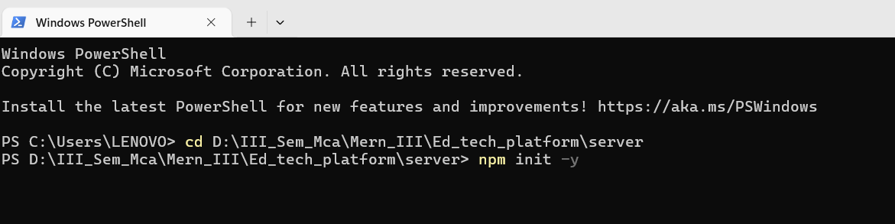

- Create these folders and files:
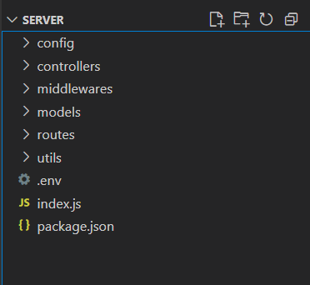
- Install some packages/libraries/dependencies
- npm i express
- npm i nodemon
- npm i dotenv
- npm i mongoose – used for database connection
- npm i cookie-parser- for authentication
- npm i jsonwebtoken
- npm i nodemailer – for sending mails
- npm i otp-generator – for generating otps
- npm i bcrypt – this package is used to hash the passwords

- Then go to package.json file , and change the start scripts:
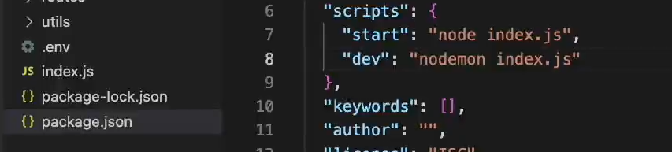

Starting with the code:
- Create a database.js file under config folder
For database connection:
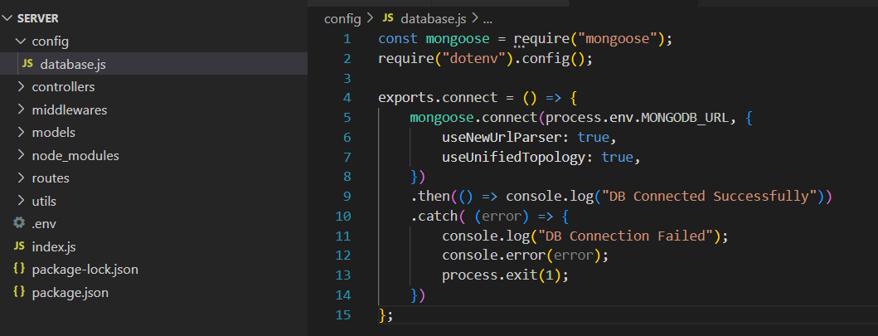

- Then we create User.js file in models (1st model)
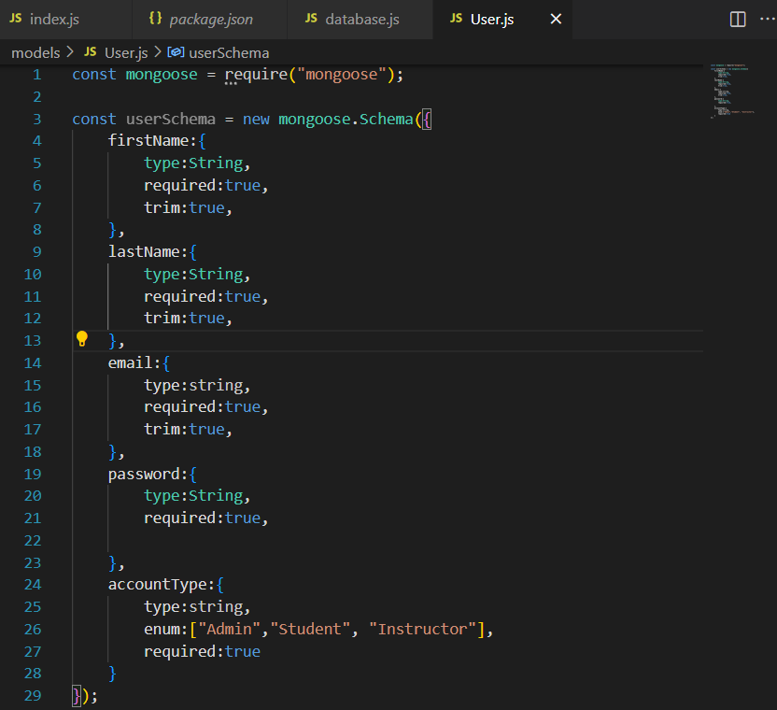
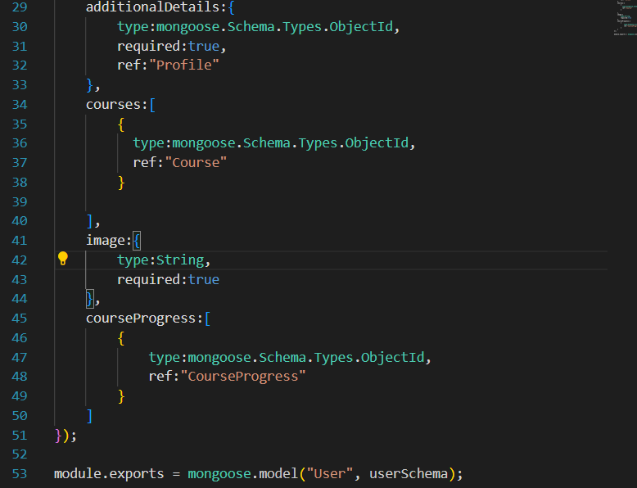

- Next , we make Profile.js , profileSchema
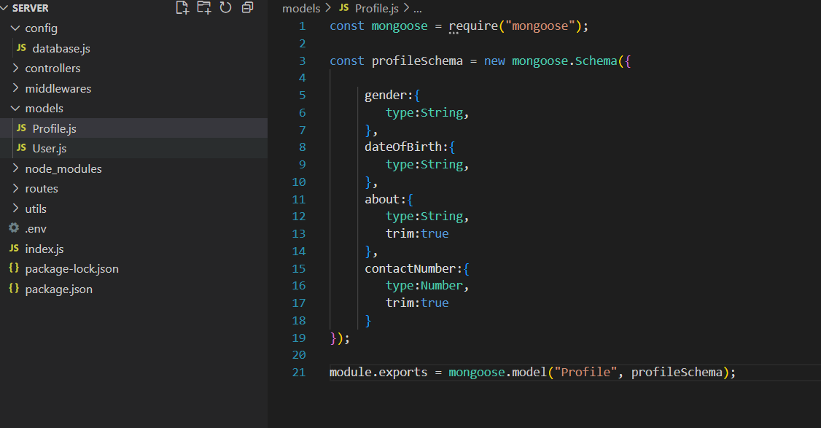

- Likewise , we make CourseProgress.js file
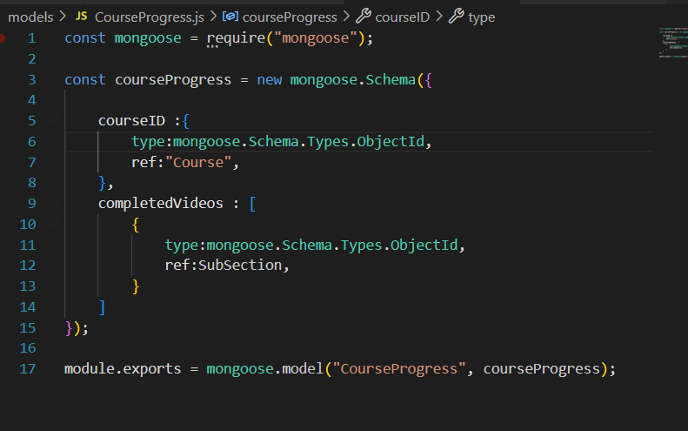

- SubSection.js – for videos
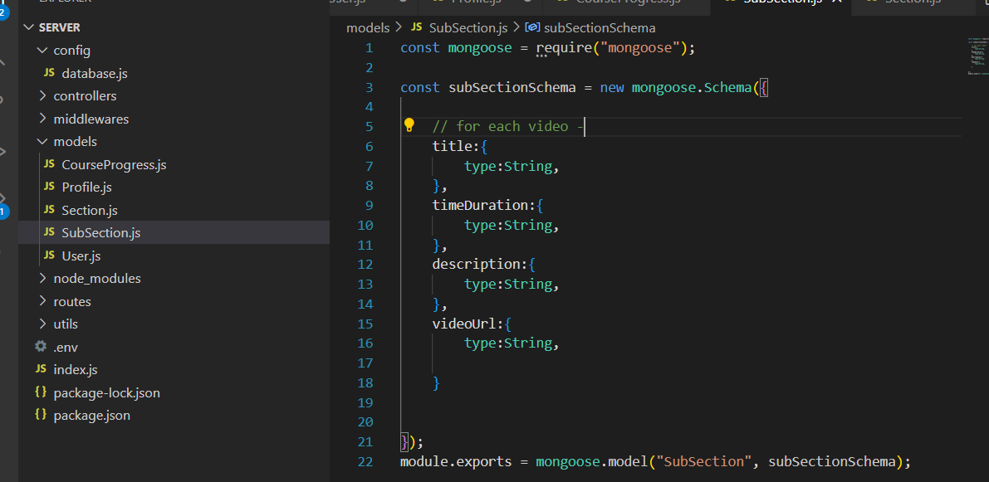
- Section.js
- Course.js
- RatingAndReview.js

