

**Laboratory 5**

**Signal Conditioning Circuit Interface- Input & Output**

**Objectives**

* To design an inverting amplifier using an OPAMP.
* Gain the experience of using the 754410 H-bridge driver interfaced with DRAGON12.
* To interface a small DC motor to the HCS12 microcontroller using the H – bridge 754410 driver.
* To interface a DC Fan using onboard relay and an external relay.

**Equipment and Tools**

* DRAGON12 trainer kit
* TLC272 Op-Amp
* DC motor
* SCC – Transistor (BC107), Relay (RAYEZ LEG 12), 56KΩ resistor.
* 12VDC – Fan - KD1204PKB3
* HIH -4000 Relative humidity sensor  [http://www.phanderson.com/hih-4000.pd](http://www.phanderson.com/hih-4000.pdf)f
* LM35 Temperature sensor

**Introduction to OP-AMP configuration**

**Inverting Amplifier**

A typical op-amp application is the inverting amplifier. An inverting amplifier inverts and scales the input signal.

|  |  |  |  |  |  |  |
| --- | --- | --- | --- | --- | --- | --- |
|  |  |  |  | RF |  |  |
|  |  |  |  | 100KΩ |  |  |
|  |  |  |  | 5V |  |  |
| vIN =- 4V | RIN | 6 | **-** | - |  |  |
|  | 8 |  |  |
|  |  |  |  |  |
|  | 100KΩ |  |  |  | 7 |  |
|  |  |  |  | TLC 272 | VOUT |  |
|  |  | 5 | + | ' |  |  |
|  |  |  |  |  |  |
|  |  |  |  | 4 |  |  |

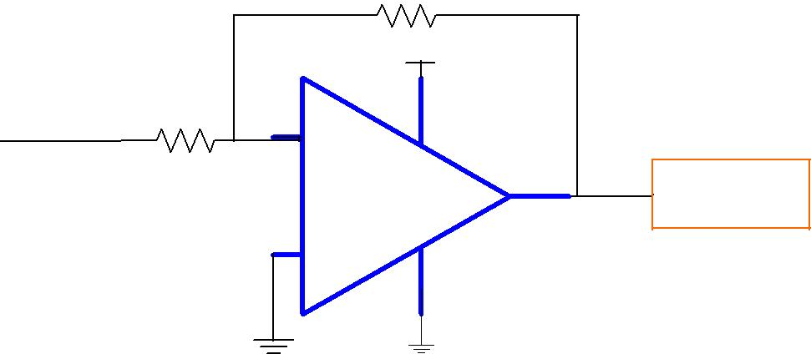

Figure 1: Inverting amplifier

The amplifier gain is given by *AV*  *Vout*   *Rf*

*Vin* *Rin*

For inverting amplifiers, non-inverting input will be grounded. The negative feedback from the output seeks to hold the inverting input's voltage at 0 volts. Voltage gain of this circuit can be changed by adjusting the values

1

of Rf and Rin. The output voltage is always with polarity opposite to the input voltage. A positive input voltage results in a negative output voltage, and vice-versa (with respect to ground).

**Non- inverting Amplifier**

|  |  |  |  |  |  |  |
| --- | --- | --- | --- | --- | --- | --- |
|  |  |  | 5V |  |  |  |
|  | 3 |  | - |  |  |  |
| vIN | + | 8 |  |  |  |
|  |  |  | TLC 272 | 1 | VOUT |  |
|  |  |  |  |  |
|  | 2 | **-** | ' |  |  |  |
|  |  |  | 4 |  |  |  |
| RIN |  |  | RF |  |  |  |
|  |  |  |  |  |  |

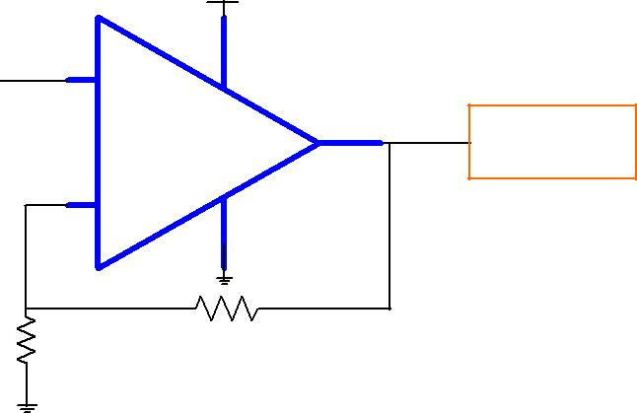

|  |  |  |  |  |  |  |  |  |
| --- | --- | --- | --- | --- | --- | --- | --- | --- |
| Figure 2: Non -inverting amplifier | | | | | | |  |  |
|  |  | *V* | |  |  | *Rf* |  |  |
| The amplifier gain is given by | *A*  |  | *out* |  1 |  |  |  |  |
|  |  |  |  |
|  | *V* |  | *V* |  |  | *R* |  |  |
|  |  |  |  |  |
|  |  |  | *in* |  |  | *in*  | |  |

**Voltage Follower:**

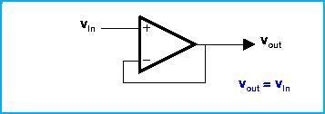

The voltage follower with an ideal op amp gives simply



**Output Signal Conditioning Circuits: DC Brushless Fan**

In this laboratory exercise a small DC motor will be interfaced to theHCS12 microcontroller.

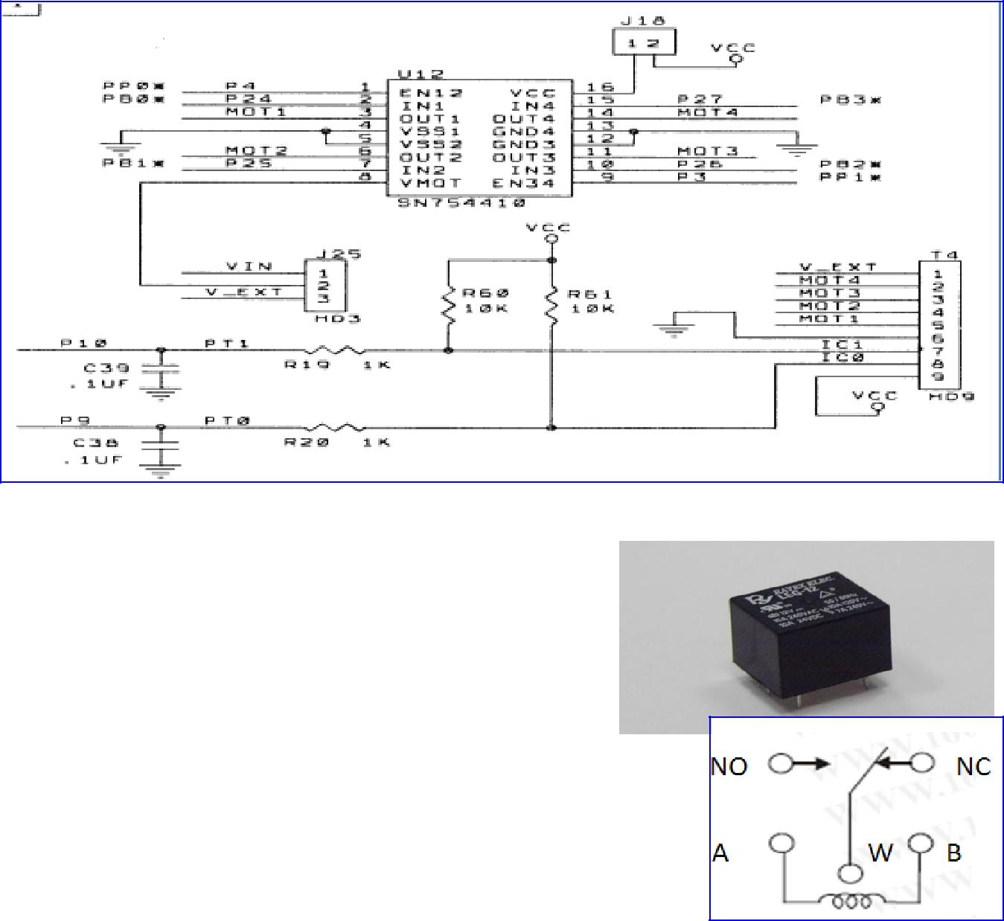**External Relays:**

A relay is a simple electromechanical switch made up of:

* an excitation coil (A and B) : a device consisting of a coil of wire wrapped around an iron core.
* a set of contacts : Normally Close (NC) and Normally Open (NO).
* a wiper (W) or Common Terminal as shown below:

This relay used in the lab is a Single Pole Double Throw (SPDT) Switch,

Where NO, NC and W are the terminals of the switch.

**Operation of Relay:**

1. When electricity is applied to the coil AB, it develops a magnetic field, and acts as an electromagnet.
2. When electricity is applied between A and B, the electromagnet acts upon the SPDT switch so that NO and W are connected.
3. When electricity is disconnected then NC and W are connected.
4. Note that the electromagnet is mechanically linked to the switch but the two are NOT linked electrically. Thus, it provides an excellent isolation between the HCS12 microcontrollers and the 12VDC brushless fan.

**Procedure**

**Steps to connect the inverting amplifier configuration**

1. Set a DC voltage of -4V in the power supply using the Digital Multi-meter (DMM).
2. Connect it as an input to the OP-AMP circuit of Fig 1, make a note of the output voltage at pin 7.

__________

**Steps to connect the brushless fan using external relay**

1. Turn OFF/Unplug the power of your Raspberry pi board before connecting the DC fan.
2. Set a DC voltage of +12V in the power supply using the Digital Multi-meter (DMM).

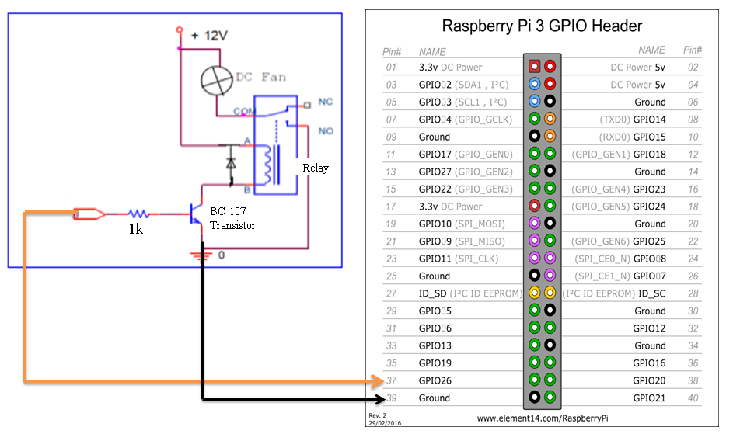

1. Connect the Signal Conditioning Circuit as shown in figure above.
2. Connect the wire marked as +12V from the Power supply terminal to one end of the external relay. Connect the ground of the power supply to the black terminal.
3. Next, connect the +5V red wire from the Power supply to the +5V of DC brushless fan. Keep a common GND for the relay and the Fan. Switch ON the power supply.

1. Write a program to:
2. Switch on the DC brushless Fan for 10 seconds and then switch it off for 5 seconds.

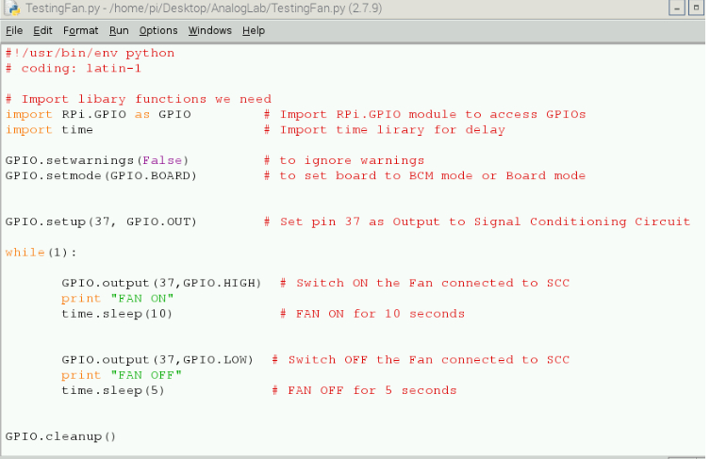

1. Read the room temperature using the SCC circuit used in Lab4.

Connect the temperature sensor to channel 2 of ADC Pi board.

Connect the +5 V and GND of ADC Pi to Raspberry Pi’s GND and +5V GPIO.

1. If (temperature >21.5), then turn ON the brushless FAN for 3 seconds, if (temperature<24.0), then the FAN should be turned OFF for 6 seconds.

. 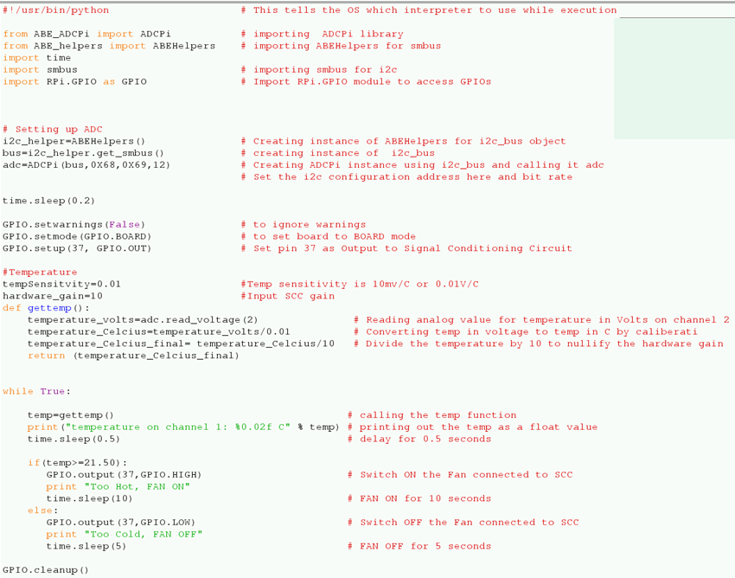

**Output:**

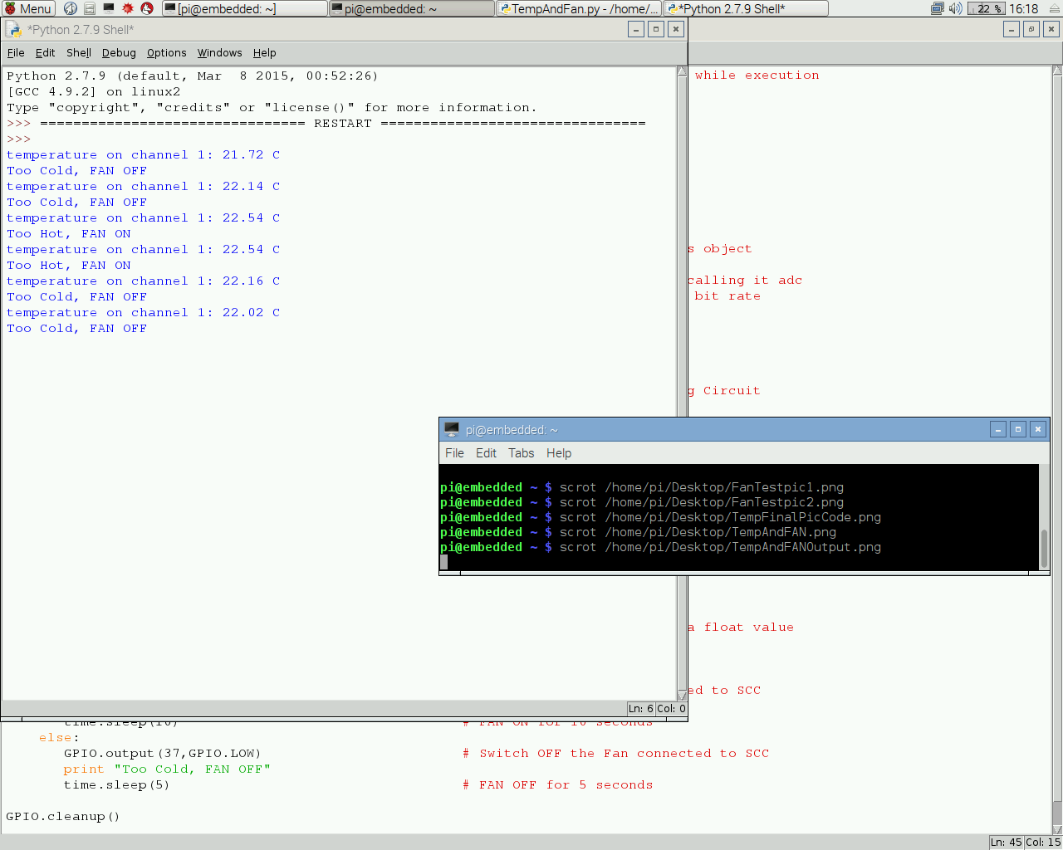

**Lab Report**

To be considered complete, the Lab report should contain the following information:

1. Cover sheet.
2. A brief discussion about H- Bridge, relay and brushless fan.
3. Measurement results of item (2).
4. Lab Question-Code with screenshots
5. Conclusion