1.Hello World Container
Step1- Create Dockerfile
# Use a minimal base image
FROM alpine:latest
# Define the command to print "Hello, World!"
CMD ["echo", "Hello, World!"]

Step2.Build the Docker Image

docker build -t hello-world .

Step3.Run the Docker Container
docker run hello-world

2.Flask application on an EC2 instance using Docker.
# Flask App Deployment on EC2 using Docker provides a step-by-step guide to deploying a Flask application on an EC2 instance using Docker.
## Prerequisite Basic knowledge of Flask, Docker, and AWS EC2.

## Project Structure

Step1 .Git clone from github repo
flask-app-ecs/
├── Dockerfile
├── README.md
├── app.py
├── requirements.txt
└── run.py
step2 . ## Dockerfile
The `Dockerfile` is used to build a Docker image for the Flask application.
```Dockerfile
# Base image (OS)
FROM python:3.9-slim
# Working directory
WORKDIR /app
# Copy src code to container
COPY . .
# Run the build commands
RUN pip install -r requirements.txt
# Expose port 80
EXPOSE 80
# Serve the app / run the app (keep it running)
CMD ["python", "run.py"]
Step3. Build image
Docker build -t flask-app .
Step4. Run Container

Docker run -d -p 80:80 flask-app
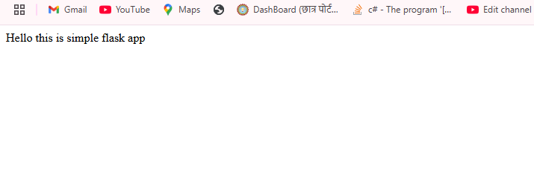
3. Node.js Express App in Docker

## Project Structure
Step1. Git clone from github repo
Node app

├── Dockerfile
├── README.md
├── docker-compose.yaml
├── package-lock.json
├── package.json
├── test.js
└── app.js
Step2. Build the Docker image:
docker build -t node-app .
Step3. Run the Docker container:
docker run -d -p 8000:8000 nodejs-app
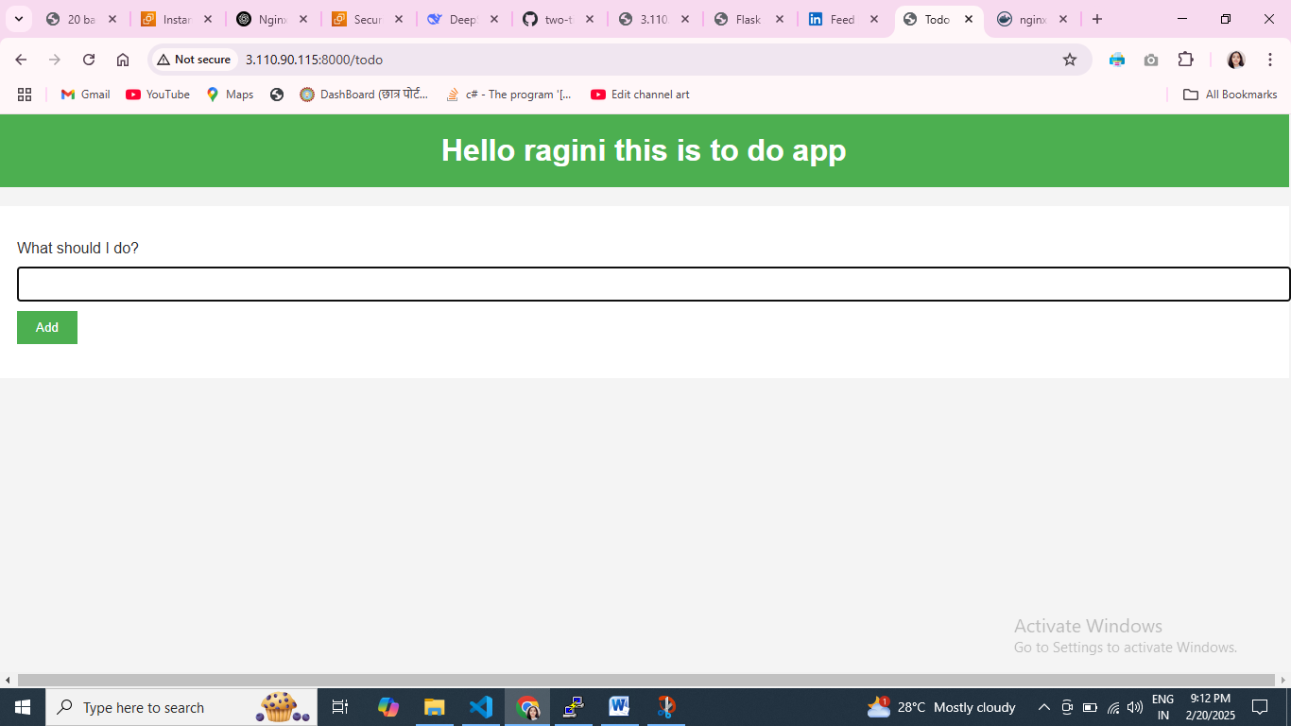

4.MySQL Database in Docker

Step 1 Pull mysql images form docker hub

Docker pull mysql

Step 2 To run images
docker run -e MYSQL_ROOT_PASSWORD=root -d mysql

Step3.connect mysql from Inside the Container
docker exec -it <container ID> bash

step4. inside bash run
mysql -u root –p
Enter password:

step5. Persist Data with Volumes
By default, Docker containers are ephemeral, meaning data will be lost if the container is removed. To persist MySQL data, use Docker volumes.
Docker volume create mysql-data
docker run -d --name mysql -v mysql-data:/var/lib/mysql -e MYSQL_ROOT_PASSWORD=root
mysql:latest
5. PostgreSQL with Adminer
• Create a docker-compose.yml file.
• Run docker-compose up -d.
• Access Adminer at http://localhost:8080.

docker-compose.yml
version: '3.8'

services:
postgres:
image: postgres:latest
container_name: postgres_db
restart: always
environment:
POSTGRES_USER: ragini
POSTGRES_PASSWORD: root
POSTGRES_DB: mydata
volumes:
- postgres_data:/var/lib/postgresql/data
ports:
- "5432:5432"

adminer:
image: adminer
container_name: adminer
restart: always
ports:
- "8080:8080"
depends_on:
- postgres

volumes:
postgres_data:

postgres Adminer 4.8.1 4.16.0
Top of Form
DB:

Bottom of Form

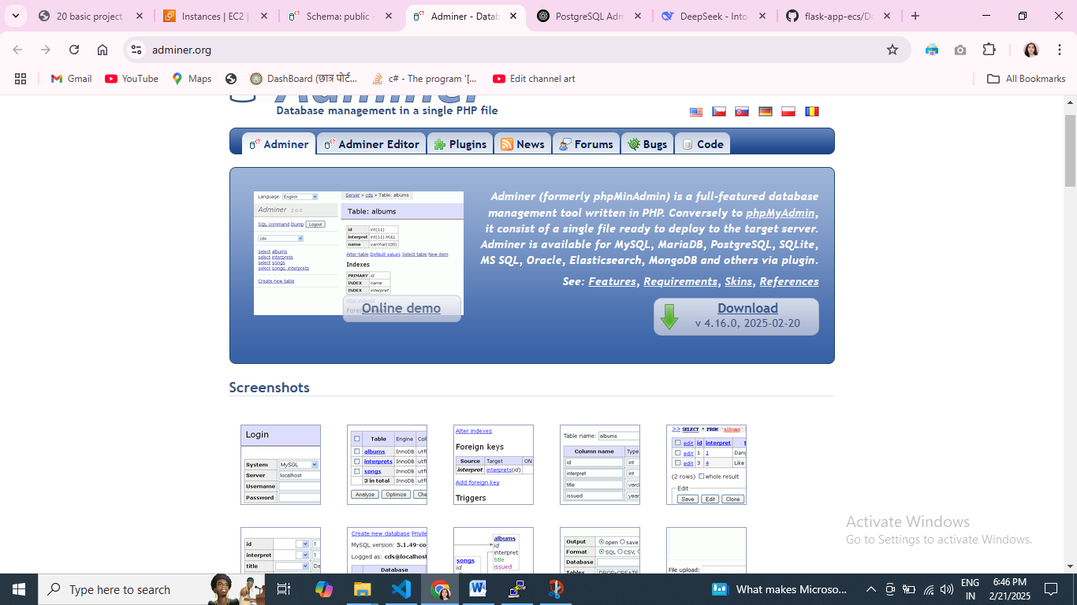
Postgress sql
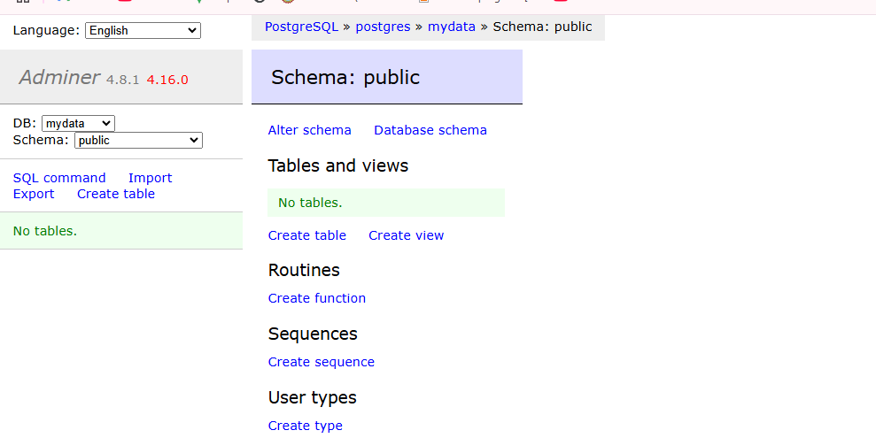

6.WordPress with MySQL
Mkdir wordpress

Step 1: Create a docker-compose.yml File

version: '3.8'

services:
db:
image: mysql:5.7
container_name: wordpress_db
restart: always
environment:
MYSQL_ROOT_PASSWORD: root
MYSQL_DATABASE: wordpress
MYSQL_USER: ragini
MYSQL_PASSWORD: root
volumes:
- db_data:/var/lib/mysql

wordpress:
image: wordpress:latest
container_name: wordpress_app
restart: always
ports:
- "8000:80"
environment:
WORDPRESS_DB_HOST: db:3306
WORDPRESS_DB_USER: ragini
WORDPRESS_DB_PASSWORD: root
WORDPRESS_DB_NAME: wordpress
volumes:
- wordpress_data:/var/www/html
depends_on:
- db

volumes:
db_data:
wordpress_data:

Step 2: Start the Containers
docker-compose up -d

check running container

👉 Open your browser and go to:
http://<ip>:8000
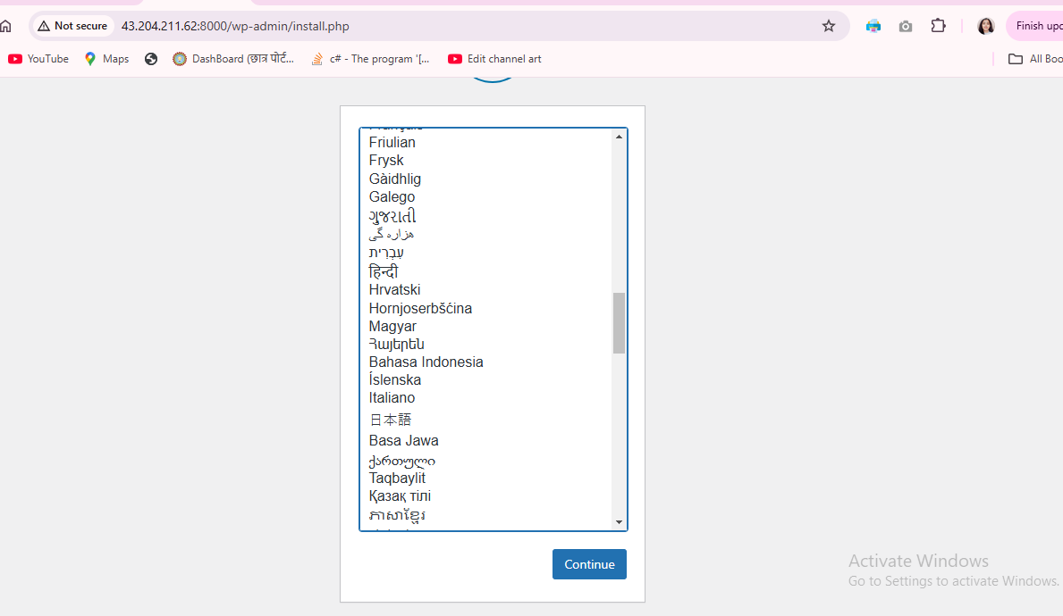

docker logs wordpress_db
If everything is fine, you should see messages like:
docker exec -it wordpress_db bash:

bash

mysql -u root –p

