  - TASK 2 REPORT: RAGINI MAHAJAN
- Column-wise analysis:
Column Name | Description | Data type | Significance | Reasoning for Selection
VIN | Unique Vehicle Identification Number. | String | Moderate | Essential for tracking specific vehicle history and preventing double-counting, but less useful for high-level trend analysis.
TRANSACTION_ID | Internal ID for the service record. | Integer | Low | Purely administrative; used for database indexing.
CORRECTION_VERBATIM | Technical notes from the mechanic on how they fixed the issue. | String | High | Critical for Engineering to understand the "fix" and evaluate if current repair procedures are effective.
CUSTOMER_VERBATIM | The specific complaint or symptom described by the owner. | String | High | Represents the "Voice of the Customer." Essential for identifying safety issues and subjective quality trends (e.g., "noise," "peeling").
REPAIR_DATE | The date the service was performed. | Datetime[ns] | High | Allows for time-series analysis to see if quality is improving or declining over months/years.
CAUSAL_PART_NM | The name of the specific part that failed (e.g., Steering Wheel). | String | High | Directly identifies the failure point. Used to trigger supplier audits or part redesigns.
GLOBAL_LABOR_CODE_DESC | Description of the standard work performed. | String | Moderate | Useful for standardizing repair types across different dealerships.
PLATFORM | The vehicle family (e.g., Full-Size Trucks). | String | High | Stakeholders use this to see which product lines are underperforming in quality.
BODY_STYLE | Vehicle configuration (e.g., Crew Cab). | String | Moderate | Helps identify if issues are specific to certain builds (e.g., water leaks in sunroof-equipped styles).
PLANT | The manufacturing factory where the car was built. | String | High | Critical for pinpointing "batch" issues or identifying if a specific factory has poor assembly quality.
REPAIRING_DEALER_CODE | ID of the dealer that performed the repair. | String | Moderate | Used to monitor dealer performance and ensure they aren't "over-repairing" vehicles.
STATE / CITY | Location of the repair. | String | Moderate | Helps identify environmental factors (e.g., salt-related corrosion in Northern states).
REPAIR_AGE | Time (usually in months) from build to repair. | Integer | High | Key metric for "Early Life Failures." High numbers here mean long-term durability issues; low numbers mean assembly/design flaws.
KM | The mileage on the vehicle at the time of repair. | Integer | High | Differentiates between "Manufacturing Defects" (low KM) and "Normal Wear and Tear" (high KM).
TOTALCOST | The total dollar amount of the repair claim. | Float | High | Financial stakeholders use this to track warranty liability and set future budgets.
ENGINE / DESC | Specific engine type and its detailed specs. | String | High | Crucial for powertrain quality teams to track failures to specific engine families.
TRANSMISSION / DESC | Specific gearbox type and its specs. | String | High | Essential for drivetrain reliability analysis and tracking recall risks.
ENGINE_SOURCE_PLANT | Factory where the engine was manufactured. | String | High | Vital for supply chain management; helps isolate a problem to a specific supplier or engine plant.
CAMPAIGN_NBR | Number assigned to recalls or special service programs. | Float | High | Essential for legal and compliance teams to track the effectiveness of a recall.
LBRCOST | The labor portion of the repair cost. | Float | Moderate | Helps management understand if a repair is "part-heavy" or "labor-intensive," which affects design for serviceability.
MEDIA_FLAG | Indicates if photos or videos of the failure exist. | String | Moderate | Provides visual evidence for engineers to see the physical state of a failure.
LINE_SERIES | Specific vehicle sub-series (e.g., 1500 vs 2500). | String | Moderate | Allows for more granular analysis within a platform (e.g., "are heavy-duty trucks failing more?").
ENCODING_ISSUE_FLAG | Data quality flag for digital records. | Boolean | Low | Primarily for data scientists to clean the data before analysis.

- Data Cleaning Summary:
1. A global configuration is applied using np.set_printoptions(suppress=True) to ensure that high-precision identifiers, such as Vehicle Identification Numbers (VINs) and Transaction IDs, are displayed in plain numerical format rather than scientific notation.
2. Data Ingestion and Preliminary Auditing: The dataset is ingested into a DataFrame via the pd.read_excel() function. Immediately following ingestion, the head(), info(), and dtypes methods are executed to conduct a structural audit. This phase allows for the identification of the 52 original columns and assesses the initial health of the data types.
3. Systematic Handling of Missing Values: The process identifies missing information through two primary methods: standard null detection (.isna().sum()) and the inspection of unique entries (.unique()).
- Placeholders: The data requires "Unknown" to be used as a string placeholder in several columns, such as CAUSAL_PART_NM and TOTAL_COST to handle missing/invalid values.
- Mapping Strategy: A comprehensive fill_map dictionary is defined to systematically replace these missing or placeholder values with standardized defaults (e.g., mapping categorical gaps to 'Unknown').
5. Normalization of Qualitative Verbatim Entries: CORRECTION_VERBATIM and CUSTOMER_VERBATIM columns are normalized to a consistent case. By converting these entries to lowercase, the workflow ensures that frequency-based keyword analysis (e.g., tracking the recurrence of specific mechanical symptoms) is not hindered by inconsistent capitalization.
6. Final Flagging: Additionally, a specific ENCODING_ISSUE_FLAG is introduced to identify and isolate records that may have encountered technical errors during the original data entry or export process.
# Visualization 1: Repairs by Platform (Bar Chart)
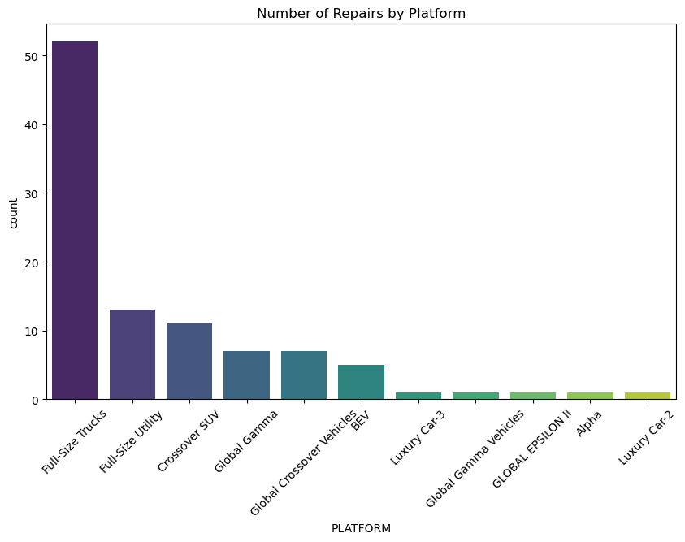

# Visualization 2: Mileage vs. Total Cost (Scatter Plot)
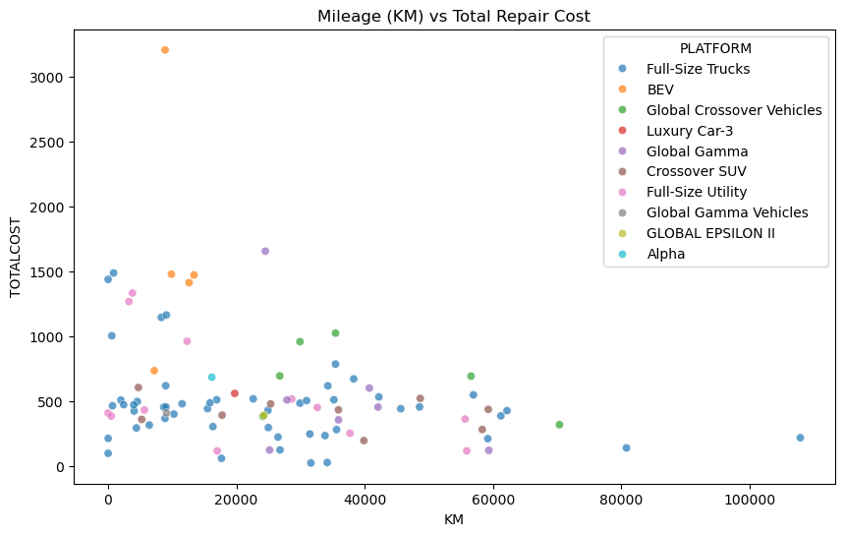

# Visualization 3: Repair Cost by Body Style (Box Plot)
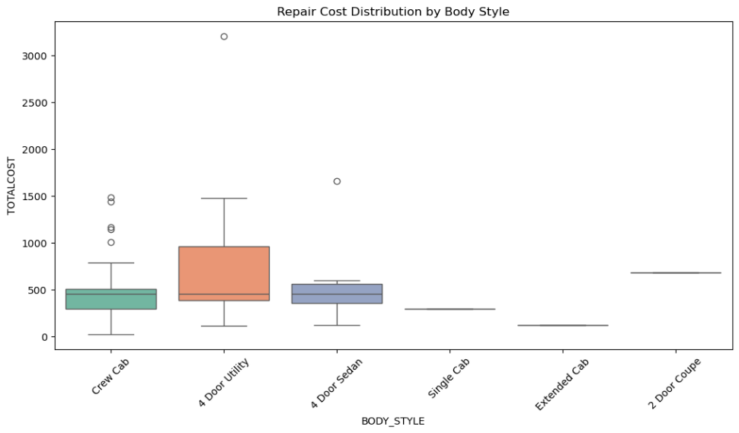

TOP 5 Critical Columns For Visualizations: PLATFORM, KM, STATE, and TOTALCOST:

- To Show Scale (PLATFORM & STATE): Stakeholders first want to know "How many?" and "Where?". Bar charts of these columns quickly answer those questions.
- To Show Timing (KM): A vehicle failing at 1,000 km is a much bigger quality concern than one failing at 100,000 km. The histogram provides this "timing" context.
- To Identify Financial Risk (TOTALCOST): By plotting cost against body styles or mileage, we can see if certain vehicle configurations are more expensive to fix, which helps in budgeting and setting warranty reserves.
- To Find Correlations (KM vs TOTALCOST): The scatter plot was used to see if there is a direct relationship between how much a car is driven and how much it costs to fix—helping stakeholders predict future costs as the fleet ages.
- Repair Cost Distribution by Body Style: Using a box plot allows you to see not just the average cost, but also the "outliers"—repairs that were exceptionally expensive for specific vehicle types.

- Generated tags & Key takeaways:
1. Key Takeaways and Summary of Tags
- The tag columns categorize the verbatim notes into structured data, revealing clear patterns in vehicle failures:
- Failure Conditions: The most frequent issues are HEATED_INOP (27 occurrences) and MODULE_FAILURE (20 occurrences). Other notable issues include STITCHING_COMING_APART and PEELING, highlighting a mix of electrical and physical degradation.
- System Impact: The HEATED_FEATURE (23) is the most affected system, followed by advanced systems like ADAS and SUPER_CRUISE.
- Failure Domains: COSMETIC issues lead the failure types (30%), closely followed by FUNCTIONAL (19%) and ELECTRICAL (18%). This suggests that while vehicles remain drivable, the tactile and visual quality is a major pain point for customers.
- Components: While the STEERING_WHEEL_ASSEMBLY is the parent component for 95% of cases, the HEATED_STEERING_MODULE (28) and STEERING_WHEEL_TRIM (21) are the primary sub-components causing failures.
2. Potential Insights
- Perceived Quality vs. Reliability: The high volume of cosmetic tags (stitching, peeling, trim lifting) suggests that even if the vehicle's core mechanics are sound, the "first-touch" quality is failing, which can significantly damage brand loyalty.
Dataset Discrepancies and Approach
During the analysis, several data quality issues were identified and addressed:
- Missing Values (Nulls/invalid): The TOTALCOST column had 6 missing entries. In the raw data, these were marked as "Unknown."
  - Approach: These were filled to a string ‘Unknown’/’Not Recorded as per column analysis to ensure they did not skew average cost calculations or cause code crashes.
- Primary Key Discrepancy: A significant discrepancy was found with TRANSACTION_ID. While there are 100 rows of data, there are only 32 unique Transaction IDs.
  - Approach: This suggests that a single repair transaction often involves multiple line items (different parts or labor codes). For analysis, the data was treated at the "line-item" level rather than the "transaction" level to capture every unique failure tag.

Github link for Python Notebook: https://github.com/raginimahajan123-sci/AXION-RAY-DATA-ANALYST-ASSIGNMENT

