Student Performance Prediction

Data Science- Internship Task 1




Ragini PS

Submitted on 12-July 2026

Abstract
The project aims to predict the academic performance of students using demographic, educational, and examination-related features. The workflow covers data preprocessing, exploratory data analysis, feature engineering, model development, model evaluation, and comparison.

Introduction
Educational institutions can use predictive analytics to identify students who may require academic support. This project demonstrates an end-to-end machine learning pipeline for predicting student performance.

Objectives
- Analyze the dataset.
- Clean and preprocess data.
- Perform exploratory data analysis.
- Feature Engineering and Selection
- Build regression models.
- Compare model performance.
- Predict math student score.

Dataset Description
The dataset contains student demographic information, parental education, lunch type, test preparation status, and mathematics, reading, and writing scores. Math score, is used as the prediction target.

Tools and Technologies
Python, Pandas, NumPy, Matplotlib, Seaborn, Scikit-learn, Jupyter Notebook.

Methodology
- Import libraries
2. Load dataset
3. Data cleaning and validation
4. Exploratory Data Analysis
5. Feature engineering
6. Train-test split
7. Train Linear Regression, Decision Tree, and Random Forest models
8. Evaluate using MAE, MSE, RMSE, and R²
9. Perform cross-validation and analyze feature importance.

Data Cleaning & Preprocessing

The dataset was first examined for missing values, duplicate records, and inconsistent column names. Since no missing values or significant data quality issues were identified, minimal preprocessing was required.
Data: Student Performance Dataset

Rows: 1000 Columns: 8 Missing Values:0 Duplicate values:0

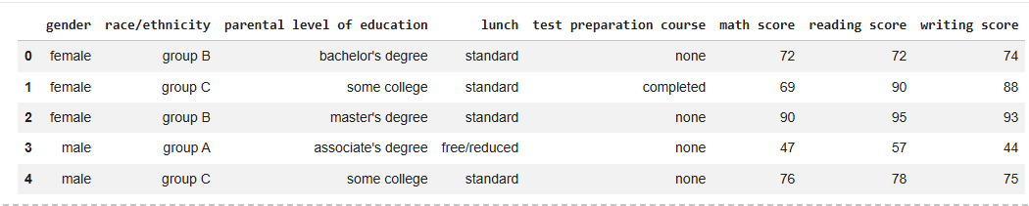
Preview of Dataset:

Exploratory Data Analysis
The notebook investigates score distributions, categorical relationships, and correlations. Reading and writing scores are strongly correlated, while mathematics shows comparatively lower averages.
Visualizations such as histograms, boxplots, pairplots, violin plots, count plots, and correlation heatmaps were used to identify trends and patterns.
Categorical variables were transformed using Label Encoding, while numerical features were standardized using StandardScaler before training machine learning models.
Preview after Encoding & Scaling:
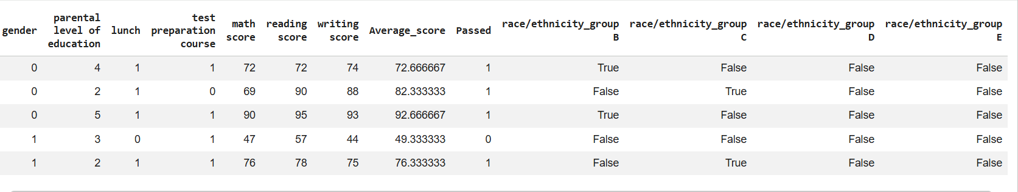

Heatmap showing Correlation between features:
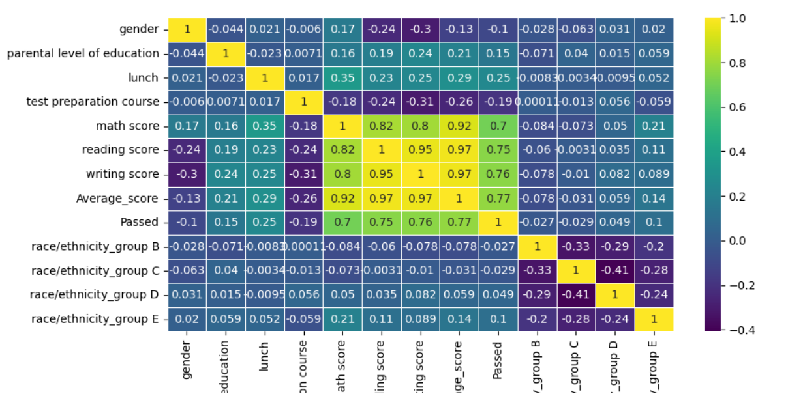
Impact of: Gender on scores – Bar Plot: Impact of: Parental Education –Cat Plot:
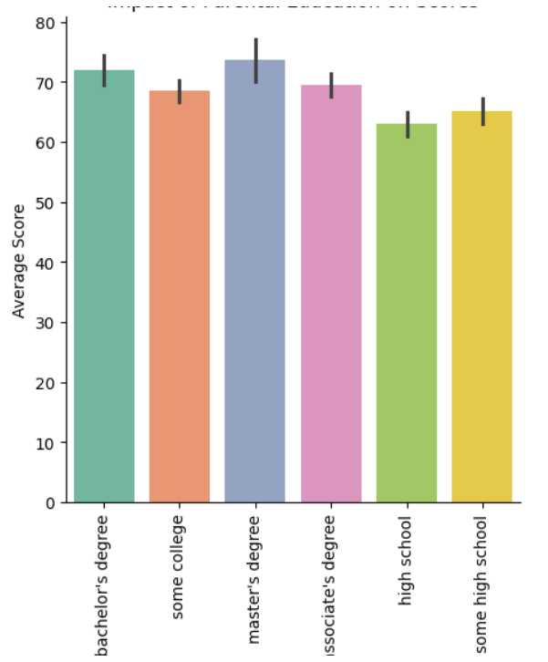
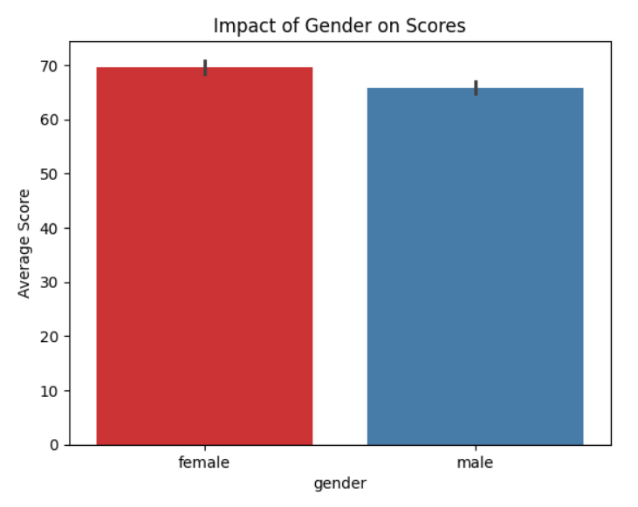
Impact of: Lunch Type – Violin Plot:
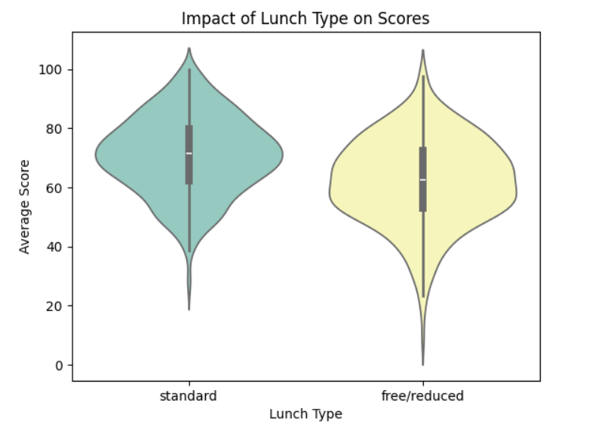

Distribution of scores – Pair Plot:
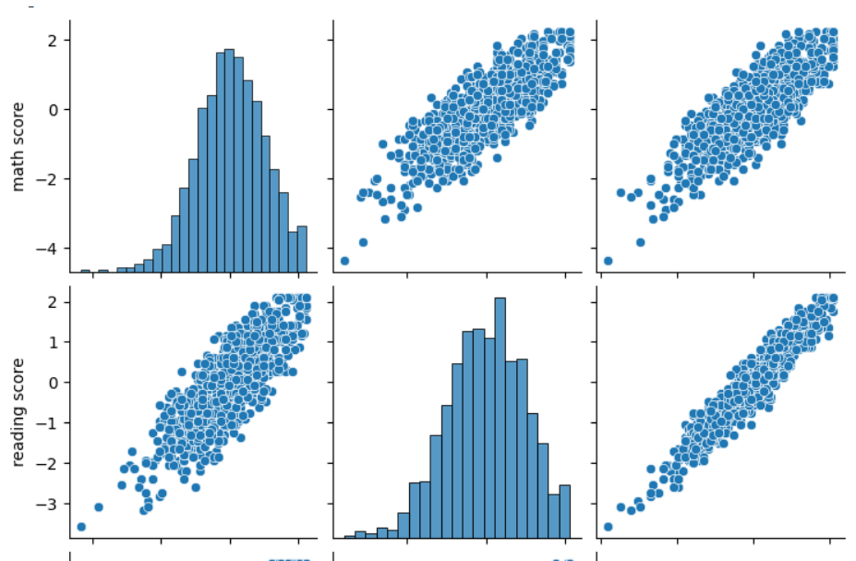
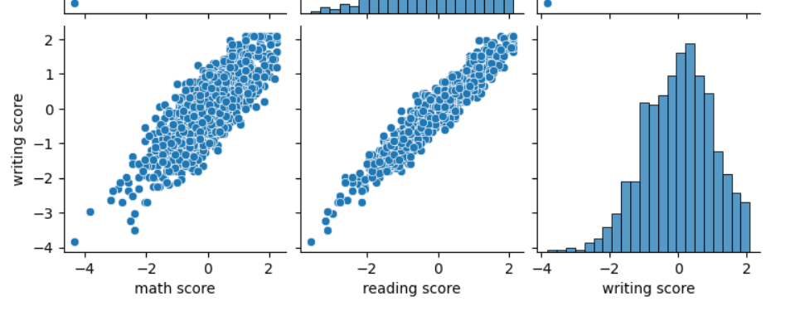
Hist Plot:
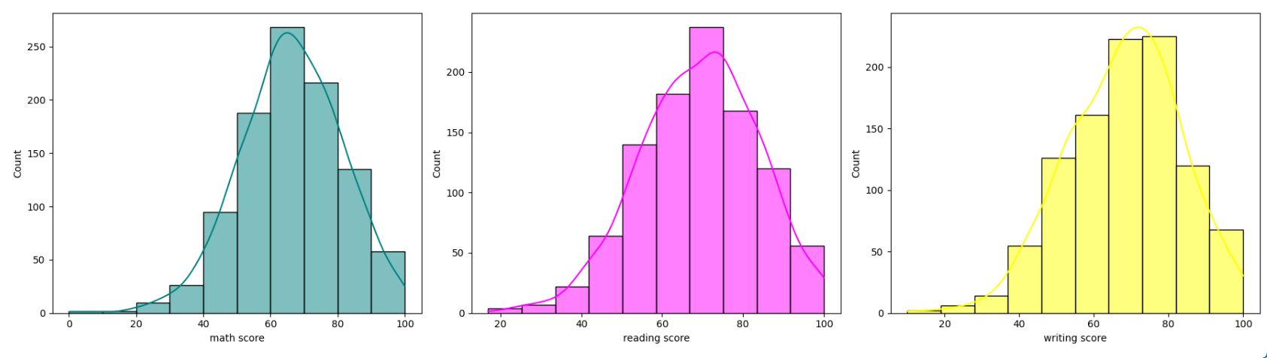

Feature Selection & Engineering

Feature Engineering was done by creating a new feature, Average Score, to represent the overall academic performance of each student which helped in studying the patterns of student overall performance with all independent features.
Selecting Features for train test split:
On basis of correlation of features the relevant features were picked for building model.
X(Independent Variable) Gender, Parental Education, Lunch, Test Preparation, Race/Ethnicity, Reading Score and Writing Score.
Y(Target) Math Score

Model Development

Three regression algorithms were implemented:
- Linear Regression
- Decision Tree Regressor
- Random Forest Regressor
The dataset was divided into training and testing sets using an 80:20 split, and model performance was evaluated using Mean Squared Error (MSE), Root Mean Squared Error (RMSE), and the coefficient of determination (R² Score).
Linear Regression serves as the baseline model. Decision Tree captures nonlinear patterns. Random Forest improves prediction accuracy through ensemble learning.

Results and Discussion
Models are compared using regression metrics. Random Forest generally provides the highest predictive performance, while Linear Regression offers better interpretability.

Key Findings
- Students who completed the test preparation course generally achieved higher average scores.
- Reading and writing scores exhibited a strong positive correlation.
- Female students demonstrated slightly higher average performance than male students.
- Lunch type and parental education level showed measurable associations with student achievement.
- The absence of significant outliers indicated that no additional outlier treatment as required.
Model Evaluation scores:
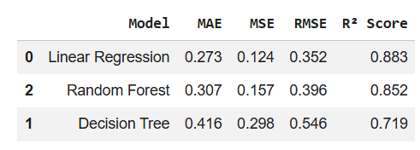
Model Performance comparison using Bar Chart
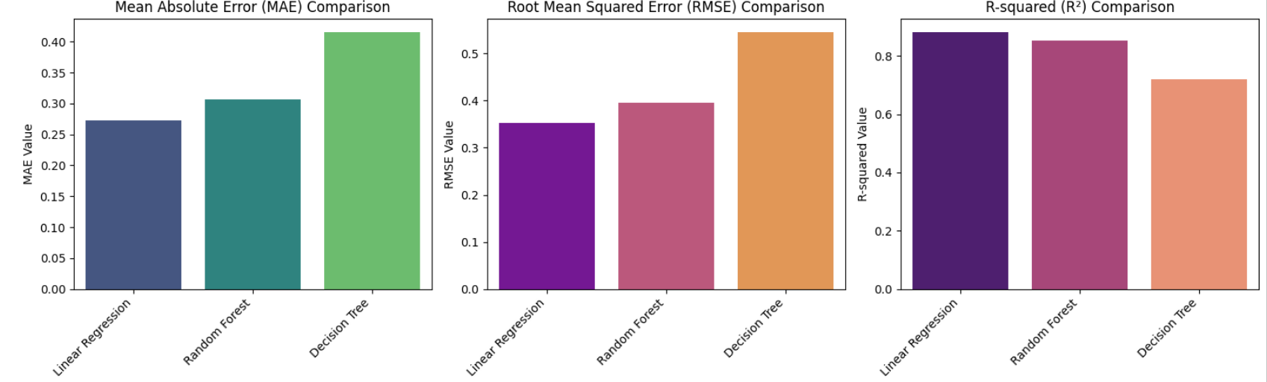
MAE: Measures the average magnitude of prediction errors.
RMSE: Penalizes larger errors more heavily than MAE.
R² Score: Indicates how much variance in the target variable is explained by the model.
Linear Regression Model has lowest RMSE and MSE. The score and R2score of linear regression model out performs Decision Tree Regressor and Random Forest Regressor with scores as:
MAE : 0.273 MSE: 0.124 RMSE: 0.352 R2: 0.883 Cross Validation: 0.872
Plotting Regression model with best fit line on predicted and actual values
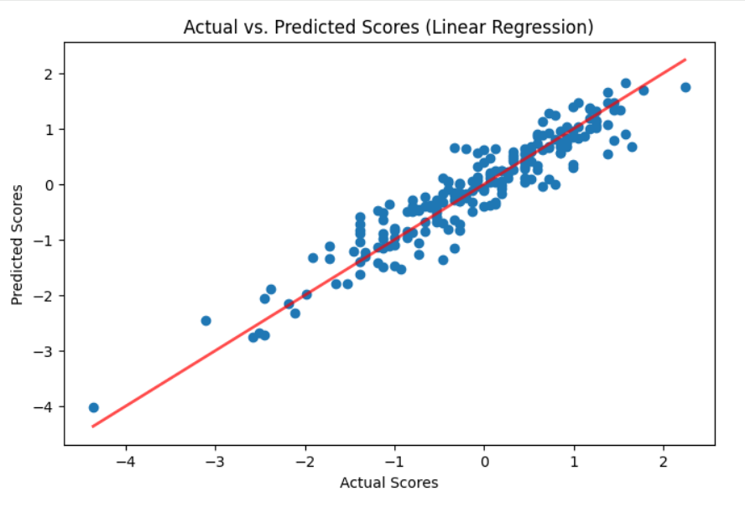

Residual Plot:
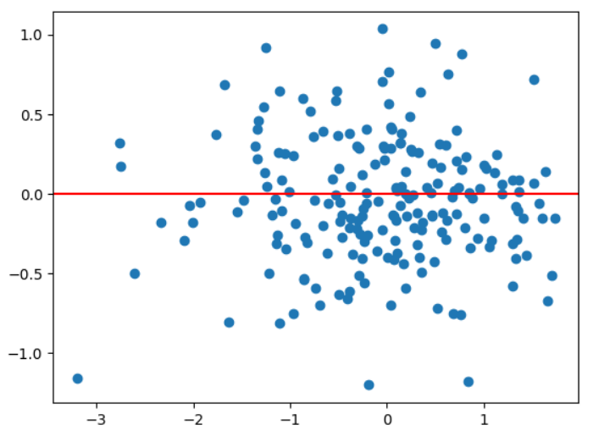

Difference between Actual and Predicted Values:

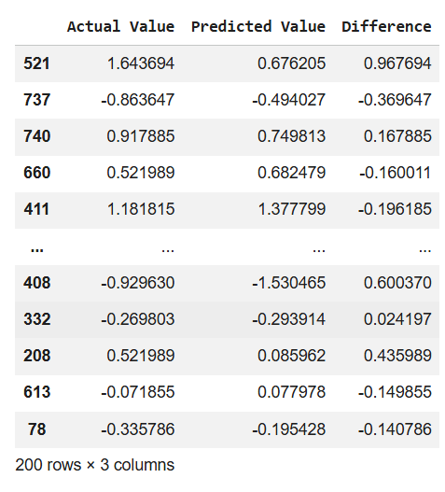

Conclusion
The project successfully demonstrates a complete machine learning workflow for student performance prediction. The developed models can assist educational institutions in identifying learning trends and supporting data-driven academic interventions.

Future Scope
Incorporate additional student attributes, experiment with boosting algorithms such as XGBoost, optimize hyperparameters, and deploy the model as a web application.

References
1. Scikit-learn Documentation
2. Pandas Documentation
3. NumPy Documentation
4. Matplotlib & Seaborn Documentation

