

Important Dates & Contact Info

SWSDI Program Dates: Sunday, July 6th to Sunday, July 20th
TWO WEEK SCHEDULE  Arrival – Sunday, July 7th  - Arrive at Barrett Honors College front desk (see map) between 12:00pm to 2:00pm to check in. | Pick-up – Sunday, July 21st  - Arrive at Barrett Honors College front desk between 12:00pm to 1:00pm to check out.

FIRST WEEK SCHEDULE (PUBLIC FORUM or INTERP)  Arrival – Sunday, July 7th  - Arrive at Barrett Honors College front desk (see map) between 12:00pm to 2:00pm to check in. | Pick-up – Sunday, July 14th  - Arrive at Barrett Honors College front desk between 12:00pm to 1:00pm to check out.

SECOND WEEK SCHEDULE (CONGRESS, EXTEMP, or ORATORY)  Arrival – Sunday, July 14th  - Arrive at Barrett Honors College front desk (see map) between 12:00pm to 2:00pm to check in. | Pick-up – Sunday, July 21st  - Arrive at Barrett Honors College front desk between 12:00pm to 1:00pm to check out.

Students arriving and departing from the airport: see “Information for out-of-state students” page for information about arrival and pick-up.

For any questions and information
info@southwestdebateinstitute.org
www.swsdi.org

For any other issues during camp—including urgent issues, to get in contact with your child, or any questions you have during camp:
TBD
Student Life Coordinator
TBD
(meanwhile, Susan Seep, Director, 480/242-3466)

If you need to contact us during camp and are unable to reach the above numbers
Barrett Honors College Front Desk (open 24/7)
480-727-5344

For campus and facilities issues
Conference Coordinator
Sage Hall North 133
480-727-5321

ASU Department of Public Safety at Tempe
(480) 965-3456

Campus Health Services at Tempe
(480) 965-3346



2013 Southwest Speech and Debate Institute
What should I bring?

Speech and Debate Related:
Laptop (strongly encouraged but not required)*****
Notebook
Paper
Folders and/or accordion (“expando”) folders
Pens/pencils
Highlighter
Timer
Anything else you would normally use at a tournament or at practice

Miscellaneous:
Photo ID
Water bottle
Sun screen
Cell phone
Spending money, for snacks, laundry, and other miscellanea (about $50 suggested)

Dorm Related (for residential students):
Clothes
Comfortable sleepwear
Bed sheets (twin size bed)
Pillow
Towel
Toiletries (toothbrush, toothpaste, shampoo, hand soap, body soap, deodorant)
Vitamins and medicine
Alarm clock

Note: This year, we are asking students to bring their own bed sheets and pillow. This is because students in past years found the sheets and pillows provided by the university to be very uncomfortable. Additionally, the university’s prices have increased so requiring students to bring their own linens helps keep tuition low. Please contact us if you have any questions.

*******LET US KNOW IF YOU WILL NOT BE BRINGING A LAPTOP OR ANOTHER DEVICE (SUCH AS AN IPAD)

What Should I Not Bring?

Bicycles/ scooters/roller blades/skateboards/go-peds
TV’s/stereos/ video games
Refrigerators/hot plates/microwaves
Weapons (knives – even pocket knives, firearms, etc.)
Drugs/Alcohol (refer to no-drug policy)

Also note that dress clothes or a suit are not required.


2013 Southwest Speech and Debate Institute
Dining

Three meals a day are included in your tuition. Continental breakfast will be provided each morning. Lunch and dinner will be served in the cafeteria.

The first meal that will be served is dinner on Saturday the 7th. The last meal that will be served is breakfast on Sunday the 21st.

Commuter students are welcome but not required to join us for breakfast each day. (See “Information for Commuter Students” for more information.)

2013 Southwest Speech and Debate Institute
Laundry

Residential students will be able to use the laundry machines and driers in the dorm building. Students planning to do laundry should bring their own detergent.

2013 Southwest Speech and Debate Institute
Information for Commuter Students
Pick Up/Drop Off
Only designated persons can check out participants. Confirm the details to this process by completing the Return Packet.
Morning Check-in  Once participants are checked in they cannot leave the complex or campus.  - Sessions will begin each morning at 9:30. Students can be dropped off anytime before that.  - Breakfast will be served from 9:00-9:30, and commuter students are welcome to come for breakfast too at no extra charge. | Evening Check-out  - Classes end each day at 9:00 pm. At that time, a staff member will accompany students to the small handicap parking lot off of Lemon Street, circled in red on the map below. Please come to the lot to pick your student up.

Note that the camp is every day between the 7th and the 29th, including the weekend in between.

If you are unable to drop off or pick up your student within the scheduled times, feel free to contact us about arranging for him or her to stay earlier or later.

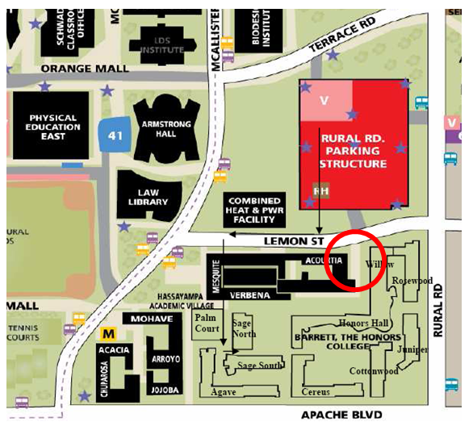

2013 Southwest Speech and Debate Institute
Information for Out-of-State Students

Out-of-state students arriving by plane should try to fly in to Sky Harbor Airport sometime in the morning to mid-afternoon of July 7th and depart sometime during the afternoon of the 21st.

We can pick up students arriving at the airport and bring them to the airport once camp is over. There is a charge of $15, which covers transportation both from and to the airport.

If your student will need a ride to or from camp from the airport, please indicate so at the appropriate page in the “return packet” and attach a copy of your flight itinerary. Your student will be picked up by the baggage claim by a staff member holding an SWSDI sign.

2013 Southwest Speech and Debate Institute
ASU Tempe Campus Directions

Directions:

- GETTING TO ASU TEMPE

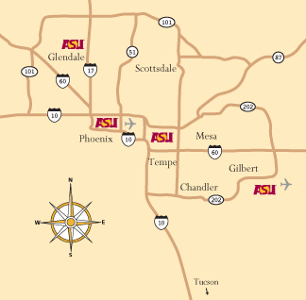

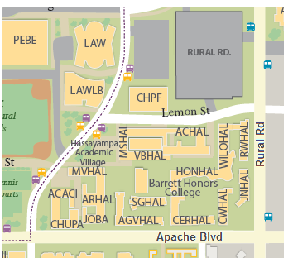
- Barrett Honors College Map (At the southeast corner of ASU campus)
- UPON ARRIVAL
  - Exit Scottsdale/Rural Road toward ASU Tempe campus
  - Drive north on McAllister Ave or Rural Rd
  - Turn on Terrace Road towards Rural Road Parking Structure
  - Entrance to Visitor Parking in Rural Road Parking Structure is on south side of street (parking is $2 per hour, or free on weekends)
  - Head south towards Barrett Honors College and enter through the gate to the west of Honors Hall (HONHAL on the map at left).
  - Turn left (east) and enter Honors Hall—the front desk is right inside the doors.

  - Metered parking is also available on Apache Blvd. (25 cents per ten minutes)

2013 Southwest Speech and Debate Institute
Financial Information

The $50 deposit to secure your student’s spot at SWSDI is due two weeks from the date that you were notified of acceptance. The remaining balance of your tuition is due on June 15. If the deposit and tuition are not received on time, you may lose your spot at the camp. All payments should be made by personal check made out to “Southwest Speech and Debate Institute” and mailed to:

Southwest Speech and Debate Institute
Attn: Susan Seep
P.O. Box 25404
Tempe, AZ 85285-5404

Refund/cancellation information:

We cannot guarantee a refund of your money if you have to cancel after June 15. Unfortunately, we have to inform ASU of our final attendance numbers and commit to paying for rooms and other major expenses in early May. If you are forced to cancel anytime after June 15, we will make an effort to refund part of your tuition, but we cannot guarantee that we will be able to refund any of it.

