DATA ENGINEERING
Study Guide & Project Workbook
A practical path from Python + SQL foundations to job-ready data engineering
Current learning project: PokéAPI -> Python -> PostgreSQL
Designed to be worked through alongside a full-time job, with GitHub evidence built as you learn.
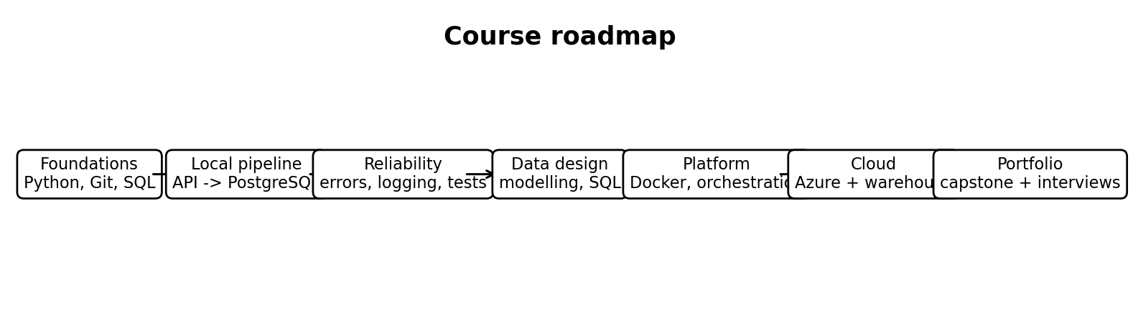
The course is intentionally cumulative: each phase builds on the same engineering mental models.
Version: August 2026

How to use this guide
Use this as a map and workbook, not as something to read cover-to-cover before building. The project is the course: learn a concept, apply it, prove it works, then commit the evidence.
- Build first, then deepen the theory. Do not wait until you feel you have “finished Python” or “finished SQL”.
- Keep one learning repository for the PokéAPI pipeline. Later, build a second capstone that looks less tutorial-like and is suitable for your CV.
- Use the [ ] boxes as progress markers. Add dates or notes beside them in Word if useful.
- When code is generated by autocomplete or AI, do not accept it blindly. You should be able to explain every important line in plain English.
- Commit meaningful milestones to Git. A clean history is evidence that you built the project incrementally.
- Do not commit secrets, passwords, API keys, .env files, or your .venv folder.
Study rhythm: A sustainable target is 6-10 focused hours per week. A “day” in this guide is a lesson-sized milestone, not necessarily one calendar day.

Current progress snapshot
You have already crossed the hardest psychological barrier: you have a working end-to-end pipeline, not just a collection of exercises.
Milestone | Status | Evidence | Next step
Python 3.13 + virtual environment | [x] | Project-specific .venv and dependencies installed | Keep dependencies isolated
Git + GitHub | [x] | Local repo, commit, remote origin, push to main | Commit each meaningful milestone
PostgreSQL setup | [x] | de_project database and pokemon table | Add related tables later
API extraction | [x] | PokéAPI list + detail endpoints | Add timeouts, pagination and larger loads
Transformation | [x] | Nested JSON reduced to clean record fields | Formalise validation later
Load to PostgreSQL | [x] | psycopg INSERT + commit | Add robust error handling
Idempotent reruns | [x] | ON CONFLICT (id) DO NOTHING | Compare with upsert/update semantics
Transaction theory | [x] | BEGIN, COMMIT, ROLLBACK, failed transaction experiment | Reproduce in Python
Python error handling | [~] | Day 2 topic | try / except / finally + rollback
Logging and observability | [ ] |  | Replace progress prints with logging

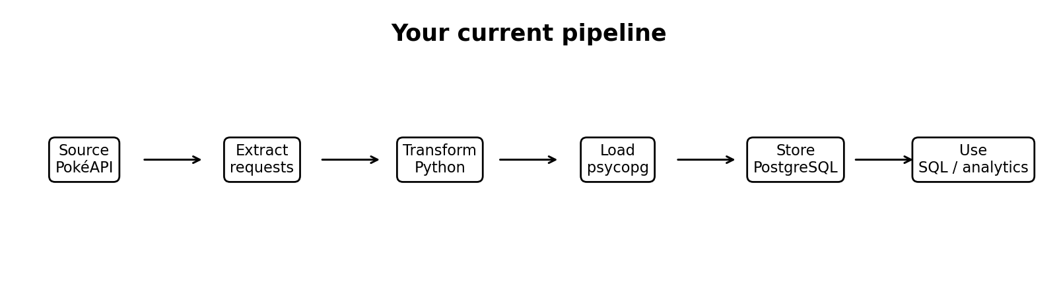
The pipeline you have already built. The rest of the course makes each arrow more reliable, scalable and production-like.

Course map
Part I - Foundations and the local pipeline
1. Environment, Git and reproducibility
2. APIs, HTTP and JSON
3. PostgreSQL and relational database foundations
4. Transactions, constraints and failure behaviour
5. Python + PostgreSQL with Psycopg
Part II - Reliable data pipelines
6. Error handling, cleanup and rollback
7. Logging, timeouts, retries and observability
8. Scaling ingestion: pagination, batching and rate limits
9. Idempotency, upserts and incremental loading
Part III - SQL and data modelling
10. Intermediate SQL
11. Relational modelling and normalization
12. Analytical modelling: facts, dimensions and star schemas
Part IV - Engineering quality
13. Testing and data quality
14. Project structure, configuration and dependency management
15. Docker and reproducible runtime environments
16. Orchestration with Airflow or Prefect
Part V - Modern data platform
17. Cloud fundamentals (Azure-first)
18. Warehouses, lakes and lakehouses
19. dbt and analytics engineering
20. Spark / Databricks (later-stage)
21. CI/CD, security and production operations
Part VI - Portfolio and job readiness
22. Capstone project
23. Interview preparation
24. 10-12 week study plan
25. Glossary and cheat sheets

Part I - Foundations and the local pipeline
Goal: understand the full path of a piece of data - where it comes from, how code moves it, how a database stores it, and what can go wrong.

1. Environment, Git and reproducibility
A data pipeline is software. Before thinking about orchestration or cloud services, you need a predictable local development environment and a way to track changes.
Python interpreter - The executable that reads and runs Python code. Multiple Python versions can exist on one computer, so it matters which interpreter a project uses.
Virtual environment (venv) - A project-specific Python environment with its own installed packages. It prevents one project’s dependencies from interfering with another.
Dependency - A package your code relies on, such as requests or psycopg.
Repository - A folder tracked by Git, including its file history and branches.
Commit - A named snapshot of staged changes in the local Git history.
Remote - A named reference to another repository location, commonly a GitHub repo called origin.
Branch - A movable line of development. main is normally the primary line; feature branches allow isolated work.
Push - Send local commits to a remote repository.
Pull - Fetch remote changes and integrate them into your current local branch.
Upstream - The remote branch that a local branch tracks by default, e.g. local main tracking origin/main.
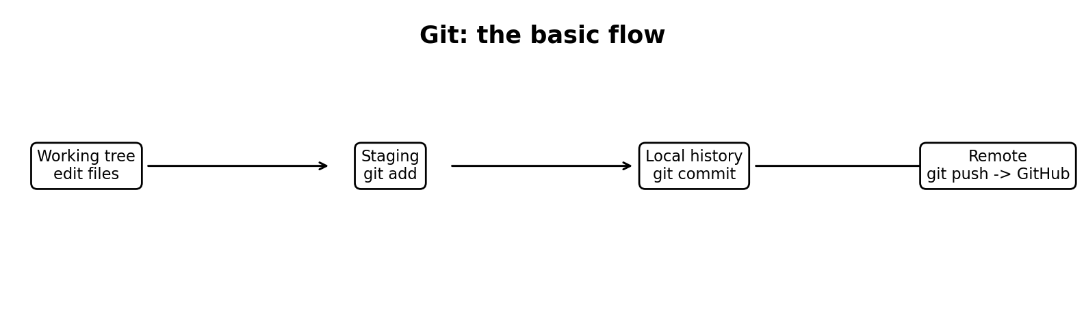
The four-stage Git mental model. GitHub is not the same thing as Git: Git is the version-control system; GitHub hosts a remote copy.

Why .gitignore matters
A .gitignore file tells Git which untracked files or folders it should not add. It is a normal text file stored in the repository.
.venv/
.env
__pycache__/
*.pyc
.vscode/
Security: Do not commit database passwords, tokens or API keys. Keep secrets in environment variables or a local .env file that is ignored by Git.

Checkpoint
- [ ] python --version reports the intended project Python version.
- [ ] The VS Code interpreter points to .venv.
- [ ] git status works and .venv is not tracked.
- [ ] The repository has at least README.md, .gitignore, src/ and sql/.
- [ ] git push sends commits to the GitHub remote.

2. APIs, HTTP and JSON
Many pipelines begin by reading data from a service. An API provides a structured interface so your code can request data without scraping a human-facing webpage.
API - Application Programming Interface: a defined way for software systems to communicate.
Endpoint - A specific API address that represents a resource or operation, such as /pokemon or /pokemon/1.
HTTP GET - A request method normally used to retrieve data.
Status code - A numeric result for an HTTP request. 2xx generally indicates success; 4xx indicates a client/request issue; 5xx indicates a server issue.
JSON - A text format built from objects, arrays, strings, numbers, booleans and null values. In Python, JSON objects commonly become dictionaries and JSON arrays become lists.
Query parameter - Extra values appended to or sent with a request, e.g. limit=100.
response = requests.get(url, params={"limit": 100}, timeout=15)
response.raise_for_status()
data = response.json()
The important separation is: response is the HTTP response object; response.json() parses the response body into Python data structures.

What to inspect when learning a new API
1. Find the collection endpoint and inspect its top-level keys.
2. Check whether the response contains results directly or links to detail endpoints.
3. Look for pagination fields such as next, offset, limit or cursor.
4. Identify stable IDs, timestamps and fields needed for your target table.
5. Check the API documentation for rate limits, authentication and error responses.

3. PostgreSQL and relational database foundations
PostgreSQL is a relational database management system (RDBMS). The database server is the process that stores and manages data. pgAdmin is only a client/management interface used to connect to that server.
Server - The running PostgreSQL service that listens for connections.
Database - A logical container within the PostgreSQL server, such as de_project.
Schema - A namespace inside a database that groups tables and other objects. The default is commonly public.
Table - A relation represented as columns and rows.
Row - One record in a table.
Column - A named attribute with a data type and optional constraints.
Primary key - A column or set of columns that uniquely identifies each row. Primary key values cannot be duplicated or null.
Constraint - A rule enforced by the database, such as PRIMARY KEY, NOT NULL, UNIQUE, CHECK or FOREIGN KEY.
Foreign key - A constraint linking values in one table to a key in another table, protecting referential integrity.
Index - A data structure that can speed up lookups at the cost of extra storage and write overhead.
CREATE TABLE pokemon (
id INTEGER PRIMARY KEY,
name VARCHAR(100),
height INTEGER,
weight INTEGER
);

Core SQL operations
SELECT * FROM pokemon ORDER BY id;
INSERT INTO pokemon (id, name, height, weight)
VALUES (1, 'bulbasaur', 7, 69);
UPDATE pokemon SET weight = 70 WHERE id = 1;
DELETE FROM pokemon WHERE id = 1;
DELETE syntax: DELETE removes rows, so SQL uses DELETE FROM table. The * in SELECT * means “all columns”; DELETE does not choose columns.

4. Transactions, constraints and failure behaviour
Transactions are one of the most important database ideas for data engineering because pipelines often make many related changes that should either all succeed or all be discarded.
Transaction - A unit of database work that is committed as a whole or rolled back as a whole.
BEGIN - Explicitly starts a transaction block.
Transaction block - The group of statements between BEGIN and COMMIT/ROLLBACK.
COMMIT - Makes the transaction’s changes permanent.
ROLLBACK - Discards the transaction’s uncommitted changes and ends the transaction.
Failed / aborted transaction - A transaction in which a statement raised an error. PostgreSQL rejects regular work statements until the transaction is rolled back (or recovered to an earlier savepoint).
SAVEPOINT - A checkpoint inside a transaction that allows partial rollback.
Autocommit - Client behaviour in which each successful statement is committed automatically instead of being grouped manually.
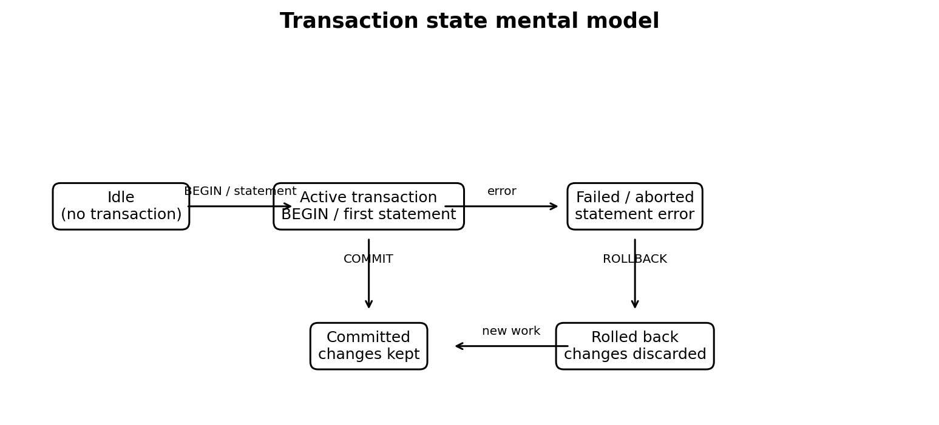
A useful state model. A failed transaction is not the same as a closed database connection.
BEGIN;
INSERT INTO pokemon (id, name, height, weight)
VALUES (6, 'test-pokemon', 10, 10);
-- deliberately fails if id 1 already exists
INSERT INTO pokemon (id, name, height, weight)
VALUES (1, 'duplicate', 10, 10);
ROLLBACK;
After the duplicate-key error, the transaction is aborted. ROLLBACK discards the successful insert of id 6 too because it was never committed.
Atomicity: The all-or-nothing property of transactions is called atomicity, one of the ACID properties of relational databases.

ACID in practical terms
Atomicity - A transaction’s changes are treated as one unit: all commit, or all are discarded.
Consistency - Transactions must leave the database obeying its declared constraints and rules.
Isolation - Concurrent transactions are controlled so they do not see unsafe partial effects from each other.
Durability - Once committed, changes are designed to survive normal failures such as process restarts.

5. Python + PostgreSQL with Psycopg
Psycopg is a PostgreSQL driver for Python. It translates Python-level calls and values into PostgreSQL’s client protocol and converts database results back into Python objects.
Driver - A library that lets an application communicate with a database system.
Connection - A live session between the Python process and PostgreSQL.
Cursor - An object used to execute SQL and fetch results through a connection.
Parameter / placeholder - A value slot kept separate from the SQL text. Psycopg uses %s positional placeholders (or named forms) and safely adapts Python values to PostgreSQL types.
connection = psycopg.connect(
host="localhost",
port=5433,
dbname="de_project",
user="postgres",
password=os.environ["POSTGRES_PASSWORD"]
)
cursor = connection.cursor()
cursor.execute(
"""
INSERT INTO pokemon (id, name, height, weight)
VALUES (%s, %s, %s, %s)
ON CONFLICT (id) DO NOTHING
""",
(record["id"], record["name"], record["height"], record["weight"])
)
The %s tokens are placeholders, not Python string formatting and not declarations that the values are strings. Psycopg adapts the actual values safely.
Why parameters matter: Never build SQL by concatenating untrusted values into SQL text. Parameterized queries prevent quoting bugs and protect against SQL injection.

Part II - Reliable data pipelines
Goal: move from “works once on my laptop” to a pipeline that can fail predictably, recover cleanly, explain what happened, and be rerun safely.

6. Error handling, cleanup and rollback
Day 2 starts here. The first production-quality improvement is to distinguish expected failure classes and guarantee cleanup.
Exception - A Python object representing an error condition that interrupts normal control flow unless it is caught.
try - The block containing code that may raise an exception.
except - The handler run when a matching exception is raised.
finally - A cleanup block that runs whether the try block succeeds or fails.
raise - Explicitly throw an exception, often after adding context or logging.
connection = None
cursor = None
try:
connection = psycopg.connect(...)
cursor = connection.cursor()
# fetch, transform and insert
connection.commit()
except psycopg.Error as error:
print(f"Database error: {error}")
if connection is not None:
connection.rollback()
raise
finally:
if cursor is not None:
cursor.close()
if connection is not None:
connection.close()
The rollback is important when the Python process continues after a database exception. A connection can still be open while its transaction is failed. rollback() clears that failed transaction and discards its uncommitted work.
Do not use bare except: except: catches almost everything, including errors you did not intend to suppress. Prefer specific exception types and usually log/re-raise unexpected failures.

Day 2 lab - prove the error path
- [ ] Wrap the database section in try / except / finally.
- [ ] Temporarily remove ON CONFLICT so duplicate IDs cause a UniqueViolation.
- [ ] Run the pipeline and observe the caught database exception.
- [ ] Confirm rollback occurs and the database is unchanged.
- [ ] Restore ON CONFLICT after the experiment.
- [ ] Confirm cursor and connection close whether the run succeeds or fails.

7. Logging, timeouts, retries and observability
Print statements are useful while learning, but logs are structured operational evidence. A production pipeline should make it easy to answer: when did it start, what step is it on, how many records were processed, what failed, and how long did it take?
Logging - Recording timestamped events with severity and context.
Log level - A severity category such as DEBUG, INFO, WARNING, ERROR or CRITICAL.
Observability - The ability to understand a system’s internal state from outputs such as logs, metrics and traces.
Timeout - A maximum time a network/database operation is allowed to wait.
Retry - Re-attempting an operation after a transient failure, usually with limits and delays.
Exponential backoff - Increasing wait time between retries so a struggling service is not hammered repeatedly.
import logging
logging.basicConfig(
level=logging.INFO,
format="%(asctime)s %(levelname)s %(message)s"
)
logging.info("Pipeline started")
logging.info("Processing %s", pokemon["name"])
Retry judgment: Do not retry every error. A network timeout may be transient; a duplicate primary key or invalid schema is usually a logic/data problem and should be handled differently.

8. Scaling ingestion: pagination, batching and rate limits
The first five records are useful for debugging. The next step is to load many records without turning the script into a slow, fragile sequence of one-off requests and commits.
Pagination - Splitting an API collection into pages so clients retrieve manageable chunks.
Offset pagination - Pages are requested using an offset and limit. Easy to understand but can behave poorly if data changes while paging.
Cursor pagination - The API returns a cursor/token for the next page. Often more stable for changing datasets.
Batching - Processing or inserting multiple records together rather than one operation per record.
Rate limit - A service rule restricting request frequency or volume.
Throughput - How much data a pipeline processes per unit time.
1. Start with 20-50 records and keep the code easy to observe.
2. Add request timeouts and status-code checks.
3. Follow pagination rather than assuming one huge limit always works.
4. Count successful, skipped and failed records.
5. Only then consider concurrent requests or bulk database insert methods.

9. Idempotency, upserts and incremental loading
Idempotent pipeline - A pipeline that can be rerun without corrupting or duplicating the intended final state.
Upsert - Insert a new row if it does not exist; otherwise update the existing row.
Incremental load - Process only data that is new or changed since the previous successful run.
Watermark - A stored marker such as last_updated_at or last_id used to determine what to load next.
INSERT INTO pokemon (id, name, height, weight)
VALUES (%s, %s, %s, %s)
ON CONFLICT (id) DO UPDATE SET
name = EXCLUDED.name,
height = EXCLUDED.height,
weight = EXCLUDED.weight;
DO NOTHING is correct when existing rows should not change. DO UPDATE is correct when the source is authoritative and changed source values should refresh the target. The “right” strategy depends on data semantics, not syntax preference.

Part III - SQL and data modelling
Goal: move beyond loading rows. A data engineer designs tables and transformations so downstream analysts, dashboards and applications can query trustworthy data efficiently.

10. Intermediate SQL
You should become fluent enough that SQL is a thinking tool, not a syntax lookup exercise.
- Filtering and ordering: WHERE, AND/OR, IN, BETWEEN, LIKE/ILIKE, ORDER BY, LIMIT.
- Aggregation: COUNT, SUM, AVG, MIN, MAX, GROUP BY, HAVING.
- Joins: INNER, LEFT, RIGHT/FULL conceptually; understand join keys and row multiplication.
- Subqueries and Common Table Expressions (CTEs).
- Window functions: ROW_NUMBER, RANK, SUM(...) OVER, LAG, LEAD.
- CASE expressions and NULL handling with COALESCE.
- Dates/timestamps and time zones.
- Indexes and EXPLAIN at an introductory level.
WITH ranked AS (
SELECT
id,
name,
weight,
ROW_NUMBER() OVER (ORDER BY weight DESC) AS weight_rank
FROM pokemon
)
SELECT *
FROM ranked
WHERE weight_rank <= 10;

SQL practice rule
For every new SQL concept: predict the result shape before running the query. Ask how many rows and columns you expect, what the key is, and whether duplicates can appear.

11. Relational modelling and normalization
Raw API JSON is often nested. A relational database works best when repeated entities are separated and relationships are represented explicitly.
Entity - A distinct thing you model, e.g. Pokémon or type.
Cardinality - The relationship count between entities: one-to-one, one-to-many or many-to-many.
Normalization - Structuring relational data to reduce unnecessary duplication and update anomalies.
Junction table - A table that represents a many-to-many relationship using foreign keys to the two related entities.
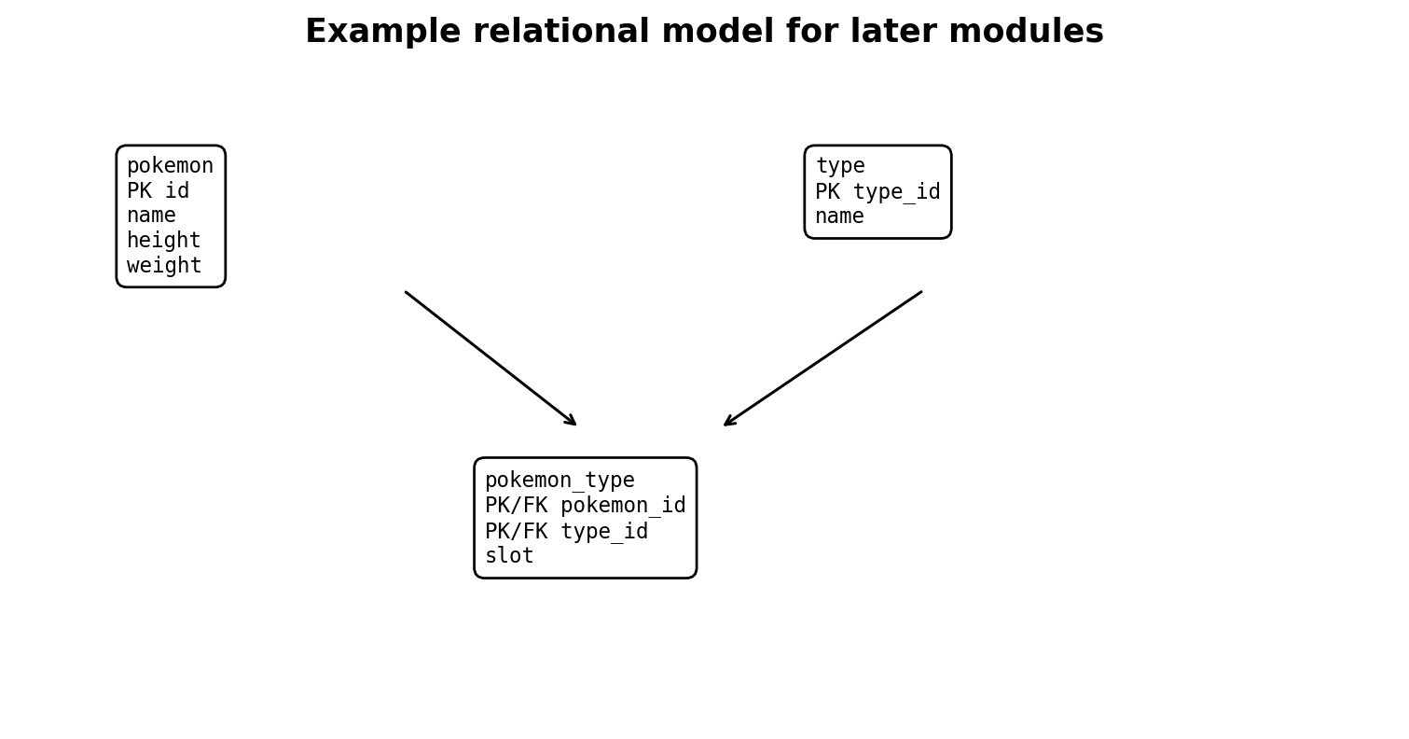
A later extension of the current one-table model. A Pokémon can have multiple types, and a type applies to many Pokémon.
Why model instead of storing nested JSON forever: JSON can be useful in raw storage, but relational tables make integrity constraints, joins and analytics easier when the structure is known and stable.

12. Analytical modelling: facts, dimensions and star schemas
Fact table - A table of measurable events or observations, usually with foreign keys to dimensions and numeric measures.
Dimension table - Descriptive context used to slice or group facts, such as customer, product or date.
Grain - Exactly what one row in a table represents. Defining grain is one of the most important modelling decisions.
Star schema - An analytical model with a central fact table connected to denormalized dimension tables.
The Pokémon project is not naturally a business fact/dimension system, so use it to learn relational modelling. The capstone should include an analytical model with an explicit grain.

Part IV - Engineering quality
Goal: make the pipeline reproducible, testable and runnable by someone other than you.

13. Testing and data quality
Unit test - Tests a small function or unit in isolation.
Integration test - Tests multiple components working together, such as Python writing to a temporary/test database.
Data quality test - Checks properties of data such as uniqueness, non-nullness, accepted ranges or referential integrity.
Regression - A previously working behaviour that breaks after a change.
- Test transformation functions with known input JSON and expected output dictionaries.
- Test that required fields are present and IDs are positive integers.
- Test uniqueness and foreign-key assumptions in SQL/dbt.
- Keep tests deterministic: do not make every unit test depend on a live external API.
def test_transform_pokemon():
sample = {"id": 1, "name": "bulbasaur", "height": 7, "weight": 69}
result = transform_pokemon(sample)
assert result["id"] == 1
assert result["name"] == "bulbasaur"

14. Project structure, configuration and dependency management
As the script grows, separate concerns so each piece is easier to understand and test.
pokeapi-postgres-pipeline/
├── README.md
├── .gitignore
├── pyproject.toml or requirements.txt
├── sql/
│ └── create_tables.sql
├── src/
│ ├── config.py
│ ├── extract.py
│ ├── transform.py
│ ├── load.py
│ └── main.py
└── tests/
└── test_transform.py
Configuration - Values that change by environment, such as host, port, database name or log level, kept separate from business logic.
Secret - Sensitive configuration such as a password or token. Secrets should not be committed to source control.
requirements.txt / pyproject.toml - Files that describe Python dependencies so an environment can be recreated.

15. Docker and reproducible runtime environments
Container - An isolated process environment built from an image. It packages application code, runtime and dependencies.
Image - An immutable template used to create containers.
Dockerfile - Instructions for building an image.
Docker Compose - A way to define and run multiple related containers, e.g. a Python pipeline plus PostgreSQL.
The goal is not “learn every Docker command”. The goal is: someone should be able to clone the repository and start the pipeline/database with a small number of documented commands.
- [ ] Create a Dockerfile for the Python pipeline.
- [ ] Run PostgreSQL as a container with a persistent volume.
- [ ] Use Docker Compose to start both services.
- [ ] Pass configuration via environment variables, not hardcoded secrets.
- [ ] Document startup and shutdown in the README.

16. Orchestration with Airflow or Prefect
Orchestrator - A system that schedules and coordinates pipeline tasks, dependencies, retries and monitoring.
DAG - Directed Acyclic Graph: tasks connected by one-way dependencies with no cycles. Airflow uses DAGs to define workflows.
Task - A unit of work in an orchestrated workflow.
Schedule - A rule determining when a workflow should run.
Backfill - Running historical periods that were missed or need recomputation.
Retry policy - Rules for reattempting failed tasks, often with delay/backoff.
extract -> transform -> load -> validate
Do not introduce orchestration until the underlying Python functions work reliably on their own. An orchestrator should coordinate good code, not hide a tangled script.

Part V - Modern data platform
Goal: move the same ideas into cloud-managed storage, compute, orchestration and analytics tooling. Learn concepts first; services are implementations of those concepts.

17. Cloud fundamentals (Azure-first)
For your first cloud implementation, use Azure as the primary platform, while learning vendor-neutral concepts so you can translate them to AWS or GCP later.
Object storage - Cheap, scalable storage for files/objects, commonly used as a data lake. In Azure this is typically Azure Blob Storage / ADLS Gen2.
Managed database - A cloud-hosted database where the provider handles much of the infrastructure and maintenance.
IAM / identity and access management - Users, service identities, roles and permissions controlling who or what can access resources.
Region - A geographic cloud deployment area. Region choice affects latency, availability, compliance and cost.
Resource group - An Azure management container that groups related resources.
Data Factory - Azure’s managed data integration/orchestration service for pipelines and connectors.
Key Vault - Azure service for storing and controlling access to secrets, keys and certificates.
- [ ] Create a small Azure resource group for the project.
- [ ] Write raw API data to object storage.
- [ ] Run a transformation/load step in a managed compute option.
- [ ] Use managed identity or Key Vault rather than embedding credentials.
- [ ] Keep costs visible and tear down resources you no longer need.
Certification: A cloud certification can support applications, but a deployed project that you can explain is usually stronger evidence than a certification alone.

18. Warehouses, lakes and lakehouses
Data warehouse - A system optimized for analytical SQL over structured data, often with columnar storage and scalable compute.
Data lake - Object storage containing raw and processed files at large scale, often using formats such as Parquet.
Lakehouse - An architecture combining lake-style storage with warehouse-like table management and analytics capabilities.
Parquet - A columnar file format designed for efficient analytical storage and reads.
Partitioning - Physically/logically dividing data, often by date or another field, so queries can scan less data.
Bronze / silver / gold - A common medallion pattern: raw ingestion, cleaned/conformed data, then business-ready outputs. Useful vocabulary, not a universal law.

19. dbt and analytics engineering
dbt - A transformation framework that lets teams define SQL models, tests, documentation and dependencies in version control.
Model - In dbt, typically a SELECT query materialized as a view/table/incremental table.
Lineage - The dependency path showing where a dataset came from and what downstream objects depend on it.
Staging model - A lightly cleaned/renamed model close to a raw source.
Mart - A business-facing analytical model organized for a domain or reporting use case.
dbt is especially relevant if you also consider analytics engineering roles. It teaches a disciplined raw -> staging -> intermediate -> mart transformation pattern.

20. Spark / Databricks (later-stage)
Do not rush into Spark while your datasets fit comfortably in local Python/PostgreSQL. Learn it after you understand why distributed processing exists.
Distributed processing - Splitting computation across multiple machines/executors.
Spark - A distributed data-processing engine used for large-scale batch and streaming workloads.
Databricks - A managed analytics/data platform built around Spark and lakehouse tooling.
Shuffle - Redistribution of data across workers, often expensive and important for performance.
When Spark matters: If one machine can process the dataset simply and cheaply, distributed processing may add complexity without benefit. Interviewers care that you understand the trade-off.

21. CI/CD, security and production operations
CI (Continuous Integration) - Automatically run checks such as tests and linting when code changes.
CD (Continuous Delivery/Deployment) - Automate packaging and/or deployment after code passes checks.
Environment - A separate runtime context such as development, test or production.
Least privilege - Give identities only the permissions required to do their job.
Secret rotation - Replace credentials periodically or after exposure rather than treating them as permanent.
SLA / SLO - Ways to define expected service reliability or performance. Exact usage varies by organization.
Data freshness - How recently a dataset has been updated relative to expectations.
Alerting - Notify someone/system when a meaningful failure or threshold breach occurs.
- [ ] Run tests automatically on GitHub push/pull request.
- [ ] Fail CI if formatting/linting/tests fail.
- [ ] Keep secrets in repository/environment secret stores.
- [ ] Add a health/freshness check for the pipeline output.
- [ ] Capture run duration and row counts in logs/metrics.

Part VI - Portfolio and job readiness
Goal: turn learning into credible evidence. Your CV should describe what you actually built and can explain, not a list of tools you touched once.

22. Capstone project
The PokéAPI repository is ideal for learning. Your final showcase should use a real-world dataset and a problem that can be explained to a hiring manager in one minute.

Recommended capstone shape
Public API / files
↓
raw object storage
↓
Python ingestion + validation
↓
warehouse / PostgreSQL
↓
dbt transformations
↓
analytics-ready model
↓
dashboard / API / documented SQL
- Use at least two data sources or one source with genuinely interesting incremental behaviour.
- Keep a raw layer so transformations can be reproduced.
- Define and test data quality rules.
- Orchestrate the workflow on a schedule.
- Containerize local development.
- Deploy at least one meaningful component to cloud.
- Create an architecture diagram and setup instructions.
- Include a short “trade-offs and future improvements” section rather than pretending the project is production-scale.

CV-readiness gate
- [ ] I can explain the source, target and purpose in under 60 seconds.
- [ ] I can explain the table grain and keys.
- [ ] I can explain what happens if the pipeline runs twice.
- [ ] I can explain how a failure is detected and recovered.
- [ ] I can explain at least one design trade-off I made.
- [ ] The repository contains no secrets or local-only junk.
- [ ] A stranger can follow the README and understand how to run or inspect it.
- [ ] I have actually used every technology I claim in the project bullet.

23. Interview preparation

SQL
- Joins and duplicate-row reasoning
- Aggregations and GROUP BY/HAVING
- CTEs and subqueries
- Window functions
- Date/time logic
- NULL behaviour
- Basic query performance and indexes

Python
- Lists/dicts/sets and comprehensions
- Functions and scope
- Exceptions and context managers
- File and JSON handling
- HTTP requests
- Basic testing
- Iterators/generators conceptually
- Writing readable transformations

Data engineering concepts
- ETL vs ELT
- Batch vs streaming
- Idempotency and incremental loads
- Transactions and ACID
- Data modelling and table grain
- Data lake vs warehouse
- Orchestration and retries
- Data quality and observability
- Partitioning and scaling trade-offs

Project explanation template
1. Problem: what data needed to move or become usable?
2. Source and volume: where did it come from and what shape was it?
3. Architecture: what components did you use and why?
4. Reliability: how did you handle reruns, errors and quality?
5. Trade-off: what did you deliberately keep simple and what would you change at larger scale?
6. Result: what can a user/analyst do with the output?

24. Suggested 10-12 week study plan
This is a direction, not a deadline. Spend longer on weak areas and move faster through concepts you already know.
Week | Build focus | Theory focus | Evidence | Interview practice
1 | Finish reliable local PokéAPI pipeline | transactions, exceptions, logging | working repo + clean commits | SQL basics
2 | Pagination + all records + related tables | joins, keys, normalization | multi-table load | joins + GROUP BY
3 | Refactor + tests + quality checks | testing, indexes, windows | pytest + data tests | window functions
4 | Dockerize app + PostgreSQL | containers, config, networking | docker compose setup | Python fundamentals
5 | Add orchestration | DAGs, retries, scheduling | scheduled local pipeline | ETL/ELT questions
6 | Azure raw storage + secrets | cloud storage, IAM, cost | cloud-deployed component | cloud fundamentals
7 | Warehouse/analytics layer | lake/warehouse, Parquet | queryable analytical layer | data modelling
8 | dbt models + tests | lineage, marts, incremental models | dbt docs/tests | analytics engineering
9 | Start capstone | architecture + source selection | capstone repo | project storytelling
10 | Capstone reliability + cloud | observability + CI/CD | end-to-end demo | system design basics
11 | Polish README/CV | trade-offs and documentation | CV-ready bullets | mock interviews
12 | Apply + iterate | review weak areas | applications + feedback loop | targeted practice

Near-term lesson plan: Days 2-10
Lesson | Focus | Definition of done
Day 2 | try/except/finally; rollback; logging basics | Pipeline fails cleanly and always closes resources.
Day 3 | HTTP timeouts, raise_for_status, API failure handling | Network failures are explicit rather than mysterious hangs.
Day 4 | Load 20-100 records; counters; progress logging | Larger run with row counts and no duplicate corruption.
Day 5 | Pagination and full collection | No hard-coded assumption that one response contains everything.
Day 6 | Second table: types; foreign keys | Nested JSON becomes a relational model.
Day 7 | Joins and analytical queries | Write useful queries over the related tables.
Day 8 | Refactor into functions/modules | Extract, transform and load logic can be tested independently.
Day 9 | pytest + data validation | Automated tests catch regressions and bad records.
Day 10 | README + architecture + clean Git milestone | A stranger can understand the project and reproduce it.

Progress tracker
Use this page as the front-door dashboard. A topic is only “done” when you can both use it and explain it without relying on autocomplete.

Local foundations
- [ ] Virtual environment
- [ ] Git/GitHub workflow
- [ ] API request + JSON
- [ ] PostgreSQL table
- [ ] Psycopg connection
- [ ] Parameterized INSERT
- [ ] Transaction experiment

Reliability
- [ ] try/except/finally
- [ ] rollback on DB error
- [ ] logging
- [ ] timeouts
- [ ] retries
- [ ] row-count metrics
- [ ] safe reruns

SQL & modelling
- [ ] joins
- [ ] aggregations
- [ ] CTEs
- [ ] window functions
- [ ] foreign keys
- [ ] normalization
- [ ] table grain
- [ ] star schema

Engineering quality
- [ ] functions/modules
- [ ] pytest
- [ ] data quality tests
- [ ] dependency file
- [ ] Docker
- [ ] Docker Compose
- [ ] CI

Platform
- [ ] orchestration
- [ ] cloud object storage
- [ ] managed secrets
- [ ] warehouse/lake
- [ ] dbt
- [ ] incremental model
- [ ] observability

Career evidence
- [ ] PokéAPI learning repo polished
- [ ] capstone architecture
- [ ] capstone deployed
- [ ] README polished
- [ ] CV bullet drafted
- [ ] project story rehearsed
- [ ] SQL mock interview

25. Glossary
ACID - Atomicity, Consistency, Isolation and Durability - core transactional database properties.
API - A defined interface through which software systems exchange requests and responses.
Batch pipeline - A workflow that processes a bounded group of records at intervals or on demand.
CDC - Change Data Capture - techniques for identifying and propagating inserts, updates and deletes from a source system.
Commit - In databases, make transaction changes permanent. In Git, record a snapshot in local version history.
Connection - A live client session with a database server.
Constraint - A database-enforced rule such as NOT NULL, UNIQUE, PRIMARY KEY or FOREIGN KEY.
Cursor - A database driver object used to execute SQL and access results.
DAG - Directed Acyclic Graph; commonly used to represent workflow task dependencies.
Data lake - Scalable object storage used for raw and processed data files.
Data lineage - Information showing where data came from, how it changed and what depends on it.
Data mart - A curated analytical dataset for a business domain or use case.
Data warehouse - A system optimized for analytical queries over structured data.
Dimension - Descriptive context in an analytical model.
ELT - Extract, Load, Transform - load raw data first, then transform in the target platform.
ETL - Extract, Transform, Load - transform before loading the target analytical store.
Fact - A measurable event or observation in an analytical model.
Foreign key - A relational constraint linking a value to a referenced key in another table.
Grain - The precise meaning of one row in a table.
Idempotency - Property that allows the same operation/pipeline to be repeated without unintended cumulative effects.
Incremental load - A load that processes only new or changed data.
Index - A database structure that speeds certain reads while adding storage/write overhead.
JSON - Text format for nested structured data; commonly mapped to Python dicts/lists.
Lakehouse - An architecture combining data-lake storage with warehouse-like tables and analytics.
Logging - Timestamped operational records describing what software is doing.
Normalization - Relational modelling techniques that reduce duplication and update anomalies.
Observability - Ability to understand system behaviour using outputs such as logs, metrics and traces.
Orchestration - Scheduling and coordinating pipeline tasks, dependencies, retries and monitoring.
Pagination - Retrieving a large API collection in pages rather than one response.
Parameterised query - SQL where values are passed separately from SQL text using driver placeholders.
Parquet - Columnar file format widely used for analytics and data lakes.
Primary key - Unique non-null identifier for a table row.
Rate limit - Restriction on request volume/frequency imposed by an API or service.
Remote - In Git, a named reference to another repository location such as GitHub.
Rollback - Discard a database transaction’s uncommitted changes.
Schema - A database namespace; also used more broadly to mean a dataset’s structural definition.
Streaming - Continuously processing events/records as they arrive rather than in bounded batches.
Transaction - A database unit of work that commits or rolls back as a whole.
Upsert - Insert a row if missing, otherwise update the existing row.
Virtual environment - An isolated Python environment for project dependencies.
Watermark - A marker used to track incremental progress, such as a last processed timestamp.
Window function - SQL function that computes over a related set of rows without collapsing them like GROUP BY.

Cheat sheet: Git
git status # inspect current state
git add . # stage changes (excluding ignored files)
git commit -m "message" # save a local snapshot
git push # send commits to configured upstream
git pull # fetch + integrate upstream changes
git branch # list local branches
git switch -c feature-name # create and switch to a branch
git remote -v # show configured remotes
Git mental model: Working files -> staging -> local commit history -> remote repository. When confused, start with git status.

Cheat sheet: PostgreSQL / SQL
SELECT * FROM pokemon ORDER BY id;
INSERT INTO pokemon (id, name, height, weight)
VALUES (1, 'bulbasaur', 7, 69)
ON CONFLICT (id) DO NOTHING;
UPDATE pokemon
SET weight = 70
WHERE id = 1;
DELETE FROM pokemon
WHERE id = 1;
BEGIN;
-- statements
COMMIT; -- keep changes
-- or ROLLBACK; -- discard uncommitted changes

Cheat sheet: Python pipeline reliability
response = requests.get(url, timeout=15)
response.raise_for_status()
data = response.json()
connection = None
cursor = None
try:
connection = psycopg.connect(...)
cursor = connection.cursor()
# execute SQL
connection.commit()
except psycopg.Error:
if connection is not None:
connection.rollback()
raise
finally:
if cursor is not None:
cursor.close()
if connection is not None:
connection.close()

Troubleshooting playbook
When something fails, do not randomly change five things. Identify which layer failed and reduce the problem.
Symptom | Likely layer | First checks
ModuleNotFoundError | Python environment | Is .venv active? Which python? Is package installed in this environment?
HTTP 4xx/5xx | API/request | URL, parameters, auth, status code, API docs, response body
Request hangs | Network/API | Add timeout; verify connectivity; check service availability
connection refused | PostgreSQL/network | Server running? host/port correct? PostgreSQL listening on 5433?
password authentication failed | Database credentials | Correct user? environment variable set in this terminal?
UniqueViolation | Database constraint | Duplicate primary key? should logic skip/update/error?
current transaction is aborted | Transaction state | Earlier statement failed; rollback before continuing
Rows missing after script | Transaction/control flow | Was execute inside loop? Was commit reached? Did exception occur?
Duplicates after rerun | Idempotency | Primary key? ON CONFLICT/upsert? incremental logic?
Git tracks .venv/.env | Git hygiene | .gitignore created before tracking? remove from index if already tracked

Practice exercises (no answer key on purpose)
The goal is to reason before running. Write down what you expect, then test it. If you get stuck, use documentation or ask for a hint rather than immediately copying a finished solution.

Transactions
Start a transaction, insert a new row, cause a duplicate-key error, recover, and prove whether the first insert survived.

Upsert semantics
Change a stored weight manually, rerun with DO NOTHING, then compare with DO UPDATE. Explain which source “wins”.

API robustness
Request a deliberately invalid endpoint. Capture the status and make the script fail with a useful message.

Transformation
Create a function that accepts raw Pokémon JSON and returns only your target columns. Test it with a small dictionary.

Relational model
Add Pokémon types without storing comma-separated strings in the pokemon table. Define keys first.

SQL joins
Return each Pokémon name with its type name(s). Predict the row count before running.

Window functions
Rank Pokémon by weight without collapsing the original rows.

Data quality
Write checks for non-null name, positive id, and unique id. Decide which checks belong in PostgreSQL and which in Python/dbt.

Git branch
Create a feature branch for one improvement, commit it, merge it back, and explain what the branch protected you from.

README
Write setup instructions as if the reader has Python and Docker but has never seen your project.

README template for the learning repository
# PokéAPI PostgreSQL Pipeline
## Purpose
What the project demonstrates and why it exists.
## Architecture
Source -> extraction -> transformation -> storage.
## Tech stack
Python, PostgreSQL, Psycopg, requests, ...
## Setup
1. Create/activate virtual environment
2. Install dependencies
3. Configure environment variables
4. Create database/table(s)
5. Run pipeline
## Data model
Explain each table, primary key and relationships.
## Reliability
Idempotency, error handling, retries, logging and validation.
## What I learned
Short, specific technical lessons.
## Future improvements
Docker, orchestration, cloud, tests, etc.

Principles to keep throughout the course
- Prefer understanding over memorisation. Syntax is searchable; mental models are what make you effective.
- Prefer one deep project over many shallow tutorial repositories.
- Every table needs a clear grain and key.
- Every pipeline needs an explicit rerun strategy.
- Every external call can fail or time out.
- Every secret should be treated as if the repository may become public.
- Every important change should be testable and visible in logs.
- Do not add a tool just because it appears in job ads. Add it when it solves a problem you can articulate.
- Be able to explain trade-offs: simple/local vs scalable/cloud, batch vs streaming, normalize vs denormalize, skip vs update conflicts.
- Your portfolio is strongest when the code, README, Git history and interview explanation all tell the same truthful story.
Finish line: The goal is not to know every data engineering technology. The goal is to be able to design, build, debug and explain a reliable data pipeline, then transfer those skills to unfamiliar stacks.

