**Exp.1** 210701202

**Downloading and installing Hadoop, Understanding different Hadoop modes, Startup scripts, Configuration files.**

**Aim:**

To Download and install Hadoop, Understanding different Hadoop modes, Startup

scripts, Configuration files.

**Procedure:**

**Step 1 : Install java jdk 8**

First of all you must install Java JDK 8 on your system. You can just type this command to install java jdk on your system.

sudo apt install openjdk-8-jdk

To check it’s there cd /usr/lib/jvm

**Step 2 : Add this configuration on you bash file**

Now just open .bashrc file and paste these commands.

export JAVA_HOME=/usr/lib/jvm/java-8-openjdk-amd64   
export PATH=$PATH:/usr/lib/jvm/java-8-openjdk-amd64/bin   
export HADOOP_HOME=~/hadoop-3.2.3/   
export PATH=$PATH:$HADOOP_HOME/bin   
export PATH=$PATH:$HADOOP_HOME/sbin   
export HADOOP_MAPRED_HOME=$HADOOP_HOME   
export YARN_HOME=$HADOOP_HOME   
export HADOOP_CONF_DIR=$HADOOP_HOME/etc/hadoop   
export HADOOP_COMMON_LIB_NATIVE_DIR=$HADOOP_HOME/lib/native   
export HADOOP_OPTS="-Djava.library.path=$HADOOP_HOME/lib/native"   
export HADOOP_STREAMING=$HADOOP_HOME/share/hadoop/tools/lib/hadoop-streaming-3.2.3.jar  
export HADOOP_LOG_DIR=$HADOOP_HOME/logs   
export PDSH_RCMD_TYPE=ssh

( ssh — secure shell — protocol used to securely connect to remote server/system — transfers data in encrypted form)

sudo apt-get install ssh

now go to hadoop.apache.org website download the tar file  
(hadoop.apache.org — download tar file of hadoop.)

tar -zxvf ~/Downloads/hadoop-3.2.3.tar.gz

(Extract the tar file)  
cd hadoop-3.2.3/etc/hadoop

now open hadoop-env.hsudo nano hadoop-env.hJAVA_HOME=/usr/lib/jvm/java-8-openjdk-amd64 (set the path for JAVA_HOME)

**Step 3 : Add this file in core-site.xml**

Now add this configuration in core-site.xml file.

core-site.xml

<configuration>   
 <property>   
 <name>fs.defaultFS</name>   
 <value>hdfs://localhost:9000</value> </property>   
 <property>   
<name>hadoop.proxyuser.dataflair.groups</name> <value>*</value>   
 </property>   
 <property>   
<name>hadoop.proxyuser.dataflair.hosts</name> <value>*</value>   
 </property>   
 <property>   
<name>hadoop.proxyuser.server.hosts</name> <value>*</value>   
 </property>   
 <property>   
<name>hadoop.proxyuser.server.groups</name> <value>*</value>   
 </property>   
</configuration>

**Step 3 : Add this file in hdfs-site.xml**

Now add this configuration in hdfs-site.xml file.

hdfs-site.xml

<configuration>   
 <property>   
 <name>dfs.replication</name>   
 <value>1</value>   
 </property>   
</configuration>

**Step 4: Add this file in mapred-site.xml**

Now add this configuration in mapred-site.xml file.

mapred-site.xml

<configuration>   
 <property>   
 <name>mapreduce.framework.name</name> <value>yarn</value>   
 </property>   
 <property>  
 <name>mapreduce.application.classpath</name>   
   
<value>$HADOOP_MAPRED_HOME/share/hadoop/mapreduce/*:$HADOOP_MAPRED_HOME/share/hadoop/mapreduce/lib/*</value>   
 </property>   
</configuration>

**Step 4: Add this file in yarn-site.xml**

Now add this configuration in yarn-site.xml file.

yarn-site.xml

<configuration>   
 <property>   
 <name>yarn.nodemanager.aux-services</name>   
 <value>mapreduce_shuffle</value>   
 </property>   
 <property>   
 <name>yarn.nodemanager.env-whitelist</name>   
   
<value>JAVA_HOME,HADOOP_COMMON_HOME,HADOOP_HDFS_HOME,HADOOP_CONF_DIR,CLASSPATH_PREP END_DISTCACHE,HADOOP_YARN_HOME,HADOOP_MAPRED_HOME</value>   
 </property>   
</configuration>

ssh

ssh localhost   
ssh-keygen -t rsa -P '' -f ~/.ssh/id_rsa   
cat ~/.ssh/id_rsa.pub >> ~/.ssh/authorized_keys   
chmod 0600 ~/.ssh/authorized_keys   
hadoop-3.2.3/bin/hdfs namenode -format

format the file system

export PDSH_RCMD_TYPE=ssh

**Step 5 : Start hadoop**

To start

start-all.sh(Start NameNode daemon and DataNode daemon)

This is how you can install hadoop on your ubuntu operating system and start using on your system.

**Step 6 : Check the status using jps**

Jps

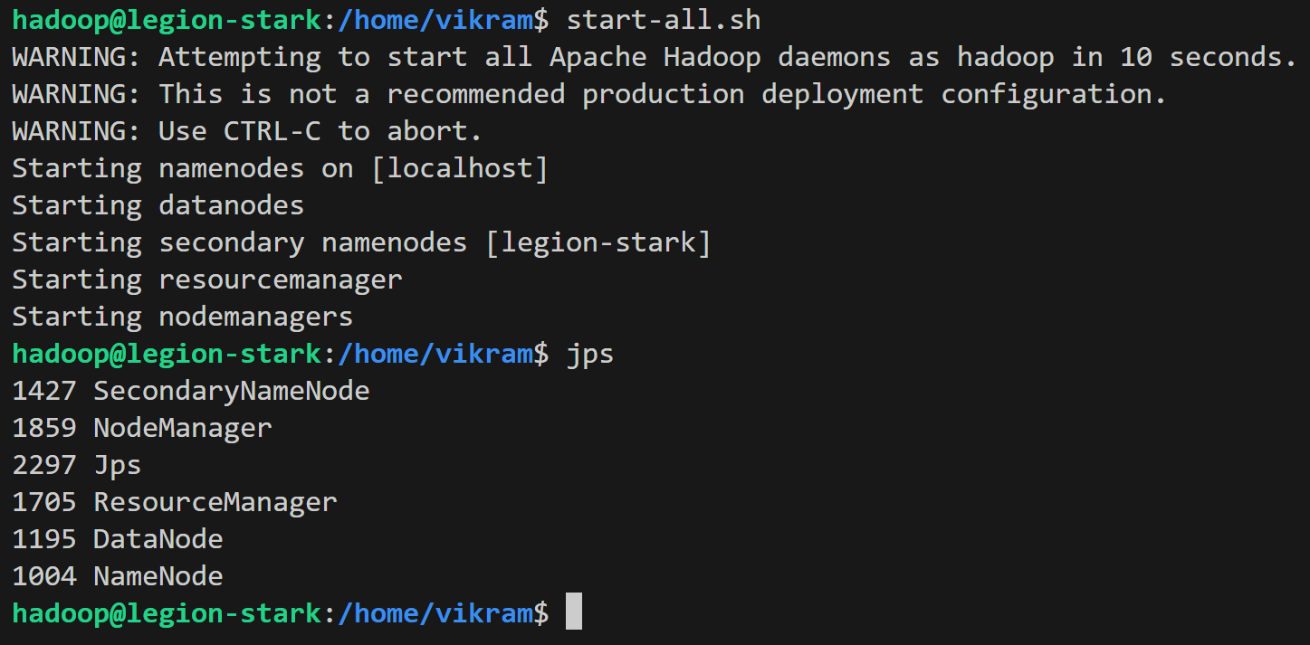

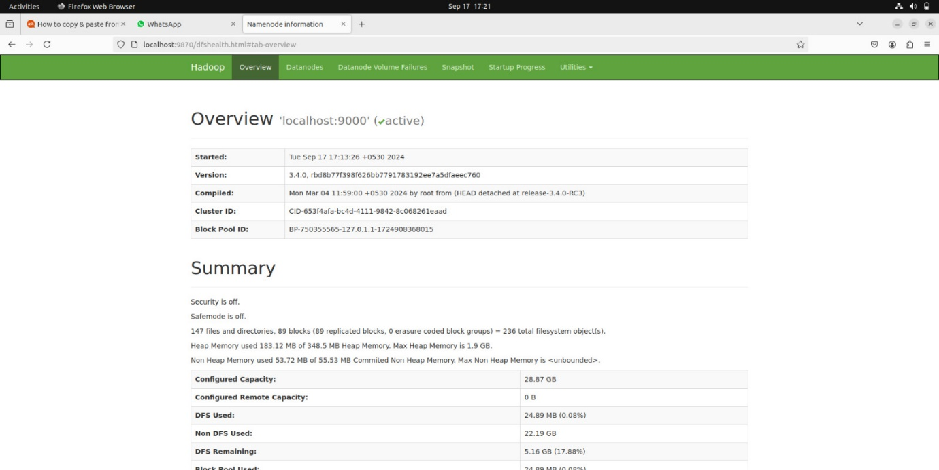

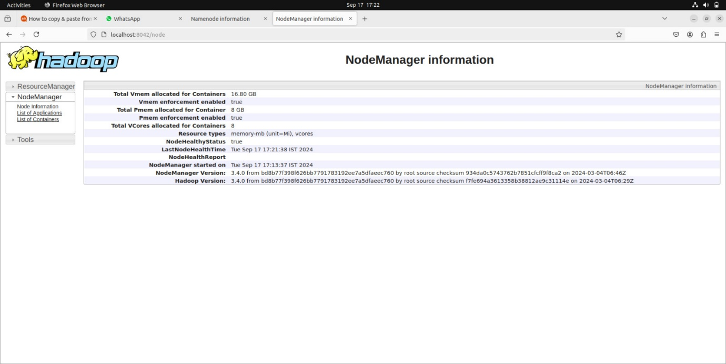

**Result:**

The step-by-step installation and configuration of Hadoop on Ubutu linux system have been

successfully completed.