
MESA User Guide
Mapping Environmentally Sensitive Assets
MESA 5.7.1: desktop tool

Author: Ragnvald Larsen
Affiliation: Norwegian Environment Agency
Issued: October 2026

Contents
Right-click here and choose Update Field (or press F9) to build the table of contents.

1. Introduction
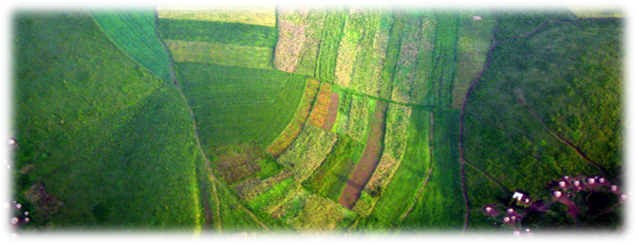
MESA: Mapping Environmentally Sensitive Assets.
The MESA method identifies and evaluates key environmental factors such as ecological significance, biodiversity, species abundance, habitat quality, and the presence of sensitive or protected areas. By combining these factors, the method supports a structured assessment of how pollution incidents may affect the environment.
Complementing the method, the MESA tool provides a Windows desktop workflow for conducting environmental sensitivity assessments and producing map- and report-ready outputs. The current MESA 5.2 build produces:
- GeoParquet tables under output/geoparquet/ as the canonical analysis store
- MBTiles under output/mbtiles/ for fast map viewing
- A ready-to-open QGIS project under qgis/ for cartographic production
- Word reports under output/reports/
If you use the packaged distribution, start with mesa.exe. If you are running from source, start with python mesa.py.
MESA 5.2 is the current release line. The method continues to evolve, and ongoing method development will guide future tool development.

1.1 System requirements (minimum)
- Windows 11
- 16 GB RAM
- 8 CPU cores
Together, the MESA method and tool support better pollution preparedness, response planning, and environmental management. By systematically assessing and mapping environmental sensitivities, stakeholders can make better-informed decisions, prioritize mitigation, and improve coordination across teams.
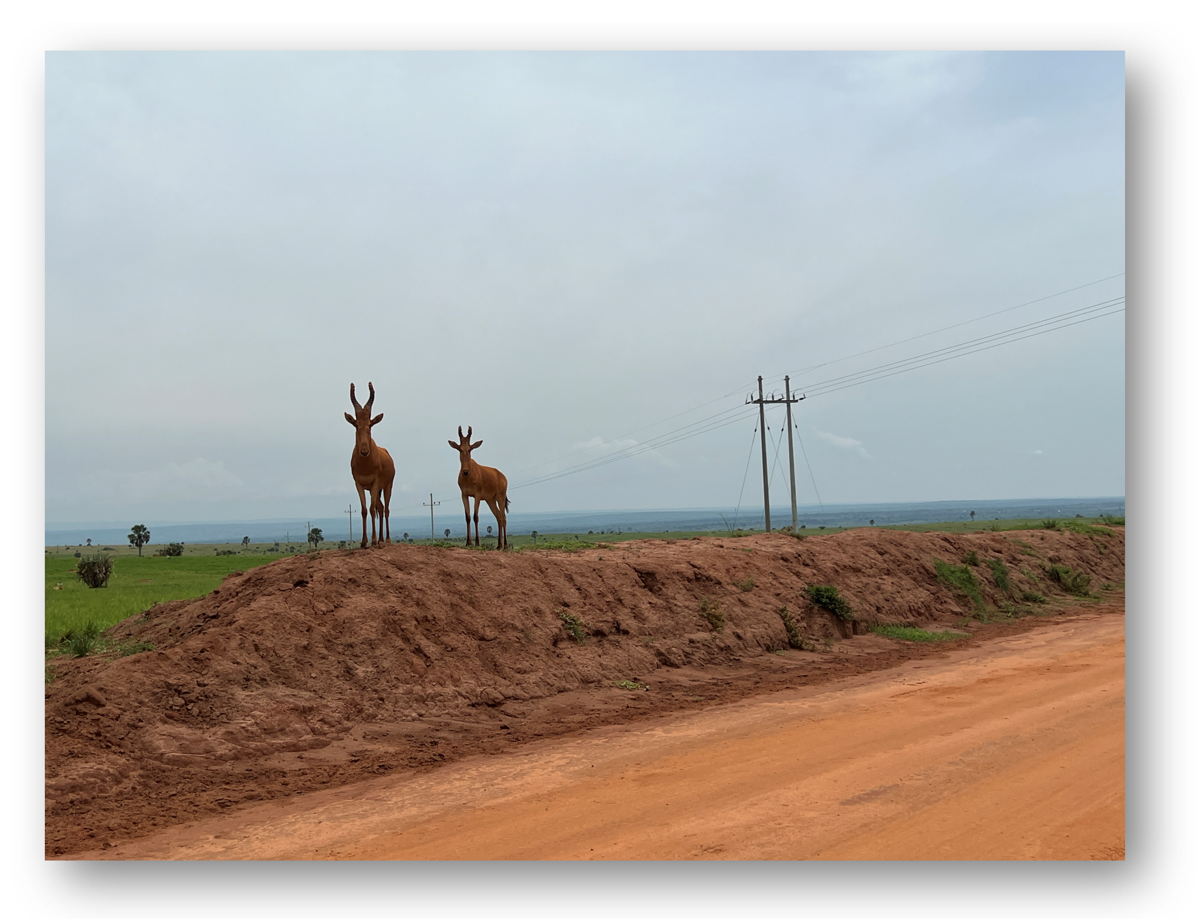
Conflicting interests captured by sensitivity mapping.

2. What's new in MESA 5.7
MESA 5.7 is a release about scale and safety. Projects take far less disk and memory, map tiles render faster, and a data-loss bug that affected every earlier MESA 5 release is fixed. Around that, the interface was gone through window by window: MESA now asks before unsaved edits are lost, destructive actions are harder to trigger by accident, and the report, the QGIS project and GeoNode publishing have gained new features.
MESA 5.7.1 corrects four things in 5.7.0 and adds nothing new. The Welcome and About tabs spelled out the name of the program wrongly; MESA is Mapping Environmentally Sensitive Assets. The Lines tab in Special focus could open empty with an error message. Windows that were too small for their content cut off text and tick boxes; they now open large enough, and scroll when the screen is too low. A black command-line window no longer flashes by during processing. Projects and results are not affected, and nothing needs to be run again.

2.1 Read this first: check your mosaic
If you added an H3 or QDGC level to a project with a large basic_mosaic in any MESA 5 release up to and including 5.6, the mosaic could be deleted without any message, and processing afterwards silently left it out. Open Geocodes and look at the object count next to basic_mosaic. A group listed with 0 objects was emptied by this bug: rebuild the mosaic and run Process again. In 5.7 a geocode table that cannot be read stops the operation instead of being treated as absent.

2.2 Smaller projects and nine numbered stages
The analysis table used to store a full copy of a cell's outline on every row of that cell. Outlines are now stored once and looked up when needed. The same project gives identical rows and values in a table about 93% smaller, with unchanged processing time. Existing projects keep working, and running Process again is what shrinks them.
- The Backfill stage is removed. The processing runner now has nine numbered stages: Prep, Intersect, Flatten, Segment, Classification, Tiles, QGIS project, Lines and Analysis.
- Classification is the most expensive stage and is now opt-in. Tick Run Classification as part of Process under Configure, Classification if you want it in every run.
- The QGIS project (qgis/mesa_results.qgz) is its own stage and no longer needs Tiles. It carries two interactive 3D views per geocode layer.
- Study areas work on large projects: the analysis reads only the cells a study-area polygon touches.
- Tiles render faster, and where a zoomed-out pixel covers many cells the highest value now wins, so two runs of the same data give the same picture.
- Generated grid levels are named with two digits (H3_R07, QDGC_L06) so that lists sort in level order. Existing projects and restored packages are renamed automatically.
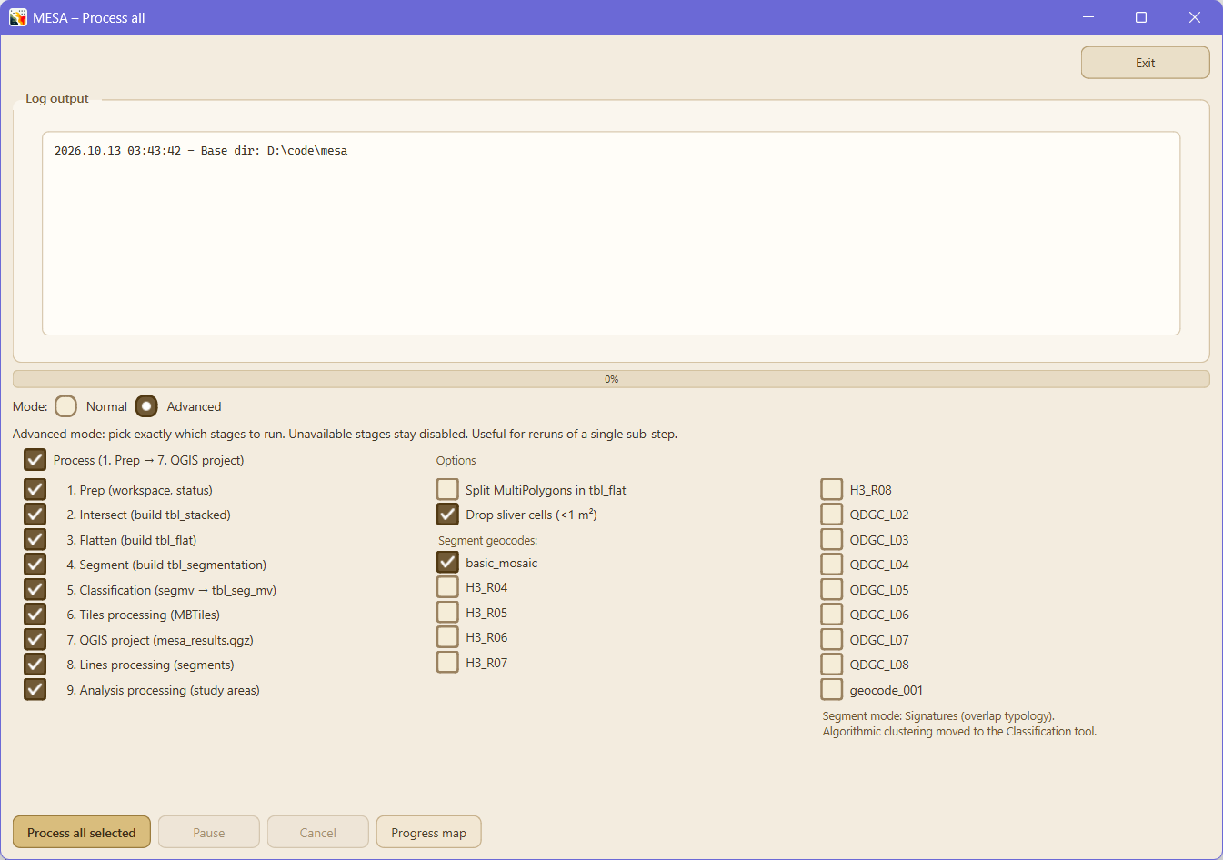
The processing runner in Advanced mode, with one tick box per stage.

2.3 MESA asks before your edits are lost
Every window with editable fields now asks Save, Discard or Cancel before edits would be lost: on close, on Reload, on Previous and Next in the Atlas editor, and before a job that rewrites what is being edited. Cancel is the default answer.
- Exit is in the top right corner of every window, and each window has one highlighted main action.
- Destructive buttons are marked as such, and Enter no longer confirms a deletion. The safe answer is the default for Clear output, Restore, Move workspace and deleting geocode groups.
- A running job cannot be started twice: its buttons are locked until it finishes.
- Parameters no longer overwrites edits made in Assets. It saves only importance and susceptibility, and no longer saves by itself on close.

2.4 Lines and study areas are edited the same way
The two tabs of the Special focus window used to follow different rules: Lines kept changes until you saved, while the other tab wrote every change at once with no way back. Both now have Save and Discard, the same layout (toolbar, list, form, map) and the same way of adding an item: click the points and finish with Enter or a double-click. The second tab is called Study areas.
Three faults that affected figures were fixed at the same time. A study area with only a drawn polygon could be invisible to Process and the report, results for deleted polygons stayed in the totals, and nothing said when a study area had been edited after its analysis ran. The tab, the report and Compare study areas now say so.
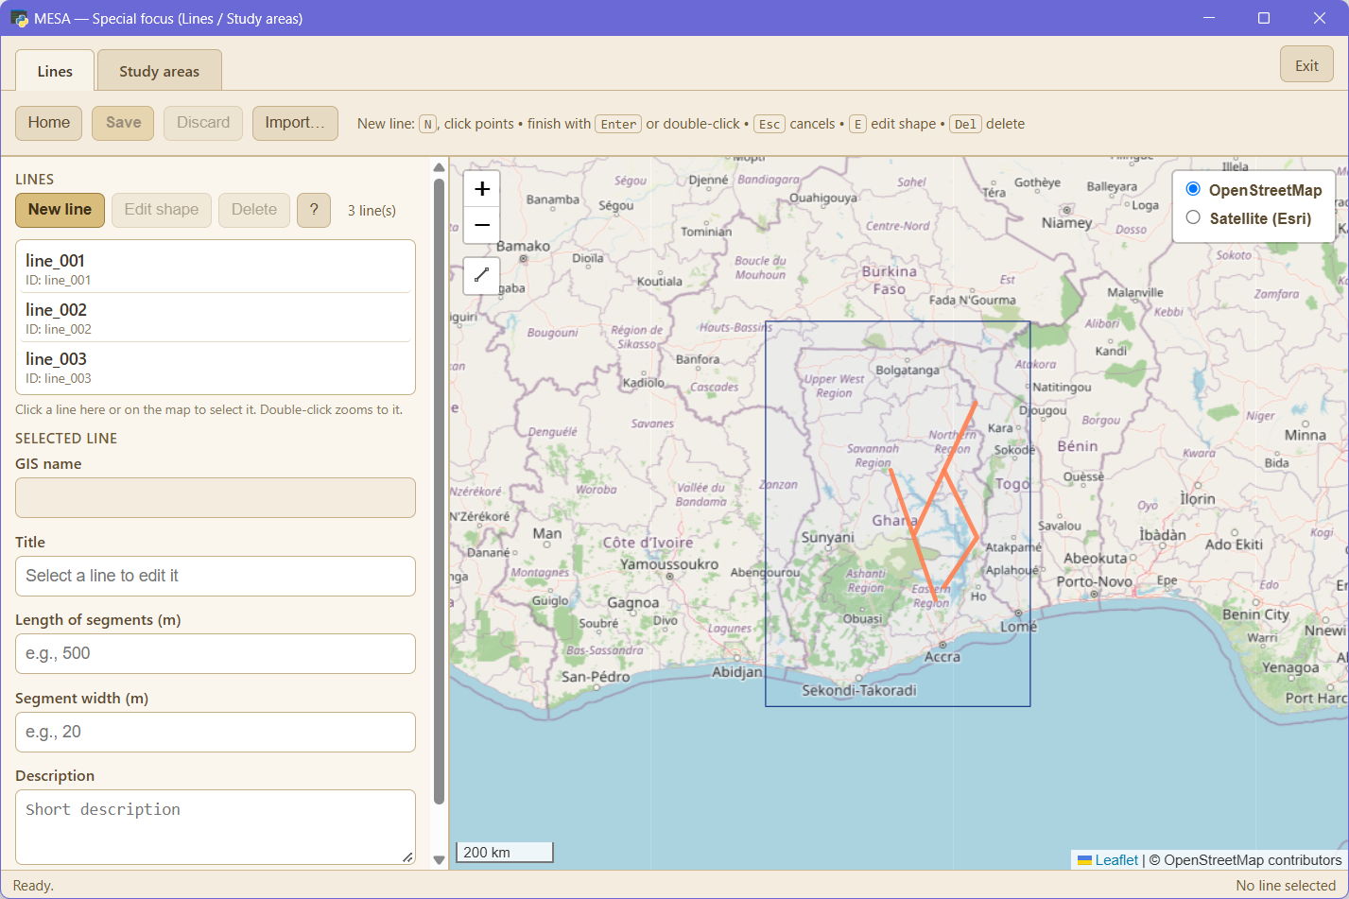
Special focus: lines and study areas are edited in two tabs with the same layout.

2.5 The Word report
- Maps are wider and have a margin around the data. A heading, its introduction, the map and its legend stay on the same page, and table rows no longer split across pages.
- The Other maps and atlas tile pages have a colour key under each map.
- The table of geocode groups shows the average and the total area of the cells in each group.
- The Classification section lists the sensitivity types in a table and draws each type as a grid of importance against susceptibility, with an explanation of how to read it.
- A status line under the progress bar says which map is being drawn, how many basemap tiles are being downloaded and roughly how much time is left.
- Only one report can run at a time. Pressing Create report while one is running says so and when it started.
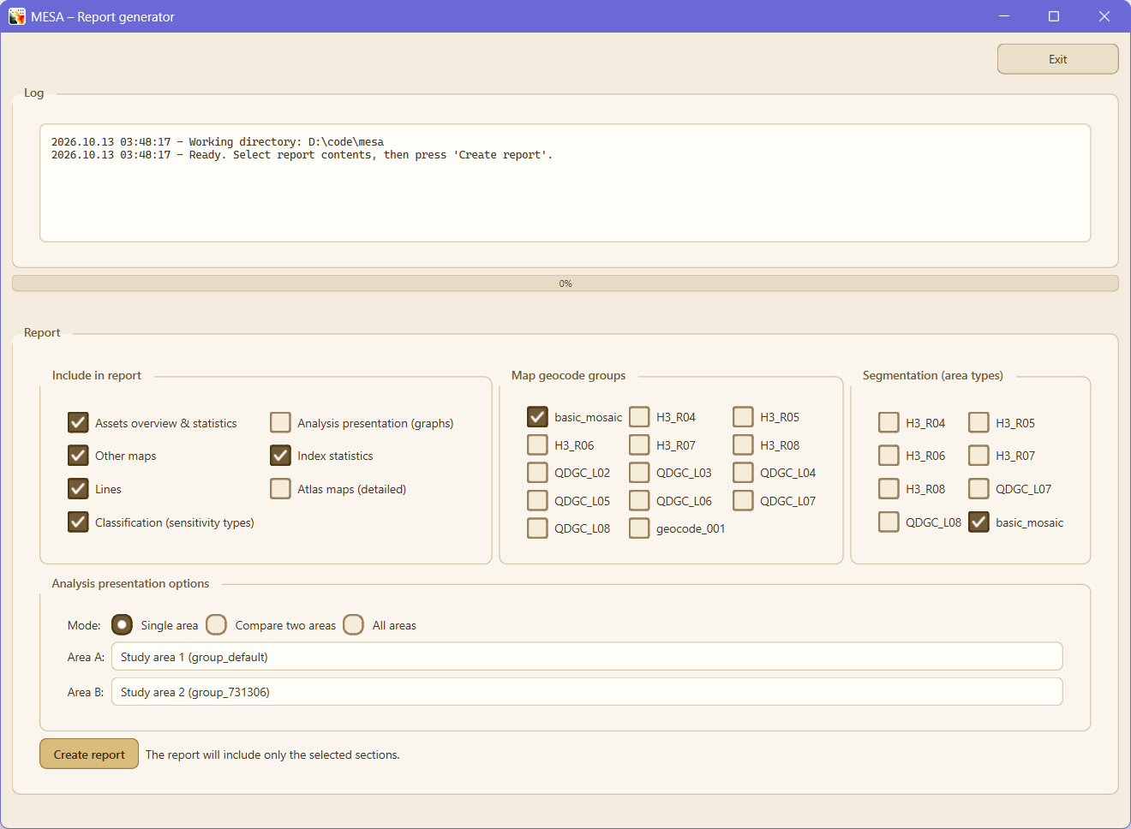
The report window, where you choose what the report contains.

2.6 Publishing, assets and project data
- Publish to GeoNode creates one map per geocode group, with Sensitivity, OWA index, Importance, number of asset groups and number of asset objects as switchable layers styled as in MESA. It can also create a dashboard per geocode group and segmentation level, and a Manage server tab lists and deletes what is on the server.
- Upload assets copies .gpkg, .shp or .parquet files from anywhere on disk into the asset folder and offers to import them. Delete asset removes one asset group from the project and leaves the source file in place.
- Delete all data on the Manage data tab empties results and source folders. config.ini and input/settings.xlsx are kept.
- MESA is delivered without project data. Demonstration packages are published separately on Zenodo; see section 3.2.

2.7 Upgrading from an earlier version
- Projects from earlier versions open as before. Grid names are migrated on first start.
- Run Process again to get the smaller analysis table.
- Scripts that pass --no-backfill to the processing runner must drop it, because the flag no longer exists. backfill_max_workers in config.ini is ignored.
- If you relied on Classification running automatically, tick it under Configure, Classification.

3. Quickstart
This quick-start guide shows how to run the current MESA 5 workflow end-to-end: prepare inputs, configure parameters, run processing, and review outputs.
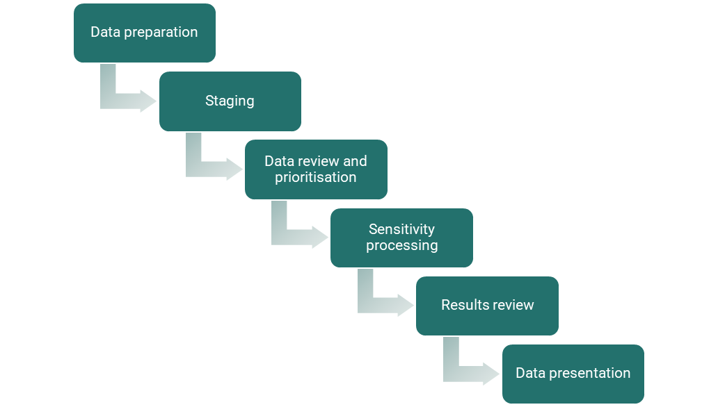
MESA process overview: prepare data, configure, process, review.

3.1 The MESA tool
MESA is operated from the desktop launcher. Use mesa.exe for the packaged distribution or python mesa.py when running from source. From the launcher you can import data, configure parameters, run processing, open interactive viewers, and export reports.

3.2 Getting ready
- System: Windows 11, minimum 16 GB RAM, minimum 8 CPU cores, and optional QGIS for atlas authoring.
- Workspace: unzip the latest MESA release (packaged) or clone the repository (source). Keep the folder structure intact.
- Disk space: plan for several GB free space for GeoParquet, MBTiles, logs, reports, and temporary processing files.
Data set | Description | Required
Environmental assets | Natural or anthropogenic entities that provide ecological, socio-cultural, economic, or political value. Stored under input/asset/<collection>. | Yes
Geocode layer | Spatial grids or polygons that aggregate sensitivity. H3 hexagons, quarter-degree grid cells, municipalities, or any non-overlapping polygons under input/geocode/. | Yes
Line data | Roads, pipelines, coastlines, rivers, or similar linear assets stored under input/lines/. | No
Atlas tiles | Optional atlas polygons for QGIS atlas exports and report rendering. Created inside MESA or imported from input/atlas/. | No
Analysis areas | Optional study areas / groups used for side-by-side comparison and analysis outputs. | No

Demonstration data. MESA is delivered without project data. To try MESA before you have your own data, download a demonstration package from Zenodo. A package holds input data only, and restoring it replaces the input/, output/ and config.ini of the project you restore into. Classification is switched off in the packages.
- Synthetic test data, four small projects with invented and deliberately overlapping asset layers. Process takes 12 to 15 seconds, so start here: https://doi.org/10.5281/zenodo.21744039
- Open data from sites in Uganda, Kenya and Ghana, five projects built from ESA WorldCover, OpenStreetMap and the Allen Coral Atlas: https://doi.org/10.5281/zenodo.21744272
- Each record includes a guide, and every package carries docs/readme_demodata.txt with its sources and credits. Both links always lead to the newest version of the data.
From a package to results takes five steps, and MESA lists them when the restore has finished:
- Manage data, Restore data: pick the zip file.
- Assets, Import assets from folder.
- Parameters, Load from Excel. This reads importance and susceptibility from input/settings.xlsx. Without it Process stops in its check before it starts.
- Geocodes, Build mosaic.
- Process.

3.3 Importing data
- Copy asset datasets into input/asset/.
- Copy geocode layers into input/geocode/.
- Copy line datasets into input/lines/ when you need segment-level sensitivity.
- Review config.ini if you need to adjust projections, tile zoom levels, buffers, or performance knobs.
Then use Workflows → Prepare data (step 1):
- Assets imports asset datasets and lets you maintain asset-group metadata.
- Geocodes imports geocode layers and can also generate or refresh supported grids.
- Lines imports and edits line data plus segmentation settings.
- Atlas imports or creates atlas polygons when you need atlas pages later.

3.4 Configuring the project
Use Workflows → Configure (step 2) before heavy runs. Parameters edits processing rules such as sensitivity weights, thresholds, and related settings. Analysis defines optional study-area polygons and named analysis groups.

3.5 Running processing
- Open Workflows → Process (step 3) → Process.
- In the process runner, select the steps you want: Data processing (Prep / Intersect / Flatten / Segment), Tiles processing, Lines processing, Analysis processing.
- Leave Data processing enabled at minimum for a first full run.
- Enable Tiles processing if you want MBTiles in the same run.
- Enable Lines and/or Analysis processing when those datasets have been prepared.
- Use Progress map inside the process runner if you want a live minimap during longer runs.
- Use the Normal / Advanced toggle at the top of the runner to expose per-stage selectors and the sliver-cleanup option.
After the first end-to-end run, every stage's output sits on disk and downstream stages can be re-run on their own. To explore parameter changes, switch the runner to Advanced and tick only the stages affected by your change. The full mapping from 'what I changed' to 'which stages I need to rerun' is in section 10.2 Iterative workflow.

3.6 Reviewing results
After processing, use Workflows → Results (step 4): Maps opens one tabbed window with Overview (index/sensitivity layers), Segmentation (the Segment-stage output), and Assets (imported asset layers), with linked zoom & pan, opacity, a basemap selector, and PNG export; Compare study areas compares analysis groups side by side; and Report engine creates a Word report from the latest outputs.

3.7 Backup and restore
- Create backup saves input/, output/, and config.ini into one ZIP archive.
- Restore backup replaces the current input/, output/, and config.ini with the selected archive.
- Clear output removes generated outputs while keeping inputs and configuration.
Restore is destructive. Make sure no MESA windows are actively using the project folder before restoring.

4. Desktop user interface
The MESA 5.2 desktop launcher opens on the Welcome tab, where you can name the project and add a short description, then continue to Workflows. The Workflows tab organizes the project into four practical phases: prepare data, configure the project, run processing, and review results.
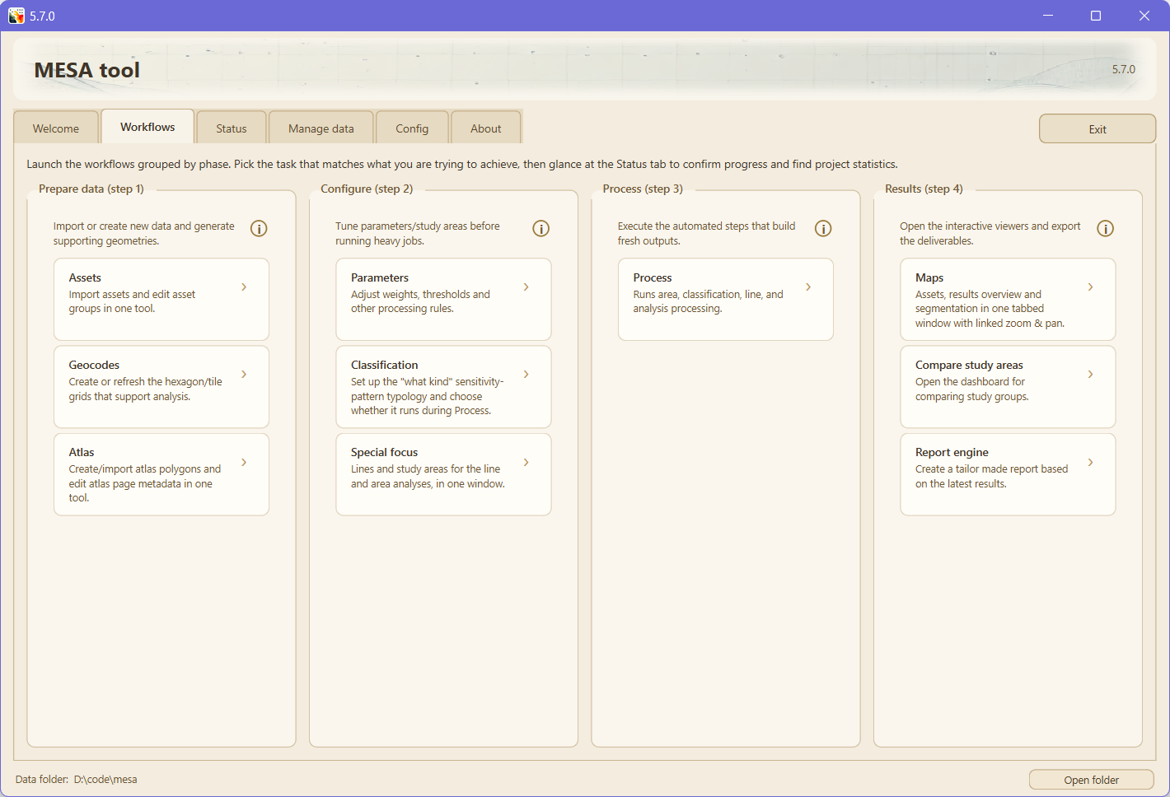
Desktop launcher: Workflows tab.
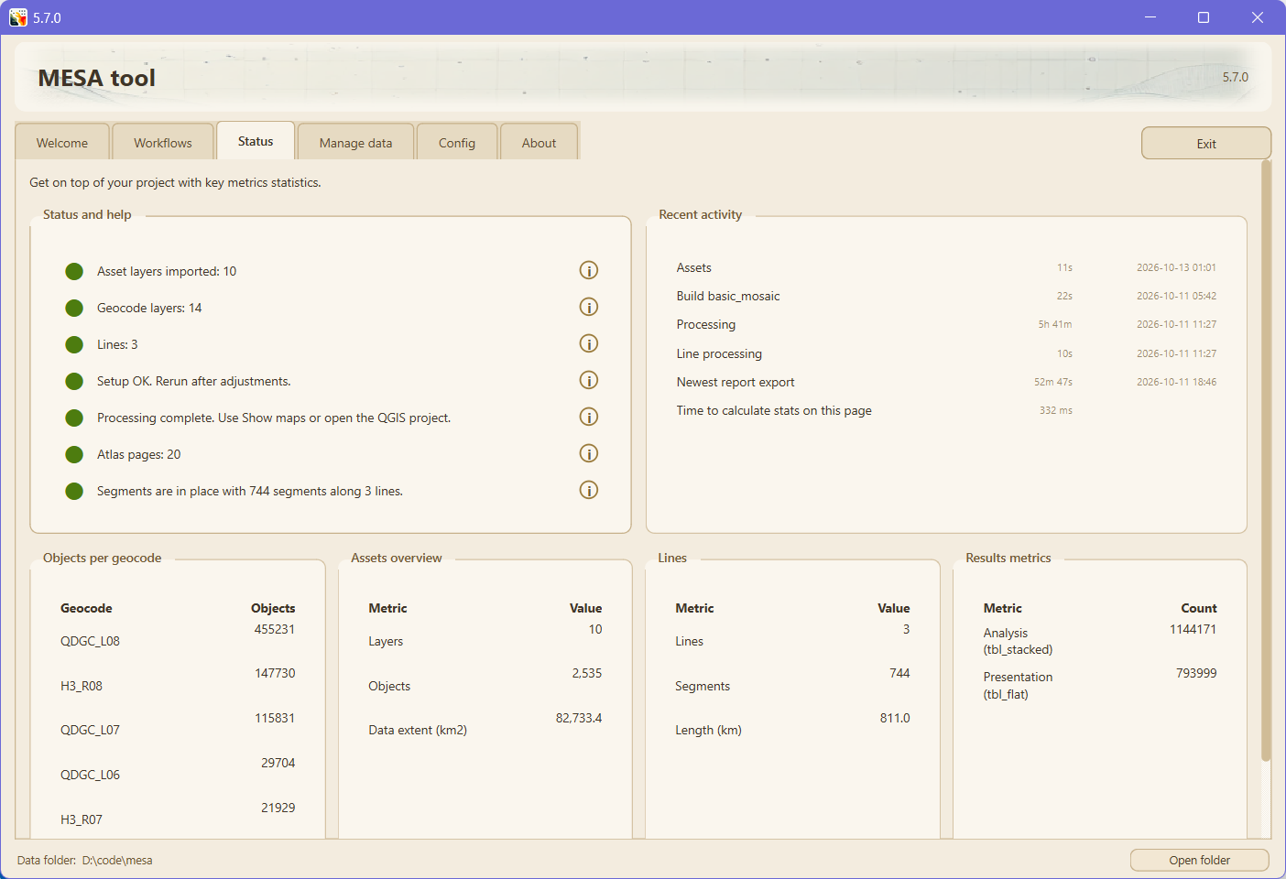
Status tab: counters, recent activity, headline metrics.
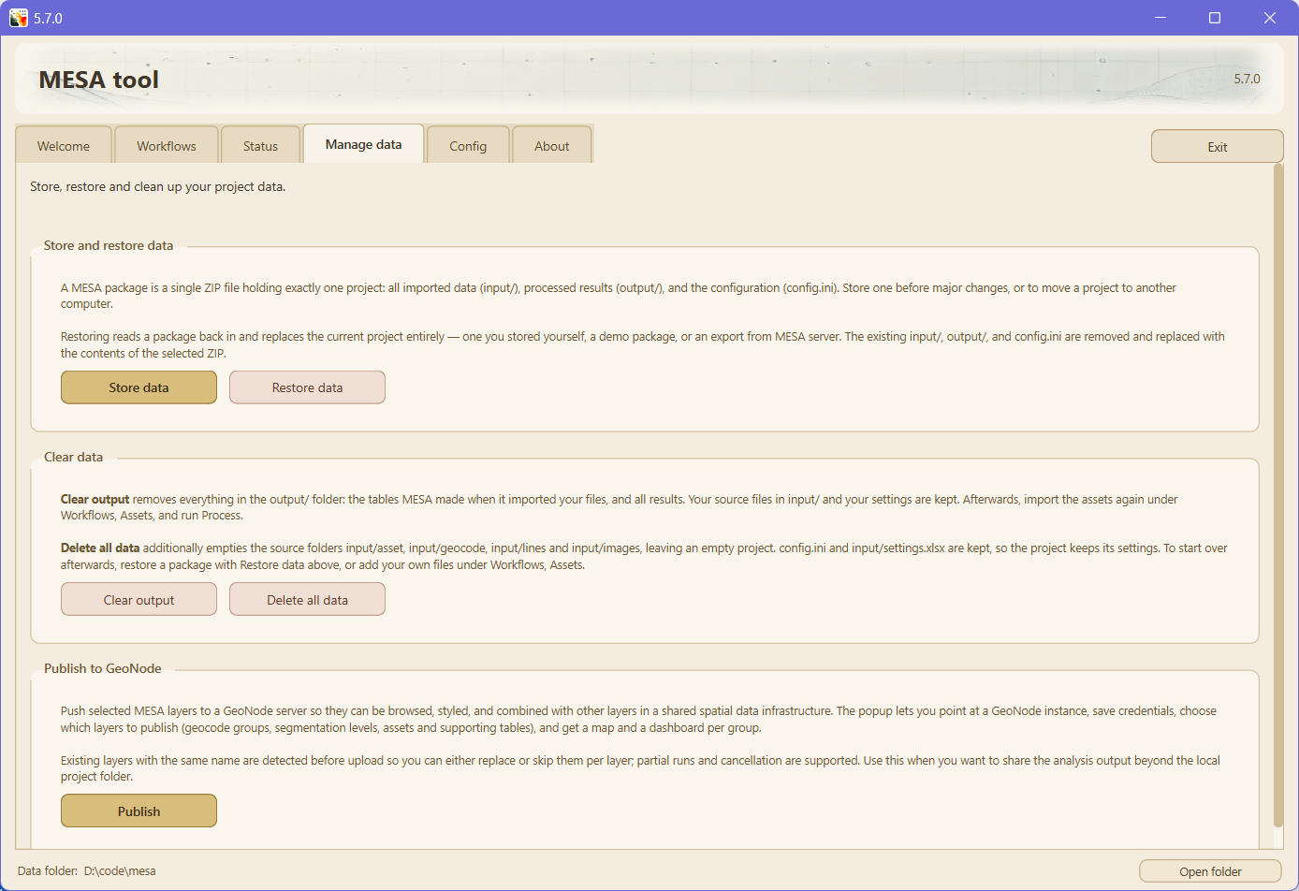
Manage data tab: backup, restore, clear output, GeoNode publish.
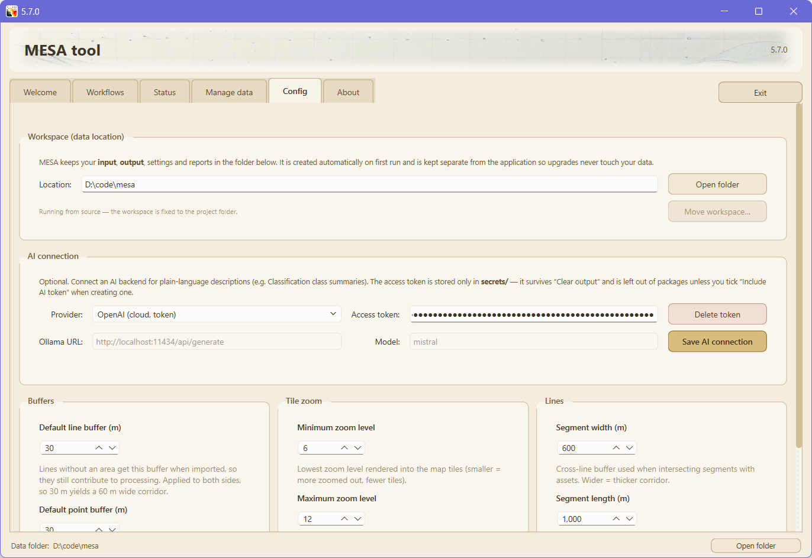
Config tab: direct editor for config.ini, with Tune processing popup.
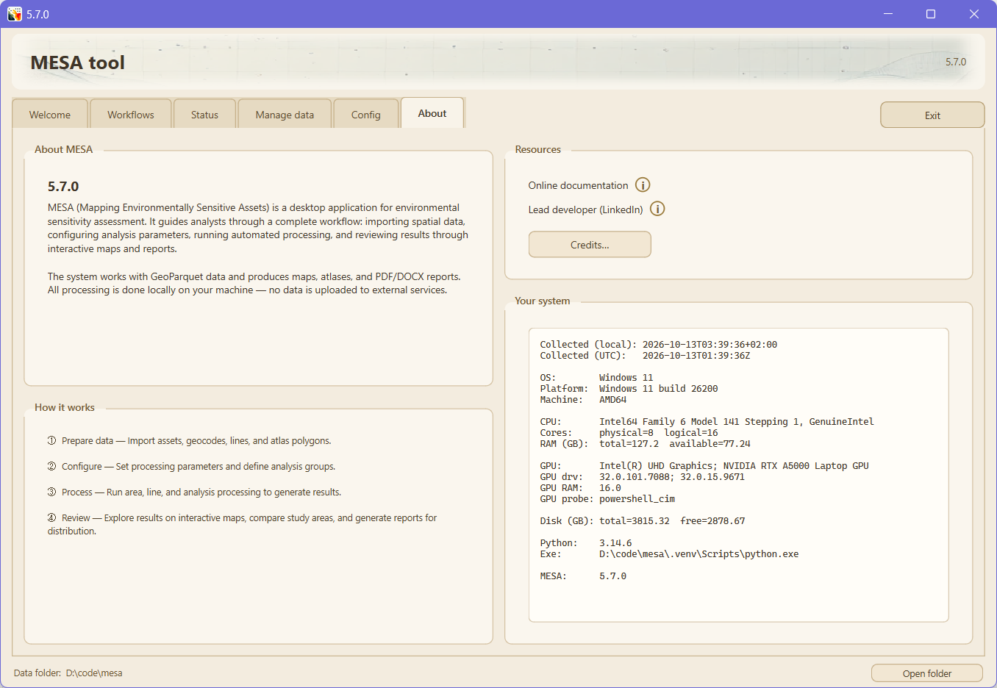
About tab: build banner and system profile.

4.1 Prepare data (step 1)
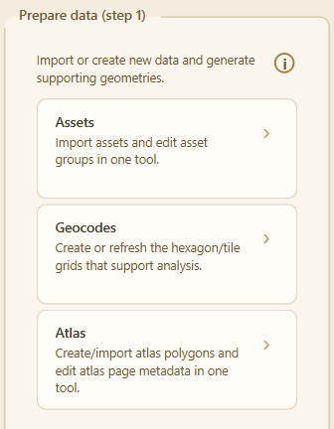
Prepare data: assets, geocodes, atlas.
- Assets: import area assets from input/asset/ and maintain asset-group metadata. Two convenience options are on by default: Dissolve adjacent polygons (removes source-grid moiré) and automatic buffering of point and line inputs.
- Geocodes: import geocode layers or generate supported grids used by analysis and reporting.
- Atlas: import or create atlas polygons and maintain atlas page metadata. The helper now surfaces existing atlas state on open and includes a Delete action.
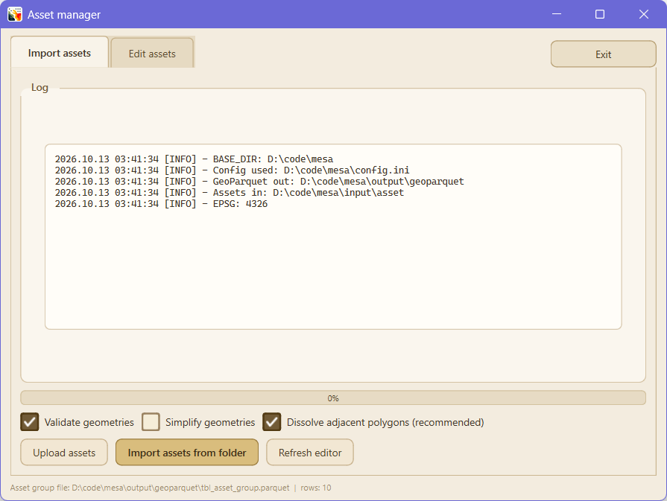
Asset manager: group metadata and per-layer controls.
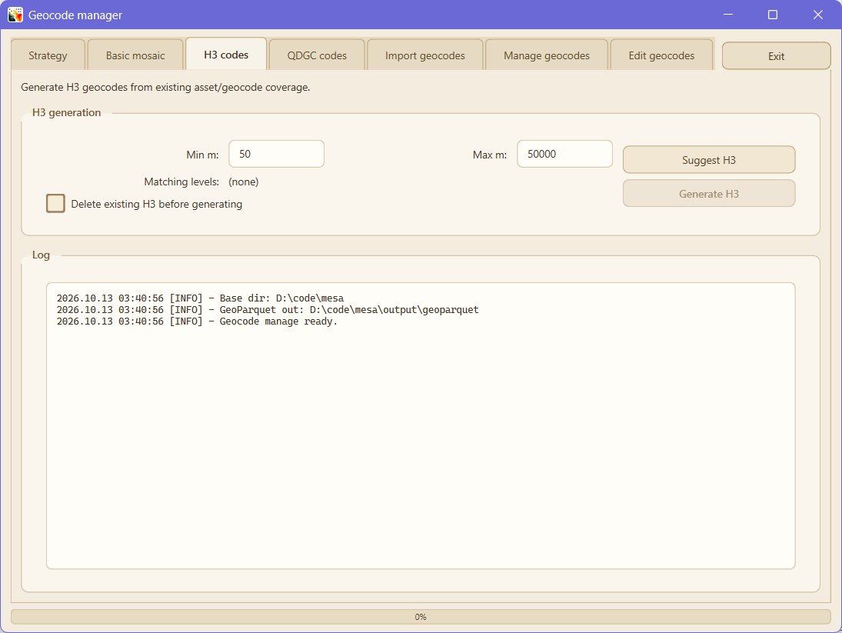
Geocode creation: generate or import geocode layers.
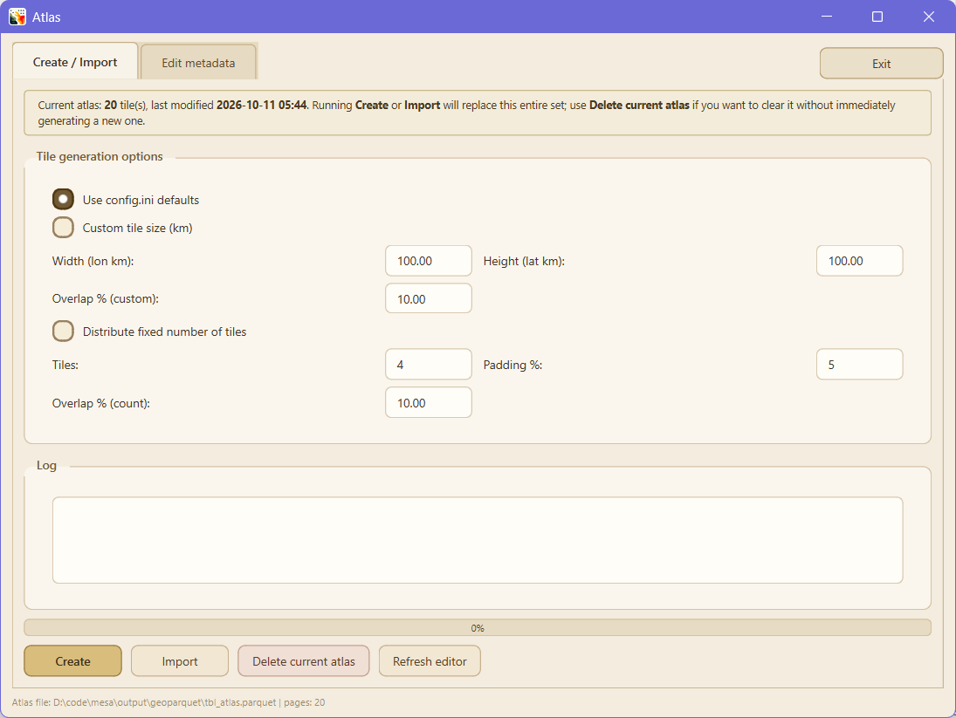
Atlas manager: atlas pages and metadata.

4.2 Configure (step 2)
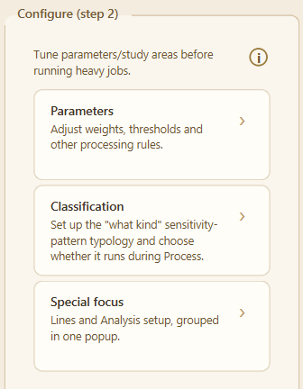
Configure: parameters, lines, analysis.
- Parameters: adjust processing rules such as weights, thresholds, and related setup values.
- Lines: import and edit line datasets such as transport, rivers, utilities, or coastlines.
- Analysis: define study-area polygons and named analysis groups.
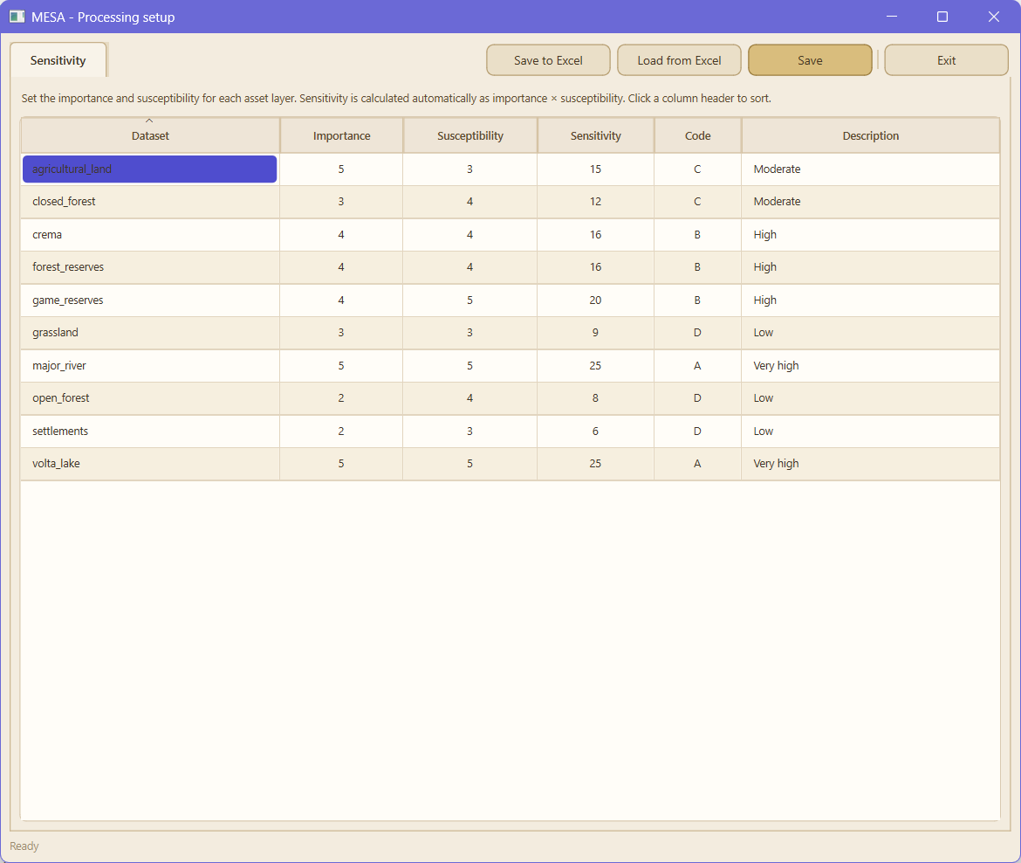
Parameters helper: sensitivity setup.
Line manager: line layers and segmentation settings.
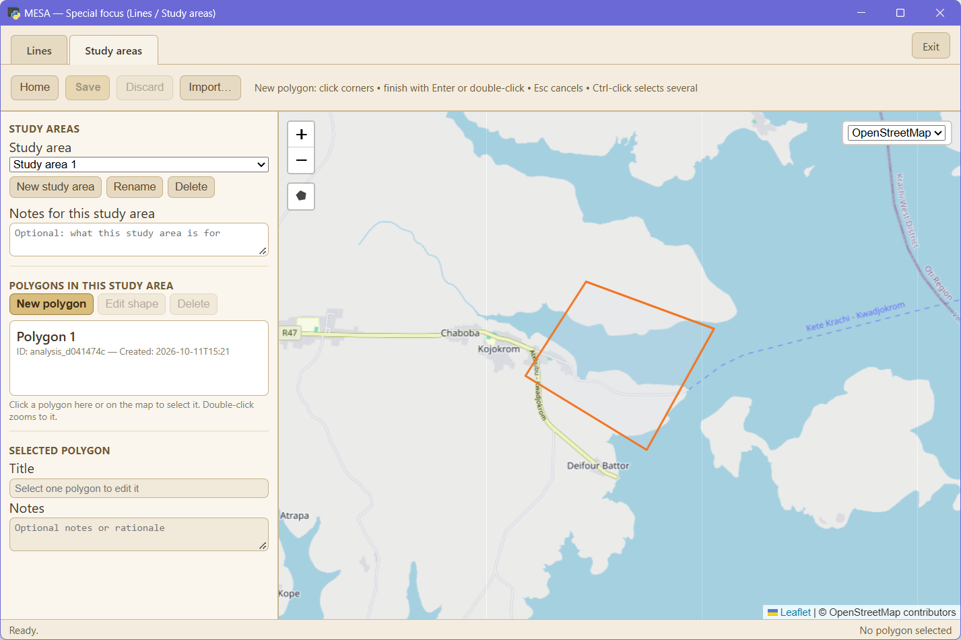
Analysis setup: study areas and analysis groups.

4.3 Process (step 3)
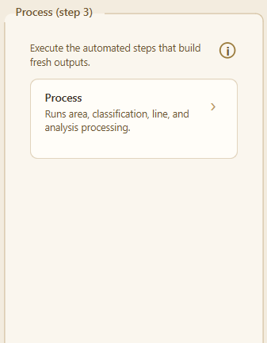
Process: unified processing runner.
The runner can execute nine numbered stages, in order: Prep, Intersect, Flatten, Segment, Classification, Tiles, QGIS project, Lines and Analysis. Classification is off unless you have ticked it under Configure, Classification. The Segment sub-stage builds a per-geocode-layer segmentation (tbl_segmentation) and is on by default when data is available. Each materially-costly stage has its own checkbox in the run grid, so any one of them can be re-run without forcing the others to repeat. A Normal / Advanced toggle at the top keeps the default view simple. Worker counts for each stage are decided at runtime by the auto-tune step unless explicit values are set in config.ini.
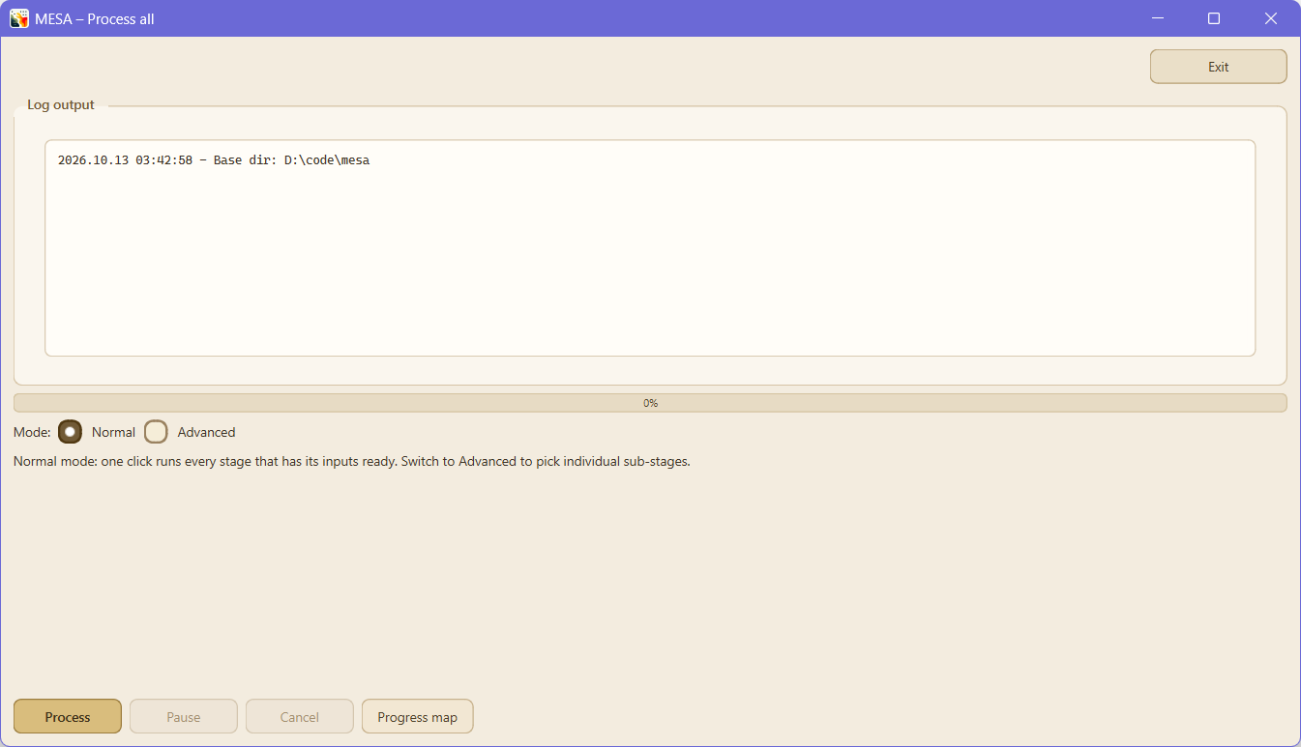
Processing pipeline runner: numbered stages and per-stage controls.

4.4 Results (step 4)
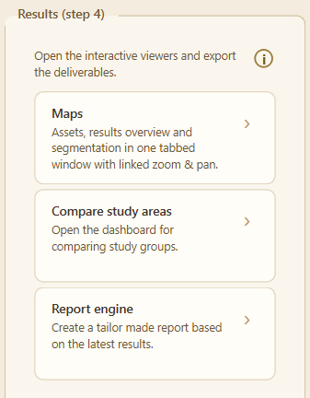
Results: Maps, compare study areas, report engine.
- Maps: one tabbed window (replacing the former separate Asset map and Results map viewers) with Overview (index/sensitivity layers), Segmentation (Segment-stage output), and Assets (imported asset layers) tabs; linked zoom & pan, an opacity slider, a basemap selector, floating layer controls, and Export PNG.
- Compare study areas: compare analysis groups side by side.
- Report engine: create a Word report from the latest results, now including per-method segmentation sub-tables.
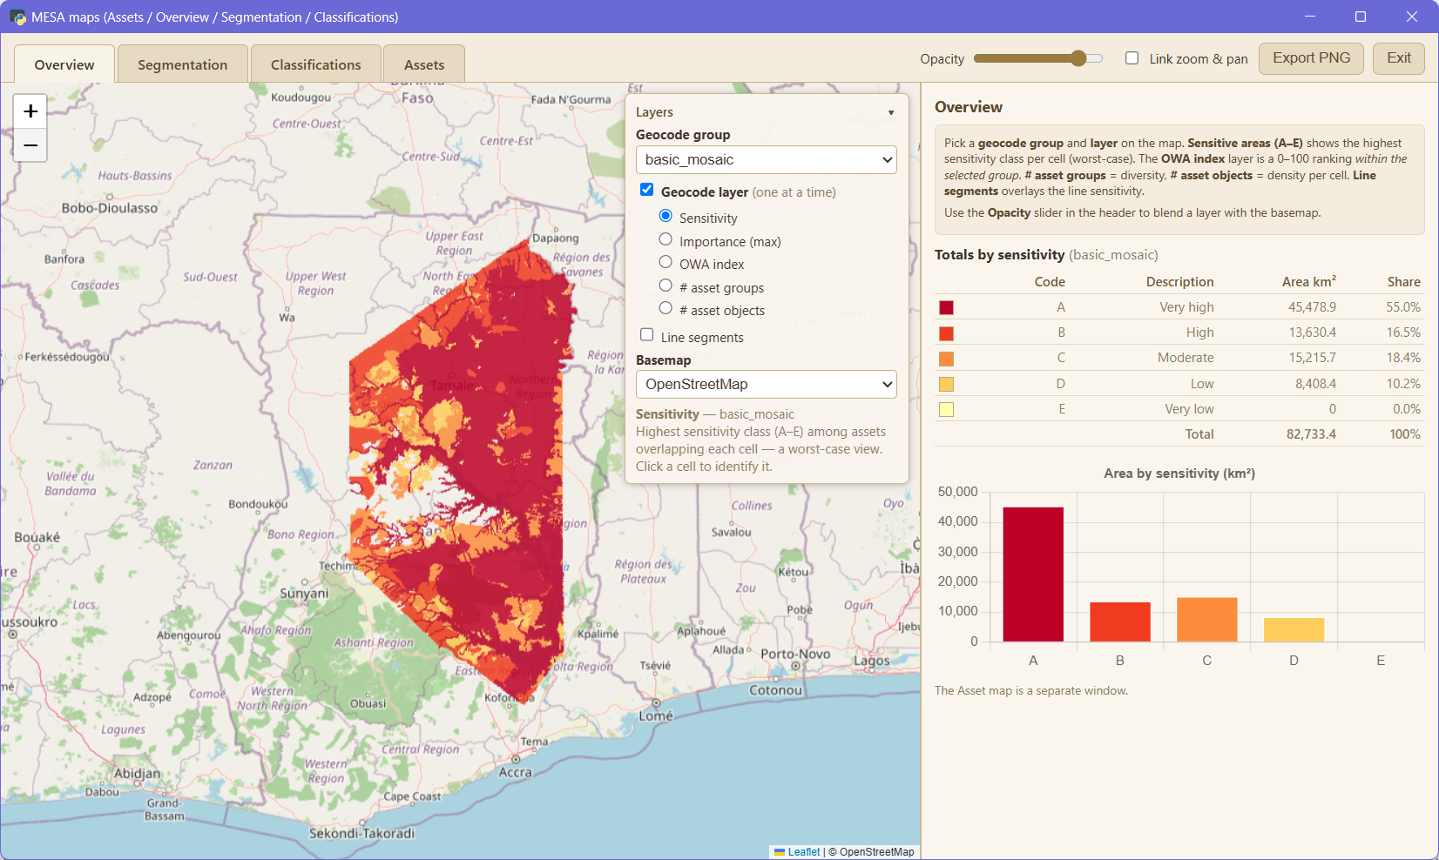
Maps window: Overview / Segmentation / Assets tabs.
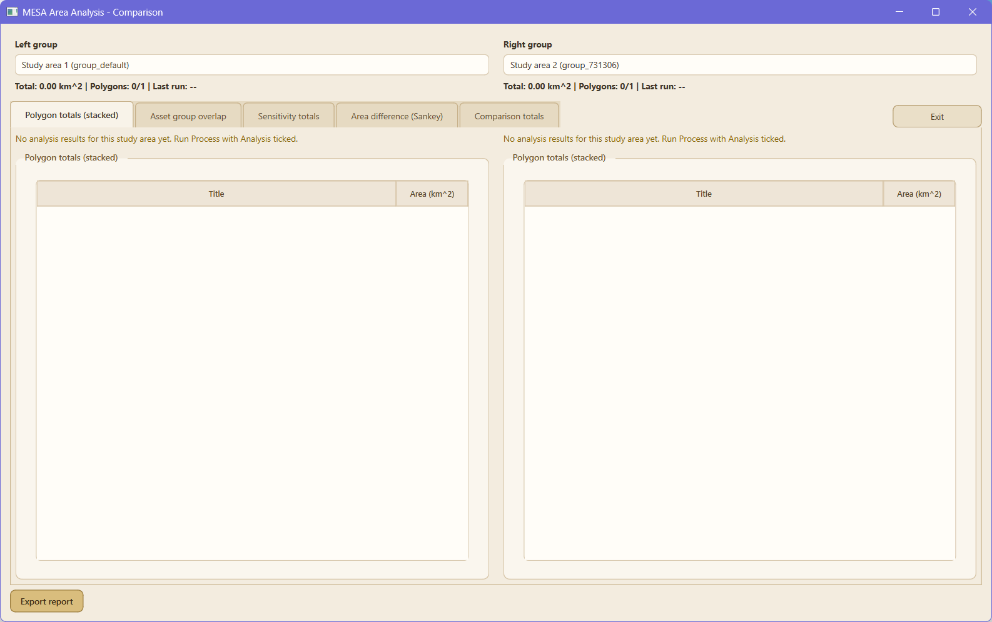
Compare study areas.
Report engine.

4.5 Tune processing popup
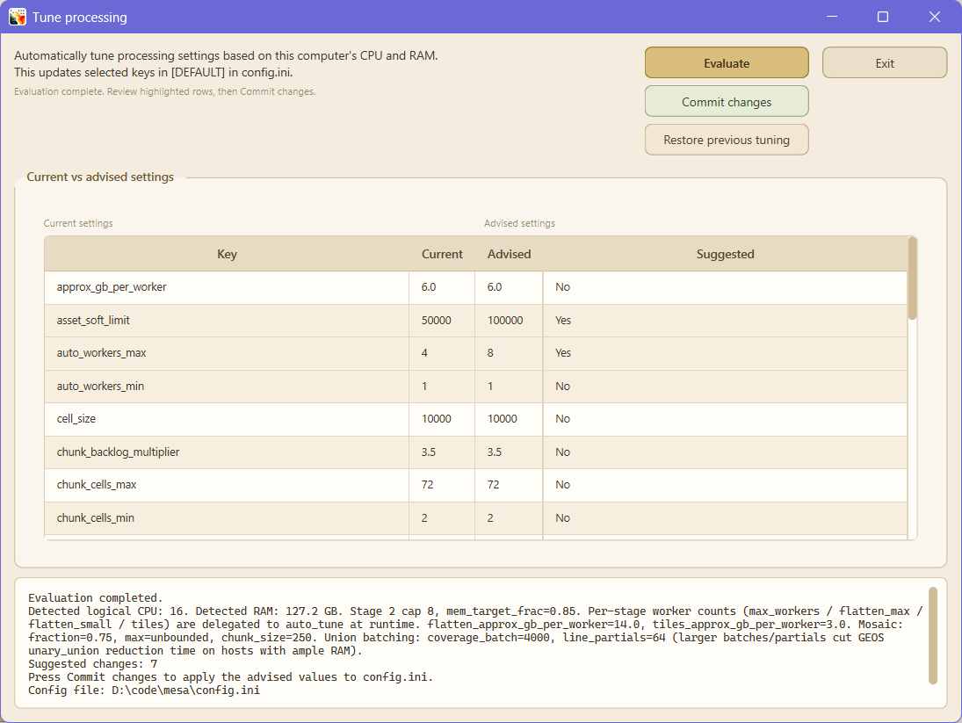
Tune processing popup: evaluate, commit, restore.
Evaluate compares current values with advised values based on detected CPU and RAM. Commit changes writes the advised values into config.ini. Restore previous tuning restores the last saved pre-tuning values.

5. Data and data quality
Most MESA results trace back to the quality of the inputs. Two layers with the same geographic extent and the same sensitivity values can produce very different mosaics depending on how their geometry was prepared and what attributes survive into MESA's processing tables.
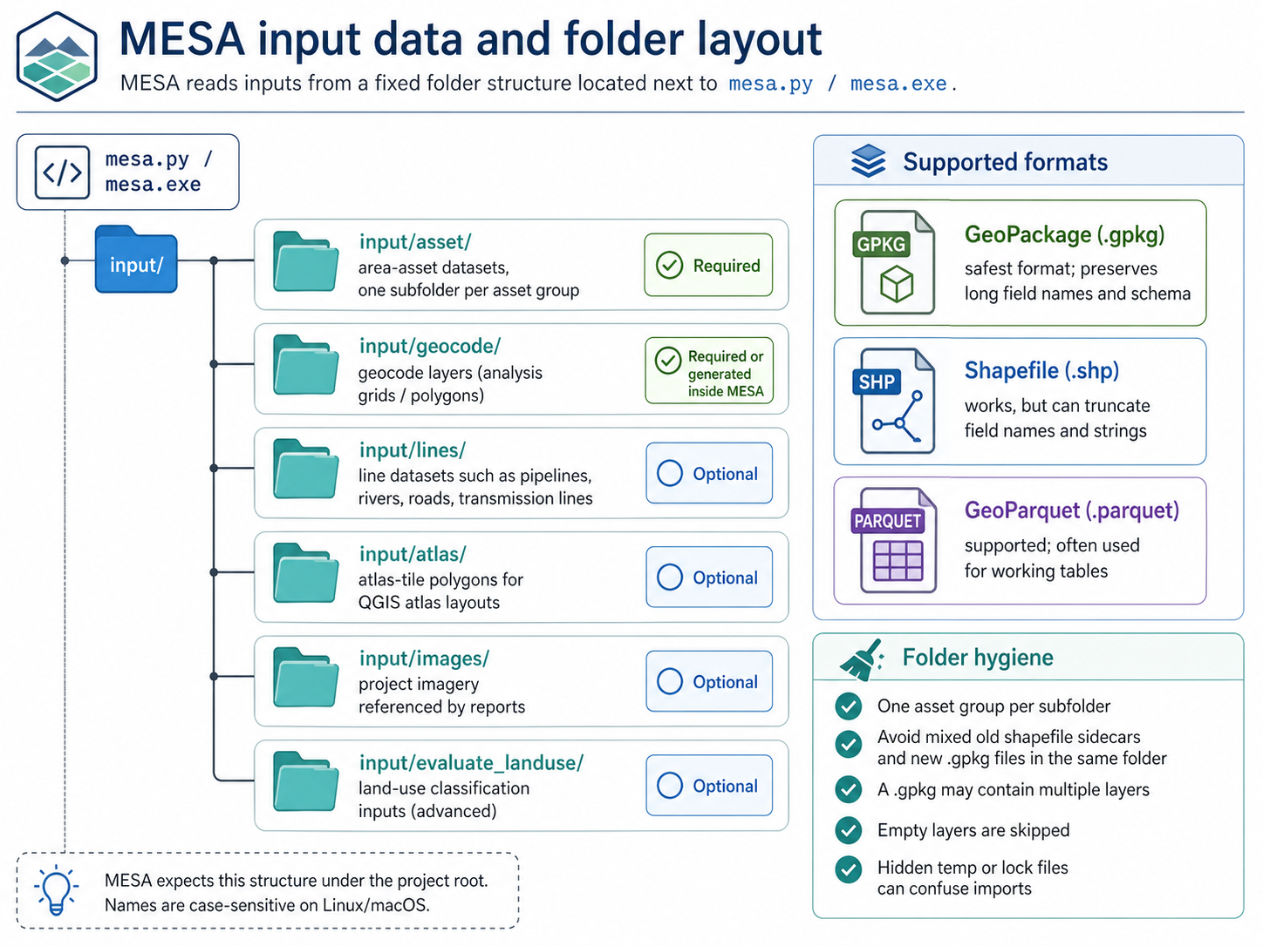
MESA input data and folder layout.

5.1 Input data folders
Folder | Contents | Required
input/asset/ | Area-asset datasets, organised into one subfolder per asset group. | Yes
input/geocode/ | Geocode layers (analysis grids / polygons). | Yes (or generate inside MESA)
input/lines/ | Line datasets: pipelines, rivers, roads, transmission lines. | Optional
input/atlas/ | Atlas-tile polygons used by QGIS atlas layouts. | Optional
input/images/ | Project imagery referenced by reports. | Optional
input/evaluate_landuse/ | Land-use classification inputs (advanced). | Optional

5.2 Supported file formats
MESA reads inputs through GeoPandas and Fiona/PyOGRIO, so common vector formats work: GeoPackage (.gpkg), Shapefile (.shp + sidecars), GeoParquet (.parquet), and a few others. GeoPackage is the safest input format. Shapefile works but truncates: column names are silently shortened to 10 characters, string values longer than 254 characters are clipped, and field types may be downgraded.

5.3 Coordinate systems and projections
- working_projection_epsg (default 4326): the projection MESA uses for fast spatial work in lat/lon.
- area_projection_epsg (default 3035 for Europe): equal-area projection used to compute areas in m². Pick one appropriate to your study region.
- output_projection_epsg (default 4326): the projection MESA writes outputs in.

5.4 Preparing your data
Ecological / organic asset polygons work best: wetland outlines, settlement footprints, river polygons, protected-area boundaries. The mosaic stays compact and the result map reads as discrete sensitivity zones. Gridded / raster-derived asset layers are the failure mode: per-cell visual moiré, and mosaic-face collapse if the layer has no honest classifier column. The takeaway: raster-derived asset layers without a classifying attribute are a known hazard. MESA handles them conservatively (no dissolve → moiré), but the right fix is upstream.
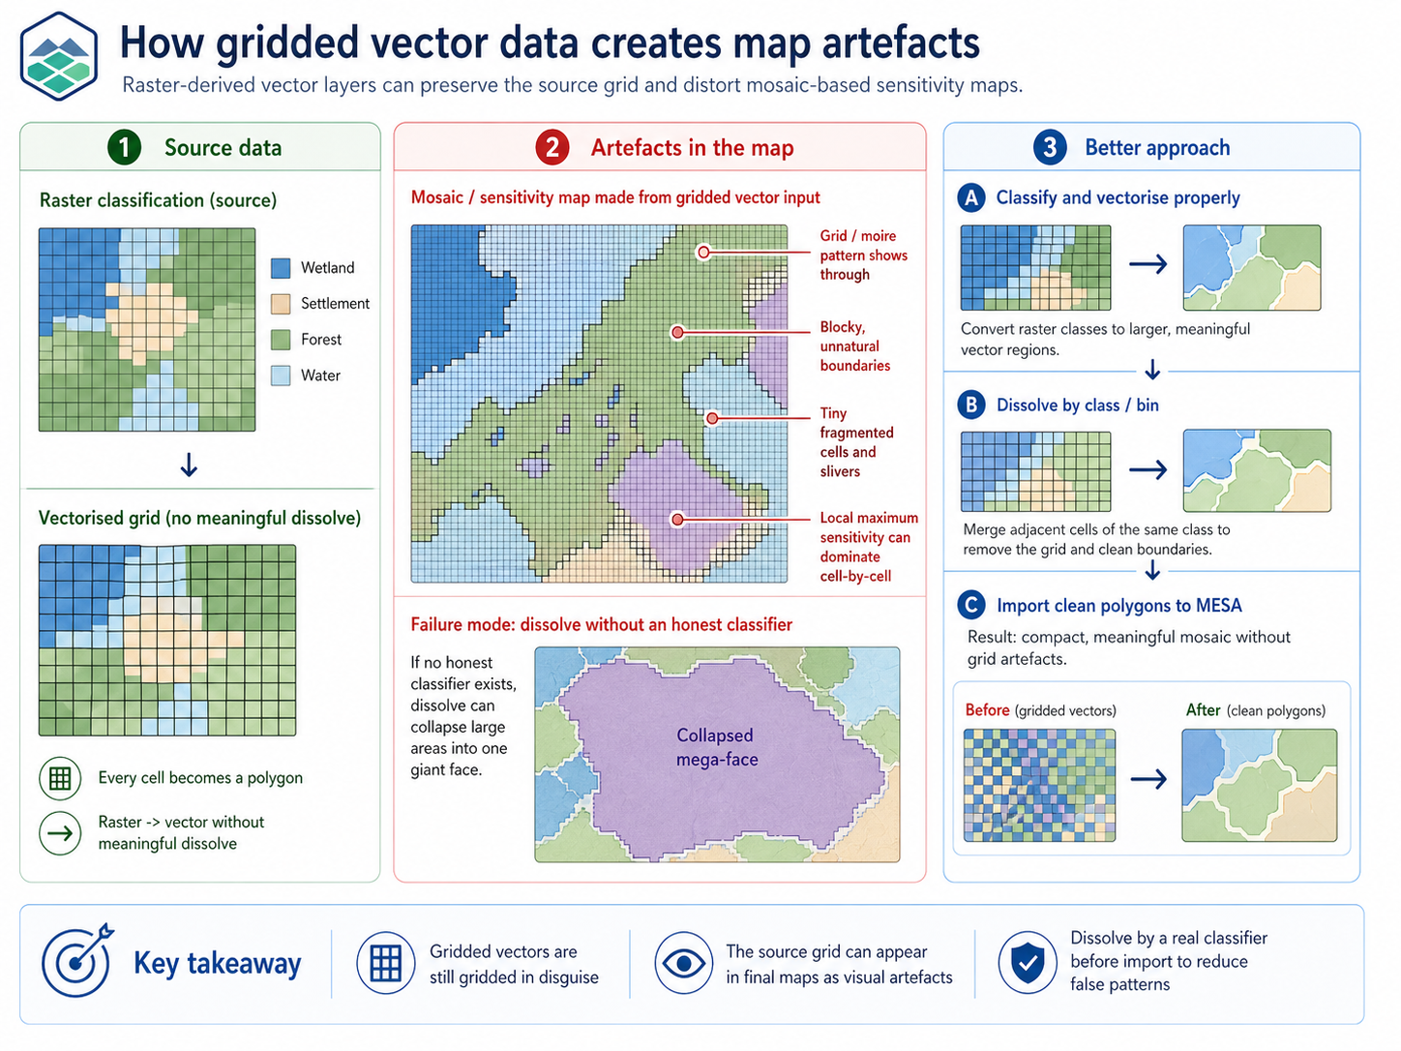
How gridded vector data creates map artefacts.

5.5 What MESA does at import
- Geometry validation (on by default; "Validate geometries" in the import window): every geometry passes through make_valid() with a buffer(0) fallback.
- Smart-key dissolve: classifies attribute columns as uniform or diverging; merges touching polygons that share uniform-attribute values.
- Buffer points and lines (always on for non-polygon inputs): Points and LineStrings are buffered using default_point_buffer_m and default_line_buffer_m before intersection.

5.6 Output data tables
Table | Contents
tbl_asset_group | One row per asset group (subfolder under input/asset/).
tbl_asset_object | One row per imported asset polygon, with attributes and serialised attributes string.
tbl_geocode_group | One row per geocode group (basic_mosaic, H3 levels, ...).
tbl_geocode_object | One row per geocode cell, with parent group reference.
tbl_stacked | Where assets touch geocodes: one row per (asset, geocode) pair.
tbl_flat | Flattened analysis result: one row per cell with summary sensitivity (max, mean, count, codes, area_m²).
tbl_system_capabilities | Host fingerprint snapshot used by About and auto_tune.

6. Method
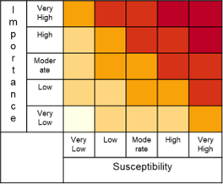
MESA: Mapping Environmentally Sensitive Assets.
MESA (Mapping Environmentally Sensitive Assets) is a method intended for a broad audience of individuals working on the development and use of environmental sensitivity maps. The method provides a step-by-step protocol for developing an environmental sensitivity atlas based on a standardized methodology that was developed following a review of several existing methods.

6.1 Introduction
Environmental Sensitivity Atlases display the relative sensitivity of places to one or more clearly defined pressures. Historically, many sensitivity atlases were developed for coastal emergency response and acute pollution scenarios. In MESA, the same underlying idea is used more broadly for early-stage screening of an area of interest by relating it to mapped assets.
In this broader planning context it is important to be explicit about the chain from activity → pressure → pathway → asset. Sensitivity is not an inherent property of a location: it is conditional on what pressure is being considered, how and when it is expressed, and which assets are valued.
Process overview: methodological steps.

6.2 Importance, susceptibility, sensitivity
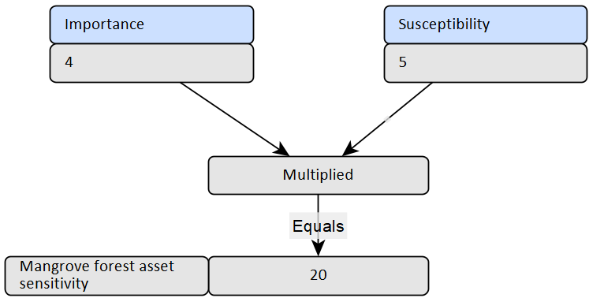
MESA calculation: importance × susceptibility = sensitivity.
- Asset importance: an asset's value based on its rarity, significance, functional and intrinsic value. Quantified with a value from 1 to 5.
- Asset susceptibility: the degree to which an asset will be affected by a pressure, based on the predicted severity of the impact and the asset's ability to recover. Quantified from 1 to 5.
- Sensitivity: the product of importance and susceptibility, also expressed on a 1–5 scale.

6.3 Intended use
Knowing whether the atlas is intended to be used at a strategic (national planning), operational (project management) or tactical (emergency response) level helps identify the appropriate resolution and assets to include, as well as providing a filter for identifying relevant pressures.

6.4 Pressures
The pressures considered will determine which assets are most sensitive. Sources of impact must be clearly identified by users prior to mapping. Table 6.1 lists potential pressures from oil & gas operations across terrestrial, coastal, and marine realms.
Terrestrial | Coastal | Marine
Oil Spill | Oil Spill | Oil Spill
Habitat Loss | Habitat Loss | Habitat Loss
Habitat Fragmentation | Habitat Fragmentation | Habitat Fragmentation
Disturbance | Disturbance | Disturbance
Atmospheric emissions | Atmospheric emissions | Atmospheric emissions
Aquatic pollution (excl. oil) | Aquatic pollution (excl. oil) | Aquatic pollution (excl. oil)
Soil erosion and degradation | Soil erosion | Increased biological resource use
Airborne particulates (e.g. dust) | Airborne particulates (e.g. dust)
Increased biological resource use | Increased biological resource use

6.5 Assets
While identifying all features that meet the broad definition of ecological assets is ideal, there is a need to find a pragmatic starting point that captures key biodiversity values. Recommended ecological assets include areas with protected status, biodiversity designations (KBA, AZE), Critical Habitats per IFC PS6, areas supporting Threatened Species, habitats of high biodiversity (mangroves, forests, coral reefs), and other ecologically important assets.

6.6 Geocoding and segmentation
Geocode layers define how MESA aggregates results spatially. Drop polygon datasets (Quarter Degree Grid Cells, municipal boundaries, H3 hexagons, or any custom tessellation) into input/geocode/ and reference them in config.ini. Linear features follow a similar pattern: place line datasets under input/lines/. MESA buffers and optionally segments these features and stores results in tbl_segment_flat.parquet.
Distinct from line segmentation, MESA 5.2 adds geocode-layer segmentation: the Segment stage of the processing runner groups the polygons of a geocode layer into a smaller number of zones that share a similar sensitivity profile, so a dense result map can be read as a handful of distinct area types instead of thousands of individual cells. Two methods are offered, Signatures, a deterministic typology where each polygon is labelled by the set of sensitivity codes (A–E) carried by its overlapping assets (the default, needing no tuning), and Clusters, an algorithmic grouping by numeric sensitivity profile (KMeans or a spatially-contiguous variant). The output (tbl_segmentation) carries no geometry and joins back to geocode polygons on code at render time; the resulting zones appear on the Segmentation tab of the Maps window and in the report engine.

7. Indexes
An index is a function that maps one or more measured or derived variables to a single summary value. Index construction typically involves selecting variables, normalising them, applying weights, and aggregating them. Indices reduce complexity but introduce modelling choices: weighting, scaling, and aggregation rules can substantially affect interpretation and ranking.
MESA produces one normalised composite index plus a set of raw indicators that summarise the intensity and composition of overlapping assets within each spatial reporting unit (a geocode polygon, and in some workflows along buffered/segmented lines). The OWA index (index_owa) serves as the precautionary primary overlay, alongside four supplementary per-cell indicators that provide raw maxima and counts: Sensitivity (sensitivity_max), Importance (importance_max), Asset groups (asset_groups_total), and Asset objects (assets_overlap_total). All five are stored as fields in tbl_flat.parquet and rendered as overlays in the desktop viewer. (The earlier Importance index and Sensitivity index were removed in MESA 5.2.)
For map presentation, an index value of 0 indicates the absence of relevant overlaps and is not symbolised in the index overlays: those units therefore remain blank in map outputs.

7.1 OWA index (index_owa)
OWA is used as a precautionary ranking device: locations that contain any very high sensitivity overlaps are prioritised ahead of locations that merely contain many moderate overlaps. This corresponds to a lexicographic comparison of the count-vector of sensitivity classes from highest to lowest. The OWA index is intentionally non-compensatory: a small number of high-sensitivity overlaps can dominate the ranking, so it should be paired with contextual reporting before management decisions.

7.2 Sensitivity (sensitivity_max)
The single highest sensitivity value present in the overlap stack of a spatial unit. Sensitivity per overlap is the product of importance and susceptibility (typically 1–25); this layer reports the worst-case overlap: a single A-rated asset is enough to colour the cell as A, even if many lower-rated assets also overlap.

7.3 Importance (importance_max)
The maximum importance class among the overlapping assets in a spatial unit. Importance classes are typically integers in 1..5. This layer answers: what is the highest-importance asset class present in this cell, regardless of how many lower-importance assets share the cell?

7.4 Asset groups (asset_groups_total)
The number of distinct asset groups whose footprints overlap a spatial unit. An asset group is a logical category of features (e.g., wetlands, industrial sites); multiple objects from the same group count as one. This layer is a diversity indicator: high values mark cells where many kinds of features coincide (a multi-themed hotspot), independent of how many individual objects are involved. The names of the contributing groups are stored in the asset_group_names field.

7.5 Asset objects (assets_overlap_total)
The total number of individual asset objects (polygons, lines, points) overlapping a spatial unit. Two objects from the same asset group both count. This layer is a density indicator: high values mark cells where many features are stacked, regardless of group diversity. Pair with Asset groups to distinguish 'lots of one thing' (1 group, 50 objects) from 'diverse mix, but thin' (5 groups, 5 objects).

8. QGIS
MESA ships with a QGIS project template (qgis/mesa.qgz). The project loads GeoParquet tables from output/geoparquet/ (analysis outputs) and MBTiles from output/mbtiles/ (fast rendering layers). Paths are relative to the qgis/ folder, so keep the standard MESA folder structure.
Prerequisites: run MESA processing at least once so the output/ folders exist and contain data; install QGIS 3.36 or newer (the project is authored with QGIS 3.44). Open QGIS by double-clicking qgis/mesa.qgz.

8.1 QGIS opened
When QGIS opens, the project can optionally pan/zoom to your data. This depends on QGIS macros: if you see a prompt about macros, enable them to allow the startup logic to run. If you prefer not to enable macros, you can still use the project, just zoom to your layers manually. If layers appear broken or empty, confirm that output/geoparquet/ and output/mbtiles/ were created by a successful MESA run.
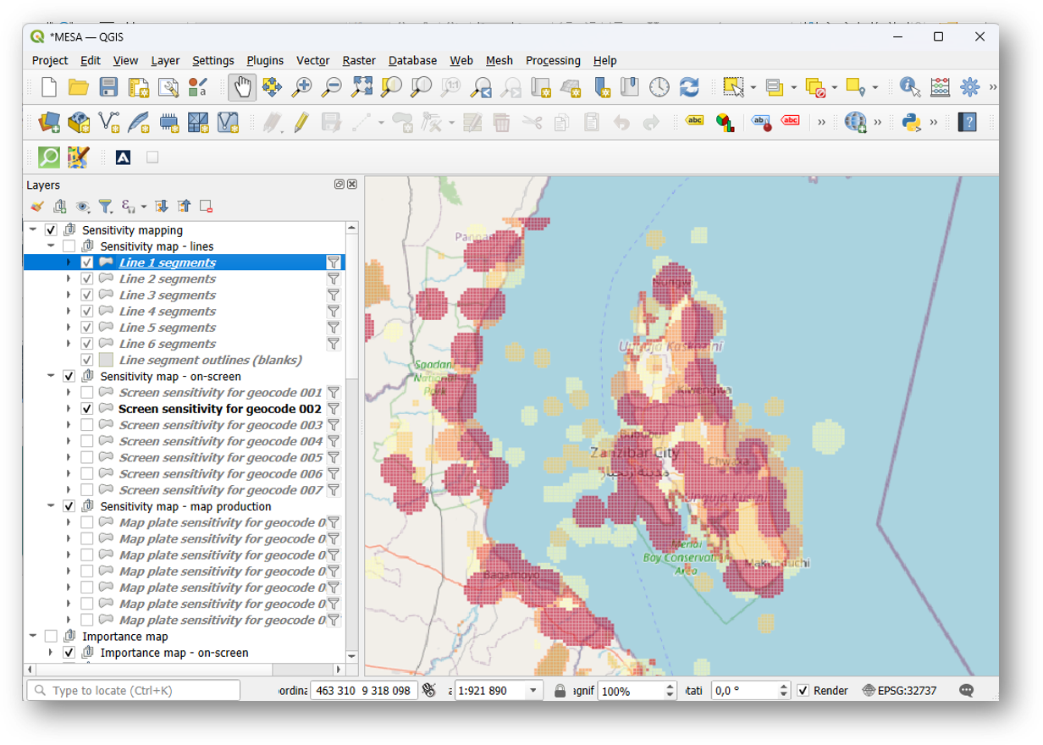
Default QGIS project view.

8.2 Segments
The Segments group visualizes results for processed line assets (roads, rivers, coastlines, pipelines, etc.). These layers are backed by GeoParquet tables under output/geoparquet/.
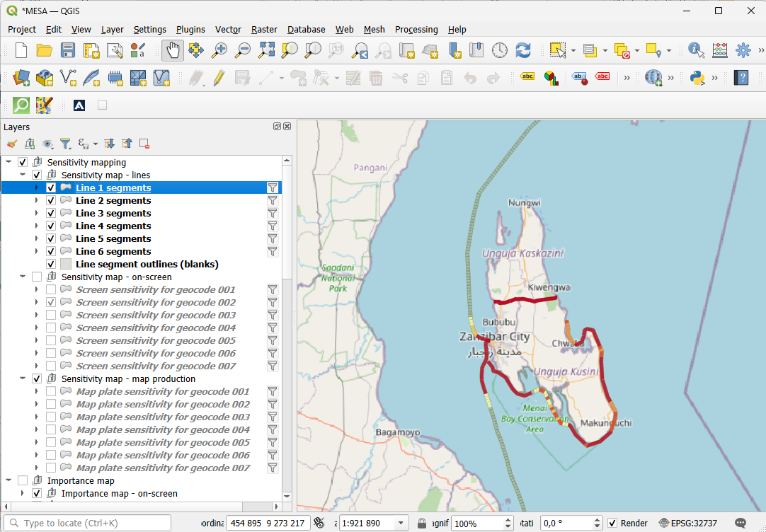
QGIS: segments group.

8.3 Importance
The Importance layers show the calculated importance index and/or categorical outputs. They are typically driven by tbl_flat.parquet (polygons) and related tables.
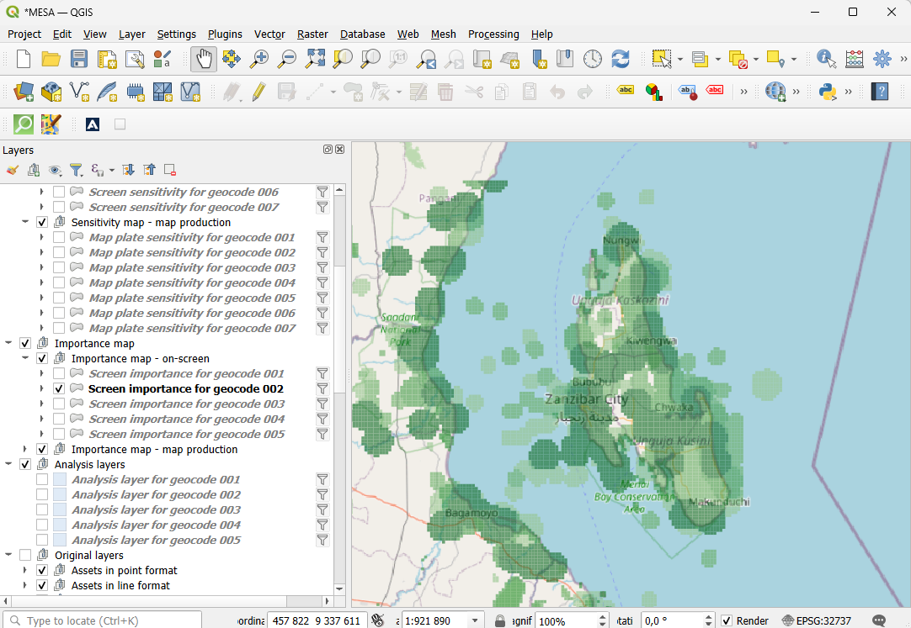
QGIS: importance overlay.

8.4 Assets
The Assets group shows imported assets (often with multiple geometry types) loaded from the GeoParquet store. Use these layers to QA imports and to understand which datasets contribute to hotspots.
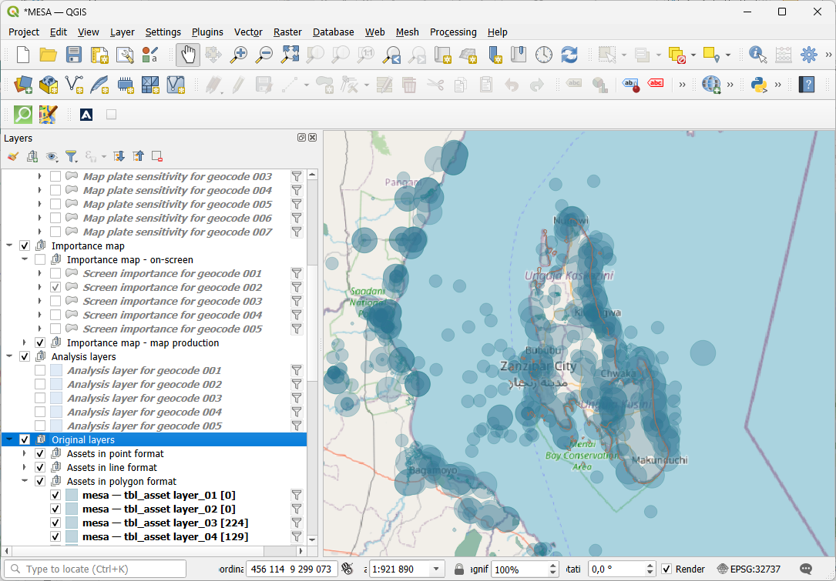
QGIS: assets group.

9. Definitions

9.1 Sensitivity mapping
Sensitivity mapping is a structured, anticipatory method for integrating environmental, social, and cultural considerations into spatial decision-making. It identifies assets that society values, habitats, species, ecosystem functions, cultural heritage, livelihoods, and evaluates their sensitivity to specific pressures or interventions. Sensitivity mapping is explicitly designed for early-stage planning and screening: it does not replace detailed impact assessments, but supports strategic choices by making trade-offs visible.

9.2 Geocodes
In MESA, geocodes are polygon layers used as the common reference units for aggregating results (indices, counts, summaries). The built-in geocode basic_mosaic is a non-overlapping polygon mosaic produced from the combined footprint of all imported asset objects. Other geocodes you can use include Quarter Degree Grid Cells (QDGC), administrative boundaries, H3 hexagons, and any custom polygon set intended as a set of analysis zones (ideally non-overlapping).

9.3 Lines
Lines in MESA are used to analyze sensitivity along linear features (rivers, roads, coastlines, power lines, pipelines, etc.). To represent their footprint or risk area, MESA buffers the input lines before analysis. Buffer width is configurable in config.ini. Lines can also be split into segments so results vary along the feature; MESA stores per-segment metrics in output/geoparquet/tbl_segment_flat.parquet.
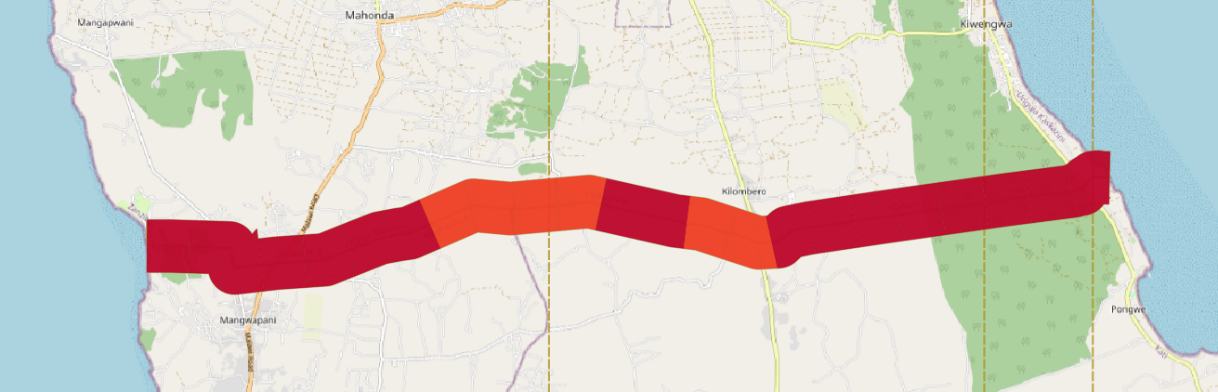
Line segments: sensitivity along linear features.

9.4 Atlas
The QGIS atlas functionality automates the creation of map series based on a given layout and data, ideal for presenting comprehensive spatial analyses. By integrating the QGIS atlas with MESA, users can efficiently produce a series of maps that align with the MESA method, facilitating better visualization and decision-making in conservation planning and resource management. ESRI's ArcGIS Pro offers comparable functionality through its Map Series tool.

9.5 Other definitions
- Environmental Sensitivity Atlas: a collection of maps and supporting narrative text presenting spatial data on the sensitivity of ecological and/or socio-economic assets to a specific pressure.
- Environmental Sensitivity: combination of susceptibility and importance of an affected asset that signifies the potential impact of a given pressure.
- Pressure (stressor): the source of potential impact from an activity (habitat loss, disturbance, pollution, altered water levels, ...).
- Ecological Asset: naturally occurring entities that provide ecological functions or services, including those without monetary value.
- Socio-Economic Asset: natural or anthropogenic entities providing social, cultural, economic or political value.
- Importance: an asset's value at global, national, or local scale in relation to rarity, significance, functional and intrinsic value.
- Susceptibility: the degree to which an asset will be affected by a pressure, based on severity of impact and recovery ability.
- Sensitivity: overall rating of consequences of allowing an impact to occur. Combines importance and susceptibility for a given pressure.

10. Advanced

10.1 Workspace location overrides (MESA_BASE_DIR)
By default, MESA assumes the workspace folders (input/, output/, qgis/, config.ini) live next to mesa.py (source) or next to mesa.exe (packaged). If you want to keep the application code in one folder but your data workspace somewhere else, set the MESA_BASE_DIR environment variable to the workspace root before launching. When set, MESA reads config.ini and writes output/ under that folder.

10.2 Iterative workflow: full run first, then re-run only what changed
The processing pipeline is a chain of stages, each reading the previous stage's parquet output from disk and writing its own. That on-disk hand-off is what makes selective re-runs possible: once a stage has finished, you can change parameters that only affect a downstream stage and rerun just that stage without redoing the heavy work upstream.
The intended workflow is therefore:
- First time: run the entire pipeline end-to-end so every stage has a valid output.
- Iterate: change the parameter you want to explore, then in the Process runner switch to Advanced, untick everything except the affected stage and the ones downstream from it, and rerun.
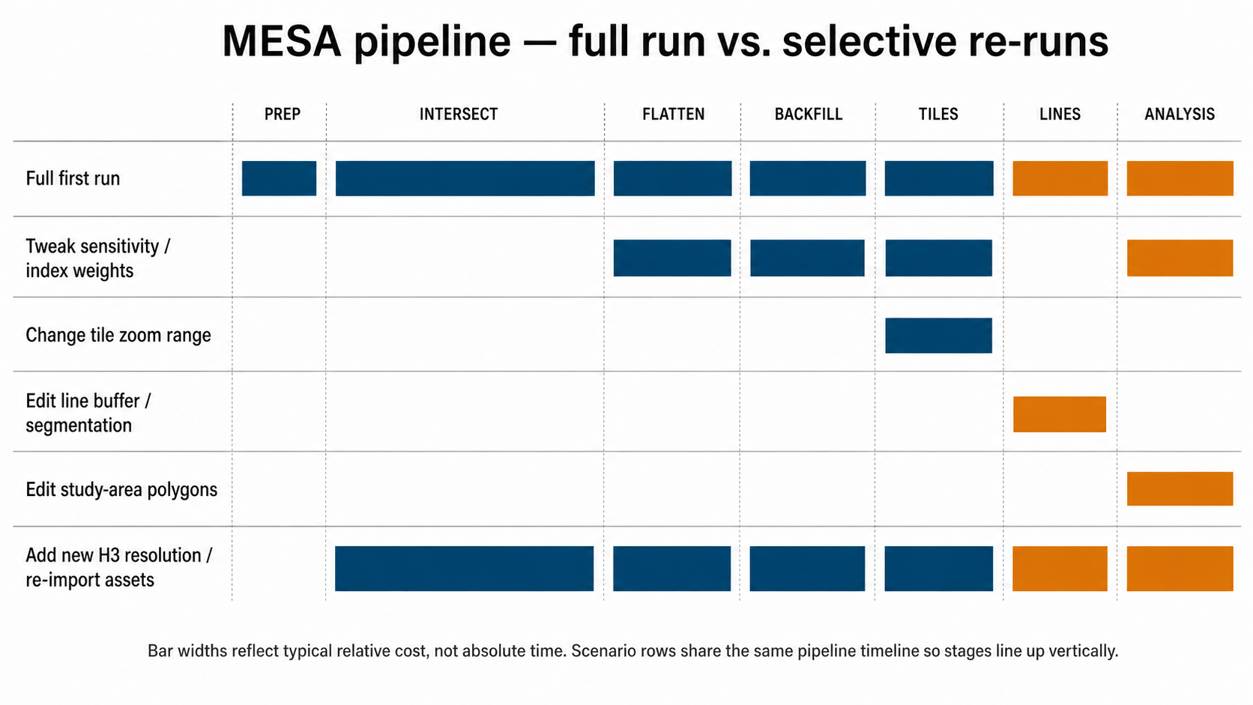
MESA pipeline scenarios: full run vs. selective re-runs. Each row is a scenario; bars show which stages run.

10.2.1 What each stage reads and writes
Stage | Reads | Writes | Re-run cost
Prep | input parquet metadata, asset/geocode counts | workspace status files | seconds
Intersect | tbl_asset_object, tbl_geocode_object | tbl_stacked/ (partitioned dataset) | minutes to hours; the heaviest stage
Flatten | tbl_stacked, sensitivity classification from config.ini | tbl_flat.parquet | seconds to minutes; scales with tbl_stacked size
Tiles | tbl_flat | output/mbtiles/*.mbtiles | minutes; depends on zoom range and bounding box
Lines | line inputs, tbl_flat | tbl_lines_buffered, tbl_segments, tbl_segment_flat | seconds to minutes
Analysis | tbl_flat, tbl_stacked, analysis polygons | tbl_analysis_* outputs and JSON summaries | seconds per study area

A stage's checkbox is greyed out when its required input is missing on disk. That is the safety net: the runner refuses to run Tiles without tbl_flat, refuses to run Flatten without tbl_stacked, and so on.

10.2.2 Cookbook: what changed → which stage to re-run
The first column lists the parameter or input you changed; the second lists the minimum stage set you need to tick in Advanced mode. 'Plus downstream' means anything later in the pipeline that produces an output you still want refreshed (Tiles map, Analysis report, etc.).
If you changed… | Re-run from… | Notes
Importance / susceptibility per asset group (Parameters helper) | Flatten (plus Tiles / Analysis) | Intersect output is unchanged; only tbl_flat recomputes. The cheapest meaningful iteration loop.
Sliver cleanup toggle (flatten_sliver_min_area_m2, the runner checkbox) | Flatten (plus Tiles / Analysis) | Sliver removal is part of flatten.
tiles_minzoom / tiles_maxzoom | Tiles only | tbl_flat is unchanged; only MBTiles regenerate.
Line buffer / segmentation parameters, line geometry edits | Lines only | Line outputs are independent of the geocode pipeline.
Analysis polygons / study-area definitions | Analysis only | Reads existing tbl_flat and tbl_stacked.
cell_size, chunk_size, geocode_soft_limit, asset_soft_limit | Intersect + Flatten (plus downstream) | These shape tbl_stacked itself.
Added a new H3 resolution or a new custom geocode group | Intersect + Flatten (plus downstream) | New geocode IDs appear in tbl_stacked, so flatten and everything after must rerun.
Re-imported assets (Workflows → Prepare data → Assets) | Intersect + Flatten (plus downstream) | New asset rows in tbl_asset_object invalidate the existing intersection.
Re-imported or regenerated geocodes | Intersect + Flatten (plus downstream) | Same reason: tbl_geocode_object changed.
Mosaic tuning (mosaic_coverage_union_batch, mosaic_line_union_max_partials, mosaic_coverage_union) | Re-publish basic_mosaic from Geocodes, then Intersect + Flatten (plus downstream) | These tune the mosaic build. The mosaic is a geocode group, so changes propagate from intersect onwards.
Worker counts (max_workers, flatten_*_workers, tiles_max_workers) | Whatever stage is next | These don't change outputs, only how the next run executes. Override what you need, rerun the affected stage.
report_basemap_mode, report-level layout / styling | Re-run Report engine (Workflows → Results) | Reports read existing parquet/MBTiles. Processing stages do not need to rerun.

10.2.3 Practical tips
- Read the [auto-tune] block at the top of every run log to verify the runner picked the worker counts you expected. If you have just set flatten_max_workers = 4 in config.ini but the log shows flatten_max_workers = 1, auto-tune was constrained by available RAM: close other apps or raise mem_target_frac and rerun.
- The pre-flight at the start of Flatten checks both system-wide RAM use and a dataset-aware peak estimate (see 10.4 Memory safety nets). It will let small datasets through on busy desktops; if it ever blocks you incorrectly, the abort message names the two operator knobs to relax.
- Use Manage data → Create backup before exploratory parameter sweeps. Reverting is one click; figuring out what changed three iterations later is not.
- The Status tab shows row counts for tbl_stacked and tbl_flat. If you tick 'Flatten only' and rerun, watch the tbl_flat row count change; tbl_stacked should stay the same.
- For pure parameter sweeps (importance / susceptibility only), tick just Flatten. Tiles and Analysis can wait until you have settled on a parameter set worth rendering.

10.3 Performance knobs (config.ini)
- chunk_size: processing chunk size for heavy spatial operations.
- max_workers, flatten_max_workers, flatten_small_max_workers, tiles_max_workers: per-stage worker caps. Leave at 0 to let auto_tune decide; set a positive integer to override exactly.
- h3_max_cells: safeguard for extremely fine H3 resolutions.
- tiles_minzoom / tiles_maxzoom: output MBTiles zoom range.
- mem_target_frac / approx_gb_per_worker: memory targeting for the auto-tuner.

10.4 Memory safety nets
- Pre-flight check before flatten: evaluates two signals and aborts only when both fail: system-wide RAM use above flatten_preflight_max_vm_percent AND available RAM below flatten_preflight_avail_safety_factor × estimated peak (estimated from on-disk tbl_stacked size and the auto-tuned worker counts). Pagefile/swap above flatten_preflight_max_swap_gb is still its own hard signal. Small datasets on busy desktops now go through; big datasets on starved hosts still abort cleanly.
- Per-pool panic watchdog (mem_panic_percent / mem_panic_grace_secs): if RAM crosses the threshold past the grace period, the pool is terminated cleanly.
- Process-lifetime sentinel (mem_lifetime_panic_percent / mem_lifetime_panic_grace_secs): last-resort backstop covering parent-side work between pools.

10.5 Mosaic union batching
- mosaic_coverage_union_batch: bigger batches (~2000–4000 on 64+ GB hosts) produce fewer, larger intermediate unions.
- mosaic_line_union_max_partials: higher cap (32–64) means fewer reduction rounds.
- mosaic_coverage_union = false: escape hatch that skips the coverage-reduction stage entirely and falls back to STRtree filtering.

10.6 Basemap and tile caching
- xyz: use the built-in downloader with persistent cache under output/tile_cache/.
- contextily: use contextily if installed.
- auto: prefer contextily, fall back to xyz.
First-run cost: the first report run on a new AOI (or after the cache has expired) must download every basemap tile the report touches from tile.openstreetmap.org. With each map covering several hundred tiles across multiple zoom levels, this can add minutes to tens of minutes to the run depending on report scope, network speed, and OSM tile-server response. Subsequent runs that touch the same area read from output/tile_cache/ and complete much faster. Tiles are cached for 30 days (TILE_CACHE_MAX_AGE_DAYS in code/report_generate.py); older tiles are re-fetched the next time they are needed. The cache is keyed by zoom/x/y, so entries are reusable across atlases and reports that overlap geographically.
- Run the report once on a representative AOI before a workshop or live demo so the cache is warm.
- The cache is portable: copying output/tile_cache/ between machines or projects covering the same area skips the download phase entirely.
- If you regenerate reports frequently and tile-server response is slow, prefer a single wide first run that covers the eventual report extent rather than running narrow then expanding.
- Be respectful of the OpenStreetMap tile-server usage policy (https://operations.osmfoundation.org/policies/tiles/); the local cache is partly there for that reason.

11. Troubleshooting

11.1 What 'slow' is normal
MESA works with large geospatial datasets and uses a Python stack (GeoPandas/Shapely/PyProj/Arrow) that can take time to import and warm up. Startup and the first opening of heavy tools may feel slow (tens of seconds). Once loaded, the UI and map interaction are usually responsive and stable. Prefer an SSD and keep the MESA workspace on a local disk; avoid network drives or highly synced folders such as OneDrive if performance is poor.

11.2 Maps: window does not open / opens blank
MESA's built-in map viewers use pywebview with WebView2 (Edge Chromium). WebView2 is not Google Chrome and does not depend on Chrome. Check Windows Settings → Apps → Installed apps for Microsoft Edge WebView2 Runtime. If missing, run Windows Update fully and reboot, or install the Evergreen WebView2 Runtime (or via 'winget install Microsoft.WebView2Runtime').
If the map opens but shows no layers, the analysis map renders overlays from MBTiles under output/mbtiles/. If that folder is empty, run Workflows → Process with Area enabled and verify .mbtiles files exist.
Offline behaviour (MESA 5.0.2 and later): map windows ship with the Leaflet library bundled locally, so they render even on hosts with no internet access or with corporate proxies that block public CDNs. When the WebView reports the host is offline, a thin orange banner appears at the top of the map with the text 'Offline – showing cached map tiles only. Pan to areas you have viewed online before.' OpenStreetMap basemap tiles continue to be served from MESA's on-disk tile cache (output/cache/osm_tiles), so areas previously viewed online remain available. Areas never visited online will appear as a grey grid until network access returns; the editor controls themselves work either way.

11.3 'Nothing happens' when clicking a map button
In the packaged app, some helper tools are launched in-process and others are started as separate processes from tools/. Open PowerShell in the MESA folder and run the standalone helper directly to see errors: tools\map_overview.exe, tools\asset_map_view.exe, tools\analysis_setup.exe, tools\line_manage.exe, tools\tiles_create_raster.exe.

11.4 Common Windows setup pitfalls
- Running from a protected folder (e.g. C:\Program Files) can prevent MESA from writing output/ and logs. Prefer a user-writable workspace folder.
- Unzipping 'partial' releases: keep the shipped folder structure intact (input/, output/, tools/, system_resources/, qgis/, config.ini).
- On fresh Windows installs, maps may fail until all Windows updates and runtimes (including WebView2) are in place.

11.5 Processing aborts at flatten with PRE-FLIGHT ABORT
The flatten stage refuses to start if the host already looks too memory-pressured to finish safely. As of MESA 5.0.2 the check evaluates two signals together, system-wide RAM use AND a dataset-aware headroom estimate, and aborts only when both fail. The swap-residue check is still a separate hard signal. The log line names the gate that tripped it, for example 'vm.percent 78.4% > 60% AND avail 6.2 GB < 1.25 × est_peak 8.0 GB = 10.0 GB' or 'swap_used 7.3 GB > 5.0 GB'. Close other heavy applications, wait a minute for swap to drain, restart the MESA launcher, and rerun Process. If pre-flight keeps tripping on a host with plenty of free RAM, raise flatten_preflight_avail_safety_factor (default 1.25) or flatten_preflight_max_vm_percent (default 60) in config.ini; the abort message itself names both knobs.

11.6 'Reducing coverage' looks stuck
Basic_mosaic's coverage-reduction stage runs single-threaded GEOS unions. On larger projects this can take hours, and the heartbeat goes silent during a single very-large union call. Confirm the process is alive in Task Manager (CPU at ~85% on a single core means it is grinding, not deadlocked). For long-term improvement, run Tune processing → Evaluate → Commit changes: advised values for mosaic_coverage_union_batch and mosaic_line_union_max_partials scale with the host's RAM tier and dramatically reduce reduction rounds. For an extreme dataset, set mosaic_coverage_union = false in config.ini to skip the coverage-reduction stage entirely.

11.7 Still stuck?
When reporting a problem, include: Windows version (Home/Pro + build); whether you run packaged or from source; whether Microsoft Edge WebView2 Runtime is installed; whether output/mbtiles contains .mbtiles files; the newest lines from log.txt in the MESA folder.

