MESA — Unsupervised Segmentation
Proof of concept: turning per-cell sensitivity into area types and zones
Experimental devtools study · test dataset: basic_mosaic (9,012,542 H3 polygons)

1. Executive summary
MESA already scores every analytical cell for environmental sensitivity, importance and susceptibility. What it does not yet do is answer the two questions an analyst asks next: “what kinds of areas exist here?” and “where are the natural zones?”. This proof of concept shows that those answers can be produced directly from the data MESA already computes (tbl_stacked), with no new inputs, and rendered as decision-ready maps and charts.
Three complementary techniques were prototyped as standalone devtools and run against a real 9-million-polygon H3 layer (“basic_mosaic”): a deterministic overlap-signature typology, attribute-only clustering (KMeans / HDBSCAN), and spatially-contiguous clustering (Agglomerative ward with Queen adjacency). The study produced GeoPackage layers with ready-made QGIS styling, summary CSVs, and the three visualisations documented below. The work is read-only on the pipeline outputs and was engineered to survive the memory pressure that large MESA datasets create.
Headline finding: the segmentation is both meaningful and explainable. The deterministic signatures reduced 9M polygons to 31 interpretable classes; the spatial clustering recovered 6 coherent zones whose defining features (fish-breeding sites, Ramsar wetlands, World Heritage natural sites, species-richness bands) match real environmental structure rather than noise.

2. The gap this fills in MESA
MESA’s outputs today are per-cell index values. They are excellent for a graduated “heat-map”, but they leave higher-order interpretation to the eye:
- An analyst cannot point at the map and name a small number of area “types”.
- There is no object that says “this contiguous region is the moderate-high vulnerability zone” — something a report or a stakeholder briefing needs.
- Rare but strategically critical combinations (e.g. a cell overlapping every sensitivity category at once) are invisible in a single graduated ramp.
Segmentation closes that gap. It is the standard analytical step after scoring: collapse many scored units into a few interpretable groups so they can be named, counted, compared and reported.

3. How it works — the process
The pipeline is identical for all three techniques up to the clustering step:

3.1 Inputs (read-only)
- tbl_geocode_object — the polygons of one geocode layer (e.g. an H3 resolution).
- tbl_stacked — the stacked geocode×asset rows, read partition-by-partition with a pyarrow filter so the full table is never materialised.
- tbl_asset_group — asset-group metadata, used only to give features readable labels.

3.2 Per-polygon signature (feature vector)
Each polygon’s stacked rows are collapsed into one fixed-length vector:
- Intensity: sens_sum, sens_mean, sens_max, sens_std, stack_depth
- Composition by asset group: one column per asset group (sum of sensitivity contributed), with human-readable labels.
- Composition by MESA category: count and summed sensitivity of overlapping assets per code A–E (cat_count_A..E, cat_sens_A..E).
All features are standardised (StandardScaler) so a z-score of 0 means the polygon matches the global average on that feature. Polygons with no overlapping assets become zero vectors and are flagged “unassigned”.

3.3 Three techniques, three questions
Technique | Question it answers | Output character
Overlap signatures  (deterministic) | “What is in this polygon?” | Up to 31 explainable classes (the set of A–E codes present). No tuning, fully reproducible.
Attribute clustering  (KMeans / HDBSCAN) | “What kinds of areas exist, regardless of where?” | Types appear as scattered patches wherever the signature recurs. HDBSCAN also isolates rare niches.
Spatial + attribute  (Agglomerative ward + Queen) | “Where are the natural zones?” | Contiguous regions you can point at and name. The main ‘deliverable’ map.

3.4 Outputs & engineering
- segmentation_results.gpkg — one layer per (method, k) and per signature set, each carrying a default QGIS QML style so the map is correctly coloured on first open.
- CSV summaries — cluster_profiles.csv (size, mean sensitivity, top asset groups, area) and cluster_determinants.csv (the z-scored features that define each cluster).
- Dissolve step — an optional pass merges same-class polygons into one multipolygon, shrinking a 9M-feature layer to a handful and making QGIS rendering instant.
- Memory safety — a background watchdog tracks RAM+swap pressure and a per-call joblib budget caps parallel fan-out, after an early run drove the host into 45 GB of swap. This mirrors the same discipline the main pipeline learned.

4. The visualisations explained
Three figures carry the story. The first two describe the deterministic signature typology; the third profiles the spatial clusters. All use the MESA sensitivity ramp (A = very high → deep red, E = very low → deep blue).

4.1 Overlap-signature frequency (stacked bar)
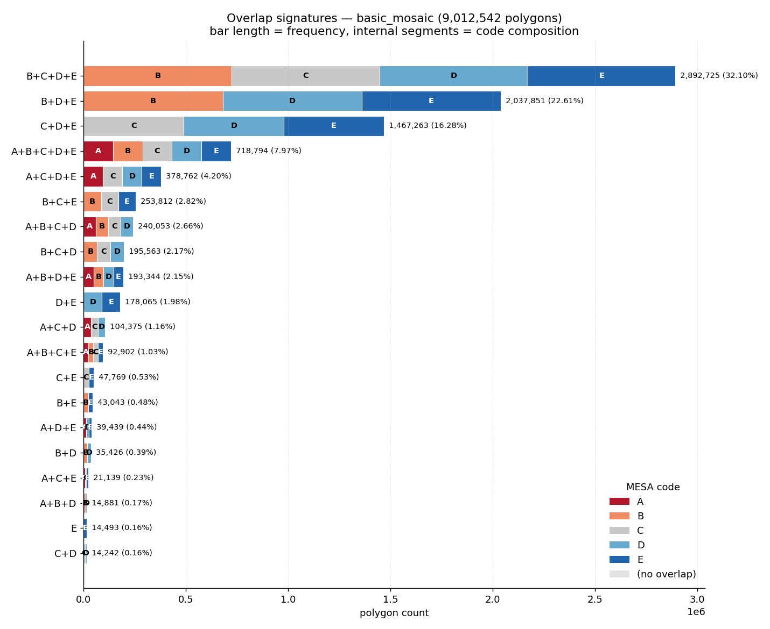
Figure 1 — Overlap signatures ranked by frequency. Bar length = number of polygons carrying that signature; the coloured segments inside each bar show which sensitivity codes are present in the signature.
How to read it:
- Each row is one signature — the set of sensitivity codes a polygon overlaps (e.g. B+C+D+E means it touches B-, C-, D- and E-coded assets).
- Bar length is how common that combination is across the layer.
- The internal colour blocks are the codes in the signature, in A–E order.
What it reveals: the layer is dominated by a few ‘broad mix’ signatures — B+C+D+E (32%), B+D+E (23%) and C+D+E (16%) together cover ~71% of all polygons. Pure single-code areas are vanishingly rare (only 72 polygons are pure-A). The full A+B+C+D+E ‘everything overlaps’ class is the 4th most common at ~8% — a large, strategically important set that a graduated heat-map would never surface on its own.

4.2 Marimekko / mosaic view
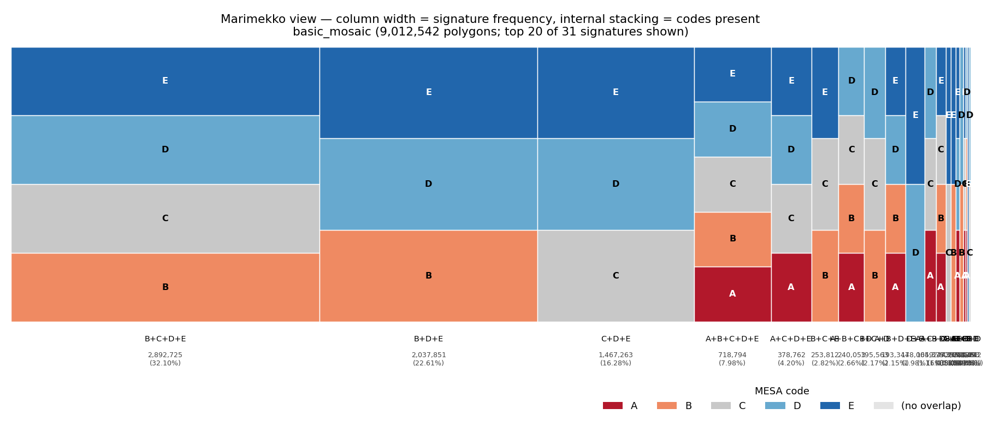
Figure 2 — The same signatures as a Marimekko mosaic. Column width is proportional to how many polygons carry the signature; the stacked blocks show the codes present.
How to read it:
- Width encodes frequency — the three wide columns on the left are the dominant signatures; the thin slivers on the right are the rare ones.
- Height within a column is split evenly across the codes present, so you read composition vertically and prevalence horizontally in one glance.
Why it complements Figure 1: the mosaic makes the ‘long tail’ visible — 31 signatures exist, but a handful own the canvas. It is the single best one-slide answer to “what is this study area made of?”

4.3 Sensitivity-code mix per spatial cluster
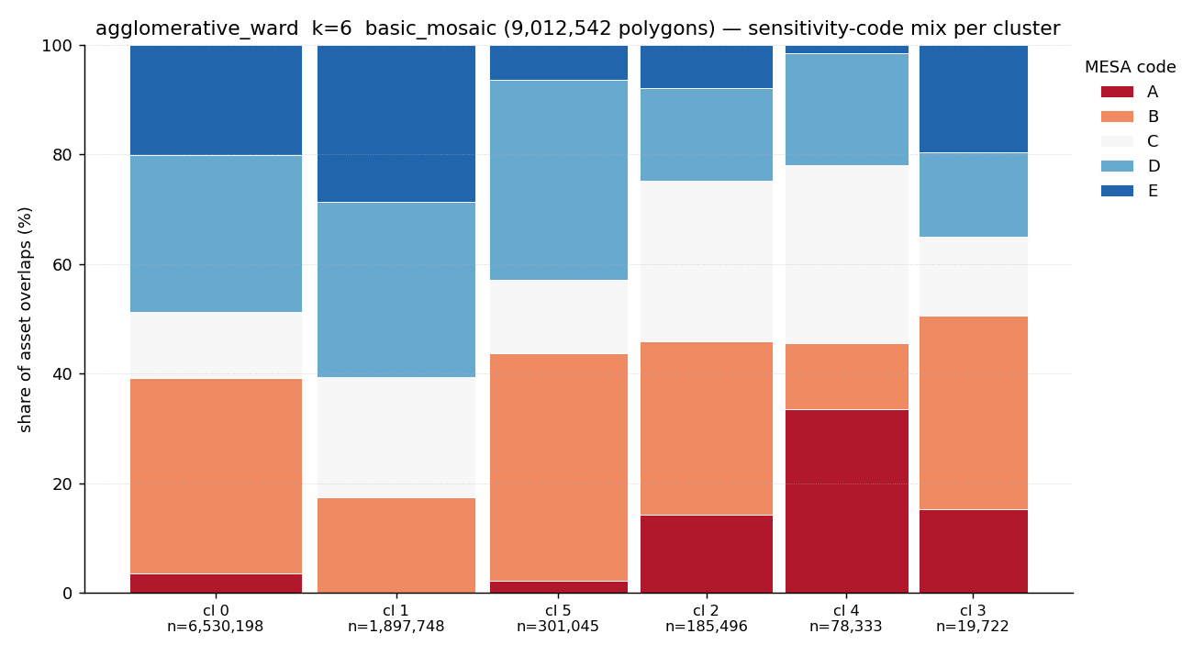
Figure 3 — For the 6 spatially-contiguous clusters (Agglomerative ward, k=6), the share of asset overlaps falling in each sensitivity code. Cluster size (polygon count) is annotated on the x-axis.
How to read it:
- Each bar is one spatial zone; the stack shows what fraction of its asset overlaps are A, B, C, D or E.
- Cluster 0 is the ‘background’ zone (6.5M polygons, mostly D/E — low sensitivity). Clusters 2, 3 and 4 are small but A/B-rich — the hotspots.
What it reveals: the spatial clustering separates a vast low-sensitivity matrix from a few compact, high-sensitivity zones. That is exactly the structure a response plan needs: most of the map is background, and a nameable minority drives the priority.

4.4 What defines each spatial zone (determinants)
The determinants table turns each cluster into a sentence. For every zone it lists the features furthest from the global average (z-score). This is what makes the clustering explainable rather than a black box:
Zone | Size | What defines it (top z-scored features)
0 | 6,530,198 | Background matrix — near global average; slightly low ‘very poor land condition’.
1 | 1,897,748 | +Very poor land condition (z=+0.76), low overall sensitivity — degraded land.
5 | 301,045 | +Species richness 11–15, +woodland — moderate biodiversity belt.
2 | 185,496 | +Species richness 16–20 (z=+4.9), +Ramsar sites (z=+4.2) — wetland/biodiversity.
4 | 78,333 | +World Heritage natural (z=+9.7), +species richness 21–25, +Ramsar — protected core.
3 | 19,722 | +Fish breeding sites (z=+20.3), +Ramsar, +surface water — rare aquatic hotspot.
A z-score above ~5 means the cluster is essentially defined by that one feature. Zone 3’s fish-breeding-sites z of +20 is the clearest possible signal that the algorithm found a real, rare environmental niche — not an artefact.

5. Why this is a good addition to MESA

5.1 It uses data MESA already produces
Everything is derived from tbl_stacked, tbl_geocode_object and tbl_asset_group — the canonical GeoParquet store. No new inputs, no new asset processing. The marginal cost is one read-and-aggregate pass per layer.

5.2 It is explainable, not a black box
The deterministic signature mode needs no tuning and is fully reproducible — a polygon’s class is simply the set of codes it overlaps. Even the algorithmic clusters come with a determinants table that names why each zone exists. This matters for a tool whose outputs feed environmental and regulatory decisions.

5.3 It produces decision-ready objects
- Named zones for briefings and reports (“Zone 3 is the fish-breeding hotspot”).
- A typology for prioritisation — count and rank areas by class.
- Rare-combination detection (A+B+C+D+E cells, single high-sensitivity niches) that a graduated ramp hides.
- A QA lens on asset coverage — unexpected signatures often reveal data gaps.

5.4 It fits the existing report and QGIS workflow
The GeoPackage layers ship with QML styles, so they drop straight into the QGIS project MESA already generates. The per-zone profiles (size, mean sensitivity, top asset groups, area) are exactly the rows a Word-report ‘zone summary’ table would contain.

5.5 It scales
Partitioned reads keep memory bounded; the dissolve step makes even a 9M-polygon result render instantly. The prototype already ran end-to-end on a 9-million-polygon layer.

6. Limitations & open questions
- Choice of k is still manual for the clustering paths; the deterministic signatures avoid this entirely and may be the better first integration target.
- Spatial clustering trades attribute fit for contiguity — silhouette scores are lower than attribute-only by design; that is expected, not a defect.
- Each run segments a single geocode layer. Cross-layer / multi-resolution segmentation is out of scope for the prototype.
- SKATER is rigorous but too slow above ~10k polygons; Agglomerative-ward is the practical default and was used for the figures here.
- The KMeans contiguity-repair fallback (used only when libpysal is absent) does not guarantee globally contiguous clusters.

7. Appendix — reproduce it

7.1 Devtools scripts
- devtools/test_segmentation.py — feature build + attribute & spatial clustering + gpkg/CSV/PNG outputs.
- devtools/signature_analysis.py — deterministic A–E overlap-signature typology + charts.
- devtools/dissolve_clusters.py — collapse same-class polygons for fast rendering.

7.2 Example invocation
python devtools/signature_analysis.py \
--working_dir <project> --geocode_layer H3_R5
python devtools/test_segmentation.py \
--working_dir <project> --geocode_layer H3_R5 \
--methods both --spatial_method agglomerative --dissolve

7.3 Cluster profiles (test dataset)
cluster | polygons | mean sens | top asset groups
0 | 6,530,198 | 11.55 | layer_013, layer_025, layer_001
1 | 1,897,748 | 9.73 | layer_013, layer_002, layer_032
2 | 185,496 | 14.80 | layer_013, layer_001, layer_023
3 | 19,722 | 14.06 | layer_013, layer_011, layer_023
4 | 78,333 | 17.06 | layer_001, layer_008, layer_023
5 | 301,045 | 12.50 | layer_013, layer_025, layer_015

Generated by devtools/build_segmentation_doc.py from output/segmentation_test/. Figures and tables refresh automatically when the segmentation devtools are re-run.

