Brief description of the test
Create an interactive picture gallery using prepared HTML document and some ready-to-use JavaScript components.

Source files and their description
gallery.doc | This document
video/gallery.html | Video demo of completed job
gallery.html | Ready-to-use HTML document*
gallery.js | Empty JavaScript file**
gallery.css | Empty CSS file
pic*.jpg | All needed pictures to be linked from HTML
events2.js | Ready-to-use JavaScript component to attach event handlers to DOM nodes
js-css.js | Ready-to-use JavaScript component that loads js.css only when JavaScript is enabled in browser.
js.css | Empty CSS file that loads only when JavaScript is enabled in browser.
* You can only include JavaScripts and CSS files. Don’t touch anything else in the HTML document.
** gallery.js already contains one useful function: getElementsByClass

Design of gallery
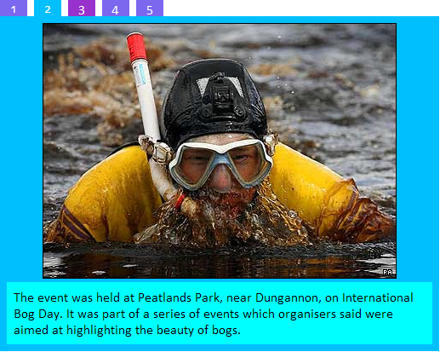
You can see design in action in this video (video/gallery.html)

Description of the test
Create an interactive picture gallery using prepared HTML document and some ready-to-use JavaScript components (you can use any JavaScript library or framework you like). The gallery should also be usable without JavaScript.
Some gallery items may have unique id, some may not (you can see in HTML source that some DL elements have ids).
Default elements in gallery should be shown by default after page is loaded and have class named “shown”.
Tabs for each gallery on the page should generate automatically after document is loaded.
Tabs should have tips with text that are grabbed from alt attribute of a picture.
Don’t use tables for creating tabs – use appropriate HTML markup+CSS for that.
HTML and CSS should be valid according to W3C standards.

