Project Report

Raggi Hosni - 144711

Modeling and Simulation

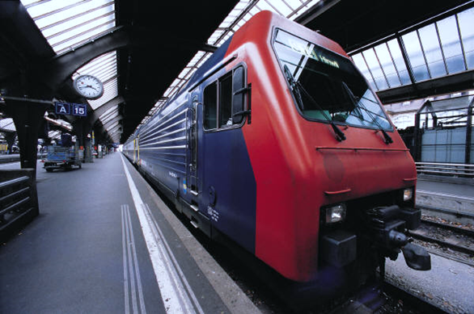

Problem 1

# Problem Formulation

## Environment

The environment in this problem is a Multiple-channel Queue represented in a banking system that serves customers in two queues. The first queue, is the drive-in teller queue which serves customers in their cars, this queue has a maximum capacity of 2 customers. When full, newly arriving customers are served instead in a queue inside the bank (Inside queue) this queue has no maximum capacity. It is also assumed that the servers of both queues have the same performance.

## Objectives

**Estimate the system performance for the following**

* Estimate the average serving times of both queues.
* Estimate the average waiting time of both queues.
* Estimate the maximum queue in the inside queue.
* Estimate how often will a customer go to the inside queue.
* Estimate the idle time of the inside queue server.
* Determine if the Theoretical average of the service time and interarrival times match the practical ones.
* Estimate the average waiting times of both queues if the Drive-in has a maximum capacity of 3.

# Model Conceptualization

## System Components

|  |  |  |
| --- | --- | --- |
| Entity | Attribute | Event |
| Customer | Interarrival time | Arrival, Departure |
| Teller | Time of serving customer | Begin serving customer, End serving customer, |

## System Analysis

**Inter-arrival Time Probability Table**

|  |  |  |  |
| --- | --- | --- | --- |
| Arrival time | Probability | Cumulative | Range |
| 0 | 0.09 | 0.09 | 1-09 |
| 1 | 0.17 | 0.26 | 10-26 |
| 2 | 0.27 | 0.53 | 27-53 |
| 3 | 0.20 | 0.73 | 54-73 |
| 4 | 0.15 | 0.88 | 74-88 |
| 5 | 0.12 | 1 | 89-00 |

Theoretical Average: 2.51  
**Service Time Probability Table**

|  |  |  |  |
| --- | --- | --- | --- |
| Service Time | Probability | Cumulative | Range |
| 1 | 0.2 | 0.20 | 1-20 |
| 2 | 0.4 | 0.60 | 21-60 |
| 3 | 0.28 | 0.88 | 61-88 |
| 4 | 0.12 | 1 | 89-00 |

Theoretical Average: 2.32  
**Calendar Table**(D) = Drive-in queue, (I) = Inside bank queue

|  |  |  |  |  |  |  |  |  |  |  |
| --- | --- | --- | --- | --- | --- | --- | --- | --- | --- | --- |
| Customer | Rand Interarrival Time | Rand Service Time | Interarrival Time | Arrival Time | Service Time | Service Begin | Waiting | Service End | Time spent | Idle Time |
| 1 (D) | 19 | 18 | - | 0 | 1 | 0 | 0 | 1 | 1 | 0 |
| 2 (D) | 88 | 7 | 4 | 4 | 1 | 4 | 0 | 5 | 1 | 3 |
| 3 (D) | 64 | 63 | 3 | 7 | 3 | 7 | 0 | 10 | 3 | 2 |
| 4 (D) | 34 | 25 | 2 | 9 | 2 | 10 | 1 | 12 | 3 | 0 |
| 5 (I) | 13 | 80 | 1 | 10 | 3 | 10 | 0 | 13 | 3 | 10 |
| 6 (I) | 5 | 92 | 0 | 10 | 4 | 13 | 1 | 17 | 7 | 0 |
| 7 (D) | 44 | 27 | 2 | 12 | 2 | 12 | 0 | 14 | 2 | 0 |
| 8 (D) | 77 | 16 | 4 | 16 | 1 | 16 | 0 | 17 | 1 | 2 |
| 9 (D) | 40 | 4 | 2 | 18 | 1 | 18 | 0 | 19 | 1 | 1 |
| 10 (D) | 74 | 12 | 4 | 22 | 1 | 22 | 0 | 23 | 1 | 3 |

# Experimental Design

## Parameters

The simulation is done with 30 Trials with 100 Customers.

## Justification

Due to some statistical studies (1,2), at 30 samples we start to see the data approach a normal distribution which is further proven with the Central Limit Theorem (3). Given these reasons it was reasonable to do the simulation with 30 Trials to take benefit of the CLT.

# Result analysis and Conclusion

## Results

|  |  |  |
| --- | --- | --- |
| Criteria | Value | Comment |
| Avg Service Time (ALL) | 2.33 | This result is close to the theoretical average (2.5) |
| Avg Interarrival Time (ALL) | 2.29 | This result is close to the theoretical average (2.5) |
| Avg Service Time Drive-in | 2.34 | This result is close to the theoretical average (2.5) |
| Avg Service Time Inside | 2.30 | This result is close to the theoretical average (2.5) |
| Avg Waiting Time Drive-in | 0.57 | A relatively small waiting time |
| Avg Waiting Time Inside | 0.53 | Relatively small waiting time |
| Maximum Inside Queue Length | 2 | Very low maximum queue length |
| Probability to Go Inside | 0.17 | Very low probability to go inside |
| Portion of Idle Time Inside | 210 | Relatively High portion of idle time inside |
| Avg Waiting Drive-in (Two Cars) | 1.49 | A higher waiting time than the normal queue |
| Avg Waiting Inside (Two Cars) | 0.36 | A lower waiting time than the normal queue |

## Charts

Avg Service Time (ALL)

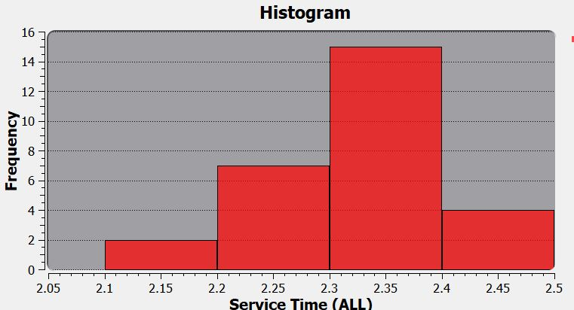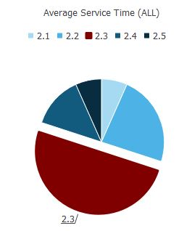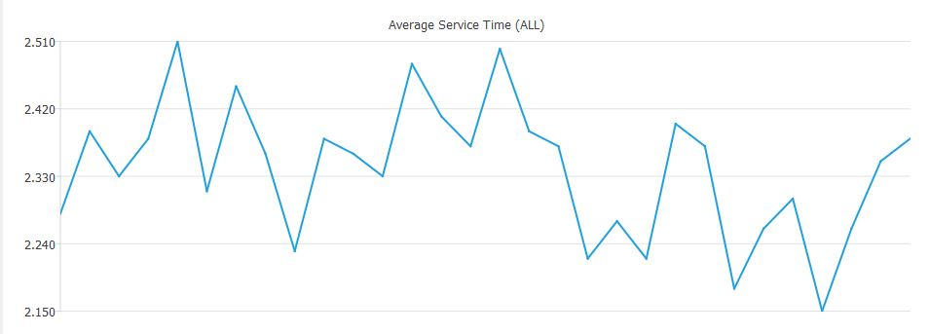 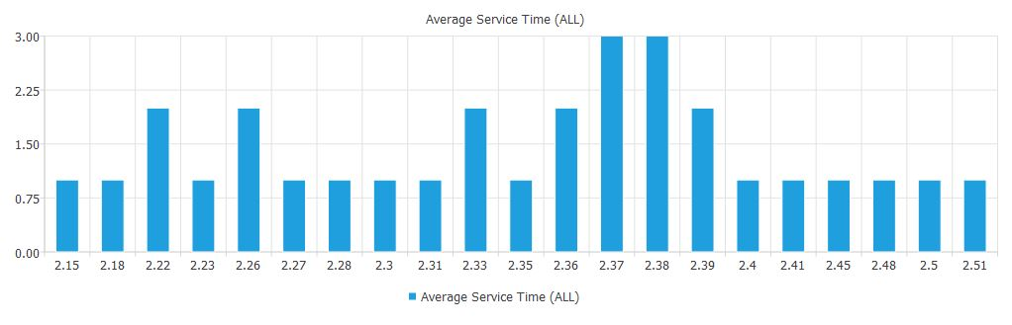

Avg Interarrival Time (ALL)

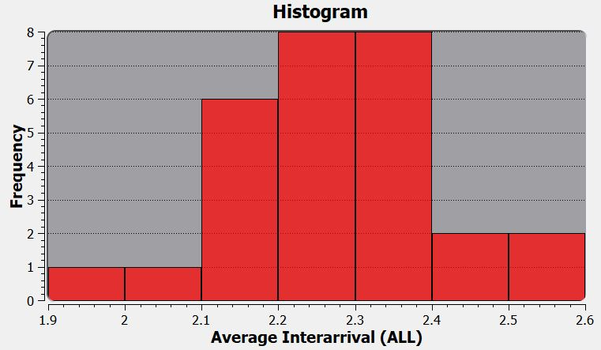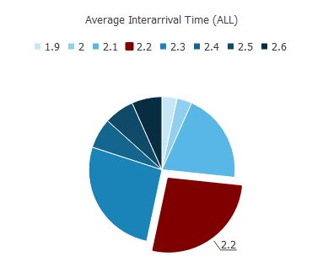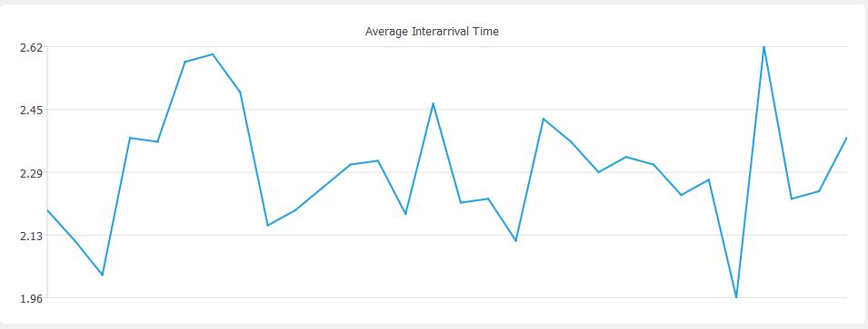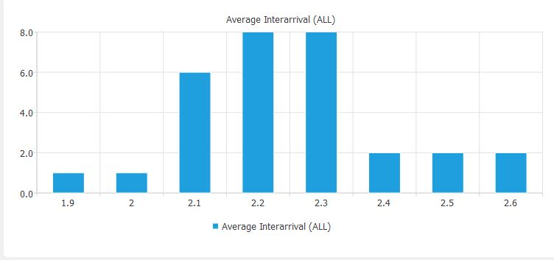

Avg Service Time Drive-in

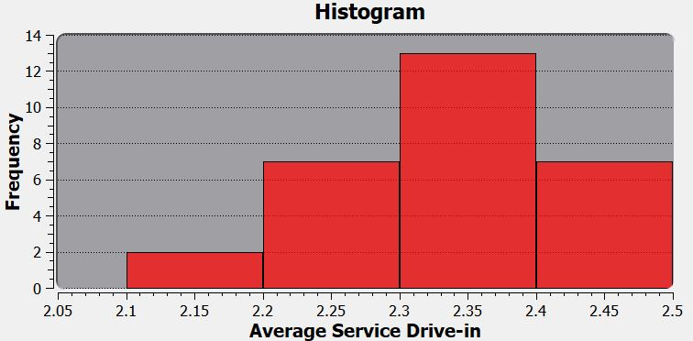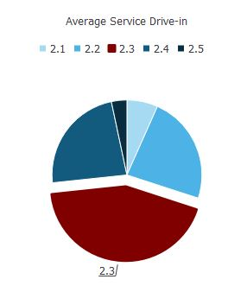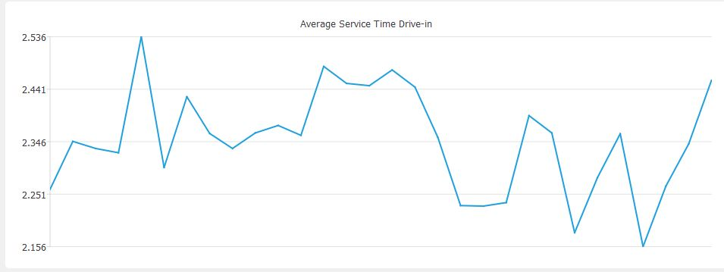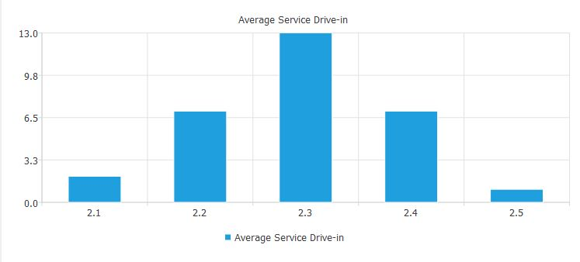

Avg Service Time Inside

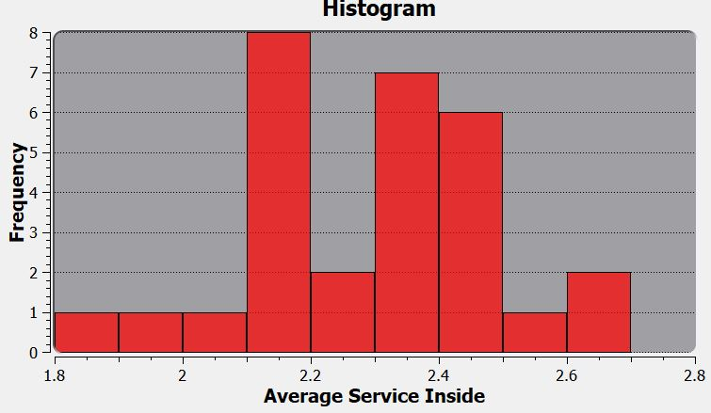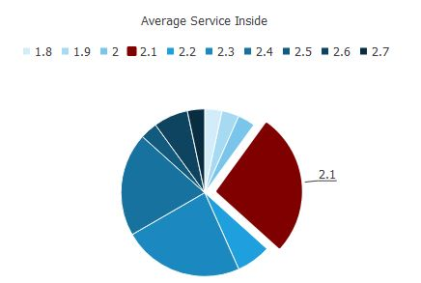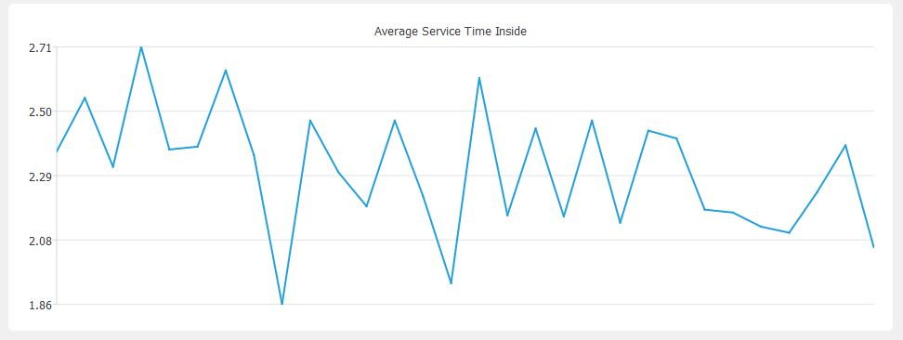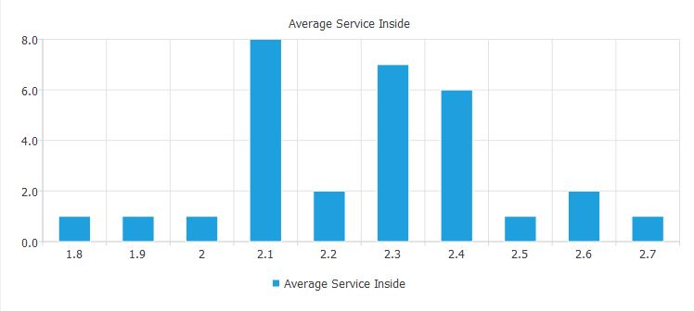

Avg Waiting Time Drive-in

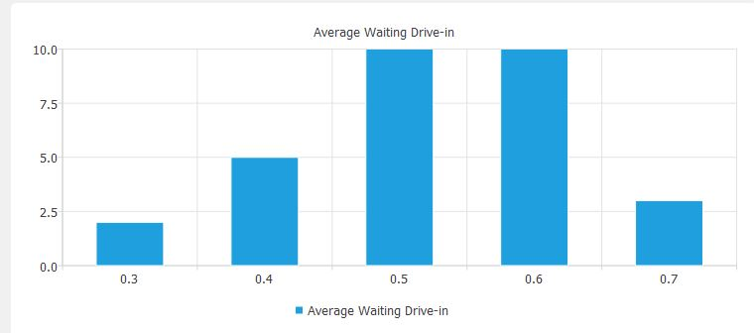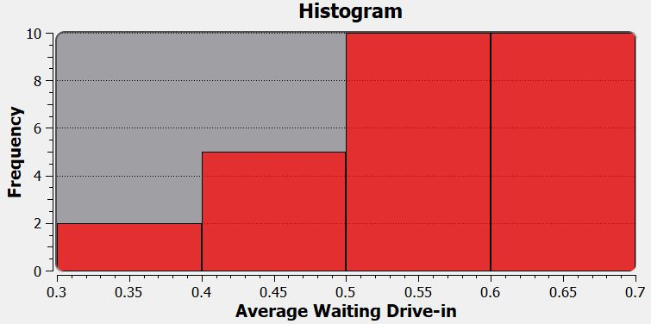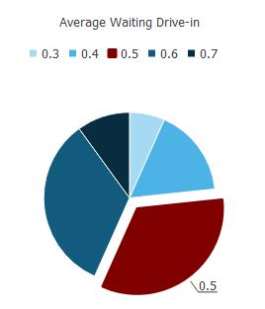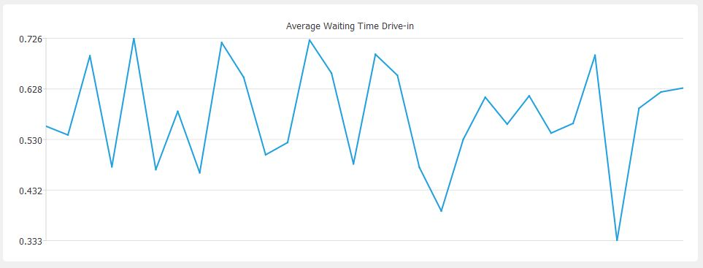

Avg Waiting Time Inside

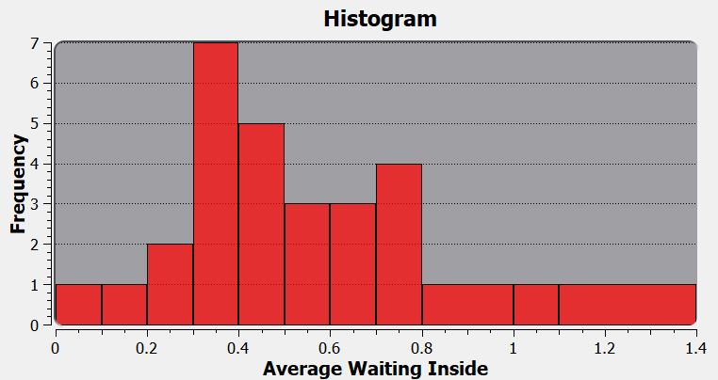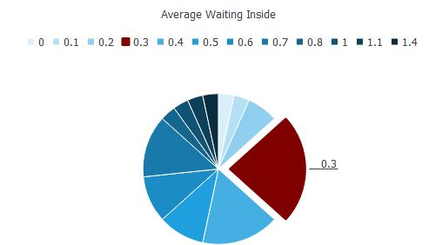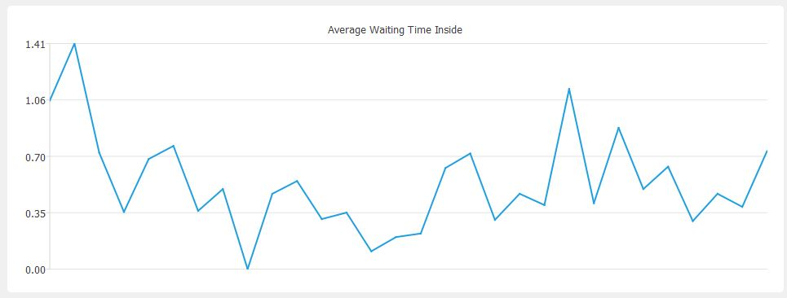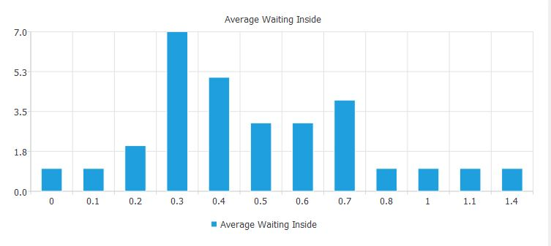

Maximum Inside Queue Length

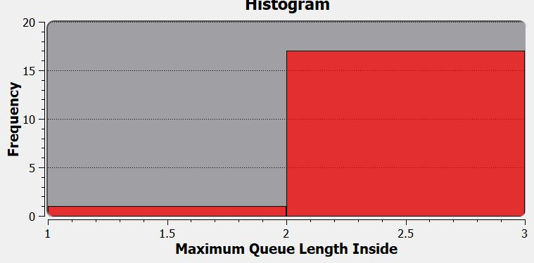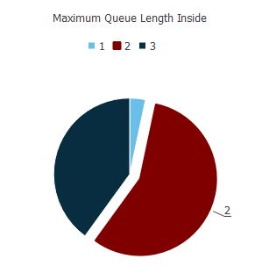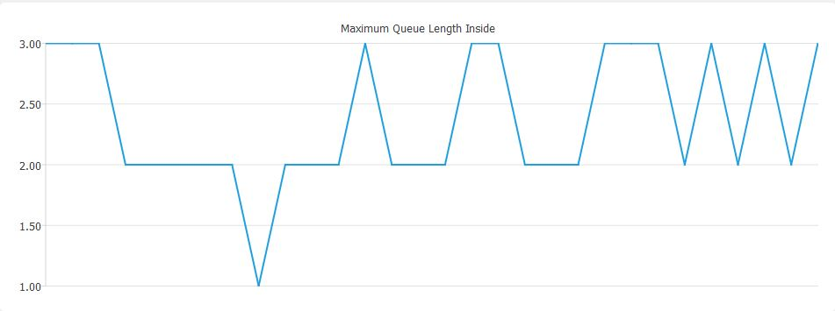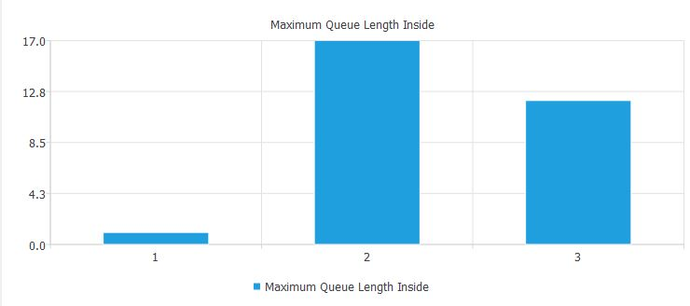

Probability to Go Inside

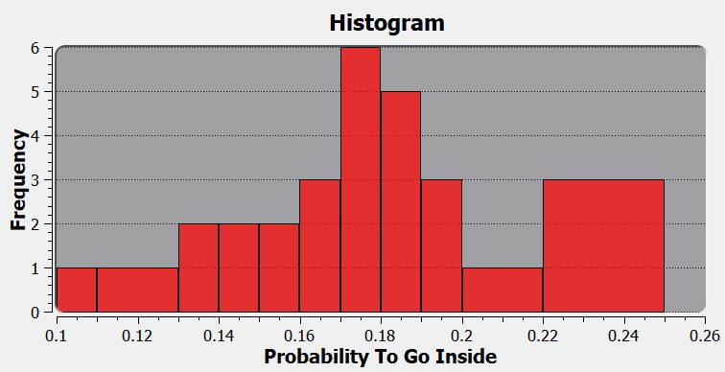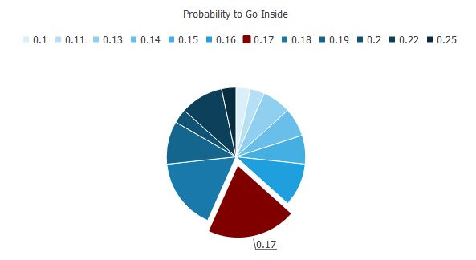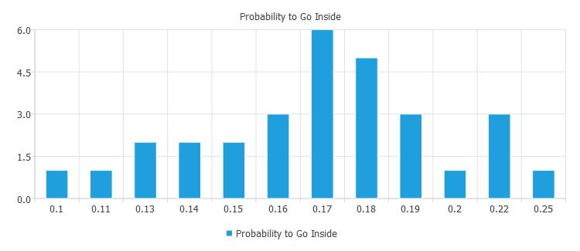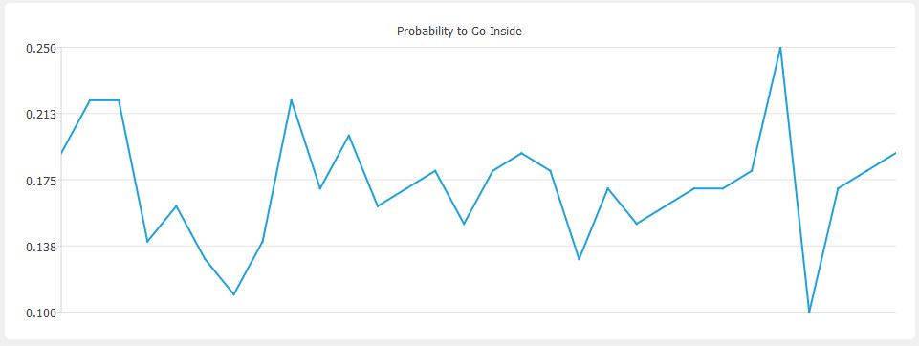

Portion of Idle Time Inside

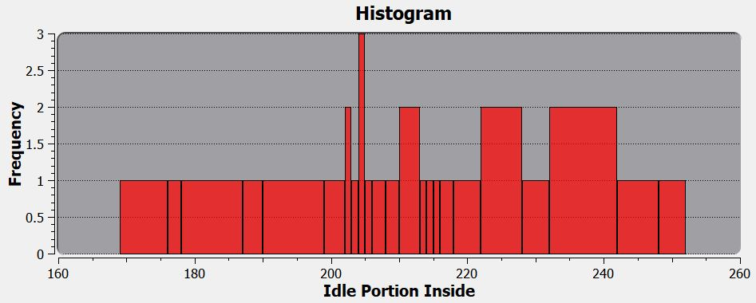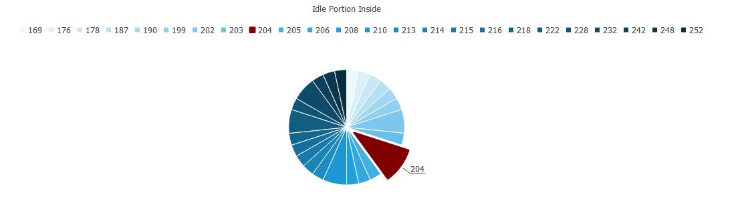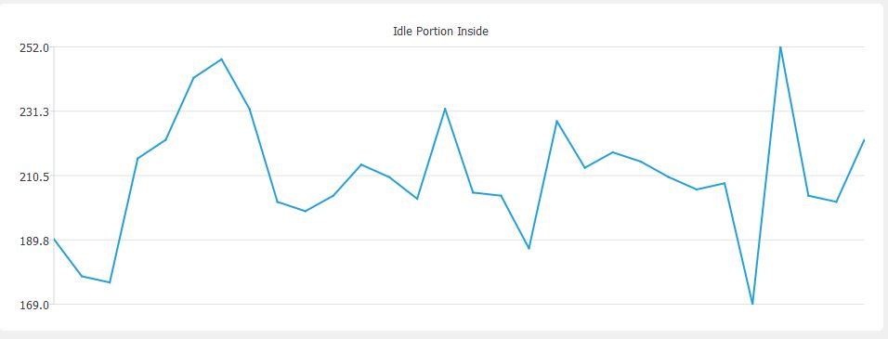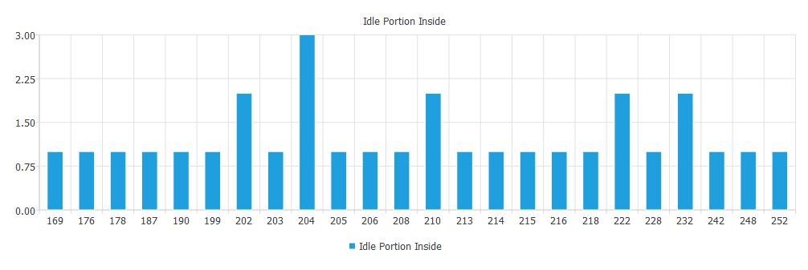

**Conclusions:**

* Close to theoretical service and inter arrival times which coincide with the Central Limit Theorem (3)
* Low Waiting times due to the dual channel nature of the system
* Low maximum Queue Lengths since the customers are divided among two queues
* Low probability to go to the inside queue since the average numbers of the service and interarrival times make it unlikely for two customers to arrive before one of the customers in the drive-in queue finish serving.
* High idle time in the inside queue due to the low probability for customers to go in it.

Problem 2

Problem Formulation

**Environment**

The environment in this problem is a car shop that consists of a showroom and an inventory. A certain random purchase demand is made every business day, cars from the show room are sold from the inventory first, after the inventory runs out, cars start to get sold from the showroom. The showroom’s maximum capacity is 4 cars while that of the inventory is 8 cars.   
Each defined period (review period) of time if the inventory has less than a certain number of cars (minimum threshold), the owner makes an order to restock the showroom and the inventory to their maximum capacity. This order has a random lead time (delay before arrival) to the shop.

**Assumptions**

**-** It is assumed that the review period is 2 days and the minimum inventory threshold to make an order is 4 cars.

- It is assumed the car shop starts with 4 cars in the show room and 2 cars in the inventory. Also, there is an already pending order scheduled to arrive after 2 days with 5 cars.

- It is assumed that orders are made at the end of a business day and are received on the start of a business day. For example, an order made at the end of day 1 with a lead time of 1 will arrive at the start of day 3.   
  
- It is assumed that no orders are placed before receiving already pending orders. For example, if an order is made on day 1 with a lead time of 1, the owner can’t place any other orders before day 3 (since he will receive this pending order on day 3).

- It is assumed that if the demand of the cars is more than the current stock, the day is considered a shortage day. All the cars get sold and the remaining demanded cars are dismissed.

**Objectives**

**Estimate the system performance for the following**

* Estimate the average demand of the customers.
* Estimate the average order lead time.
* Estimate the average ending cars in the show room.
* Estimate the average ending cars in the inventory.
* Estimate the average number of days a shortage occurs.
* Determine if the Theoretical average of the demand and order lead time match the practical ones.
* Determine if there is a better review period than the assumed one (2).
* Determine the optimal combination of period time and minimum threshold.

Model Conceptualization

**System Components**

|  |  |  |
| --- | --- | --- |
| Entity | Attribute | Event |
| Customer | Demand | Purchase a car, |
| Owner | Order Lead Time | Make orders |

**System Analysis**

**Demand Probability Table**

|  |  |  |  |
| --- | --- | --- | --- |
| Demand | Probability | Cumulative | Range |
| 0 | 0.05 | 0.05 | 1-5 |
| 1 | 0.28 | 0.33 | 6-33 |
| 2 | 0.37 | 0.70 | 34-70 |
| 3 | 0.20 | 0.90 | 71-90 |
| 4 | 0.10 | 1 | 91-00 |

Theoretical Average: 2  
**Order Lead Time Probability Table**

|  |  |  |  |
| --- | --- | --- | --- |
| Service Time | Probability | Cumulative | Range |
| 1 | 0.55 | 0.55 | 1-20 |
| 2 | 0.35 | 0.90 | 56-90 |
| 3 | 0.10 | 1 | 91-00 |

Theoretical Average: 1.55

**Calendar Table**

|  |  |  |  |  |  |  |  |
| --- | --- | --- | --- | --- | --- | --- | --- |
| Day | Demand | Lead Time | Start Showroom | Start Inventory | End Showroom | End Inventory | Shortage |
| 1 | 1 | 0 | 4 | 2 | 4 | 1 | No |
| 2 | 2 | 0 | 4 | 1 | 3 | 0 | No |
| 3 | 1 | 0 | 4 | 4 | 4 | 3 | No |
| 4 | 1 | 1 | 4 | 3 | 4 | 2 | No |
| 5 | 1 | 0 | 4 | 2 | 4 | 1 | No |
| 6 | 1 | 0 | 4 | 7 | 4 | 6 | No |
| 7 | 2 | 0 | 4 | 6 | 4 | 4 | No |
| 8 | 3 | 2 | 4 | 4 | 4 | 1 | No |
| 9 | 2 | 0 | 4 | 1 | 3 | 0 | No |
| 10 | 3 | 0 | 3 | 0 | 0 | 0 | No |

Experimental Design

**Parameters**

The simulation is done with 30 Trials with 100 Days.

**Justification**

Due to some statistical studies (1,2), at 30 samples we start to see the data approach a normal distribution which is further proven with the Central Limit Theorem (3). Given these reasons it was reasonable to do the simulation with 30 Trials to take benefit of the CLT.

Result analysis and Conclusion

**Results**

|  |  |  |
| --- | --- | --- |
| Criteria | Value | Comment |
| Average Demand | 2 | This result is close to the theoretical average (2) |
| Average Lead Time | 1.5 | This result is close to the theoretical average (1.55) |
| Average Ending Showroom | 3.1 | Relatively high to the maximum capacity which indicated a low shortage. |
| Average Ending Inventory | 1.5 | Relatively low to the maximum capacity, indicates that the inventory is close to be empty most of the days. |
| Shortage Days | 5.3 | A low value indicating that most of the time no shortage conditions are met. |

**Charts**

Average Demand

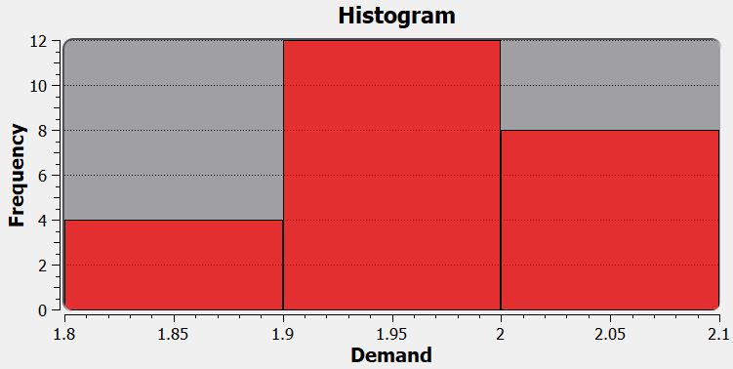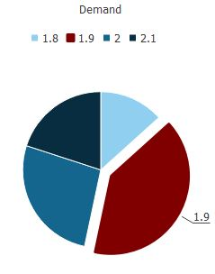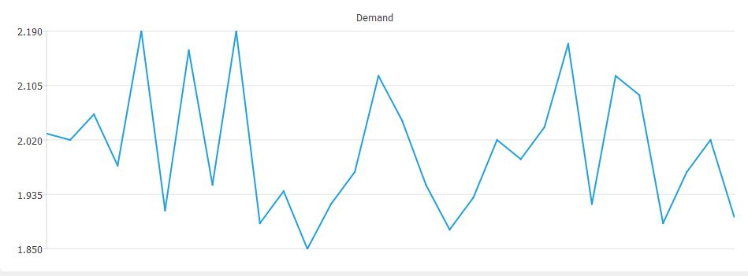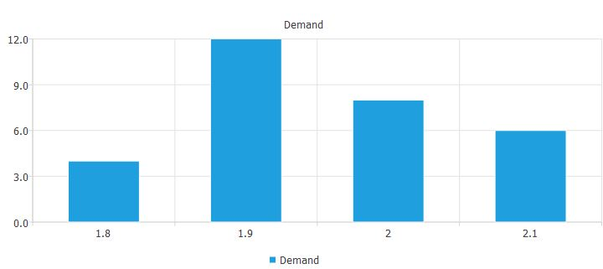

Average Lead Time

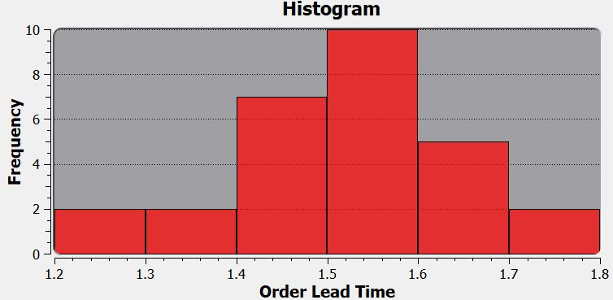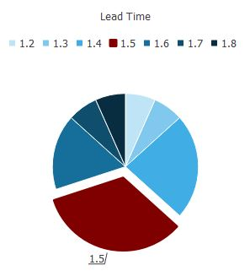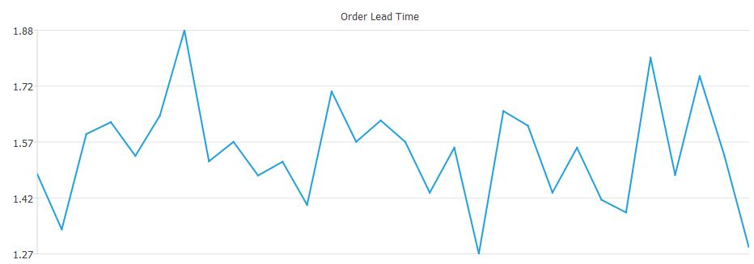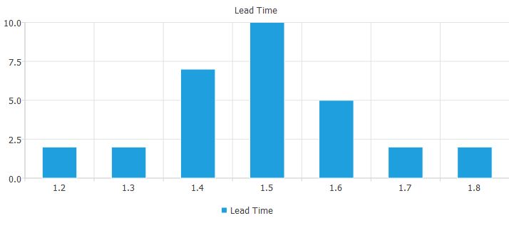

Average Ending Showroom

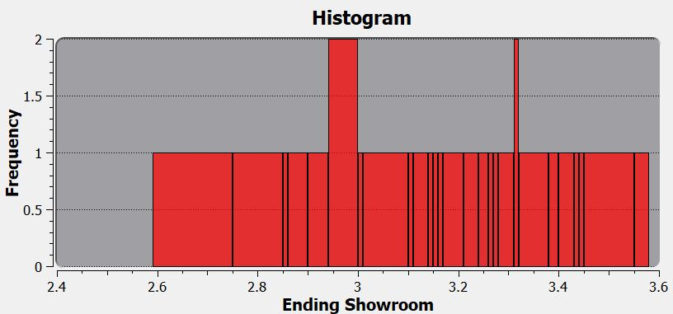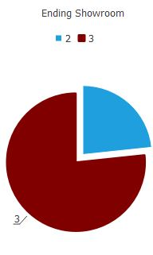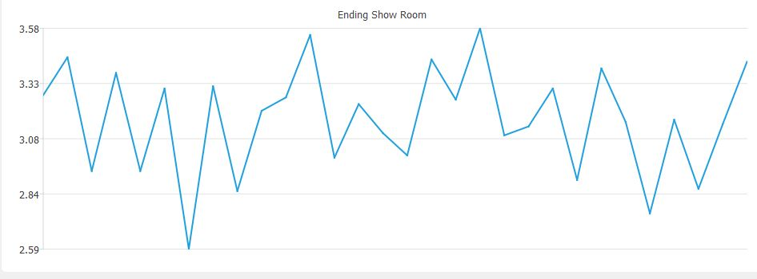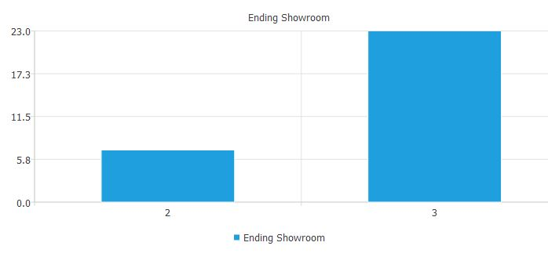

Average Ending Inventory

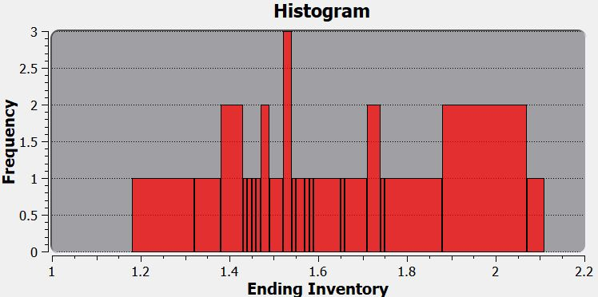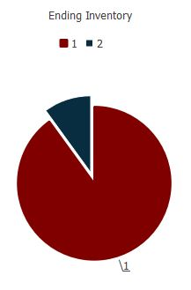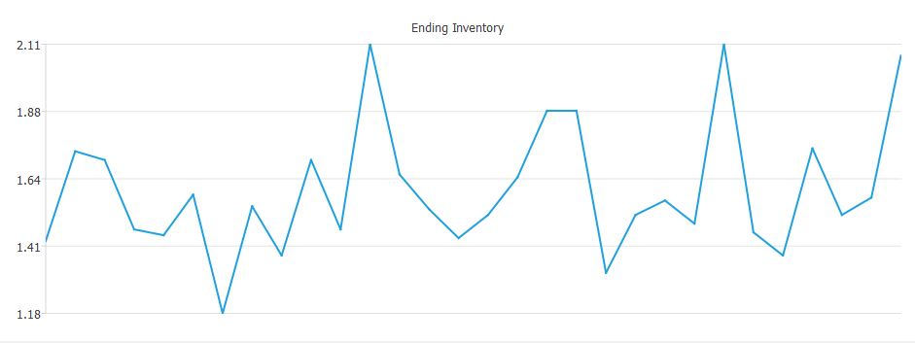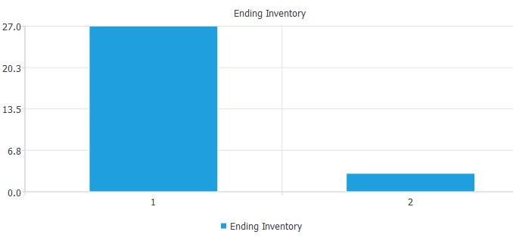

Average Shortage Days

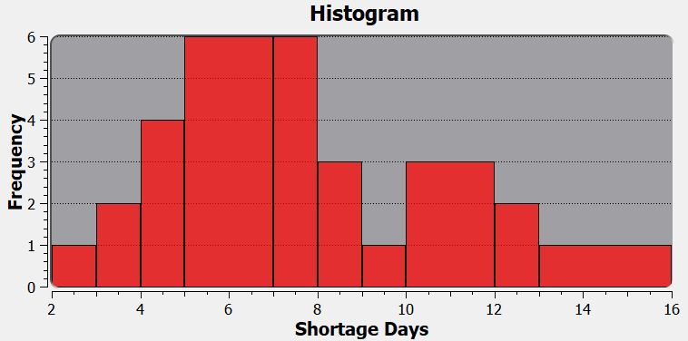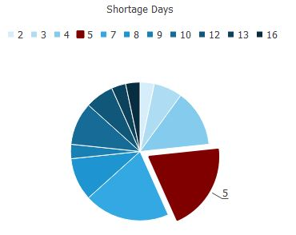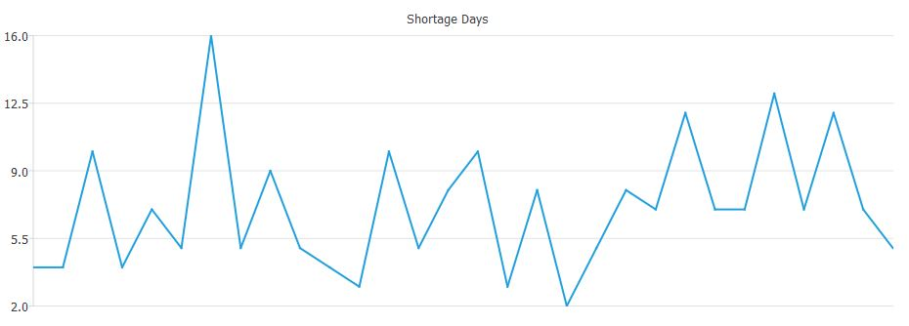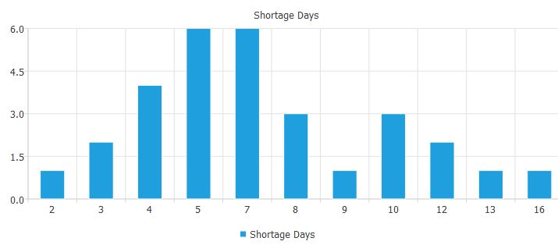

References

1. Westland, J. Christopher (2010). "Lower bounds on sample size in structural equation modeling". Electron. Comm. Res. Appl. 9 (6): 476–487.
2. Yamane, Taro. 1967. Statistics: An Introductory Analysis, 2nd Ed., New York: Harper and Row
3. Peter Brown,2011, Measure Theory and the Central Limit Theorem