SAFETY ORIENTATION COURSE (TUNNELING) FOR WORKERS

(English, Tamil, Malay, Mandarin, Bengali, Thai, Hindi and Burmese)

Course Date: ____________________________________ Batch No: ____________________________________

Company Name: ________________________________________________________________________________

Contact Person: ____________________________________ H/P: ____________________________________

Tel: ________________ Fax: _________________ Email: ______________________________________________

Address: ______________________________________________________________________________________

No. | NRIC/FIN/WP No: | Full Name | Nationality | DOB | Mobile No. | Email ID
1.
2.
3.
4.
5.
6.
7.
8.
9.
10.
Terms and conditions
- Trainees are reminded to be dressed in proper attire. E.g. Long pants, shirts, covered shoes or safety shoes for classes etc. No shorts and slippers are allowed.
- Participants are reminded to be in class on time. Latecomers are STRICTLY NOT ALLOWED into the class.
- Results will not be uploaded to MOM website, if the trainee is registered for the course with the passport number.
- Personal information collected is for the use ONLY for course registration, account servicing of course-related activities, course survey and / or for application of course-related funding (only if applicable)
- Course surveys shall be conducted by SSG for selected courses through the trainees’ emails or contact given
- Registration forms shall be submitted 3 days before the course commencement date
- The company reserves the right to revise the course fee without prior notice, to cancel or postpone the course due to unforeseen circumstances.

Refund and Withdrawal Policy
- Payment is required upon receipt of confirmation.
- A 100% refund will be provided if a written notice of withdrawal is received by EFG at least three (3) working days before the course commencement date.
- No refund will be given if EFG receives the notice of withdrawal within three (3) working days before the course commencement date.
- No refund will be issued if the participant fails to attend the course on the commencement date or discontinues mid-way through the course.
- Participant replacement is allowed, provided that the request is made prior to course commencement.
- If EFG cancels the course within three (3) working days before the course commencement date, the refund or alternative arrangement will be reviewed and decided by Management on a case-by-case basis.
- EFG reserves the right to review and decide on any exceptional cases at Management’s discretion.

I, the Applicant consents to the collection, use and disclosure of my personal data and training records to companies that access the Ministry of Manpower (MOM)’s Training Record System (TRS). Companies using the Check Workers’ WSH Training Records eService on the MOM website may verify my training records, including the following information:
- Identification Number (Work Permit / FIN / NRIC Number) & Name Eligibility for 4 years of Safety Orientation Course (CSOC / SSIC / MSOC certification, if applicable) & Course Title & Name of Training Provider & Date of Assessment & Certificate Expiry Date & Result of Assessment
- I confirm I have received and understood pre-course information and all pages of this document.
By checking the boxes above and signing below, I confirm my consent for the disclosure of the selected information.

___________________ __________________________
For Official Use Only
Verify By:
Signature:
Date :

Name: Signature/Date
For Official Use Only
Verify By:
Signature:
Date :

Company Stamp

Course Fees: $50/-per participant (Excluding 9% GST)
Total course fee: $____

Payment Mode: Cash Cheque Cheque No. __________ Pay Now Bank Transfer

(payable to EFG Training Services Private Ltd)
For Official Use Only
Verify By:
Signature:
Date :

For Office Use Only
Verify By:
Signature:
Date:

SAFETY ORIENTATION COURSE (TUNNELING) FOR WORKERS

Course Overview
This course is intended for all workers carrying out tunneling works in building and engineering construction worksites. The course will familiarize participants with the hazards associated when working in a tunnel. They will then be able to identify the hazards, know the preventive measures to be adopted and understand the importance of observing safety signs and safe work procedures.

Who should attend this course?
All workers are required to carry out tunneling works in their daily operations and activities exposing themselves to hazards arising from tunnels.

Course Objectives
This course is aimed at providing individuals with the requisite Tunneling knowledge and skills to perform their Tunneling activities properly and safely. At the end of the course, participants will be able to:
  - Understanding general safety in Tunneling Works
  - Identify and eliminate hazards working in a Tunnel
  - Practice safety procedures when operating Tunneling Equipment and Machinery
  - Able to work safely in Confined Spaces
  - Practice safety procedure when doing Hot Work and working in Compressed Air
  - Competent in wearing Personal Protective Equipment (PPE)
  - Know the dangers and precautionary measures associated with Tunneling Works

Pre-Requisites / Assume Skills and Knowledge
As a prerequisite to the course, learners must complete and pass the Apply Workplace Safety and Health in Construction Sites previously known as Construction Safety Orientation Course for Workers.

Trainer to Trainee Ratio
Theory / Assessment; 1: 40

Course Duration
4.0 Hours (Including 15 min e-Assessment)

Attendance requirements
100%

Assessment
Comprising Theory Session
Online MCQ

Medium of Instruction
English, Tamil, Malay, Mandarin, Bengali, Thai, Hindi and Burmese

Training Methodology
Slides presentation, sharing of best practice and incident. Short Videos.

Passing marks
Examination: 60%

Certifications
Certificates Cards shall be endorsed by EFG Training Services Private Ltd and issued to participants at the end of course.

Course Fees
$50/-(Excluding 9%GST)

Course Venue

Venue 1&2: No. 3 Soon Lee Street, #01-16&23 Pioneer Junction, Singapore 627606
Venue 3: No. 5 Soon Lee Street, #04-19 Pioneer Point, Singapore 627607

SAFETY ORIENTATION COURSE (TUNNELING) FOR WORKERS

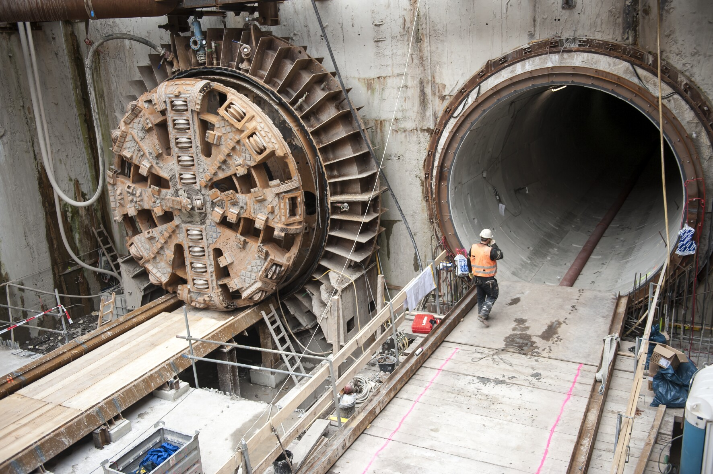

Ways to register
EFG TRAINING SERVICES PRIVATE LTD
WSQ Approved Training Organization (SSG), Learning Service Provider by GIC. No: 3 Soon Lee Street # 01-16&23 Pioneer Junction
Tel: 6334-7872, WhatsApp: 91814091
Singapore 627606
E-mail: admin@efg.com.sg
Website: www.efg.com.sg

