CHEMICAL SAFETY AWARENESS COURSE

Company Name: ________________________________________________________________________________

Contact Person: ____________________________________ H/P: ____________________________________

Tel: ________________ Fax: _________________ Email: ______________________________________________

Address: ______________________________________________________________________________________

No. | NRIC/FIN/WP No: | Full Name | Nationality | MobileNo | Email ID
1.
2.
3.
4.
5.

Course Fees: $120/-per participant (Excluding 9% GST)
Total course fee: $___________Payment Mode: Cash Cheque Cheque No. ______________ (payable to EFG Training Services Private Ltd)

- The company reserves the right to revise the course fee without prior notice, to cancel or postpone the course due to unforeseen circumstances
- Replacement and Withdrawal
- 90% refund will be made if the notice of withdrawal in writing is received by EFG at one week before the course commencement date. If such notice is received by EFG less than one week but more than three working days before the course commencement date, 75% refund will be made. No refund will be given if EFG received the notice of withdrawal 3 working days before the course commencement date. Replacement of participant is allowed if the request is made before the commencement of the course
__________________ __________________________
Name: Signature/Date \
Company Stamp

CHEMICAL SAFETY AWARENESS COURSE

For Whom

The course is suitable for Competent chemical handlers, Process plant Supervisors, Process plant Technicians, Process plant Workers, WSH Committee Members, Laboratory Personnel and WSH professionals.

Entry Requirement

Competent Chemical handlers, Process Plant Supervisors, Process plant Technicians, Process plant Workers, WSH committee members, Laboratory personnel and WSH professionals.
Course Overview

The Chemical Awareness Safety Training program aims to educate industrial workers on the risks associated with chemicals and promote safe handling practices. Participants will learn key aspects such as hazard identification, interpreting Safety Data Sheets (SDS), conducting risk assessments, and best practices for safe storage and handling of chemicals. The course emphasizes the use of Personal Protective Equipment (PPE), emergency response protocols, and includes practical case studies to enhance learning. Assessment ensures participants can apply these safety measures effectively in their workplaces.

Course Content
- New Workplace Health and Safety Act (WSHA) Framework and legal requirements
- Overview of chemical hazards and their associated risks
- Risk assessment process
- Safe work practices for chemical handling, transporting, storage and disposal
- Chemical emergency response procedures
- Case Studies

Course Duration:

4.5 Hrs

Medium of Instruction:

English

Teaching Methodology:
- Blended learning – Class Room Facto face Training

Class Size:

Recommended Class Size – Classroom: 20

Facilitator/Learner Ratio:

1:20 (In-person Workshop)

Course Attendance:

100%

Assessment Advice:

Written Assessment – 0.5 Hour – 20 MCQs – 60% competency based

Course Fees
$120+GST

CHEMICAL SAFETY AWARENESS COURSE

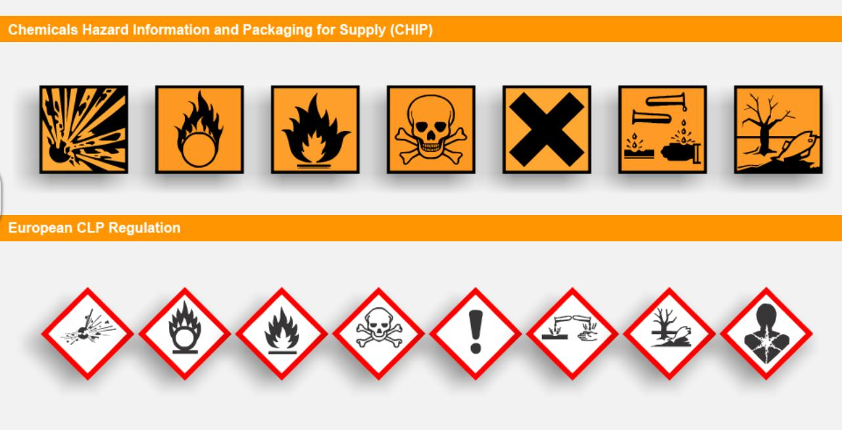

EFG TRAINING SERVICES PRIVATE LTD
Learning service PROVIDER by gic

No: 3 Soon Lee Street
# 01-16 Pioneer Junction
Singapore 627606

Ways to register
TEL: 6334-7872
FAX: 6334-7891
E-mail: admin@efg.com.sg
No: 3 Soon Lee Street
# 01-16 Pioneer Junction
Singapore 627606

Website:www.efg.com.sg

