SUPERVISE WORK IN CONFINED SPACE OPERATION

Company Name: ________________________________________________________________________________

Contact Person: ____________________________________ H/P: ____________________________________

Tel: ________________ Fax: _________________ Email: ______________________________________________

Address: ______________________________________________________________________________________

No. | NRIC/FIN/WP No: | Full Name | Nationality | Mobile No | Email ID
1.
2.
3.
4.
5.
Course Fees: $250/-per participant (Excluding 9% GST)
Total course fee: $___________Payment Mode: Cash Cheque Cheque No. ______________ (payable to EFG Training Services Private Ltd)

- The company reserves the right to revise the course fee without prior notice, to cancel or postpone the course due to unforeseen circumstances
- Replacement and Withdrawal
- 90% refund will be made if the notice of withdrawal in writing is received by EFG at one week before the course commencement date. If such notice is received by EFG less than one week but more than three working days before the course commencement date, 75% refund will be made. No refund will be given if EFG received the notice of withdrawal 3 working days before the course commencement date. Replacement of participant is allowed if the request is made before the commencement of the course
__________________ __________________________
Name: Signature/Date

Company Stamp

SUPERVISE WORK IN CONFINED SPACE OPERATION

Course Overview
The Workplace Safety and Health Sect. 12 (3) stipulates that “It shall be the duty of every employer to ensure that those person at any work have received adequate instruction, information, training and supervision as is necessary unless he has undergone a safety and health training course approved by the commissioner for Workplace Safety and Health”.
Participants are expected to be self-directed, with a mind to acquire skills and knowledge. They should be able to apply the acquired skill & knowledge to perform the duties of an entrant and attendant when working in a confined space, use gas detection instruments and participate in an emergency situation.

Who should attend this course?
The job roles / occupations that this unit would be relevant to may include but not limited to the following parties related to / in the industry performing the duties:
- Supervisor
- Rescue personnel
- Manager
- Company Safety Personnel
- Engineers
- Technician / Operators

Course Objectives
CE1 – Identify duties and responsibilities of a Confined space work under the WSH Legislations and Codes of Practice
CE2 – Identify, prevent and control confined space hazards
CE3 – Carry out and comply with the requirements of the Confined Space Entry Permit System using a systematic approach
CE4 – Apply Gas Detection Instruments and other control measures when working in confined space
CE5 – Implement the safe use of personal protective equipment and respiratory protective equipment when in a confined space
CE6 – Assist in implementing an Emergency Response Plan

Content Coverage
Learners will be taught on the practical approach in using various tools, tactics, tips and know-how, contextualised to the needs of different sectors, including building and engineering construction services. Learners will also acquire a deeper skill set as they learn how to match these skills to different situations and have the knowledge and expertise at their disposal.
Supervise Work in Confined Space Operation is one of the skills that comes under all process sectors for competency level 3.

Trainer to Trainee Ratio
1: 20

Attendance requirements
100% classroom session

Assessment
Online Assessment
Practical Performance (PP)

Training Methodology
Slides presentation, sharing of best practice and incident. Hands on practical session.

Passing marks
Learners must achieve Competent results

Certifications
Upon successful completion of the course a Statement of Attainment (SOA) will be awarded by SkillsFuture Singapore Agency (SSG). Certificates Cards shall be endorsed by EFG Training Services Private Ltd and issued to participants at the end of course

Course Fees
$250+GST

SUPERVISE WORK IN CONFINED SPACE OPERATION

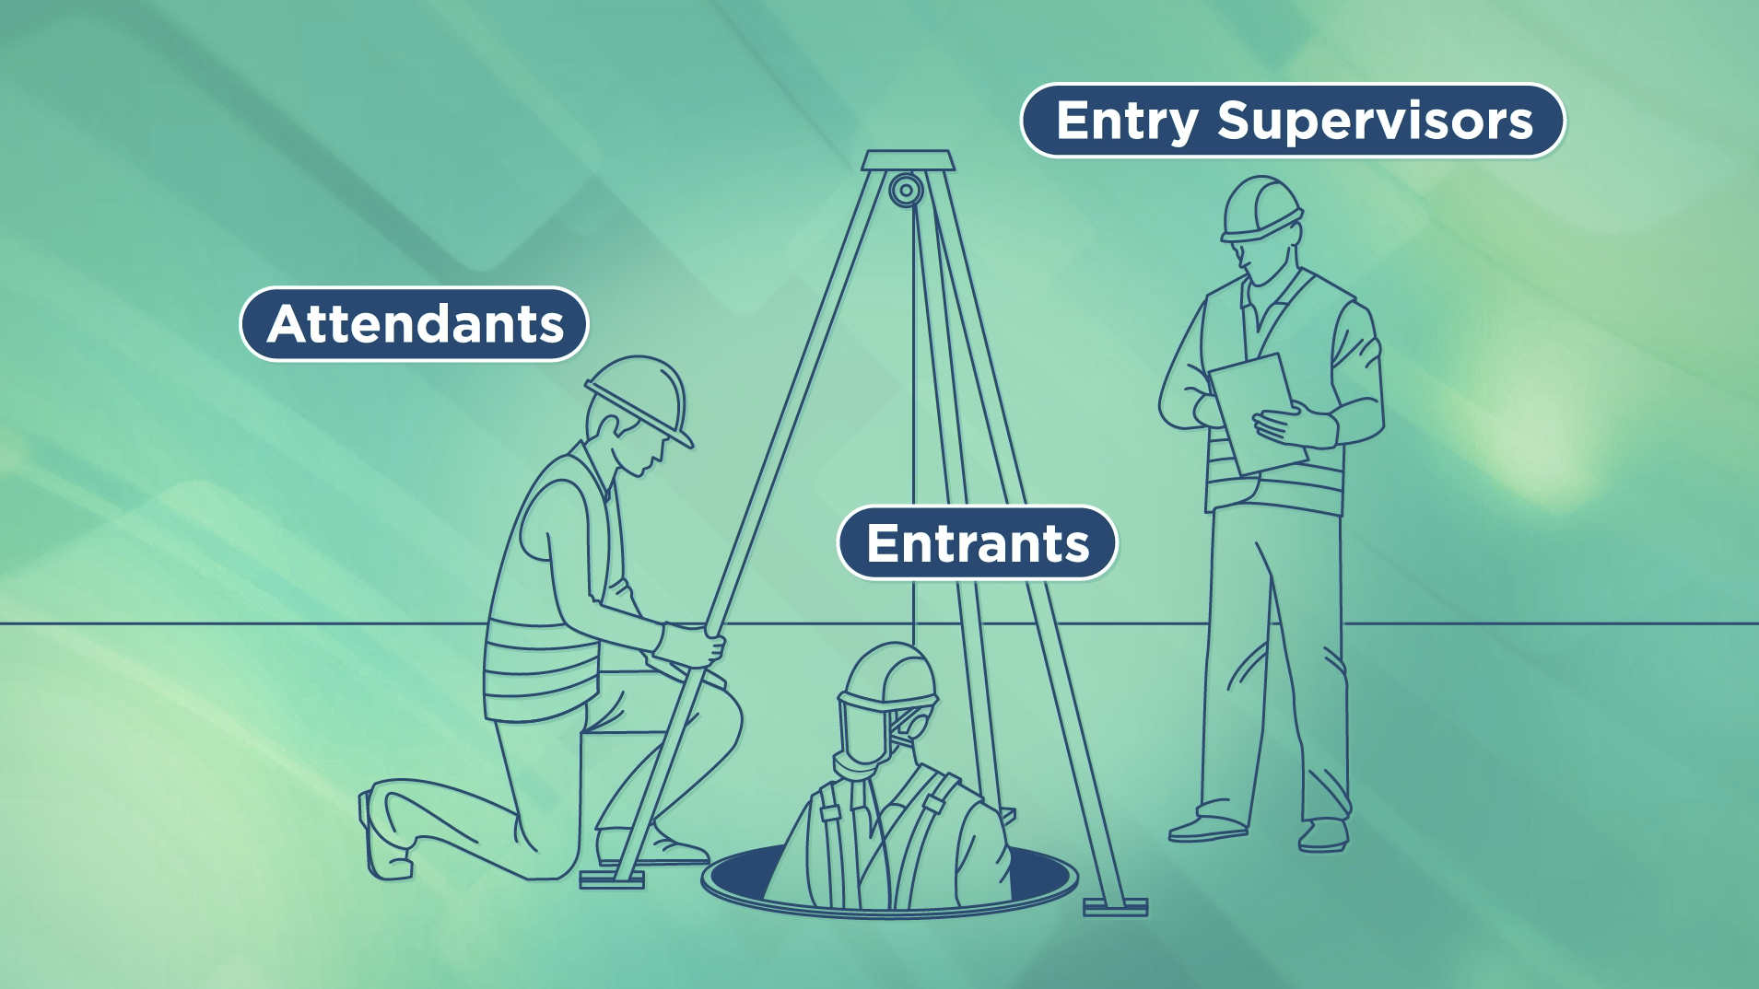

EFG TRAINING SERVICES PRIVATE LTD
Learning service PROVIDER by gic

No: 3 Soon Lee Street
# 01-16 Pioneer Junction
Singapore 627606

Ways to register
TEL: 6334-7872
FAX: 6334-7891
E-mail: admin@efg.com.sg
No: 3 Soon Lee Street
# 01-16 Pioneer Junction
Singapore 627606

Website:www.efg.com.sg

