CHEMICAL SAFETY AWARENESS COURSE

Course Date: ____________________________________ Batch No: ____________________________________

Company Name: ________________________________________________________________________________

Contact Person: ____________________________________ H/P: ____________________________________

Tel: ________________ Fax: _________________ Email: ______________________________________________

Address: ______________________________________________________________________________________

No. | NRIC/FIN/WP No: | Full Name | DOB | Nationality | Mobile No | Email ID
1.
2.
3.
4.
5.
6.
7.
8.
9.
10.

Terms and conditions
- Trainees are reminded to be dressed in proper attire. E.g. Long pants, shirts, covered shoes or safety shoes for classes etc. No shorts and slippers are allowed.
- Participants are reminded to be in class on time. Latecomers are STRICTLY NOT ALLOWED into the class.
- Results will not be uploaded to MOM website, if the trainee is registered for the course with the passport number.
- Personal information collected is for the use ONLY for course registration, account servicing of course-related activities, course survey and / or for application of course-related funding (only if applicable)
- Course surveys shall be conducted by SSG for selected courses through the trainees’ emails or contact given
- Registration forms shall be submitted 3 days before the course commencement date
- The company reserves the right to revise the course fee without prior notice, to cancel or postpone the course due to unforeseen circumstances.

Refund and Withdrawal Policy
- Payment is required upon receipt of confirmation.
- A 100% refund will be provided if a written notice of withdrawal is received by EFG at least three (3) working days before the course commencement date.
- No refund will be given if EFG receives the notice of withdrawal within three (3) working days before the course commencement date.
- No refund will be issued if the participant fails to attend the course on the commencement date or discontinues mid-way through the course.
- Participant replacement is allowed, provided that the request is made prior to course commencement.
- If EFG cancels the course within three (3) working days before the course commencement date, the refund or alternative arrangement will be reviewed and decided by Management on a case-by-case basis.
- EFG reserves the right to review and decide on any exceptional cases at Management’s discretion.

- I confirm I have received and understood pre-course information and all pages of this document.

By checking the boxes above and signing below, I confirm my consent for the disclosure of the selected information.

___________________ __________________________
Name: Signature/Date
Company Stamp

Course Fees: $120/-per participant (Excluding 9% GST)
Total course fee: $____

Payment Mode: Cash Cheque Cheque No. __________ Pay Now Bank Transfer

(payable to EFG Training Services Private Ltd)
For Official Use Only
Verify By:
Signature:
Date :

For Office Use Only
Verify By:
Signature:
Date:

CHEMICAL SAFETY AWARENESS COURSE

For Whom

The course is suitable for Competent chemical handlers, Process plant Supervisors, Process plant Technicians, Process plant Workers, WSH Committee Members, Laboratory Personnel and WSH professionals.

Entry Requirement

Competent Chemical handlers, Process Plant Supervisors, Process plant Technicians, Process plant Workers, WSH committee members, Laboratory personnel and WSH professionals.
Course Overview

The Chemical Awareness Safety Training program aims to educate industrial workers on the risks associated with chemicals and promote safe handling practices. Participants will learn key aspects such as hazard identification, interpreting Safety Data Sheets (SDS), conducting risk assessments, and best practices for safe storage and handling of chemicals. The course emphasizes the use of Personal Protective Equipment (PPE), emergency response protocols, and includes practical case studies to enhance learning. Assessment ensures participants can apply these safety measures effectively in their workplaces.

Course Content
- New Workplace Health and Safety Act (WSHA) Framework and legal requirements
- Overview of chemical hazards and their associated risks
- Risk assessment process
- Safe work practices for chemical handling, transporting, storage and disposal
- Chemical emergency response procedures
- Case Studies

Course Duration:

6 Hrs

Medium of Instruction:

English

Teaching Methodology:
- Blended learning – Class Room Face to face Training

Class Size:

Recommended Class Size – Classroom: 20

Facilitator/Learner Ratio:

1:20 (In-person Workshop)

Course Attendance:

100%

Assessment Advice:

Written Assessment – 0.5 Hour – 20 MCQs – 60% competency based

Course Fees
$120+GST

CHEMICAL SAFETY AWARENESS COURSE

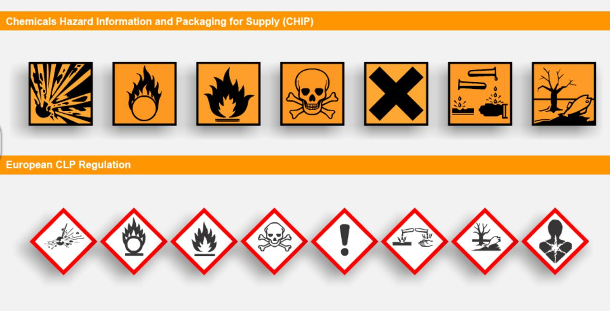

Ways to register
EFG TRAINING SERVICES PRIVATE LTD
WSQ Approved Training Organization (SSG), Learning Service Provider by GIC
No: 3 Soon Lee Street, # 01-16 Pioneer Junction, Singapore 627606
TEL: 6334-7872, FAX: 6334-7891
E-mail: admin@efg.com.sg
Website: www.efg.com.sg

