CONFINED SPACE ENTRY AND RESCUE COURSE

Course Date: ____________________________________ Batch No: ____________________________________

Company Name: ________________________________________________________________________________

Contact Person: ____________________________________ H/P: ____________________________________

Tel: ________________ Fax: _________________ Email: ______________________________________________

Address: ______________________________________________________________________________________

No. | NRIC/FIN/WP No: | Full Name | DOB | Nationality | Mobile No | Email ID
1.
2.
3.
4.
5.
6.
7.
8.
9.
10.

Terms and conditions
- Trainees are reminded to be dressed in proper attire. E.g. Long pants, shirts, covered shoes or safety shoes for classes etc. No shorts and slippers are allowed.
- Participants are reminded to be in class on time. Latecomers are STRICTLY NOT ALLOWED into the class.
- Results will not be uploaded to MOM website, if the trainee is registered for the course with the passport number.
- Personal information collected is for the use ONLY for course registration, account servicing of course-related activities, course survey and / or for application of course-related funding (only if applicable)
- Course surveys shall be conducted by SSG for selected courses through the trainees’ emails or contact given
- Registration forms shall be submitted 3 days before the course commencement date
- The company reserves the right to revise the course fee without prior notice, to cancel or postpone the course due to unforeseen circumstances.

Refund and Withdrawal Policy
- Payment is required upon receipt of confirmation.
- A 100% refund will be provided if a written notice of withdrawal is received by EFG at least three (3) working days before the course commencement date.
- No refund will be given if EFG receives the notice of withdrawal within three (3) working days before the course commencement date.
- No refund will be issued if the participant fails to attend the course on the commencement date or discontinues mid-way through the course.
- Participant replacement is allowed, provided that the request is made prior to course commencement.
- If EFG cancels the course within three (3) working days before the course commencement date, the refund or alternative arrangement will be reviewed and decided by Management on a case-by-case basis.
- EFG reserves the right to review and decide on any exceptional cases at Management’s discretion.

- I confirm I have received and understood pre-course information and all pages of this document.

By checking the boxes above and signing below, I confirm my consent for the disclosure of the selected information.

___________________ __________________________
Name: Signature/Date
Company Stamp

Course Fees: $350/-per participant (Excluding 9% GST)
Total course fee: $____

Payment Mode: Cash Cheque Cheque No. __________ Pay Now Bank Transfer

(payable to EFG Training Services Private Ltd)
For Official Use Only
Verify By:
Signature:
Date :

For Office Use Only
Verify By:
Signature:
Date:

CONFINED SPACE ENTRY AND RESCUE COURSE

Course Overview

This course has been designed to meet the minimum standard for Confined Space Rescue, as recommended in the WSH (Confined Space) Regulations 2009, SS 568 : 2011, Technical Advisory on Working Safely in Confined Spaces and Confined Space Safety Guidebook for Supervisors and Workers.

Who should attend this course?

The course is for anyone involved in the supervision, planning / assessment or management of confined space work activities.

Course Objectives/Contents
The aim of the course is to provide Learners with the requisite skills, knowledge to manage and rescue, so that work can be carried out safely. At the end of the course, the Learner shall be able to:

- Identify, explain and apply the relevant Workplace Safety and Health (WSH) Legislations / Approved Code of Practice / Singapore Standards applicable to Confined Space
- Identify and explain the Roles & Responsibilities of stakeholders, competent and responsible persons.
- Identify hazards, evaluate the risk, and implement control measures for Confined Space Work activities
- Review the necessary fall preventive / protective control measures for safe execution of Confined Space Work activities
- Establish, evaluate, review and implement a Confined Space Rescue Plan
- Establish and implement a system for an effective rescue and control of Confined Space Work risks
- Demonstrate competency in donning, checking and correcting of Confined Space Rescue Equipment and Responding to a confined space emergency and Perform Confined Space Rescue.

Pre-Requisites / Assume Skills and Knowledge

The Learner should have at least WSQ ESS Workplace Literacy and Numeracy Level 4 and above or equivalent and the ability to carry out hazards identification, risk assessment, and risk control measures.

Trainer to Trainee Ratio
1: 20 Theory & 1: 20 Theory Assessment
1: 10 Practical & 1: 1 Practical Assessment

Course Duration
7 Hours (Including 2.5 hours Assessment)

Attendance requirements
100%

Assessment
Comprising both Theory and Practical Session
Written Test (WT) / Practical Performance (PP)

Medium of Instruction
English

Training Methodology
Slides presentation, sharing of best practice and incident. Hands on practical session.

Passing marks
Theory Examination (WT): 70%
Practical Assessments (PP): 100%

Certifications
Certificates and Cards shall be endorsed by EFG Training Services Private Ltd and issued to participants at the end of course.

Course Fees
$350+GST

CONFINED SPACE ENTRY AND RESCUE COURSE

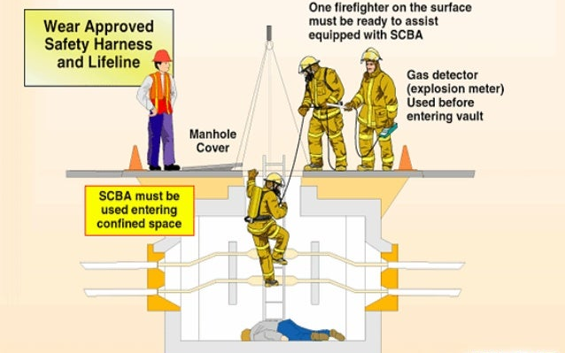

Ways to register
EFG TRAINING SERVICES PRIVATE LTD
WSQ Approved Training Organization (SSG), Learning Service Provider by GIC
No: 3 Soon Lee Street, # 01-16 Pioneer Junction, Singapore 627606
TEL: 6334-7872, FAX: 6334-7891
E-mail: admin@efg.com.sg
Website: www.efg.com.sg

