PERSONAL FALL PROTECTION EQUIPMENT INSPECTOR – PFPEI (English)

Course Date: ____________________________________ Batch No: ____________________________________

Company Name: ________________________________________________________________________________

Contact Person: ____________________________________ H/P: __________________________________

Tel: ________________ Fax: _________________ Email: ______________________________________________

Address: ______________________________________________________________________________________

No. | NRIC/FIN/WP No: | Full Name | DOB | Nationality | Mobile No. | Email ID
1.
2.
3.
4.
5.
6.
7.
8.
9.
10.

Terms and conditions
- Trainees are reminded to be dressed in proper attire. E.g. Long pants, shirts, covered shoes or safety shoes for classes etc. No shorts and slippers are allowed.
- Participants are reminded to be in class on time. Latecomers are STRICTLY NOT ALLOWED into the class.
- Results will not be uploaded to MOM website, if the trainee is registered for the course with the passport number.
- Personal information collected is for the use ONLY for course registration, account servicing of course-related activities, course survey and / or for application of course-related funding (only if applicable)
- Course surveys shall be conducted by SSG for selected courses through the trainees’ emails or contact given
- Registration forms shall be submitted 3 days before the course commencement date
- The company reserves the right to revise the course fee without prior notice, to cancel or postpone the course due to unforeseen circumstances.

Refund and Withdrawal Policy
- Payment is required upon receipt of confirmation.
- A 100% refund will be provided if a written notice of withdrawal is received by EFG at least three (3) working days before the course commencement date.
- No refund will be given if EFG receives the notice of withdrawal within three (3) working days before the course commencement date.
- No refund will be issued if the participant fails to attend the course on the commencement date or discontinues mid-way through the course.
- Participant replacement is allowed, provided that the request is made prior to course commencement.
- If EFG cancels the course within three (3) working days before the course commencement date, the refund or alternative arrangement will be reviewed and decided by Management on a case-by-case basis.
- EFG reserves the right to review and decide on any exceptional cases at Management’s discretion.

- I confirm I have received and understood pre-course information and all pages of this document.

By checking the boxes above and signing below, I confirm my consent for the disclosure of the selected information.

___________________ __________________________
Name: Signature/Date
Company Stamp

Course Fees: $250/-per participant (Excluding 9% GST)
Total course fee: $____

Payment Mode: Cash Cheque Cheque No. __________ Pay Now Bank Transfer

(payable to EFG Training Services Private Ltd)
For Official Use Only
Verify By:
Signature:
Date :

For Office Use Only
Verify By:
Signature:
Date:

PERSONAL FALL PROTECTION EQUIPMENT INSPECTOR

For Whom
All personnel interested in additional experience inspecting personal fall protection equipment. The typical participant is responsible for the care, marking and maintenance of equipment.
Entry Requirement
- Workplace literacy and numeracy Level 4 under Employability Skills System (ESS) or equivalent.
- Work at height course for Supervisors.
Course Overview
The aim of the course is to provide course participants with the requisite knowledge on the work at height, capability to conduct pre-use and annual fall protection equipment inspection, knowledge on equipment maintenance, storage and servicing.
Course Content
- Introduction to Work-at-Height.
- Work At Height Legislations.
- Introduction to different PPE.
- Regulations specific to the Inspection of PPE.
- Common wear and tear, lifespan and expiry dates of PPE.
Course Duration: 4 hours
Medium of Instruction: English
Class Size: Maximum 20
Facilitator/Learner Ratio:
1:20 for Theory Lesson
Course Attendance: 100% attendance.
Assessment Advice
Create Inspection Checklist

Personal Fall Protection Equipment Inspector - PFPEI

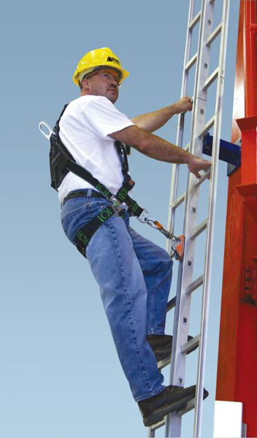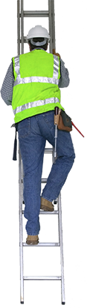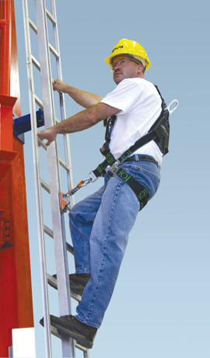

Ways to register
EFG TRAINING SERVICES PRIVATE LTD
WSQ Approved Training Organization (SSG), Learning Service Provider by GIC
No: 3 Soon Lee Street, # 01-16 Pioneer Junction, Singapore 627606
TEL: 6334-7872, FAX: 6334-7891
E-mail: admin@efg.com.sg
Website: www.efg.com.sg

