PART A: COURSE INFO | RMATION
COURSE TITLE:
COURSE DATE:
COURSE LANGUAGE: | BATCH NO:

PART B: APPLICANT DETAILS
NAME (as in NRIC): |  |  |  |  |  |  | GENDER: | Male Female
ID TYPE: |  | N | RIC Passport | S-Pass Dependent’s Pass |  |  | NATIONALITY:
 |  | PR |  | Employment Pass |  |  | RACE:
NRIC/FIN/PP: |  |  |  |  |  |  | DATE OF BIRTH:
CONTACT  NUMBER: ( | HP)
EMAIL ADDRESS:
HIGHEST QUALIFICATION:
EMPLOYMENT STATUS: |  |  | Employed (If employed, please state) |  | Company:
 |  |  | Unemployed |  | Designation:
If employed, please state monthly salary: |  |  | Below $1000  $3000 - $3500 | $1000 - $1499  $3500 and above | $1500 - $2000 |  | $2000 - $2500 | $2500 - $3000
Note: Required for SSG funding requirement

PART C: ACADEMIC/PROFESSIONAL QUALIFICATION/WORK EXPERIENCE
Academic Qualification:

‘N’ Level ‘O’ Level WPLN Diploma Degree (or)
Professional Qualification:
BCSS LSSC OPISCS SSSC CSSA ECO RM Level 4 Formwork WAH(S) RS

(or) Others
Work Experience: I have years of experience in WSH in Sector (industry).
(Participants shall provide copies of relevant certificates/documents/NRIC)

PART D: OTHER DETAILS (PLEASE TICK ACCORDINGLY)
1. Are you applying for funding? | Yes No | If yes, please state:
2. Have you been given funding before for the course you are applying for? | Yes No | If yes, please state:
3. Are you applying for Skills Future - Credit | Yes No
* Note: Skills Future Credit must be submitted 60 days before the course start date *

Terms and conditions
- Trainees are reminded to be dressed in proper attire. E.g. Long pants, shirts, covered shoes or safety shoes for classes etc. No shorts and slippers are allowed.
- Participants are reminded to be in class on time. Latecomers are STRICTLY NOT ALLOWED into the class.
- Results will not be uploaded to MOM website, if the trainee is registered for the course with the passport number.
- Personal information collected is for the use ONLY for course registration, account servicing of course-related activities, course survey and / or for application of course-related funding (only if applicable)
- Course surveys shall be conducted by SSG for selected courses through the trainees’ emails or contact given
- Registration forms shall be submitted 3 days before the course commencement date
- The company reserves the right to revise the course fee without prior notice, to cancel or postpone the course due to unforeseen circumstances.

Refund and Withdrawal Policy
- Payment is required upon receipt of confirmation.
- A 100% refund will be provided if a written notice of withdrawal is received by EFG at least three (3) working days before the course commencement date.
- No refund will be given if EFG receives the notice of withdrawal within three (3) working days before the course commencement date.
- No refund will be issued if the participant fails to attend the course on the commencement date or discontinues mid-way through the course.
- Participant replacement is allowed, provided that the request is made prior to course commencement.
- If EFG cancels the course within three (3) working days before the course commencement date, the refund or alternative arrangement will be reviewed and decided by Management on a case-by-case basis.
- EFG reserves the right to review and decide on any exceptional cases at Management’s discretion.

- I confirm I have received and understood pre-course information and all pages of this document.

By checking the boxes above and signing below, I confirm my consent for the disclosure of the selected information.

___________________ __________________________ __________________________
Name: Signature Date
For Official Use Only
Verify By:
Signature:
Date :

For Office Use Only
Verify By:
Signature:
Date:

Course Fees: $100/-per participant (Excluding 9% GST)
Total course fee: $____

Payment Mode: Cash Cheque Cheque No. __________ Pay Now Bank Transfer

(payable to EFG Training Services Private Ltd)

For Official Use Only
Verify By:
Signature:
Date :

CONFINED SPACE ATTENDANT SAFETY COURSE

For Whom –
Confined Space Attendant, Confined Space Entrant (Worker), Technician, Supervisor
Entry Requirement
Learners are assumed to:
  - Be able to listen, read, speak and write English
  - Be able to manipulate numbers
  - Be able to follow written and oral work instructions
  - Must complete Perform Work In Confined Space Operation course

Course Overview
Upon completion of this training, participants will be able to demonstrate Knowledge and skills required to safely manage entry into confined spaces. Specifically, he/she will be able to identify hazards associated with confined spaces, monitor the number of entrants moving in and out of the space, ensure adequate ventilation and atmospheric testing, use personal protective equipment (PPE), communicate effectively with the entrants and other team members, activate the emergency response plan when needed, and perform non-entry rescue operations. He/she will also be able to demonstrate an understanding of relevant regulations and standards governing confined space operations and recognize the importance of continuous monitoring and regular training to maintain a safe work environment.

Course Content
  - Introduction
  - Identify duties and responsibilities of all personnel involved in confined space work under the WSH Legislations and Codes of Practice
  - Overview of confined space
  - Common confined space hazards and their characteristics
  - Gas Detection Instruments for atmospheric monitoring
  - Comply with safe work procedures when working in confined space
  - Continuous monitoring of the confined space and entrants
  - Assist in implementing a communication and emergency response plan
  - Case Studies

Course Duration
- 6 Hours

Medium of Instruction: English

Teaching Methodology:
Blended learning – Classroom – Face to face Training and hands on Practical Training with Gas meter
Learning Environment: ·
- Room with the capacity for up to 20 candidates for conduct of written assessment
- Room or place to be used must be away from noise or interruptions

Class Size:
Recommended Class Size – Classroom: 20

Facilitator/Learner Ratio: 1:20 for Theory Lesson & Assessment

Course Attendance Minimum: 100% attendance

Assessment Advice:
- Written Assessment – 30mins – 20 MCQ – passing rate 60% &
- Practical assessment – Group Role Play &
- Oral Questions – competency based

Course Fee:
S$100+GST

CONFINED SPACE ATTENDANT SAFETY COURSE

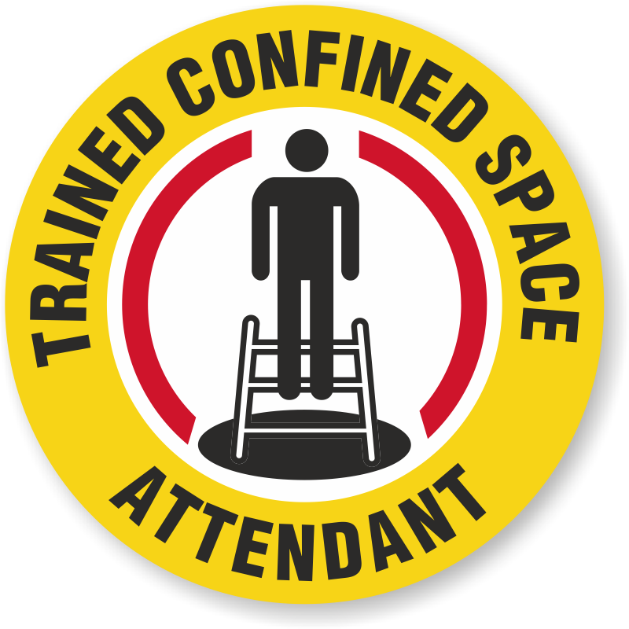

Ways to register
EFG TRAINING SERVICES PRIVATE LTD
WSQ Approved Training Organization (SSG), Learning Service Provider by GIC
No: 3 Soon Lee Street, # 01-16 Pioneer Junction, Singapore 627606
TEL: 6334-7872, FAX: 6334-7891
E-mail: admin@efg.com.sg
Website: www.efg.com.sg

