
EFG TRAINING SERVICES PRIVATE LTD
INDIVIDUAL COURSE PRE-REGISTRATION FORM
PART A: COURSE INFO | RMATION
COURSE TITLE:
COURSE DATE:
COURSE LANGUAGE: | BATCH NO:

PART B: APPLICANT DETAILS
NAME (as in NRIC): |  |  |  |  |  |  | GENDER: | Male Female
ID TYPE: |  | N | RIC Passport | S-Pass Dependent’s Pass |  |  | NATIONALITY:
 |  | PR |  | Employment Pass |  |  | RACE:
NRIC/FIN/PP: |  |  |  |  |  |  | DATE OF BIRTH:
CONTACT  NUMBER: ( | HP)
EMAIL ADDRESS:
HIGHEST QUALIFICATION:
EMPLOYMENT STATUS: |  |  | Employed (If employed, please state) |  | Company:
 |  |  | Unemployed |  | Designation:
If employed, please state monthly salary: |  |  | Below $1000  $3000 - $3500 | $1000 - $1499  $3500 and above | $1500 - $2000 |  | $2000 - $2500 | $2500 - $3000
Note: Required for SSG funding requirement

PART C: ACADEMIC/PROFESSIONAL QUALIFICATION/WORK EXPERIENCE
Academic Qualification:

‘N’ Level ‘O’ Level WPLN Diploma Degree (or)
Professional Qualification:
BCSS LSSC OPISCS SSSC CSSA ECO RM Level 4 Formwork WAH(S) RS

(or) Others
Work Experience: I have years of experience in WSH in Sector (industry).
(Participants shall provide copies of relevant certificates/documents/NRIC)

PART D: OTHER DETAILS (PLEASE TICK ACCORDINGLY)
1. Are you applying for funding? | Yes No | If yes, please state:
2. Have you been given funding before for the course you are applying for? | Yes No | If yes, please state:
3. Are you applying for Skills Future - Credit | Yes No
* Note: Skills Future Credit must be submitted 60 days before the course start date *

Terms and conditions
- Trainees are reminded to be dressed in proper attire. E.g. Long pants, shirts, covered shoes or safety shoes for classes etc. No shorts and slippers are allowed.
- Participants are reminded to be in class on time. Latecomers are STRICTLY NOT ALLOWED into the class.
- Results will not be uploaded to MOM website, if the trainee is registered for the course with the passport number.
- Personal information collected is for the use ONLY for course registration, account servicing of course-related activities, course survey and / or for application of course-related funding (only if applicable)
- Course surveys shall be conducted by SSG for selected courses through the trainees’ emails or contact given
- Registration forms shall be submitted 3 days before the course commencement date
- The company reserves the right to revise the course fee without prior notice, to cancel or postpone the course due to unforeseen circumstances.

Refund and Withdrawal Policy
- Payment is required upon receipt of confirmation.
- A 100% refund will be provided if a written notice of withdrawal is received by EFG at least three (3) working days before the course commencement date.
- No refund will be given if EFG receives the notice of withdrawal within three (3) working days before the course commencement date.
- No refund will be issued if the participant fails to attend the course on the commencement date or discontinues mid-way through the course.
- Participant replacement is allowed, provided that the request is made prior to course commencement.
- If EFG cancels the course within three (3) working days before the course commencement date, the refund or alternative arrangement will be reviewed and decided by Management on a case-by-case basis.
- EFG reserves the right to review and decide on any exceptional cases at Management’s discretion.

- I confirm I have received and understood pre-course information and all pages of this document.

By checking the boxes above and signing below, I confirm my consent for the disclosure of the selected information.

___________________ __________________________
Name: Signature/Date
Company Stamp

Course Fees: $350/-per participant (Excluding 9% GST)
Total course fee: $____

Payment Mode: Cash Cheque Cheque No. __________ Pay Now Bank Transfer

(payable to EFG Training Services Private Ltd)
For Official Use Only
Verify By:
Signature:
Date :

For Office Use Only
Verify By:
Signature:
Date:

CONFINED SPACE RESCUE COURSE

Course Overview

This course has been designed to meet the minimum standard for Confined Space Rescue, as recommended in the WSH (Confined Space) Regulations 2009, SS 568 : 2011, Technical Advisory on Working Safely in Confined Spaces and Confined Space Safety Guidebook for Supervisors and Workers.

Who should attend this course?

The course is for anyone involved in the supervision, planning / assessment or management of confined space work activities.

Course Objectives/Contents
The aim of the course is to provide Learners with the requisite skills, knowledge to manage and rescue, so that work can be carried out safely. At the end of the course, the Learner shall be able to:

- Identify, explain and apply the relevant Workplace Safety and Health (WSH) Legislations / Approved Code of Practice / Singapore Standards applicable to Confined Space
- Identify and explain the Roles & Responsibilities of stakeholders, competent and responsible persons.
- Identify hazards, evaluate the risk, and implement control measures for Confined Space Work activities
- Review the necessary fall preventive / protective control measures for safe execution of Confined Space Work activities
- Establish, evaluate, review and implement a Confined Space Rescue Plan
- Establish and implement a system for an effective rescue and control of Confined Space Work risks
- Demonstrate competency in donning, checking and correcting of Confined Space Rescue Equipment and Responding to a confined space emergency and Perform Confined Space Rescue.

Pre-Requisites / Assume Skills and Knowledge

The Learner should have at least WSQ ESS Workplace Literacy and Numeracy Level 4 and above or equivalent and the ability to carry out hazards identification, risk assessment, and risk control measures.

Trainer to Trainee Ratio
1: 20 Theory & 1: 20 Theory Assessment
1: 10 Practical & 1: 1 Practical Assessment

Course Duration
7 Hours (Including 2.5 hours Assessment)

Attendance requirements
100%

Assessment
Comprising both Theory and Practical Session
Written Test (WT) / Practical Performance (PP)

Medium of Instruction
English

Training Methodology
Slides presentation, sharing of best practice and incident. Hands on practical session.

Passing marks
Theory Examination (WT): 70%
Practical Assessments (PP): 100%

Certifications
Certificates and Cards shall be endorsed by EFG Training Services Private Ltd and issued to participants at the end of course.

Course Fees
$350+GST

CONFINED SPACE RESCUE COURSE

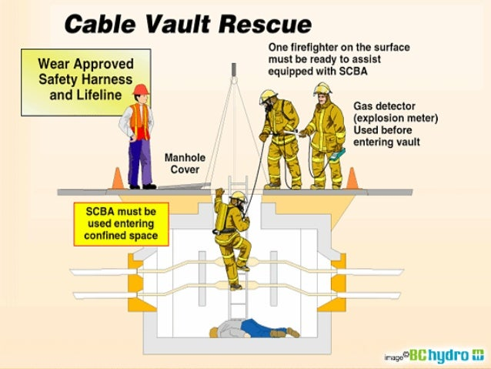

EFG TRAINING SERVICES PRIVATE LTD
Learning service PROVIDER by gic

No: 3 Soon Lee Street
# 01-16 Pioneer Junction
Singapore 627606

Ways to register
TEL: 6334-7872
FAX: 6334-7891
E-mail: admin@efg.com.sg
No: 3 Soon Lee Street
# 01-16 Pioneer Junction
Singapore 627606

Website:www.efg.com.sg

