PART A: COURSE INFO | RMATION
COURSE TITLE:
COURSE DATE:
COURSE LANGUAGE: | BATCH NO:

PART B: APPLICANT DETAILS
NAME (as in NRIC): |  |  |  |  |  |  | GENDER: | Male Female
ID TYPE: |  | N | RIC Passport | S-Pass Dependent’s Pass |  |  | NATIONALITY:
 |  | PR |  | Employment Pass |  |  | RACE:
NRIC/FIN/PP: |  |  |  |  |  |  | DATE OF BIRTH:
CONTACT  NUMBER: ( | HP)
EMAIL ADDRESS:
HIGHEST QUALIFICATION:
EMPLOYMENT STATUS: |  |  | Employed (If employed, please state) |  | Company:
 |  |  | Unemployed |  | Designation:
If employed, please state monthly salary: |  |  | Below $1000  $3000 - $3500 | $1000 - $1499  $3500 and above | $1500 - $2000 |  | $2000 - $2500 | $2500 - $3000
Note: Required for SSG funding requirement

PART C: ACADEMIC/PROFESSIONAL QUALIFICATION/WORK EXPERIENCE
Academic Qualification:

‘N’ Level ‘O’ Level WPLN Diploma Degree (or)
Professional Qualification:
BCSS LSSC OPISCS SSSC CSSA ECO RM Level 4 Formwork WAH(S) RS

(or) Others
Work Experience: I have years of experience in WSH in Sector (industry).
(Participants shall provide copies of relevant certificates/documents/NRIC)

PART D: OTHER DETAILS (PLEASE TICK ACCORDINGLY)
1. Are you applying for funding? | Yes No | If yes, please state:
2. Have you been given funding before for the course you are applying for? | Yes No | If yes, please state:
3. Are you applying for Skills Future - Credit | Yes No
* Note: Skills Future Credit must be submitted 60 days before the course start date *

Terms and conditions
- Trainees are reminded to be dressed in proper attire. E.g. Long pants, shirts, covered shoes or safety shoes for classes etc. No shorts and slippers are allowed.
- Participants are reminded to be in class on time. Latecomers are STRICTLY NOT ALLOWED into the class.
- Results will not be uploaded to MOM website, if the trainee is registered for the course with the passport number.
- Personal information collected is for the use ONLY for course registration, account servicing of course-related activities, course survey and / or for application of course-related funding (only if applicable)
- Course surveys shall be conducted by SSG for selected courses through the trainees’ emails or contact given
- Registration forms shall be submitted 3 days before the course commencement date
- The company reserves the right to revise the course fee without prior notice, to cancel or postpone the course due to unforeseen circumstances.

Refund and Withdrawal Policy
- Payment is required upon receipt of confirmation.
- A 100% refund will be provided if a written notice of withdrawal is received by EFG at least three (3) working days before the course commencement date.
- No refund will be given if EFG receives the notice of withdrawal within three (3) working days before the course commencement date.
- No refund will be issued if the participant fails to attend the course on the commencement date or discontinues mid-way through the course.
- Participant replacement is allowed, provided that the request is made prior to course commencement.
- If EFG cancels the course within three (3) working days before the course commencement date, the refund or alternative arrangement will be reviewed and decided by Management on a case-by-case basis.
- EFG reserves the right to review and decide on any exceptional cases at Management’s discretion.

- I confirm I have received and understood pre-course information and all pages of this document.

By checking the boxes above and signing below, I confirm my consent for the disclosure of the selected information.

___________________ __________________________ __________________________
Name: Signature Date
For Official Use Only
Verify By:
Signature:
Date :

Course Fees: $250/-per participant (Excluding 9% GST)
Total course fee: $____

Payment Mode: Cash Cheque Cheque No. __________ Pay Now Bank Transfer

(payable to EFG Training Services Private Ltd)
For Official Use Only
Verify By:
Signature:
Date :

For Office Use Only
Verify By:
Signature:
Date:

Personal Fall Protection Equipment Inspector - PFPEI
For Whom
All personnel interested in additional experience inspecting personal fall protection equipment. The typical participant is responsible for the care, marking and maintenance of equipment.
Entry Requirement
- Workplace literacy and numeracy Level 4 under Employability Skills System (ESS) or equivalent.
- Work at height course for Supervisors.
Course Overview
The aim of the course is to provide course participants with the requisite knowledge on the work at height, capability to conduct pre-use and annual fall protection equipment inspection, knowledge on equipment maintenance, storage and servicing.
Course Content
- Introduction to Work-at-Height.
- Work At Height Legislations.
- Introduction to different PPE.
- Regulations specific to the Inspection of PPE.
- Common wear and tear, lifespan and expiry dates of PPE.
Course Duration: 4 hours
Medium of Instruction: English
Class Size: Maximum 20
Facilitator/Learner Ratio:
1:20 for Theory Lesson
Course Attendance: 100% attendance.
Assessment Advice
Create Inspection Checklist

Personal Fall Protection Equipment Inspector - PFPEI

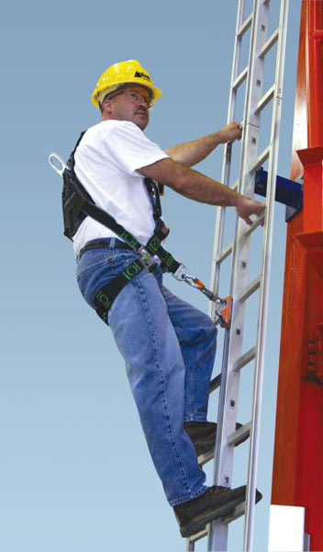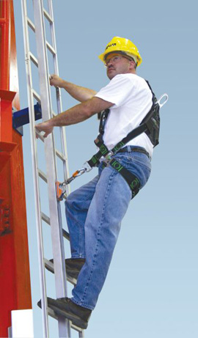

Ways to register
EFG TRAINING SERVICES PRIVATE LTD
WSQ Approved Training Organization (SSG), Learning Service Provider by GIC
No: 3 Soon Lee Street, # 01-16 Pioneer Junction, Singapore 627606
TEL: 6334-7872, FAX: 6334-7891
E-mail: admin@efg.com.sg
Website: www.efg.com.sg

