PART A: COURSE INFORMATION
COURSE TITLE:
COURSE DATE:
COURSE LANGUAGE: |  |  |  | BATCH NO:

PART B: APPLICANT DETAILS
NAME (as in NRIC): |  |  |  |  |  | GENDER: |  |  | Male Female
ID TYPE: |  | NRIC Passport S-Pass Dependent’s Pass |  |  |  | NATIONALITY:
 |  | PR Work Permit Employment Pass |  |  |  | RACE:
NRIC/FIN/PP: |  |  |  |  |  | DATE OF BIRTH:
CONTACT NUMBER: | (HP) _______________________________
EMAIL ADDRESS:
HIGHEST QUALIFICATION:
EMPLOYMENT STATUS: |  |  | Employed (If employed, please state) |  | Company:
 |  |  | Unemployed |  | Designation:
If employed, please  state monthly salary: |  |  | Below $1000 $1000 - $1499 $1500 - $2000 $2000 - $2500 $2500 - $3000  $3000 - $3500 $3500 and above
Note: Required for SSG funding requirement

PART C: ACADEMIC/PROFESSIONAL QUALIFICATION/WORK EXPERIENCE

Academic Qualification:

‘N’ Level ‘O’ Level WPLN Diploma Degree (or) ______________________________

Professional Qualification:

BCSS LSSC OPISCS SSSC CSSA ECO RM Level 4 Formwork WAH(S) RS

(or) Others ____________________________

Work Experience: I have _________________years of experience in WSH in ______________________Sector (industry).

(Participants shall provide copies of relevant certificates/documents/NRIC)

PART D: OTHER DETAILS (PLEASE TICK ACCORDINGLY)
1. Are you applying for funding? | Yes No |  | If yes, please state:
2. Have you been given funding before for the course you are applying for? | Yes No |  | If yes, please state:
3. Are you applying for Skills Future - Credit |  | Yes No
* Note: Skills Future Credit must be submitted 60 days before the course start date *

Grant Details
- Are you applying for SSG funding? Yes No
These grants are applicable only for Singapore citizens and Singapore Permanent Residents. Foreigners are not eligible.
Grant Disbursement Criteria
To qualify for grant disbursement, the following conditions must be met:

- Training Grant Criteria: To qualify for SkillsFuture Singapore (SSG), the trainee must be receiving at least 03 months of CPF contributions from the sponsoring company. Otherwise, funding will likely be rejected, and we will have to back charge the fees to you. Thank you for your understanding
Please note that the funding is subject to final approval and disbursement by Skills Future Singapore (SSG). If the funding is not approved or released for any reason after the course, the trainee and/or sponsoring company shall be liable to pay the full outstanding course fees. This may include, but is not limited to, reasons such as insufficient attendance, failure to meet assessment requirements, ineligibility based on CPF contributions, or any other non-compliance with SSG funding criteria
- Attendance Requirement: The Trainee must achieve 100% attendance.
- Assessment: The Trainee must pass all prescribed examinations or assessments.

- Payment: All course fees must be paid in full on or before course date

(Please note that EFG Training Services will not be held liable for any rejected grant applications if the required procedures
And documentation is not followed.)

Singapore Citizens/Singapore Permanent Residents applying for grants- mandatory to take attendance using Singpass App

Terms and conditions
- Trainees are reminded to be dressed in proper attire. E.g. Long pants, shirts, covered shoes or safety shoes for classes etc. No shorts and slippers are allowed.
- Participants are reminded to be in class on time. Latecomers are STRICTLY NOT ALLOWED into the class.
- Results will not be uploaded to MOM website, if the trainee is registered for the course with the passport number.
- Personal information collected is for the use ONLY for course registration, account servicing of course-related activities, course survey and / or for application of course-related funding (only if applicable)
- Course surveys shall be conducted by SSG for selected courses through the trainees’ emails or contact given
- Registration forms shall be submitted 3 days before the course commencement date
- The company reserves the right to revise the course fee without prior notice, to cancel or postpone the course due to unforeseen circumstances.

Refund and Withdrawal Policy
- Payment is required upon receipt of confirmation.
- A 100% refund will be provided if a written notice of withdrawal is received by EFG at least three (3) working days before the course commencement date.
- No refund will be given if EFG receives the notice of withdrawal within three (3) working days before the course commencement date.
- No refund will be issued if the participant fails to attend the course on the commencement date or discontinues mid-way through the course.
- Participant replacement is allowed, provided that the request is made prior to course commencement.
- If EFG cancels the course within three (3) working days before the course commencement date, the refund or alternative arrangement will be reviewed and decided by Management on a case-by-case basis.
- EFG reserves the right to review and decide on any exceptional cases at Management’s discretion.

I, the Applicant consents to the collection, use and disclosure of my personal data and training records to companies that access the Ministry of Manpower (MOM)’s Training Record System (TRS). Companies using the Check Workers’ WSH Training Records eService on the MOM website may verify my training records, including the following information:
- Identification Number (Work Permit / FIN / NRIC Number) & Name Eligibility for 4 years of Safety Orientation Course (CSOC / SSIC / MSOC certification, if applicable) & Course Title & Name of Training Provider & Date of Assessment & Certificate Expiry Date & Result of Assessment
- I confirm I have received and understood pre-course information and all pages of this document.
By checking the boxes above and signing below, I confirm my consent for the disclosure of the selected information.

___________________ __________________________ ______________
For Official Use Only
Verify By:
Signature:
Date :

Name: Signature Date
For Official Use Only
Verify By:
Signature:
Date :

For Office Use Only
Verify By:
Signature:
Date:

Course Fees: $90/-per participant (Excluding 9% GST)
Total course fee: $____

Payment Mode: Cash Cheque Cheque No. __________ Pay Now Bank Transfer

(payable to EFG Training Services Private Ltd)
For Official Use Only
Verify By:
Signature:
Date :

For Official Use Only
Verify By:
Signature:
Date :

APPLY WORKPLACE SAFETY AND HEALTH IN PROCESS PLANT

Course Overview
Workplace Safety and Health Sect. 12 (3) stipulate that "It shall be the duty of every employer to ensure that those people at any work have received adequate instruction, information, training and supervision as is necessary unless he has undergone a safety and health training course approved by the commissioner for Workplace Safety and Health".
Learners are expected to be self-directed, with a mind to acquire skills and knowledge. They should be able to apply the acquired skill & knowledge in the workplace safety and health practices to ensure the safety of oneself and others at work in the Oil and Petrochemical Industry

Who should attend this course?
The job roles/occupations that this unit would be relevant to may include the following parties related to /in the process industry, but not limited to:
Workers, Foremen, Supervisors, Technicians, Engineers, Etc.

Pre-Requisites
- Ability to listen, read, speak, and write English at a proficiency level equivalent to ESS Level 2 (Employability Skills System).
- Ability to manipulate numbers at a level equivalent to ESS Level 2 (Employability Skills System).

Course Objectives
CE1 - Identify the roles and responsibilities under the Workplace Safety and Health Act
CE2 - Identify and prevent fire and explosion hazards at the workplace
CE3 - Comply with safe work practices and control measures for material handling
CE4 - Comply with safe work practices and control measures for mechanical and electrical work
CE5 - Comply with safe work practices and control measures when working on specialized operations
CE6 - Comply with safe work practices and control measures when working at Heights
CE7 - Comply with safe work practices and control measures when working in a confined space

Assume Skills and Knowledge
Learners will be taught on the practical approach in using various tools, tactics, tips and know-how, contextualised to the needs of different sectors, including building and engineering construction services. Learners will also acquire a deeper skill set as they learn how to match these skills to different situations and have the knowledge and expertise at their disposal.

Trainer to Trainee Ratio
1: 20

Course Duration
9.0 Hours (8 hour Facilitated Learning (Theory), 1 hour Assessment)

Medium of Instruction
English, Mandarin, Bengali, Tamil, Burmese, Hindi, Malay, Thai

Attendance requirements
100% classroom session

Assessment

Passing marks
MCQ -60 %
Practical-100%
Learners must achieve MCQ & Practical Competent results

Training Methodology
Slides presentation, sharing of best practice and incident. Hands on practical session.

Assessment Principles
Learner shall be assessed before being Competent

Certifications
Upon successful completion of the course a Statement of Attainment (SOA) will be awarded by Skills Future Singapore Agency (SSG). Cards should be endorsed by EFG Training Services Private Ltd and issued to participants at the end of course.

Course Fees

$90+GST

Course Venue
Venue 1&2: No. 3 Soon Lee Street, #01-16&23 Pioneer Junction, Singapore 627606
Venue 3: No. 5 Soon Lee Street, #04-19 Pioneer Point, Singapore 627607

Funding & Claims

  - Skills future credit/funding available
SFC:
-All Singaporeans aged 25 and above can us their $500 Skill Future Credit from the government to pay for a wide range of approved skills-related courses. visit the Skills Future Credit website (www.skillsfuture.sg/credit) to choose from the courses available on the Training Exchange course directory
Mandatory adoption of e-attendance via Sing pass from 1 October 2023: As per the SSG regulation we are introducing “e-attendance via Sing Pass,” for participants applying for funding. To ensure a smooth process, please verify your Sing Pass app access before attending the course. Kindly note that manual attendance submissions will not be accepted for funding invoices. Thank you for your cooperation.
Skills Future Singapore Hotline: For enquiries relating to skills, training and portal issues, please contact Skills Future Singapore at 6785 5785

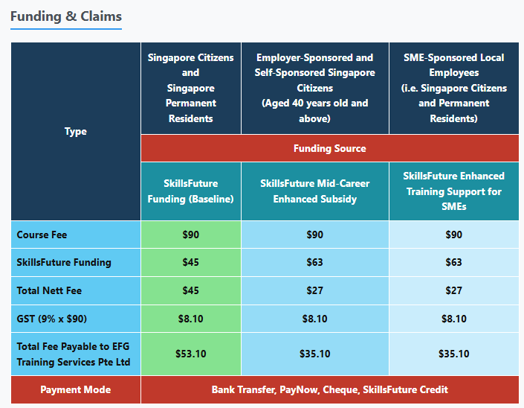

APPLY WORKPLACE SAFETY AND HEALTH IN PROCESS PLANT



Ways to register
EFG TRAINING SERVICES PRIVATE LTD
WSQ Approved Training Organization (SSG), Learning Service Provider by GIC. No: 3 Soon Lee Street # 01-16&23 Pioneer Junction
Tel: 6334-7872, WhatsApp: 91814091
Singapore 627606
E-mail: admin@efg.com.sg
Website: www.efg.com.sg

