
EFG TRAINING SERVICES PRIVATE LTD
INDIVIDUAL COURSE PRE-REGISTRATION FORM
PART A: COURSE INFO | RMATION
COURSE TITLE:
COURSE DATE:
COURSE LANGUAGE: | BATCH NO:

PART B: APPLICANT DETAILS
NAME (as in NRIC): |  |  |  |  |  |  | GENDER: | Male Female
ID TYPE: |  | N | RIC Passport | S-Pass Dependent’s Pass |  |  | NATIONALITY:
 |  | PR |  | Employment Pass |  |  | RACE:
NRIC/FIN/PP: |  |  |  |  |  |  | DATE OF BIRTH:
CONTACT  NUMBER: ( | HP)
EMAIL ADDRESS:
HIGHEST QUALIFICATION:
EMPLOYMENT STATUS: |  |  | Employed (If employed, please state) |  | Company:
 |  |  | Unemployed |  | Designation:
If employed, please state monthly salary: |  |  | Below $1000  $3000 - $3500 | $1000 - $1499  $3500 and above | $1500 - $2000 |  | $2000 - $2500 | $2500 - $3000
Note: Required for SSG funding requirement

PART C: ACADEMIC/PROFESSIONAL QUALIFICATION/WORK EXPERIENCE
Academic Qualification:

‘N’ Level ‘O’ Level WPLN Diploma Degree (or)
Professional Qualification:
BCSS LSSC OPISCS SSSC CSSA ECO RM Level 4 Formwork WAH(S) RS

(or) Others
Work Experience: I have years of experience in WSH in Sector (industry).
(Participants shall provide copies of relevant certificates/documents/NRIC)

PART D: OTHER DETAILS (PLEASE TICK ACCORDINGLY)
1. Are you applying for funding? | Yes No | If yes, please state:
2. Have you been given funding before for the course you are applying for? | Yes No | If yes, please state:
3. Are you applying for Skills Future - Credit | Yes No
* Note: Skills Future Credit must be submitted 60 days before the course start date *

Grant Details
- Are you applying for SSG funding? Yes No
These grants are applicable only for Singapore citizens and Singapore Permanent Residents. Foreigners are not eligible.
Grant Disbursement Criteria
To qualify for grant disbursement, the following conditions must be met:

- Training Grant Criteria: To qualify for SkillsFuture Singapore (SSG), the trainee must be receiving at least 03 months of CPF contributions from the sponsoring company. Otherwise, funding will likely be rejected, and we will have to back charge the fees to you. Thank you for your understanding
Please note that the funding is subject to final approval and disbursement by Skills Future Singapore (SSG). If the funding is not approved or released for any reason after the course, the trainee and/or sponsoring company shall be liable to pay the full outstanding course fees. This may include, but is not limited to, reasons such as insufficient attendance, failure to meet assessment requirements, ineligibility based on CPF contributions, or any other non-compliance with SSG funding criteria
- Attendance Requirement: The Trainee must achieve 100% attendance.
- Assessment: The Trainee must pass all prescribed examinations or assessments.

- Payment: All course fees must be paid in full on or before course date

(Please note that EFG Training Services will not be held liable for any rejected grant applications if the required procedures
And documentation is not followed.)

Singapore Citizens/Singapore Permanent Residents applying for grants- mandatory to take attendance using Singpass App

Terms and conditions
- Trainees are reminded to be dressed in proper attire. E.g. Long pants, shirts, covered shoes or safety shoes for classes etc. No shorts and slippers are allowed.
- Participants are reminded to be in class on time. Latecomers are STRICTLY NOT ALLOWED into the class.
- Results will not be uploaded to MOM website, if the trainee is registered for the course with the passport number.
- Personal information collected is for the use ONLY for course registration, account servicing of course-related activities, course survey and / or for application of course-related funding (only if applicable)
- Course surveys shall be conducted by SSG for selected courses through the trainees’ emails or contact given
- Registration forms shall be submitted 3 days before the course commencement date
- The company reserves the right to revise the course fee without prior notice, to cancel or postpone the course due to unforeseen circumstances.

Refund and Withdrawal Policy
- Payment is required upon receipt of confirmation.
- A 100% refund will be provided if a written notice of withdrawal is received by EFG at least three (3) working days before the course commencement date.
- No refund will be given if EFG receives the notice of withdrawal within three (3) working days before the course commencement date.
- No refund will be issued if the participant fails to attend the course on the commencement date or discontinues mid-way through the course.
- Participant replacement is allowed, provided that the request is made prior to course commencement.
- If EFG cancels the course within three (3) working days before the course commencement date, the refund or alternative arrangement will be reviewed and decided by Management on a case-by-case basis.
- EFG reserves the right to review and decide on any exceptional cases at Management’s discretion.

I, the Applicant consents to the collection, use and disclosure of my personal data and training records to companies that access the Ministry of Manpower (MOM)’s Training Record System (TRS). Companies using the Check Workers’ WSH Training Records eService on the MOM website may verify my training records, including the following information:
- Identification Number (Work Permit / FIN / NRIC Number) & Name Eligibility for 4 years of Safety Orientation Course (CSOC / SSIC / MSOC certification, if applicable) & Course Title & Name of Training Provider & Date of Assessment & Certificate Expiry Date & Result of Assessment
- I confirm I have received and understood pre-course information and all pages of this document.
By checking the boxes above and signing below, I confirm my consent for the disclosure of the selected information.

_______________________ ________________________ __________________
For Official Use Only
Verify By:
Signature:
Date :

Name: Signature Date
For Official Use Only
Verify By:
Signature:
Date :

For Office Use Only
Verify By:
Signature:
Date:

Course Fees: $250/-per participant (Excluding 9% GST)
Total course fee: $____

Payment Mode: Cash Cheque Cheque No. __________ Pay Now Bank Transfer

(payable to EFG Training Services Private Ltd)
For Official Use Only
Verify By:
Signature:
Date :

For Official Use Only
Verify By:
Signature:
Date :

OPERATE SCISSOR LIFT
Course Overview
The “Operate Scissor lift “Course is aimed at providing individuals with the knowledge and skills to operate scissor lifts safely. At the end of the course, participants will be proficient in selection of appropriate scissor lifts, conducting risk assessment and route checks, identification of hazards for scissor lift operations, basic scissor lift operations and reinstating scissors lift in a safe manner.

Entry Requirement
Learners must be above 18 years of age and are assumed to
- Have a basic knowledge of the relevant sector of work
- WPLN 3
- Be medically fit to work at height

Target Audience
The “Operate Scissor Lift” Course is suitable for aspiring and experienced individuals assigned as Scissor Lift Operators in the workplace.
Course Content
- Prepare to carry out Scissor lift operations
- Carry out Scissor lift operations
- Conduct post operation

Course Duration
- 9 Hours 15 Minutes including 1 Hour 15 Minutes of assessment

Medium of Instruction: English, Tamil, Bengali, Mandarin

Teaching Methodology: Face to face classroom and practical teaching

Learning Environment: Our ergonomically designed classrooms are fully air-conditioned, equipped with
whiteboards; audio/video equipment and free wi-fi.

Class Size: Maximum 5

Facilitator/Learner Ratio: 1:5 for Theory Lesson & Assessment

Course Attendance Minimum: 100% attendance

Assessment Advice: E-MCQ Assessment / Practical Performance
Passing Criteria
MCQ – 80%
Practical – 100%

Certifications
Based on the successful completion of the course and assessment, a card of achievement endorsed by EFG Training Services Private Ltd a Statement of Attainment (SOA) will be awarded by Skills Future Singapore Agency (SSG) will be awarded to the trainee. E-cert available

Course Fees
$250+GST

Course Venue Theory & Practical

No. 3 Soon Lee Street, #01-16 & 23 Pioneer Junction, Singapore 627606

Funding & Claims

  - Skills future credit/funding available
SFC:
-All Singaporeans aged 25 and above can us their $500 Skill Future Credit from the government to pay for a wide range of approved skills-related courses. visit the Skills Future Credit website (www.skillsfuture.sg/credit) to choose from the courses available on the Training Exchange course directory
Mandatory adoption of e-attendance via Sing Pass from 1 October 2023: As per the SSG regulation we are introducing “e-attendance via Sing Pass,” for participants applying for funding. To ensure a smooth process, please verify your Sing Pass app access before attending the course. Kindly note that manual attendance submissions will not be accepted for funding invoices. Thank you for your cooperation.
Skills Future Singapore Hotline: For enquiries relating to skills, training and portal issues, please contact Skills Future Singapore at 6785 5785

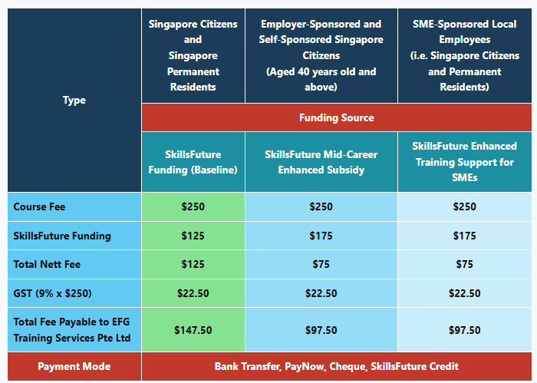.

OPERATE SCISSOR LIFT
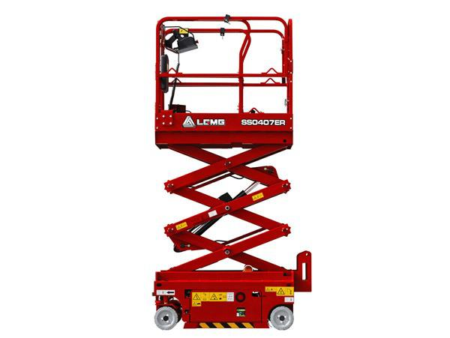

Ways to register
EFG TRAINING SERVICES PRIVATE LTD
WSQ Approved Training Organization (SSG), Learning Service Provider by GIC. No: 3 Soon Lee Street # 01-16&23 Pioneer Junction
Tel: 6334-7872, WhatsApp: 91814091
Singapore 627606
E-mail: admin@efg.com.sg
Website: www.efg.com.sg

