SUPERVISE WORK IN CONFINED SPACE OPERATION (ENGLISH)

Course Date: ___________________________________ Batch No: ____________________________________

Company Name: ________________________________________________________________________________

Contact Person: ____________________________________ H/P: ____________________________________

Tel: ________________ Fax: _________________ Email: ______________________________________________

Address: ______________________________________________________________________________________

No. | NRIC/FIN/WP No: | Full Name | DOB | Nationality | Mobile No | Email ID
1.
2.
3.
4.
5.
6.
7.
8.
9.
10.

Grant Details
- Are you applying for SSG funding? Yes No
These grants are applicable only for Singapore citizens and Singapore Permanent Residents. Foreigners are not eligible.
Grant Disbursement Criteria
To qualify for grant disbursement, the following conditions must be met:

- Training Grant Criteria: To qualify for SkillsFuture Singapore (SSG), the trainee must be receiving at least 03 months of CPF contributions from the sponsoring company. Otherwise, funding will likely be rejected, and we will have to back charge the fees to you. Thank you for your understanding
Please note that the funding is subject to final approval and disbursement by Skills Future Singapore (SSG). If the funding is not approved or released for any reason after the course, the trainee and/or sponsoring company shall be liable to pay the full outstanding course fees. This may include, but is not limited to, reasons such as insufficient attendance, failure to meet assessment requirements, ineligibility based on CPF contributions, or any other non-compliance with SSG funding criteria
- Attendance Requirement: The Trainee must achieve 100% attendance.
- Assessment: The Trainee must pass all prescribed examinations or assessments.

- Payment: All course fees must be paid in full on or before course date

(Please note that EFG Training Services will not be held liable for any rejected grant applications if the required procedures
And documentation is not followed.)

Singapore Citizens/Singapore Permanent Residents applying for grants- mandatory to take attendance using Singpass App

Terms and conditions
- Trainees are reminded to be dressed in proper attire. E.g. Long pants, shirts, covered shoes or safety shoes for classes etc. No shorts and slippers are allowed.
- Participants are reminded to be in class on time. Latecomers are STRICTLY NOT ALLOWED into the class.
- Results will not be uploaded to MOM website, if the trainee is registered for the course with the passport number.
- Personal information collected is for the use ONLY for course registration, account servicing of course-related activities, course survey and / or for application of course-related funding (only if applicable)
- Course surveys shall be conducted by SSG for selected courses through the trainees’ emails or contact given
- Registration forms shall be submitted 3 days before the course commencement date
- The company reserves the right to revise the course fee without prior notice, to cancel or postpone the course due to unforeseen circumstances.

Refund and Withdrawal Policy
- Payment is required upon receipt of confirmation.
- A 100% refund will be provided if a written notice of withdrawal is received by EFG at least three (3) working days before the course commencement date.
- No refund will be given if EFG receives the notice of withdrawal within three (3) working days before the course commencement date.
- No refund will be issued if the participant fails to attend the course on the commencement date or discontinues mid-way through the course.
- Participant replacement is allowed, provided that the request is made prior to course commencement.
- If EFG cancels the course within three (3) working days before the course commencement date, the refund or alternative arrangement will be reviewed and decided by Management on a case-by-case basis.
- EFG reserves the right to review and decide on any exceptional cases at Management’s discretion.

I, the Applicant consents to the collection, use and disclosure of my personal data and training records to companies that access the Ministry of Manpower (MOM)’s Training Record System (TRS). Companies using the Check Workers’ WSH Training Records eService on the MOM website may verify my training records, including the following information:
- Identification Number (Work Permit / FIN / NRIC Number) & Name Eligibility for 4 years of Safety Orientation Course (CSOC / SSIC / MSOC certification, if applicable) & Course Title & Name of Training Provider & Date of Assessment & Certificate Expiry Date & Result of Assessment
- I confirm I have received and understood pre-course information and all pages of this document.
By checking the boxes above and signing below, I confirm my consent for the disclosure of the selected information.

___________________ __________________________
For Official Use Only
Verify By:
Signature:
Date :

Name: Signature/Date
For Official Use Only
Verify By:
Signature:
Date :

Company Stamp

Course Fees: $250/-per participant (Excluding 9% GST)
Total course fee: $____

Payment Mode: Cash Cheque Cheque No. __________ Pay Now Bank Transfer

(payable to EFG Training Services Private Ltd)
For Official Use Only
Verify By:
Signature:
Date :

For Official Use Only
Verify By:
Signature:
Date :

For Office Use Only
Verify By:
Signature:
Date:

SUPERVISE WORK IN CONFINED SPACE OPERATION

Course Overview
The Workplace Safety and Health Sect. 12 (3) stipulate that “It shall be the duty of every employer to ensure that those person at any work have received adequate instruction, information, training and supervision as is necessary unless he has undergone a safety and health training course approved by the commissioner for Workplace Safety and Health”.
Participants are expected to be self-directed, with a mind to acquire skills and knowledge. They should be able to apply the acquired skill & knowledge to perform the duties of an entrant and attendant when working in a confined space, use gas detection instruments and participate in an emergency.

Who should attend this course?
The job roles / occupations that this unit would be relevant to may include but not limited to the following parties related to / in the industry performing the duties:
- Supervisor
- Rescue personnel
- Manager
- Company Safety Personnel
- Engineers
- Technician / Operators

Course Objectives
CE1 – Identify duties and responsibilities of a Confined space work under the WSH Legislations and Codes of Practice
CE2 – Identify, prevent and control confined space hazards
CE3 – Carry out and comply with the requirements of the Confined Space Entry Permit System using a systematic approach
CE4 – Apply Gas Detection Instruments and other control measures when working in confined space
CE5 – Implement the safe use of personal protective equipment and respiratory protective equipment when in a confined space
CE6 – Assist in implementing an Emergency Response Plan

Pre-Requisites
Learners will be taught on the practical approach in using various tools, tactics, tips and know-how, contextualised to the needs of different sectors, including building and engineering construction services. Learners will also acquire a deeper skill set as they learn how to match these skills to different situations and have the knowledge and expertise at their disposal.
Supervise Work in Confined Space Operation is one of the skills that comes under all process sectors for competency level 3.

Trainer to Trainee Ratio
1: 20

Attendance requirements
100% classroom session

Assessment
Online Assessment (MCQ – 50 Questions)
Case Studies & RA (Passing Mark 65%)

Training Methodology
Slides presentation, sharing of best practice and incident. Hands on practical session.

Passing marks
Learners must achieve Competent results

Certifications
Upon successful completion of the course a Statement of Attainment (SOA) will be awarded by SkillsFuture Singapore Agency (SSG). Certificates Cards shall be endorsed by EFG Training Services Private Ltd and issued to participants at the end of course

Course Fees
$250+GST

Course Venue

Venue 1&2: No. 3 Soon Lee Street, #01-16&23 Pioneer Junction, Singapore 627606
Venue 3: No. 5 Soon Lee Street, #04-19 Pioneer Point, Singapore 627607

Funding & Claims

  - Skills future credit/funding available
SFC:
-All Singaporeans aged 25 and above can us their $500 Skill Future Credit from the government to pay for a wide range of approved skills-related courses. visit the Skills Future Credit website (www.skillsfuture.sg/credit) to choose from the courses available on the Training Exchange course directory
Mandatory adoption of e-attendance via SingPass from 1 October 2023: As per the SSG regulation we are introducing “e-attendance via Sing Pass,” for participants applying for funding. To ensure a smooth process, please verify your Sing Pass app access before attending the course. Kindly note that manual attendance submissions will not be accepted for funding invoices. Thank you for your cooperation.
Skills Future Singapore Hotline: For enquiries relating to skills, training and portal issues, please contact Skills Future Singapore at 6785 5785
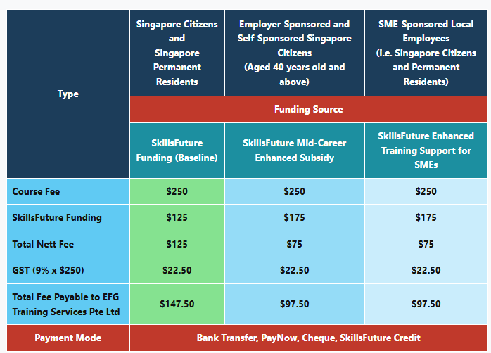

SUPERVISE WORK IN CONFINED SPACE OPERATION

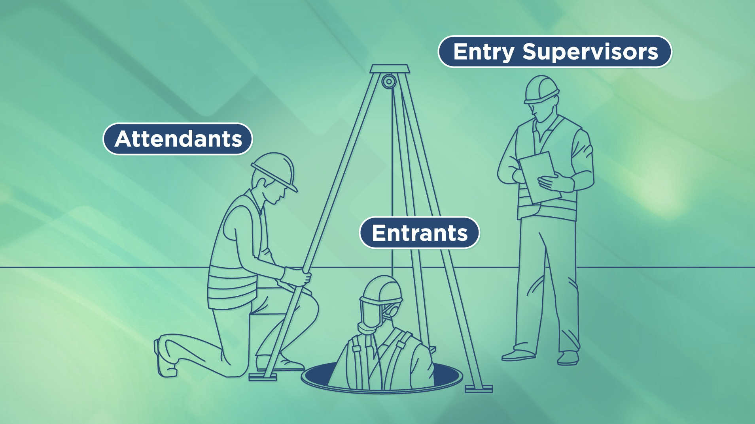

Ways to register
EFG TRAINING SERVICES PRIVATE LTD
WSQ Approved Training Organization (SSG), Learning Service Provider by GIC. No: 3 Soon Lee Street # 01-16&23 Pioneer Junction
Tel: 6334-7872, WhatsApp: 91814091
Singapore 627606
E-mail: admin@efg.com.sg
Website: www.efg.com.sg

