FORKLIFT OPERATOR REFRESHER TRAINING

(English & Tamil)

Course Date: ____ ________________________________ Batch No: ____________________________________

Company Name: ______ __________________________________________________________________________

Contact Person: ____ ________________________________ H/P: ____________________________________

Tel: _ _______________ Fax: _________________ Email: ______________________________________________

Address: _____ _________________________________________________________________________________

No. | NRIC/FIN/WP No: | Full Name | DOB | Nationality | Mobile No. | Email ID
1.
2.
3.
4.
5.

Grant Details
- Are you applying for SSG funding? Yes No
These grants are applicable only for Singapore citizens and Singapore Permanent Residents. Foreigners are not eligible.
Grant Disbursement Criteria
To qualify for grant disbursement, the following conditions must be met:

- Training Grant Criteria: To qualify for SkillsFuture Singapore (SSG), the trainee must be receiving at least 03 months of CPF contributions from the sponsoring company. Otherwise, funding will likely be rejected, and we will have to back charge the fees to you. Thank you for your understanding
Please note that the funding is subject to final approval and disbursement by Skills Future Singapore (SSG). If the funding is not approved or released for any reason after the course, the trainee and/or sponsoring company shall be liable to pay the full outstanding course fees. This may include, but is not limited to, reasons such as insufficient attendance, failure to meet assessment requirements, ineligibility based on CPF contributions, or any other non-compliance with SSG funding criteria
- Attendance Requirement: The Trainee must achieve 100% attendance.
- Assessment: The Trainee must pass all prescribed examinations or assessments.

- Payment: All course fees must be paid in full on or before course date

(Please note that EFG Training Services will not be held liable for any rejected grant applications if the required procedures
And documentation is not followed.)

Singapore Citizens/Singapore Permanent Residents applying for grants- mandatory to take attendance using Singpass App

Terms and conditions
- Trainees are reminded to be dressed in proper attire. E.g. Long pants, shirts, covered shoes or safety shoes for classes etc. No shorts and slippers are allowed.
- Participants are reminded to be in class on time. Latecomers are STRICTLY NOT ALLOWED into the class.
- Results will not be uploaded to MOM website, if the trainee is registered for the course with the passport number.
- Personal information collected is for the use ONLY for course registration, account servicing of course-related activities, course survey and / or for application of course-related funding (only if applicable)
- Course surveys shall be conducted by SSG for selected courses through the trainees’ emails or contact given
- Registration forms shall be submitted 3 days before the course commencement date
- The company reserves the right to revise the course fee without prior notice, to cancel or postpone the course due to unforeseen circumstances.

Refund and Withdrawal Policy
- Payment is required upon receipt of confirmation.
- A 100% refund will be provided if a written notice of withdrawal is received by EFG at least three (3) working days before the course commencement date.
- No refund will be given if EFG receives the notice of withdrawal within three (3) working days before the course commencement date.
- No refund will be issued if the participant fails to attend the course on the commencement date or discontinues mid-way through the course.
- Participant replacement is allowed, provided that the request is made prior to course commencement.
- If EFG cancels the course within three (3) working days before the course commencement date, the refund or alternative arrangement will be reviewed and decided by Management on a case-by-case basis.
- EFG reserves the right to review and decide on any exceptional cases at Management’s discretion.

I, the Applicant consents to the collection, use and disclosure of my personal data and training records to companies that access the Ministry of Manpower (MOM)’s Training Record System (TRS). Companies using the Check Workers’ WSH Training Records eService on the MOM website may verify my training records, including the following information:
- Identification Number (Work Permit / FIN / NRIC Number) & Name Eligibility for 4 years of Safety Orientation Course (CSOC / SSIC / MSOC certification, if applicable) & Course Title & Name of Training Provider & Date of Assessment & Certificate Expiry Date & Result of Assessment
- I confirm I have received and understood pre-course information and all pages of this document.
By checking the boxes above and signing below, I confirm my consent for the disclosure of the selected information.

___________________ __________________________
For Official Use Only
Verify By:
Signature:
Date :

Name: Signature/Date Company Stamp
For Official Use Only
Verify By:
Signature:
Date :

Course Fees: $190/-per participant (Excluding 9% GST)
Total course fee: $____

Payment Mode: Cash Cheque Cheque No. __________ Pay Now Bank Transfer

(payable to EFG Training Services Private Ltd)
For Official Use Only
Verify By:
Signature:
Date :

For Official Use Only
Verify By:
Signature:
Date :

For Office Use Only
Verify By:
Signature:
Date:

FORKLIFT OPERATOR REFRESHER TRAINING

Course Overview
This Competency Unit specifies the skills and knowledge required by people to operate in the trade pertaining to operate forklift in the manufacturing / logistics industry in a WSQ Level 1 operation.

Entry Requirement
Learners are assumed to
Trainees must have Valid Forklift License (Candidate must submit their forklift license for verification before enrollment)
Must have completed “Operate Forklift” more than 3 years ago
• Be able to interpret work instructions and technical information.
• WPLN 3
- Above 18 years of age
- Safety shoes and proper attire (no singlet/ shorts/ Bermudas) are COMPULSORY for all

Target Audience
This course aims to provide people already working or wishing to enter the generic manufacturing industry with the skills and knowledge required to operate forklift. The Competency unit would be appropriate for people with job titles such as Forklift driver.
Course Content
Types of forklifts and their load capacities
- Parts of forklift and their functions
- Workplace safety and health code of practice relating to forklift practice
- Protecting loads from damage during documentation
- Reporting procedures if work preparation is not completed
- Main parts of forklifts to be inspected
- Constituents of each main part of forklift to be inspected
- Safety precautions in inspecting forklift
- Cargo handling symbols
- Forklift stability
- Operating procedures for different types of loads
- Safety precautions in lifting potentially hazardous loads
- Operating procedures for different types of terrains and confined spaces
- Workplace safety and health code of practice relating to forklift operations
- Procedures of reporting unsafe/unauthorised forklift practices
- Procedures relating to parking of forklift
- Handover procedures of forklift

Medium of Instruction: English & Tamil

Teaching Methodology:

- Online Asynchronous e-learning and In-person workshop lecture presentation, group discussion, case studies, demonstration, practical, observation, practical assessment and feedback

Course Content
Online Training (Asynchronous e-Learning for 7 modules)
Relevant Workplace Safety & Health (WSH) Legislations/Singapore Standards S5573,applicable to forklift operation
Refresh on the correct interpretation of the Load Chart
Forklift Stability
Pre-Operational & Post Checks on a Forklift Machine
Techniques and requirements for safe operations
Highlights on the common safety lapses by forklift operators and the consequences.
Safety Rules (Do’s and Don’ts)
Workshop (In person training)
4 case studies
Forklift Practical inclusive of 15 mins practical assessment
Demonstration by trainer and skills practice by learners
The trainer will explain and demonstrate the following activities:
• Prepare to carry out forklift operations
• Inspect forklift
• Carry out forklift operations
• Reinstate and handover forklift

Course Duration:

- 12 Hours (11 training hours + 1 assessment hour (theory and practical))
- Online Theory @ 4 hours via asynchronous e-learning covering 7 modules inclusive of 45 mins of Formative Assessment with 4 MCQs per module.
- 1 day workshop @ 8 hours [4 Case Study (4 hours) + Forklift Practical (4 hours inclusive of 15 mins for practical assessment per trainee]

Learning Environment:

- EFG E-Learning Portal & EFG Trainer Portal. Our ergonomically designed classrooms are fully air-conditioned, equipped with whiteboards; audio/video equipment and free wi-fi.

Class Size: Maximum 5
Facilitator/Learner Ratio: 1:20 for Theory Lesson & Assessment | 1:1 for Practical Lesson & Assessment
(Group of 5 trainees to 1 Forklift/Trainer)

Course Attendance Minimum: 100% attendance

Assessment Advice: Online Training (Asynchronous e-Learning for 7 modules)
E-MCQ Assessment 60% pass
Practical Performance 100% pass

Certifications
Based on the successful completion of the course and assessment, Card & Certificate should be endorsed by EFG Training Services Private Ltd and issued to participants at the end of course.

Course Fees: $190+GST

Course Venue Theory & Practical
No. 3 Soon Lee Street, #01-23 Pioneer Junction, Singapore 627606

Funding & Claims
  - Skills future credit/funding available
SFC:
-All Singaporeans aged 25 and above can us their $500 Skill Future Credit from the government to pay for a wide range of approved skills-related courses. visit the Skills Future Credit website (www.skillsfuture.sg/credit) to choose from the courses available on the Training Exchange course directory

Mandatory adoption of e-attendance via SingPass from 1 October 2023: As per the SSG regulation we are introducing “e-attendance via Sing Pass,” for participants applying for funding. To ensure a smooth process, please verify your Sing Pass app access before attending the course. Kindly note that manual attendance submissions will not be accepted for funding invoices. Thank you for your cooperation.
Skills Future Singapore Hotline: For enquiries relating to skills, training and portal issues, please contact Skills Future Singapore at 6785 5785

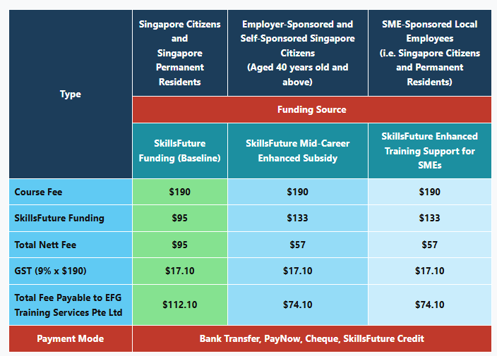

FORKLIFT OPERATOR REFRESHER TRAINING

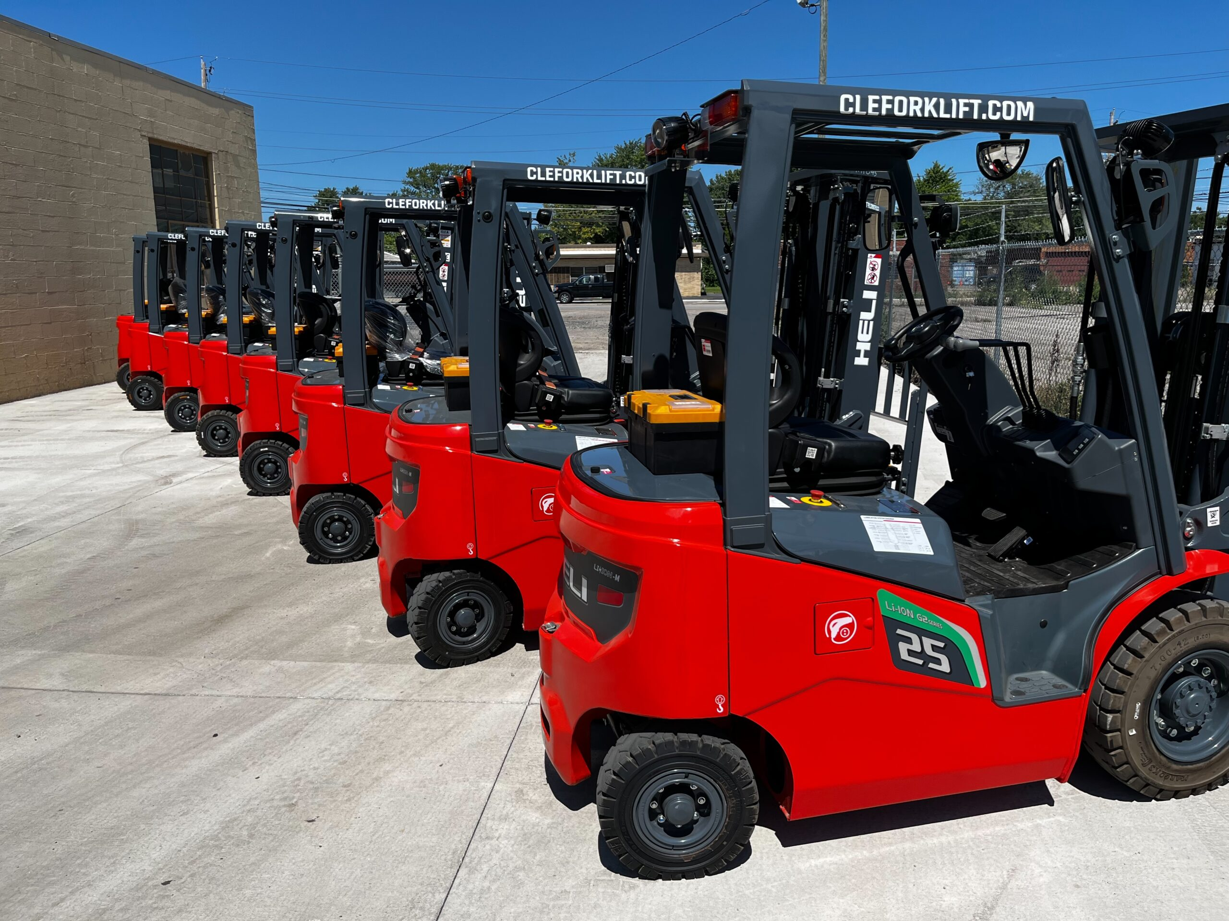

Ways to register
EFG TRAINING SERVICES PRIVATE LTD
WSQ Approved Training Organization (SSG), Learning Service Provider by GIC. No: 3 Soon Lee Street # 01-16&23 Pioneer Junction
Tel: 6334-7872, WhatsApp: 91814091
Singapore 627606
E-mail: admin@efg.com.sg
Website: www.efg.com.sg

