RETEST-SHIPYARD SAFETY INSTRUCTION COURSE FOR WORKERS (G T)
(English, Tamil, Malay, Mandarin, Bengali, Thai, Hindi and Burmese)

Company Name: ________________________________________________________________________________

Contact Person: ____________________________________ H/P: ____________________________________

Tel: ________________ Fax: _________________ Email: ______________________________________________

Address: ______________________________________________________________________________________
No. | NRIC/FIN/WP No: | Full Name | Nationality | Mobile No. | Email ID
1.
2.
3.
4.
5.
6.
7.
8.
9.
10.
Course Fees: $30/-per participant (Excluding 9% GST)

Total course fee: $___________Payment Mode: Cash Cheque No. ______________ (payable to EFG Training Services Private Ltd)

Terms and conditions

- Personal information details collected is for the use ONLY for course registration, account servicing of course-related activities, course survey and / or for application of course-related funding (only if applicable)
- Course surveys shall be conducted by SSG for selected courses thru the trainees emails or contact given
- Registration forms shall be submitted 7 days before the course commencement date
- The company reserves the right to revise the course fee without prior notice, to cancel or postpone the course due to unforeseen circumstances
- Replacement and Withdrawal
90% refund will be made if the notice of withdrawal in writing is received by EFG 6-4 days before the course commencement date. No refund will be given if EFG received the notice of withdrawal 3 working days before the course commencement date. Replacement of participant is allowed if the request is made before the commencement of the course

__________________ __________________________
Name: Signature/Date

Company Stamp

Course Overview

The Workplace Safety and Health (Shipbuilding and Ship-repairing) Regulations 2008 Reg. 6 (2) stipulates that "It shall be the duty of every person not to carry out any work deemed hazardous in a shipyard or on board a ship in a harbor unless he has undergone a safety and health training course approved by the commissioner for Workplace Safety and Health".

Who should attend this course?

The Retest Shipyard Safety Instruction Course for Workers (GT) is a mandatory WSH training course for all workers working in the shipbuilding and ship repairing industry. Workers must possess a VALID AWSHS (GT) Course before they could take this course to start work at the shipyard. The Course is Mandatory WSH training course for all workers working in the shipbuilding and ship repairing industry

Pre-Requisites / Assume Skills and Knowledge

Able to read, interpret and understand the language in which they are taking the course.

Facilitator/Accessor or Invigilator /Learner Ratio:

1: 40

Course Duration
2.0 Hours (Including 1 hour Assessment)

Attendance requirements
100%

Assessment
Online Multiple Choice Questions (MCQ)
1-hour of written assessment with 40 multiple choice questions (MCQ) test. The passing mark for the written assessment is 60%. Failure to pass the assessments shall render a “Fail” outcome for the learner and he must then re-attempt the full course and assessments.

Medium of Instruction
English, Tamil, Malay, Mandarin, Bengali, Thai, Hindi and Burmese

Certifications
Certificates Cards shall be endorsed by EFG Training Services Private Ltd and issued to participants at the end of course.

Course Fees
$30+GST

RECERTIFICATION-SHIPYARD SAFETY INSTRUCTION COURSE FOR WORKERS (G T)

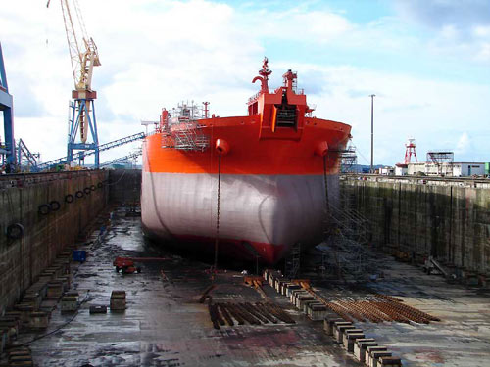

EFG TRAINING SERVICES PRIVATE LTD
WSQ Approved training organization (ATO)

No: 3 Soon Lee Street
# 01-16 Pioneer Junction
Singapore 627606

Ways to register
TEL: 6334-7872
FAX: 6334-7891
E-mail: admin@efg.com.sg
No: 3 Soon Lee Street
# 01-16 Pioneer Junction
Singapore 627606

Website: www.efg.com.sg

