FINANCIAL PODS
Engineering, Deployment & Coding Playbook
Repository standards • Agent instructions • CI/CD • security • observability • release quality • detailed environment setup
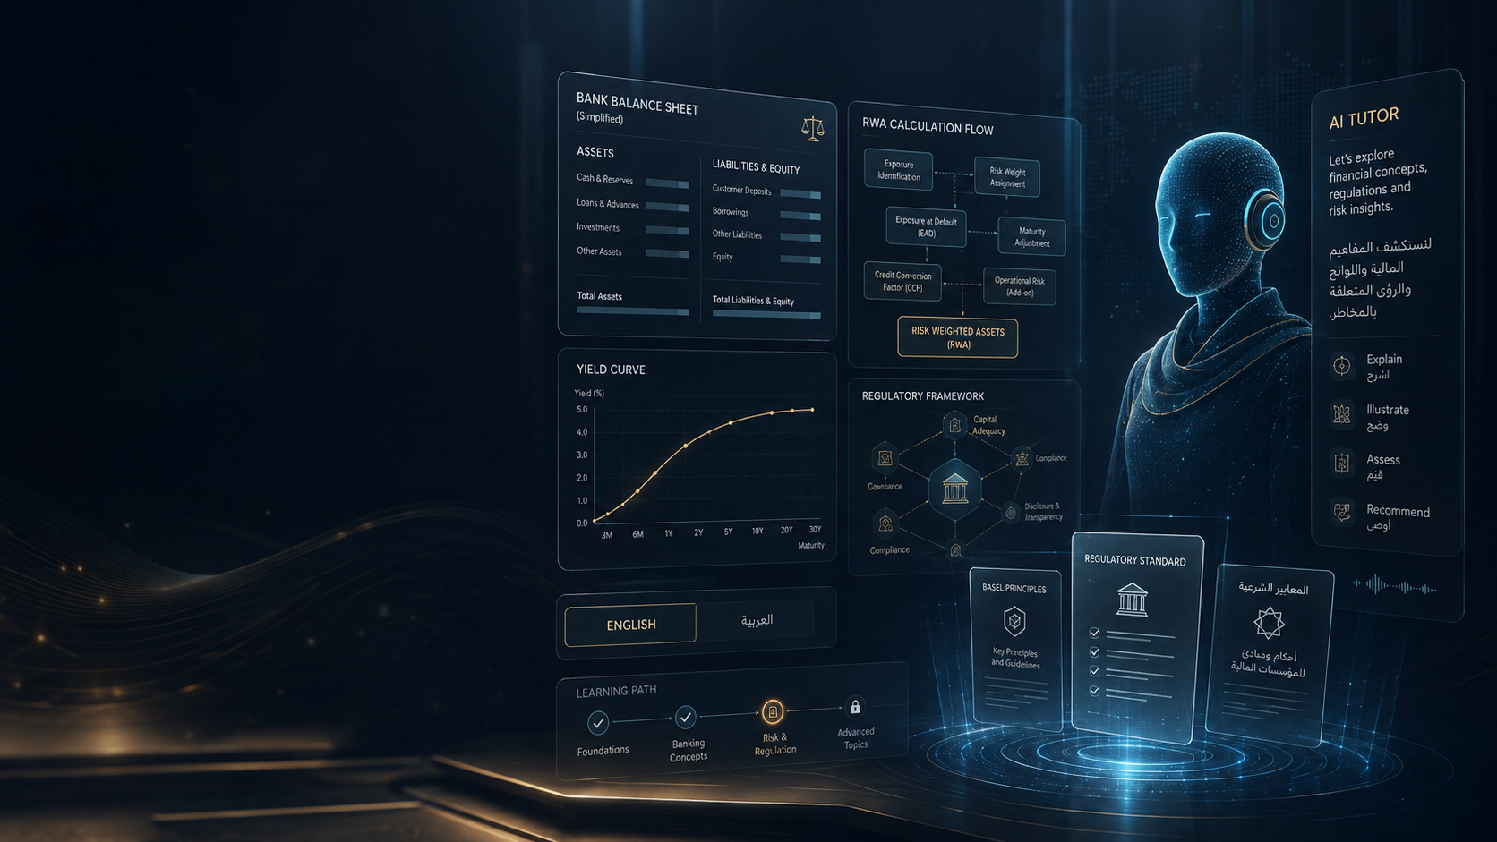
Document status
Architecture Lock Draft v0.9. This is intentionally detailed so product, engineering and SME reviewers can challenge it. Move to v1.0 only after the lock checklist at the end is accepted.

Prepared August 16, 2026

Contents
1. Engineering Principles
2. Repository and Module Structure
3. Developer Environment
4. Coding Standards
5. API and Domain Design
6. Database and Migration Standards
7. AI/Agent Engineering Standards
8. Regulatory Content Engineering
9. Testing Strategy
10. CI Pipeline
11. CD and Environment Promotion
12. AWS Deployment Strategy
13. Observability and SLOs
14. Security and Privacy Engineering
15. Cost and Provider Governance
16. Release and Incident Management
17. Enterprise Deployment Evolution
18. Agent Skills and Markdown Governance
19. Step-by-Step Build Sequence
20. Definition of Done and Lock Checklist

1. Engineering Principles
- Correctness over cleverness: financial/regulatory calculations and source status are deterministic and testable.
- Modular monolith before microservices: preserve boundaries in code; split services only for measured independent scaling or security needs.
- Managed infrastructure first: spend engineering time on differentiated tutoring, simulation and content quality.
- Providers are replaceable: AI, voice, avatar, image and video integrations live behind adapters.
- Everything versioned: rules, lesson content, prompts, model/provider choices, calculator rulesets, assessment rubrics and media.
- Every AI change is an evaluated software change, not “just a prompt tweak.”
- Every external call has timeout, retry policy, idempotency/cost awareness and observability.
- Every production incident must be diagnosable through trace IDs without exposing learner secrets in logs.

2. Repository and Module Structure
Recommended monorepo. Keep a single pull-request and release workflow while allowing web/API/worker/realtime processes to deploy independently.
financial-pods/
apps/
web/ # Next.js learner + admin UI
api/ # FastAPI REST/SSE control plane
worker/ # async/durable workflows
realtime/ # optional voice-session broker
packages/
domain/ # provider/framework-independent domain rules
calculations/ # deterministic finance rules/tools
content/ # rule/lesson schemas + publication logic
ai/ # tutor orchestration, policies, eval adapters
telemetry/ # traces/metrics/logs/cost events
ui/ # reusable design-system components
infra/
terraform/
modules/
envs/dev/ staging/ prod/
docs/
adr/
skills/
prompts/
tests/fixtures/
.github/workflows/
AGENTS.md

2.1 Dependency rules
1. Domain packages may not import FastAPI, Next.js, provider SDKs or cloud clients.
2. Application services depend on domain interfaces; infrastructure adapters implement those interfaces.
3. HTTP handlers validate/authenticate then delegate; they do not contain calculations or tutor policy.
4. React components render state and invoke typed client contracts; finance logic stays server/domain-side.
5. Database ORM structures do not become business-domain objects by default.
6. Provider SDKs are isolated so model/voice/video vendor changes do not rewrite business logic.

3. Developer Environment

3.1 Local prerequisites
- Git
- Docker/Compose
- Node.js LTS + pnpm
- Python 3.12+
- uv (or locked Python package manager)
- VS Code/IDE with EditorConfig
- Optional local FFmpeg for media workflows

3.2 Local Compose topology
Service | Purpose | External paid API required?
web | Learner/admin frontend | No
api | FastAPI | No
worker | Async jobs | No
postgres | PostgreSQL + pgvector | No
redis | Cache/session/rate coordination | No
object-store emulator | Local media/files | No
mock-ai | Deterministic tutor provider fake | No
mock-voice | Simulated transcript/voice events | No

3.3 One-command seed
The repository must include a reproducible seed that creates one demo learner, one admin/SME, Golden Lesson content, BCBS/U.S./SAMA/CBUAE rule fixtures, one FinBank corporate exposure and expected calculation results. This allows every coding agent and developer to exercise the same deterministic scenario.

4. Coding Standards

4.1 Python
Area | Standard
Runtime | Python 3.12+ target
Web/API | FastAPI + Pydantic v2
Persistence | SQLAlchemy 2.x + Alembic
Style | ruff lint + format
Typing | mypy; strict on domain/calculation packages
Tests | pytest + coverage; property/golden tests for calculations
Money/numbers | Decimal/fixed-point where authoritative
Dates | timezone-aware UTC internally
Errors | typed domain/application exceptions; no bare except
Logging | structured; no secrets/full prompts by default

4.2 TypeScript
Area | Standard
Language | TypeScript strict mode
Framework | Next.js + React
UI | Tailwind + reusable accessible component primitives
Lint/format | ESLint + Prettier
Unit tests | Vitest
E2E | Playwright
Validation | External payloads validated at boundaries
Rule | No finance/regulatory business logic inside UI components

4.3 Reviewability
- Small PRs with one primary outcome.
- Architecture changes require ADR.
- Migration and rollback described in PR.
- AI behavior changes include eval results.
- Calculation changes include golden-case diff.
- Feature flags for high-cost/experimental provider behavior.

5. API and Domain Design

5.1 API standards
- Versioned `/api/v1` surface.
- Generated OpenAPI compatibility contract.
- Cursor pagination for large lists.
- Idempotency key for billable/state-changing async jobs.
- Unified error envelope: code, message, details, trace_id.
- No provider-native response payloads exposed as public API contracts.
- Calculation output includes ruleset/version/input hash/source IDs.

5.2 State machines
Model important lifecycles explicitly: Lesson publication, regulatory-document status, assessment state, provider job state and subscription entitlement. Avoid boolean “published=true” designs that cannot represent review/superseded/withdrawn states.

6. Database and Migration Standards
- PostgreSQL is authoritative; Redis is disposable.
- Every tenant-owned row carries tenant scope in data-access layer; add database RLS when enterprise isolation needs justify it.
- Published content versions are immutable.
- Learning events are append-only; mastery is derived/current state.
- Use UUID/ULID-style opaque IDs; no business meaning embedded in primary keys.
- Every schema change is an Alembic migration and tested against realistic data volume.
- Large backfills are job-driven, resumable and separately deployable from schema expansion.
- Vector embeddings include model/version/source/content-version metadata.

6.1 Safe migration pattern
1. Expand schema with backward-compatible nullable/new objects.
2. Deploy code that writes new shape while reading old/new where required.
3. Backfill asynchronously with progress/metrics.
4. Validate invariants and counts.
5. Switch reads to new shape.
6. Remove old field only in later release after rollback window.

7. AI/Agent Engineering Standards

7.1 Tutor orchestration
Use a single Tutor Orchestrator with mode-specific policy and tools; avoid spawning many autonomous “agents” unless task boundaries truly need separate expertise. The orchestrator receives structured session context and is responsible for retrieval, tool use, citation enforcement, response policy and mastery event generation.

7.2 Provider abstraction
Interface | Responsibilities
LLMProvider | stream text/structured output, tool calls, token metrics
RealtimeVoiceProvider | session creation, audio events, interruption, transcripts
TTS/STTProvider | chained voice fallback
AvatarProvider | optional realtime or rendered avatar
ImageProvider | illustrative asset generation/editing
VideoProvider | cinematic/short generated sequences
EmbeddingProvider | index/search embeddings

7.3 Prompt versioning
- Prompts are repository files/templates with semantic version/hash.
- Production turn logs record prompt version and provider/model, subject to privacy policy.
- No prompt editing directly in production consoles without export/version control.
- Prompt changes run offline evals before promotion.

7.4 Tool rules
- Tools validate typed inputs server-side.
- Tutor cannot call admin/publication tools from learner session.
- Calculation tools return structured results and source-rule IDs.
- Tool output is never rewritten numerically by the model.
- Every tool call is traced and cost/latency measured.

8. Regulatory Content Engineering
1. Ingest/capture official source and metadata; store a content snapshot/hash where permitted.
2. Map source to canonical BCBS concept and jurisdiction rule.
3. Draft structured explanation/example using AI only as assistant.
4. Attach source locators and explicit proposed/final/effective status.
5. Build calculation fixtures/boundary cases where numerical logic applies.
6. Primary SME reviews interpretation and expected calculation.
7. Localization/editor review validates English/Arabic terminology.
8. Generate/re-render media from approved structured content.
9. Run source/citation/calculation/tutor eval suite.
10. Publish immutable version and track affected learners if a later correction is needed.

9. Testing Strategy
Layer | Tools/examples | Gate
Backend unit | pytest | Required per PR
Calculation | golden fixtures + property/boundary tests | Blocking
DB/integration | real Postgres test container | Required for persistence changes
Frontend | Vitest | Required
E2E | Playwright Golden Lesson journey | Blocking on release
AI eval | versioned Q&A/tool/pedagogy/Arabic cases | Blocking for AI changes
Performance | k6/Locust-style load tests | Before public beta and major scaling
Security | SAST/dependency/secret/container scans | P0/P1 block release

9.1 Test environments
Most automated tests use provider fakes to remain deterministic and inexpensive. A smaller scheduled/provider-integration suite validates real LLM/voice/media APIs because SDK/provider behavior can change independently of our code.

10. CI Pipeline
1. Checkout + dependency lock verification.
2. Secret scan and license/dependency policy checks.
3. Backend lint/format/type check.
4. Frontend lint/format/type check.
5. Unit tests in parallel.
6. PostgreSQL integration/migration tests.
7. Golden calculation suite.
8. Build web/API/worker container images.
9. SBOM + container vulnerability scan.
10. Playwright critical journey against ephemeral/preview environment.
11. AI eval subset when AI/content areas changed.
12. Publish immutable artifacts/images only after all blocking checks pass.

10.1 Branching
Use trunk-based development with short-lived feature branches and protected `main`. Release production from immutable artifacts built from main; do not rebuild source differently for staging and production.

11. CD and Environment Promotion
Environment | Trigger | Purpose | Data
Local | Developer command | Fast feedback | Seeded synthetic only
Preview | PR | UI/API review | Ephemeral/synthetic
Dev | Main merge | Integration | Synthetic/test
Staging | Automatic promotion candidate | Production-like validation | Sanitized/synthetic
Production | Approved promotion of same artifact | Learners | Production learner data

11.1 Production deployment
1. Terraform plan reviewed for infrastructure changes.
2. Deploy backward-compatible DB expansion first if needed.
3. Deploy containers with rolling/canary strategy.
4. Run smoke/readiness and critical Golden Lesson E2E.
5. Monitor error/latency/provider/cost dashboards.
6. Promote feature flags gradually for risky realtime/media changes.
7. Rollback application immediately on threshold breach; data migration rollback follows documented plan.

12. AWS Deployment Strategy
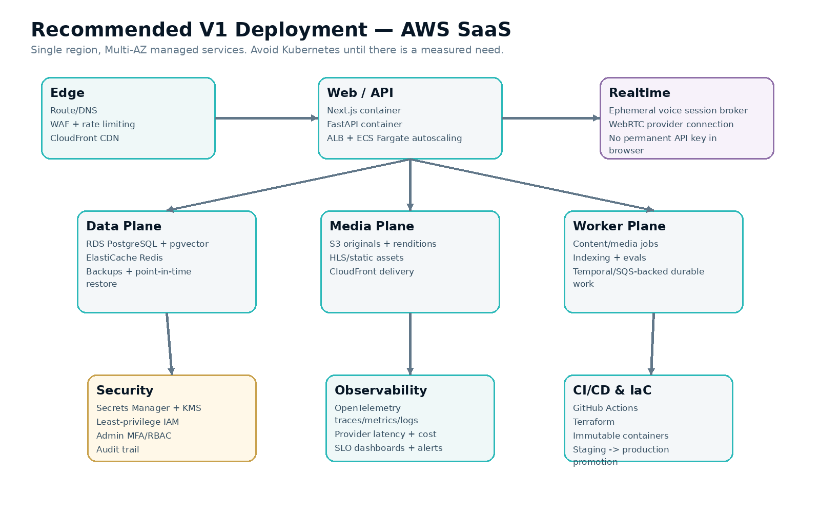
Figure 1 — V1 production topology.

12.1 Service mapping
Capability | AWS reference choice | Rationale
Containers | ECS Fargate | Managed serverless container capacity; no cluster VM administration [R5]
Load balancing | Application Load Balancer | HTTP/S routing to stateless services
Database | RDS PostgreSQL | Managed backups/PITR/Multi-AZ options
Vector retrieval | pgvector extension | Keep V1 retrieval with Postgres [R7]
Cache | ElastiCache Redis | Ephemeral cache/rate/session state
Media | S3 + CloudFront | High-volume static/video delivery without API hop
Secrets/keys | Secrets Manager + KMS | Central secret/encryption management
Edge protection | WAF + rate limits | Abuse and basic application protection
IaC | Terraform | Cloud/provider-neutral declarative infrastructure
Telemetry | OpenTelemetry -> chosen backend | Vendor-neutral instrumentation [R8]

12.2 Why not Kubernetes initially
Kubernetes introduces a second platform to operate before Financial Pods has proven scaling or customer-hosted requirements. ECS Fargate already supports container runtime and load-balanced scaling without managing the underlying VM cluster. [R5] Move to EKS only if dedicated enterprise deployments, advanced scheduling, multi-service scale or organizational needs justify the cost.

12.3 Workflow orchestration
Content/video pipelines are long-running and failure-prone. Temporal is a strong candidate because its durable execution model persists workflow history and resumes after failures. [R6] The lock decision is whether to adopt it immediately or introduce it when the content factory becomes multi-step; either way, domain workflow interfaces should prevent coupling to ad-hoc Celery task chains.

13. Observability and SLOs
Instrument web/API/workers/tutor using OpenTelemetry so traces, metrics and logs share context and can be exported to the monitoring backend we choose. [R8]
Signal | Examples
Availability | web/API health, lesson-start success
Latency | API p50/p95, tutor first-token, voice first-audio, calculation time
Quality | citation retrieval success, tool failure, eval score trends
Learning | checkpoint completion, mastery changes, abandonment points
Cost | tokens, audio seconds, avatar minutes, image/video generation by tenant/feature
Reliability | worker retries, content publication failures, provider circuit-breaker state
Security | auth failures, rate-limit/WAF events, privileged admin actions

13.1 Logging policy
- Structured JSON logs with trace/request IDs.
- Redact secrets and sensitive learner/provider payloads.
- Raw voice/audio not retained by default unless product policy requires/consents.
- Do not log full regulatory source documents repeatedly; log stable source/version IDs.

14. Security and Privacy Engineering
1. Threat-model learner, admin/SME, provider, content-ingestion and media-upload flows.
2. Enforce authorization server-side on every tenant/admin resource.
3. Use short-lived browser credentials for realtime providers; permanent provider keys stay server-side.
4. Minimize context sent to AI/voice vendors and document provider retention/configuration.
5. Protect founder cloned voice IDs/assets as privileged secrets/licensed brand assets.
6. Use dependency, secret, SAST and container scanning in CI.
7. Create audit trail for content publication, entitlements and privileged configuration.
8. Define deletion/export/retention flows before enterprise sales.
9. Review external-generated media provenance and licensing.
10. Run periodic backup-restore and incident exercises.

15. Cost and Provider Governance

15.1 Unit-cost ledger
Every external AI/media call records provider, model, feature, tenant/user/session, usage unit and estimated cost. This makes pricing and quotas evidence-based rather than guessing after launch.
Feature | Cost posture
Pre-rendered video | Generate once; amortize via CDN
Text tutor | Low/medium variable; cache safe reusable retrieval, not personalized answers
Realtime voice | Higher variable; quota/fair-use and premium plan candidate
Live avatar | High variable/optional; premium/feature flag
Image generation | Offline content cost; budget per lesson version
Generative video | Offline selective premium scenes only
Embeddings | Content-version driven, not per page view

15.2 Provider failure strategy
- Circuit breaker/timeouts.
- Fallback provider or degraded text-only mode where practical.
- No lesson should become unwatchable because avatar/voice provider is down.
- Provider contract responses translated into our stable internal interface.

16. Release and Incident Management

16.1 Two release streams
Application release | Content release
Code/infrastructure release through CI/CD | Rule/lesson/media publication through SME workflow
Can rollback container version | Can unpublish/supersede lesson version
Engineering approval | SME + editorial/calculation approval
Versioned artifact/image | Immutable lesson version

16.2 Regulatory-content severity
A materially wrong regulatory explanation/calculation can be as serious as an application outage. Treat widespread authoritative content/calculation error as a high-severity incident: unpublish/flag, preserve audit history, identify affected learners, correct through a new version, rerun all tests/evals and communicate the correction where appropriate.

17. Enterprise Deployment Evolution
Stage | Deployment model | Trigger
1 — Public/B2C SaaS | Shared app, tenant-aware data, single region Multi-AZ | Golden Lesson / early paid users
2 — Enterprise SaaS | Organizations, SSO/SAML/OIDC, SCIM, stronger audit/retention | First bank/team contracts
3 — Regional tenancy | Regional database/media plane or dedicated tenant | Data-residency/customer contract
4 — Dedicated VPC | Separate infrastructure/account/VPC, private networking | Large regulated customer
5 — Customer-hosted/on-prem | Packaged deployment; possibly Kubernetes | Only when commercial demand justifies support burden

18. Agent Skills and Markdown Governance
The companion Developer Agent Starter Pack includes repository-level instructions. Coding agents must read `AGENTS.md` first and task-specific `SKILL.md` files before making changes.
File/skill | Purpose
AGENTS.md | Non-negotiable coding/architecture rules for AI agents
docs/ARCHITECTURE.md | Dependency boundaries and topology
docs/CODING_STANDARDS.md | Python/TypeScript quality conventions
docs/TESTING_STRATEGY.md | Golden calculation + E2E + AI gates
docs/AI_TUTOR_POLICY.md | Grounding, tutor modes, forbidden behavior
docs/REGULATORY_CONTENT_POLICY.md | Source/status/SME publication rules
docs/DEPLOYMENT.md | Environment and AWS reference strategy
skills/regulatory-content-authoring | Checklist for rule/lesson changes
skills/ai-tutor-evaluation | Mandatory eval workflow
skills/release-quality-gate | Pre-production release checks

19. Step-by-Step Build Sequence

Phase A — Architecture lock and repo bootstrap
1. Review Section 20 lock checklist and accept V1 technology decisions.
2. Create Git repository/monorepo structure and copy starter pack documentation.
3. Configure protected main branch and PR template.
4. Bootstrap Next.js app and FastAPI app with health/readiness endpoints.
5. Add Dockerfiles and local Docker Compose for Postgres/pgvector, Redis and object-store emulator.
6. Add ruff/mypy/pytest and ESLint/Prettier/Vitest/Playwright configuration.
7. Add GitHub Actions CI with lint/type/unit/integration jobs.
8. Add OpenTelemetry skeleton and structured logging.
9. Create Terraform dev/staging/prod directory structure without deploying production yet.
10. Commit ADR-0001 documenting modular monolith + AWS/ECS decision.

Phase B — Golden Lesson domain and deterministic core
1. Create RegulatorySource/Document/Rule/JurisdictionRule/Citation schemas and migrations.
2. Create Concept/Lesson/LessonVersion/Segment schemas and publication state machine.
3. Import curated Golden Lesson BCBS/U.S./SAMA/CBUAE rule fixtures with status/version metadata.
4. Refactor current Python capital code behind `CalculationEngine` interface.
5. Build corporate exposure input schema and deterministic results.
6. Create reviewed golden fixtures and boundary tests.
7. Create FinBank seed record and learner-modifiable clone behavior.
8. Expose calculation and comparison APIs with rule/version metadata.

Phase C — Experience, tutor and mastery
1. Build lesson player and semantic timeline contract.
2. Persist LearningEvent stream and resume state.
3. Build text Tutor Orchestrator with approved retrieval and citation objects.
4. Add calculator/compare tools and enforce tool use for numerical answers.
5. Build AI eval harness and seed regulatory/pedagogy cases.
6. Implement checkpoints, mastery and misconception derivation.
7. Add realtime voice session, interruption and transcript events.
8. Add Arabic localization, glossary, RTL and Arabic evals.
9. Add practice templates and viva rubric/scoring.
10. Add admin content review and media publication pipeline.

Phase D — Productionization and pilot
1. Deploy dev and staging using Terraform.
2. Configure WAF, secrets, database backups, alerts and cost budgets.
3. Run load tests and provider-failure tests.
4. Complete privacy/terms/retention decisions for beta.
5. Generate reviewed English/Arabic Golden Lesson media.
6. Run full staging acceptance with SME sign-off.
7. Pilot with 10–20 practitioners and instrument completion/questions/confusion/voice usage/pay intent.
8. Use evidence to decide whether to scale Basel curriculum, change tutor interaction, or adjust pricing before major content production.

20. Definition of Done and Lock Checklist

20.1 Definition of Done
- Acceptance criteria met and accessible responsive UI implemented.
- Typed/linted/formatted code with tests green.
- Golden calculation tests updated and approved if calculation changed.
- AI eval suite passes if prompt/model/retrieval/tool behavior changed.
- Telemetry, error/loading/empty states and cost tracking present.
- Security/privacy review completed for new data/provider flow.
- Migration and rollback documented when persistent schema changes.
- Feature flag/kill switch for experimental high-cost AI/media capability.
- Documentation/ADR updated.
- SME acceptance recorded for authoritative content/calculation changes.

20.2 Decisions to lock with product owner
Decision | Recommendation | Lock?
Cloud | AWS for V1 SaaS | □
Compute | ECS Fargate; no Kubernetes V1 | □
Architecture | Modular monolith, multiple deployable processes | □
Frontend | Next.js/React/TypeScript/Tailwind | □
Backend | FastAPI/Python | □
Primary DB | PostgreSQL + pgvector | □
Cache | Redis, ephemeral only | □
Graph DB | Deferred until measured need | □
Workflow | Temporal timing decision: Sprint 0 vs Sprint 9 | □
Realtime voice | Provider adapter; primary provider selected after Golden Lesson spike | □
Avatar | Optional, not required for learning correctness | □
Languages | English + Arabic | □
Jurisdictions | BCBS + U.S. + SAMA + CBUAE | □
Content governance | SME review required before publish | □
Finance logic | Deterministic Python service, never LLM calculation | □
Repo governance | AGENTS.md + skills + ADR + CI quality gates | □

Reference basis
[R1] OpenAI Voice agents documentation
https://developers.openai.com/api/docs/guides/voice-agents
[R2] HeyGen / LiveAvatar developer documentation
https://docs.liveavatar.com/
[R3] ElevenLabs ElevenAgents documentation
https://elevenlabs.io/docs/eleven-agents/overview
[R4] Google Developers — Gemini 2.5 Flash Image / nano-banana
https://developers.googleblog.com/introducing-gemini-2-5-flash-image/
[R5] AWS — Architect for AWS Fargate for Amazon ECS
https://docs.aws.amazon.com/AmazonECS/latest/developerguide/AWS_Fargate.html
[R6] Temporal documentation — durable execution
https://docs.temporal.io/temporal
[R7] pgvector official repository/documentation
https://github.com/pgvector/pgvector
[R8] OpenTelemetry documentation
https://opentelemetry.io/docs/

