PRUDENTIAL CAPITAL
CHANGE ASSURANCE
Finalized Product, Architecture, Testing, Scalability & Go-to-Market Implementation Plan
Foundation: existing Python Basel III / U.S. ERBA capital engine, unified data model and FFIEC 101 reporting layer
Version 1.0 • 15 August 2026
Prepared as a build-and-commercialization blueprint

1. Executive decision
Build an AI-native, vendor-neutral Prudential Capital Change Assurance platform — not a generic regulatory radar and not a head-on replacement for Oracle OFSAA, Nasdaq AxiomSL, Regnology or Suade.
The current asset base already provides the most difficult foundation: a deterministic Python capital engine, a unified data model (UDM), exposure-level RWA/capital calculations and an FFIEC 101 reporting layer. The commercial strategy is to turn that calculation capability into an independent assurance and regulatory-change product rather than lead with “another Basel engine.”

1.1 First two products
Product | Primary question | Why it is differentiated | Initial buyer
Product A — U.S. 2026 Capital Change Analyzer | What does the March 2026 U.S. capital proposal change for our portfolio? | Connects rule change to products, data, executable logic, ΔRWA/Δcapital, tests and evidence. | Capital implementation, regulatory capital, change programs, consulting teams
Product B — Capital Assurance / RWA Reconciliation | Can we independently reproduce and explain the bank’s existing RWA? | Vendor-neutral comparison against OFSAA, AxiomSL, Regnology or internal engines; explains discrepancies rather than replacing production. | Capital controls, model validation, internal audit, regulatory reporting

1.2 Strategic boundaries
- Do not launch a generic regulatory-news or regulation-chatbot product; incumbent RegTech vendors already cover monitoring, change alerts, applicability, obligations and policy/control mapping.
- Do not replace the Python platform with PySpark. Introduce Spark only as a distributed compute adapter after correctness and scale benchmarks justify it.
- Do not fork a separate code base per country. Use the BCBS Basel Framework as the canonical baseline, with versioned jurisdiction-specific overlays.
- Do not allow an LLM to calculate or modify regulatory capital. AI interprets, investigates, explains, proposes tests and orchestrates controlled workflows; deterministic services own calculations.
- Do not start with every Basel risk type or jurisdiction. Credit risk / standardized / U.S. 2026 is the first implementation boundary.

1.3 Why the timing is useful
On 19 March 2026, the U.S. federal banking agencies proposed a new Expanded Risk-Based Approach (ERBA) for Category I and II banking organizations, while allowing other banking organizations to elect it; the agencies simultaneously proposed standardized-capital changes for other organizations. This creates a concrete regulatory-change use case for an executable impact analyzer. [R2]
FFIEC 101 remains, as of June 2026, the current regulatory capital report for institutions subject to the Advanced Capital Adequacy Framework; FFIEC also shows a June 2026 extension without revision. Therefore the existing FFIEC 101 module should be preserved but isolated behind a versioned reporting-mapping layer because U.S. reporting will evolve with any final capital rules. [R3]
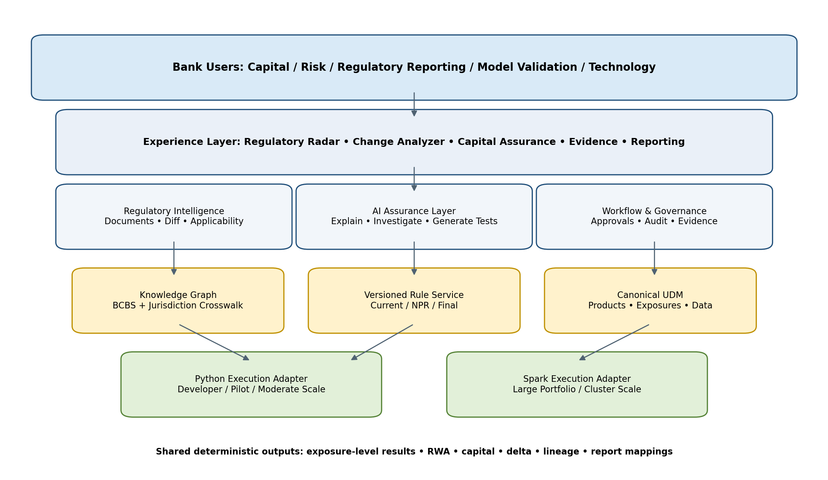
Figure 1 — Target platform architecture

2. Market thesis and competitive position

2.1 What incumbents already do well
The competitive research shows that regulatory monitoring and change management are mature categories. CUBE describes regulatory change management as capturing changes, determining impact on obligations, updating policies/controls and implementing business changes; its platform markets end-to-end regulatory-change lifecycle automation. [R9][R10] FinregE markets machine-readable regulatory records and regulatory interpretations, including prudential-capital domains. [R11][R12]
On the capital/reporting side, Nasdaq AxiomSL markets consolidated capital-risk calculations and reporting, with regulatory-change services that track mandates, assess impact, maintain logic, validate releases and promote updates; Nasdaq also states that AxiomSL is used by 90% of G-SIBs. [R13][R14] Oracle OFSAA markets Basel regulatory-capital applications and broader risk/finance analytical applications. [R15][R16] Suade markets standardized data, regulatory calculations and reporting across jurisdictions. [R17][R18]

2.2 The defendable wedge
White space to validate: vendor-neutral prudential change assurance — regulation → bank products/data → executable rule delta → old/new RWA → incumbent-engine reconciliation → test/evidence pack.
Capability | Generic RegTech vendors | Capital/reporting incumbents | Our intended strength
Regulatory source monitoring | Strong | Moderate | Basic initially; partner/license later
AI summary / obligation extraction | Strong | Increasing | Required, but not moat
Policy/control mapping | Strong | Mixed | Later module
Machine-readable regulation | Strong in some vendors | Strong in some platforms | Core regulatory graph input
Capital calculation | Usually weak/adjacent | Strong | Existing foundation
Portfolio-level old/new rule execution | Rare as primary proposition | Possible within own stack | Core product workflow
Vendor-neutral engine reconciliation | Not core | Usually tied to own stack | Primary differentiator
ΔRWA driver investigation | Not core | Increasingly available internally | Deep, vendor-neutral, evidence-linked
Auto-generated regulatory regression pack | Not core | Some vendor-managed testing | Core product feature
Independent evidence trail | Compliance-centric | Platform-centric | Cross-engine / cross-version assurance

2.3 Commercial positioning
The sales message should be “keep your existing production platform.” A large bank using OFSAA/AxiomSL/Regnology can consume the product as an independent assurance layer. A smaller institution or implementation consultancy can optionally use the embedded capital engine as the calculation backend. This reduces replacement risk and moves the product into control, validation and change-assurance budgets.

2.4 Initial market sequence
Priority | Market | Why | Initial offer
1 | United States — large/regional implementation teams | Immediate 2026 proposal; existing U.S. engine and FFIEC knowledge | Capital Change Analyzer + portfolio impact engagement
2 | Saudi Arabia | SAMA has Basel III post-crisis credit-risk rules and quarterly Q17 RWA/capital reporting. [R6] | Saudi rule pack + change assurance + Q17 mapping
3 | UAE | CBUAE capital standards/guidance are closely based on Basel while applying UAE-specific requirements. [R7][R8] | UAE rule pack + calculation/reconciliation
4 | United Kingdom | PRA Basel 3.1 reporting requirements take effect 1 Jan 2027. [R4] | Readiness/change analyzer + validation
5 | European Union | CRR3/CRD6 changes already feed supervisory reporting; EBA reporting framework has been updated. [R5] | CRR3 crosswalk + COREP impact

3. Product scope: what to build now vs later

3.1 MVP: U.S. 2026 Capital Change Analyzer
MVP capability | Definition | Exit criterion
Rule corpus | Current U.S. treatment + March 2026 NPR + BCBS crosswalk | Each implemented rule has source, version, status and BCBS mapping
Regulatory diff | Added/removed/modified/moved/effective-date/data/calculation change | Human-reviewed diff for all in-scope credit-risk rules
Applicability | Entity category, exposure class, product and rule applicability | Explainable applicability outcome with source citations
UDM impact | Map changed rules to required UDM fields | Affected/missing fields visible by portfolio
Dual execution | Run current and proposed rule sets on same input snapshot | Reproducible old/new RWA outputs
Delta engine | Exposure/product/portfolio ΔRWA and capital | Materiality-ranked driver decomposition
AI explanation | Explain why change occurred using structured evidence | No unsupported calculations; citations to rules/results
Test/evidence pack | Auto-link changed rules to tests and evidence | Exportable implementation/regression pack

3.2 Product B: Capital Assurance / reconciliation
Capability | Description
Bank result ingestion | Load exposure-level or aggregate outputs from OFSAA/AxiomSL/Regnology/internal engines.
Independent execution | Run the same portfolio through the platform’s versioned rule set.
Reconciliation | Match by exposure / legal entity / portfolio and compare classification, EAD, CCF, RW, RWA and capital.
Difference taxonomy | Classify exposure-class, rating, CCF, CRM, collateral, data, rule-version, rounding and mapping differences.
AI investigation | Rank material differences and produce evidence-linked explanations.
Control evidence | Store inputs, versions, approvals, rules, tests, actual/expected results and remediation status.

3.3 Later modules
After the two core products prove demand, add commodity and adjacent features around them rather than before them: regulatory radar/horizon scanning, alerts, obligations, policy/control mapping, change-project workflow, broader reporting, market/CVA/operational risk, liquidity, stress testing, IFRS 9, and additional jurisdictions.

4. Regulatory knowledge graph and guideline strategy

4.1 Canonical guideline: BCBS Basel Framework
Use the consolidated BCBS Basel Framework as the canonical regulatory ontology. For the first release, model only the domains required for credit-risk and capital traceability: SCO (scope), CAP (capital), RBC (risk-based capital), CRE (credit risk) and DIS (disclosures/reporting references where relevant). CRE20 defines the standardized approach for individual exposures; CRE22 covers standardized credit-risk mitigation. [R1][R19]
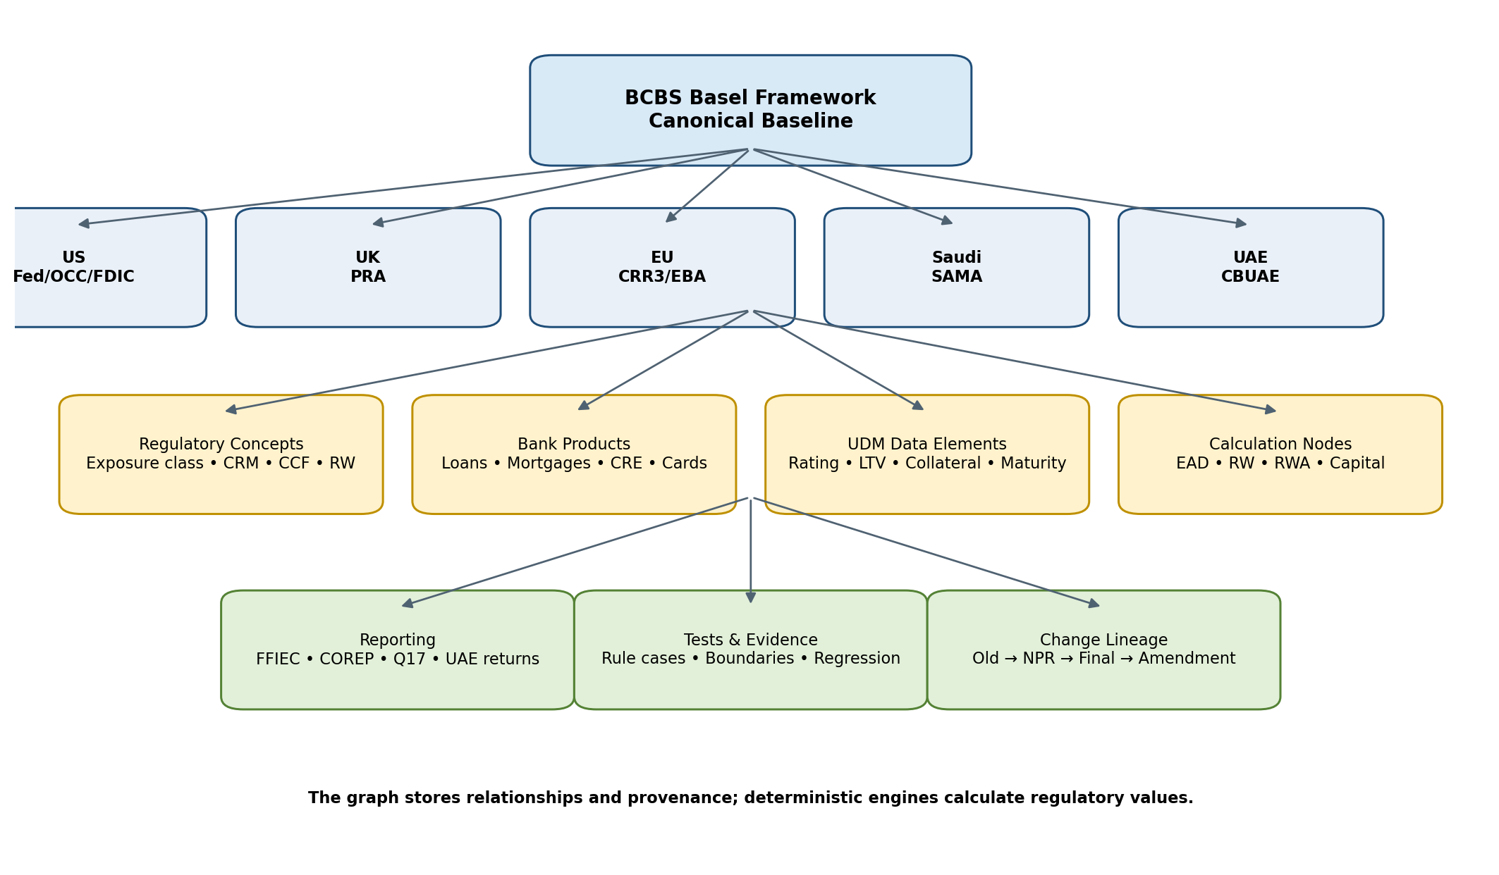
Figure 2 — Canonical BCBS graph with jurisdiction overlays and execution links

4.2 Why a canonical graph instead of country forks
Jurisdictions implement Basel differently and on different timelines. The architecture must represent “BCBS concept” separately from “jurisdiction implementation.” This makes cross-country comparison, rule reuse, change tracking and testing tractable. It also avoids maintaining independent U.S., UK, EU, Saudi and UAE calculation products.

4.3 Core graph entities
Entity | Purpose | Critical fields
regulatory_document | Official publication container | issuer, jurisdiction, publication date, status, URL/hash
canonical_rule | BCBS source rule/concept | BCBS module, paragraph, concept tags
jurisdiction_rule | Executable/local implementation | jurisdiction, source paragraph, status, effective dates
rule_version | Immutable change state | version, predecessor, supersedes, effective dates
rule_crosswalk | Maps BCBS ↔ jurisdiction / old ↔ new | relationship type, confidence, reviewer
change_event | Captures added/removed/modified/moved | change type, materiality, narrative
applicability | Who/what the rule applies to | entity category, exposure, product, thresholds
bank_product | Business product ontology | product type, subtype, jurisdictional mapping
data_element | UDM field referenced by rules | datatype, provenance, quality rules
calculation_component | Executable step | classification/EAD/CCF/CRM/RW/RWA/capital
report_mapping | Rule/result to regulatory form | form, schedule, row/cell, version
test_case | Rule assurance case | scenario, inputs, expected result, evidence
evidence_reference | Traceability object | source, hash, run ID, reviewer, timestamp

4.4 Change lineage
Every rule should retain an explicit version chain (for example: prior rule → 2023 proposal → March 2026 NPR → final rule → technical amendment). The system must never overwrite old logic; a calculation run resolves a specific ruleset as of a specific date/status. Proposed and final rules are separate executable versions.

5. Unified data model and capital data architecture

5.1 Preserve the UDM, but make it jurisdiction-neutral
The existing UDM should become the canonical bank-data contract. Jurisdiction packs must map regulatory concepts to the UDM rather than adding country-specific columns directly into calculation tables. Country-specific fields may exist as extensions, but the core entities should remain reusable.
Domain | Recommended entities / attributes
Counterparty | counterparty_id, type, legal form, jurisdiction, size indicators, credit quality, default status
Exposure | exposure_id, product_id, book, amount, currency, maturity, commitment, drawn/undrawn amounts
Product | product taxonomy, regulatory exposure candidates, secured/unsecured attributes
Rating / credit quality | agency, rating, mapping, date, internal grade, external eligibility
Collateral / guarantee | type, value, currency, haircut inputs, eligibility, guarantor, maturity
Real estate | property type, valuation, LTV inputs, occupancy, income dependency, lien position
CRM / netting | agreement, eligible collateral, guarantee, protection provider, maturity mismatch
Legal entity / consolidation | entity, parent, regulatory perimeter, country, reporting entity
Calculation context | run_id, as_of_date, ruleset_id, jurisdiction, input snapshot hash
Result | classification, EAD, CCF, RW, RWA, capital, intermediate steps, reason codes
Reporting | report version, schedule/cell mapping, source calculation IDs
Overrides / exceptions | original value, proposed value, reason, approver, expiry, evidence

5.2 Mandatory metadata to add
- `calculation_run`: immutable run identity, as-of date, bank/legal entity, ruleset, engine version and input snapshot hash.
- `calculation_step`: intermediate deterministic values; do not store only final RWA.
- `data_lineage`: source field → UDM field → regulatory classification → rule → calculation → report cell.
- `regulatory_override`: controlled ledger; never overwrite the original value.
- `data_quality_exception`: severity, owner, reason, rule, remediation and sign-off.
- `agent_action_log`: every AI prompt/tool/result/recommendation plus human approval state.

5.3 Storage recommendation
For MVP, keep transactional metadata in a relational store (PostgreSQL), regulatory relationships in a graph-capable layer (Neo4j or a graph abstraction over relational storage), and bulk portfolio/result data in Parquet/object storage. The architecture should not require Neo4j to calculate RWA; the graph answers relationships and provenance while rule/execution services calculate values.

6. Versioned rule engine and execution model

6.1 Refactor toward declarative rules
One rule definition; multiple execution adapters. Avoid maintaining a Python Basel engine and a separate Spark Basel engine.
Refactor hard-coded conditional logic gradually into versioned rule definitions with stable identifiers, source citations, applicability conditions, inputs, outputs, effective dates and test links. The rule service should compile/translate these definitions into vectorized Python expressions and, later, Spark SQL/DataFrame expressions where practical.
Rule attribute | Example
rule_id | US_ERBA_CRE_CORP_0001
jurisdiction | US
ruleset | US_NPR_2026_03
status | PROPOSED
BCBS mapping | CRE20.x / CRE22.x
exposure class | CORPORATE
inputs | exposure_amount, rating, default_status, guarantor, collateral...
output | classification / RW / CCF / EAD / RWA
source | Federal Reserve/OCC/FDIC paragraph + document hash
effective/version metadata | publication, proposed/final, valid from/to
tests | golden cases + boundaries + regression suite

6.2 Execution contract
Expose calculation through a stable orchestration contract such as `calculate(portfolio_snapshot, jurisdiction, ruleset_id, engine_adapter)`. The product chooses `python` or `spark` as the execution adapter; rule semantics and expected outputs remain identical.

6.3 Current vs proposed execution
The Change Analyzer must execute the same immutable portfolio snapshot against both the current and proposed rulesets. Store both result sets and a derived delta dataset. Every AI explanation is generated from that structured delta/evidence dataset, not by giving the model unrestricted access to the raw portfolio.

7. Bank-grade testing strategy

7.1 Testing is part of the product
Every regulatory rule version must carry its own tests, expected outputs and evidence. A regulatory change should automatically identify which tests must rerun and which expected results may legitimately change.
Layer | Purpose | Examples
T1 Schema/data validation | Validate UDM contract and data types | required fields, currencies, dates, IDs, duplicates
T2 Rule unit tests | Prove individual regulatory logic | one rule / one scenario / known expected result
T3 Boundary tests | Test every threshold edge | T-ε, T, T+ε, NULL, zero, invalid values
T4 Calculation tests | Validate EAD/CCF/CRM/RW/RWA/capital math | known worked examples
T5 Property/invariant tests | Catch systemic errors | partition additivity, monotonicity where applicable, duplication effects
T6 Portfolio regression | Protect behavior over time | golden 10K–20K portfolio
T7 Regulatory-version tests | Validate intended old/new changes | current vs NPR vs final
T8 Reporting reconciliation | Tie exposure results to regulatory report outputs | FFIEC schedules/cells and validation rules
T9 Performance/scale | Measure SLA and resource usage | 100K, 1M, 10M, 50M, 100M, stress
T10 Engine-vs-engine assurance | Validate adapters and client engines | Python vs Spark; platform vs bank incumbent

7.2 Golden Regulatory Portfolio
Create an owned, deterministic “Basel Capital Golden Portfolio” containing initially 10,000–20,000 carefully designed exposures. Each record should carry expected classification, CCF/EAD, CRM treatment, risk weight, RWA, capital, report mapping, rule ID and citation. No engine release passes CI unless all unexplained differences are resolved.

7.3 Synthetic Regulatory Portfolio Generator
Synthetic set | Purpose | Design
Rule cases | Correctness | Small, deliberate exposures covering every rule branch
Boundary cases | Threshold correctness | Just below/at/above thresholds; missing/invalid categories and dates
Realistic portfolios | End-to-end behavior | Correlated product/borrower/rating/collateral/maturity distributions
Dirty data portfolios | Data quality product testing | Missing ratings/LTV, duplicates, invalid currencies, stale collateral, broken IDs
Scale portfolios | Performance | 1M → 10M → 50M → 100M → 500M records
Change portfolios | Regulatory delta testing | Concentrated in rules changed by a proposal/final rule

7.4 Synthetic data generation rules
- Generate data from regulatory scenarios first, statistics second; random independent columns will create impossible combinations.
- Use deterministic seeds and store generator version so test portfolios are reproducible.
- Tag every synthetic record with one or more intended regulatory scenarios and expected rule paths.
- Maintain separate “known-good” deterministic datasets and large stochastic performance datasets.
- Never use synthetic expected outputs generated by the same code path being tested; golden expected values require independently verified formulas/examples/reviews.
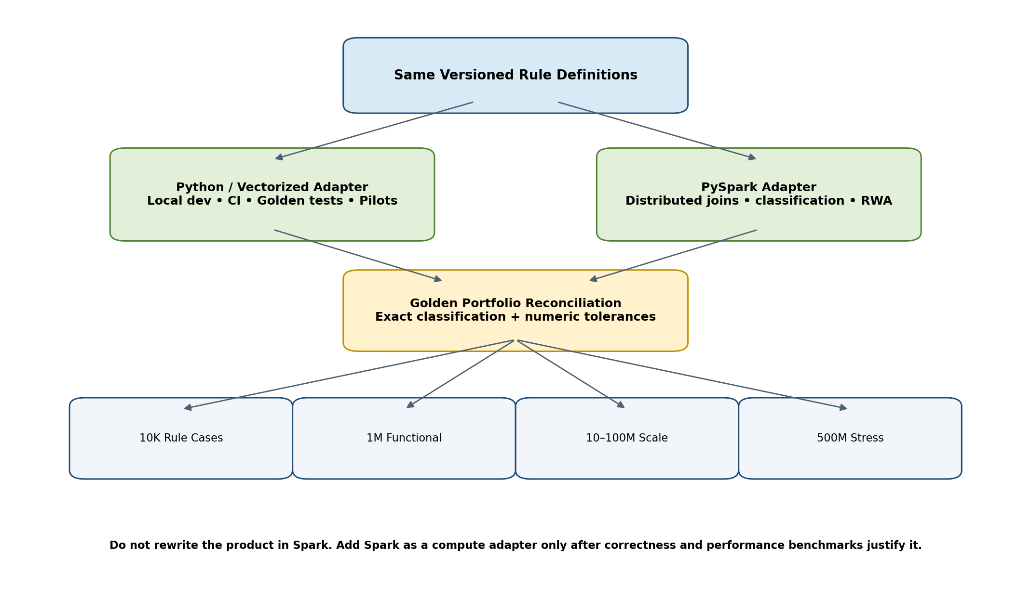
Figure 3 — Correctness-first execution and scalability strategy

8. Python vs PySpark and cluster architecture

8.1 Decision
Keep Python. Do not rewrite the product in PySpark. Add PySpark only as a distributed execution adapter after vectorization and benchmark evidence demonstrate a need.
Apache Spark is designed for large-scale structured-data processing and can run on clusters including Kubernetes. Spark SQL/DataFrames should be preferred over row-by-row Python UDF logic for distributed joins, classifications and aggregations. [R20][R21]

8.2 Workload split
Workload | Preferred layer
API / FastAPI / authentication / orchestration | Python
Regulatory ingestion, parsing, AI agents | Python
Knowledge graph services | Python + database/graph
Rule versioning and compilation | Python
Golden tests / CI | Python/vectorized
Small/moderate portfolio execution | Vectorized Python / DataFrame engine
Very large ingestion, joins, aggregation | PySpark
50M–500M portfolio execution | PySpark/DataFrame / SQL expressions
Reporting aggregation at scale | Spark SQL or warehouse SQL
AI explanation | Python; aggregated evidence only

8.3 Benchmark gate before Spark
Dataset | Purpose | Measure
10K | Developer/golden | correctness + milliseconds/seconds
100K | Functional | end-to-end latency
1M | Small institutional run | CPU/memory; batch SLA
10M | Medium portfolio | parallelism; I/O; joins
50M | Large | distributed break-even point
100M | Large-bank scale test | cluster cost/SLA
500M | Stress | failure recovery, shuffle, partitioning, peak memory

Spark is introduced only when the observed SLA/memory/cost profile justifies its operational complexity. Before that, remove Python row loops and move rule evaluation toward vectorized column expressions so logic can later compile naturally into Spark SQL/DataFrame operations.

8.4 Cluster deployment
When required, support managed Spark or customer-controlled Spark/Kubernetes. Spark’s current documentation describes a driver/executor architecture on Kubernetes. The bank-facing application/control plane remains separate and submits jobs through an execution service. [R20]

9. AI/agent architecture and control model

9.1 Agent responsibilities
Agent/service | Allowed responsibilities | Prohibited responsibilities
Regulatory ingestion agent | classify documents, extract sections/metadata, propose mappings | declare unreviewed text as final executable law
Diff agent | identify candidate added/removed/modified concepts | silently alter production rules
Applicability agent | reason over bank/entity/product metadata with citations | make unsupported legal conclusions
Impact agent | query graph/UDM/rules/results to identify affected data/products | calculate RWA itself
RWA investigator | explain deterministic deltas and reconcile differences | change input/results
Test generator | propose scenarios and edge cases | set expected numeric result without deterministic verification
Evidence/report agent | assemble audit/implementation narratives | omit source/version provenance

9.2 Safe data boundary
Do not send a full raw bank portfolio to an external LLM. Deterministic compute should reduce portfolio data to material aggregates, exceptions, rule references and selected evidence. Where institutions require it, support private/VPC-hosted models or no-external-LLM operation.

9.3 Human approval gates
- Regulatory source onboarding / mapping approval.
- Rule implementation approval and four-eyes review.
- Golden expected-result approval.
- AI-proposed applicability or change-impact approval where material.
- Production ruleset promotion approval.
- Any override or remediation affecting reported results.

10. Reporting and regulatory-change lifecycle

10.1 Reporting as a separate versioned layer
Keep reporting mappings separate from calculation logic. An exposure calculation should produce canonical results and lineage; report packs map those results into FFIEC/COREP/Q17/UAE forms by version. This prevents regulatory form changes from destabilizing core RWA logic.
The current FFIEC 101 layer is a valuable starting asset but must be explicitly versioned because FFIEC 101 remains tied to the current Advanced Capital Adequacy Framework as of June 2026. [R3]

10.2 End-to-end change lifecycle
Stage | System action | Evidence produced
Detect | Identify new official document / status change | source URL, hash, publication metadata
Interpret | Extract/compare regulatory provisions | rule diff + citations
Crosswalk | Map to BCBS and prior jurisdiction rules | crosswalk and reviewer
Applicability | Resolve affected entities/products/exposures | applicability decision
Data impact | Identify required UDM fields/data gaps | field impact/readiness report
Rule impact | Identify changed calculation components | rule implementation backlog
Execute | Run old/new rulesets | exposure-level current/proposed results
Quantify | Compute ΔRWA/Δcapital | driver decomposition
Test | Generate/run regression and boundary cases | test evidence
Report impact | Identify changed report cells/mappings | report delta
Implement | Track code/config/workflow changes | tasks/approvals
Go-live | Promote final reviewed ruleset | release package
Monitor | Detect amendments/technical corrections | new change event

11. Enterprise architecture, security and deployment

11.1 Deployment modes
Mode | Target | Data location | Notes
SaaS | Consultancies / smaller institutions | Vendor cloud | Fastest pilot; strong tenant isolation
Customer VPC | Regional/large banks | Customer cloud boundary | Preferred enterprise path
On-prem / private Kubernetes | Highly restricted institutions | Bank data center | Longer deployment but supports strict residency/control
Compute-in-place | Banks with existing Spark/warehouse | Bank-managed platform | Platform submits versioned calculation jobs to bank compute

11.2 Non-negotiable controls
- Encryption in transit and at rest; customer-managed keys where required.
- RBAC/ABAC, separation of duties, four-eyes promotion and immutable audit logs.
- Input/output dataset hashing and reproducible calculation runs.
- Secrets management and environment isolation.
- Model/agent logs with PII/data minimization and configurable retention.
- Software supply-chain controls, dependency scanning and signed releases.
- Disaster recovery, job idempotency and restartable portfolio calculation stages.
- Rule/content provenance and explicit proposed/final status to prevent draft guidance from being treated as in-force law.

12. Detailed implementation roadmap
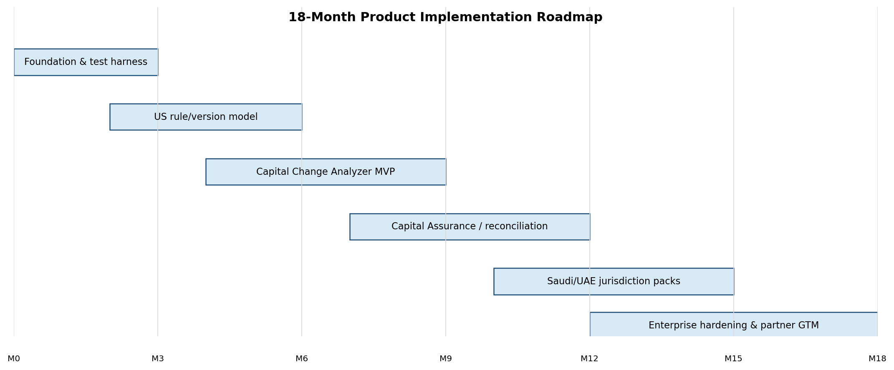
Figure 4 — Recommended 18-month delivery sequence

Phase 0 — Baseline assessment (Weeks 1–2)
Workstream | Detailed actions | Deliverable / exit criterion
Repository review | Inventory modules, APIs, dependencies, data flows, rule code, reporting mappings | Current-state architecture map
UDM review | Profile entities/fields/constraints and jurisdiction coupling | UDM gap register
Engine review | Trace classification → EAD/CCF/CRM/RW/RWA/capital | Rule-to-code inventory
FFIEC review | Trace calculation outputs to FFIEC 101 schedules/cells | Reporting lineage inventory
Performance baseline | Run current engine at 10K/100K/1M where practical | Baseline benchmark report
Quality baseline | Run current test suite; identify missing golden cases | Test coverage heatmap

Phase 1 — Correctness foundation (Weeks 2–8)
- Create `ruleset`, `rule`, `rule_version`, `calculation_run`, `calculation_step`, `evidence_reference`, `data_quality_exception` and `test_case` schemas.
- Introduce immutable calculation-run context and input snapshot hashes.
- Build Golden Regulatory Portfolio v1: prioritize all currently implemented credit-risk branches.
- Create rule/boundary/property/regression test harness in pytest.
- Create synthetic portfolio generator v1 and dirty-data scenarios.
- Refactor row loops toward vectorized expressions where feasible without changing results.
Exit gate: current Python engine reproduces all approved golden outputs; every unexplained difference is zero.

Phase 2 — Regulatory graph + U.S. rule versioning (Weeks 5–12)
- Model BCBS SCO/CAP/RBC/CRE/DIS nodes needed for in-scope credit risk.
- Ingest official March 2026 U.S. proposal and map in-scope provisions to BCBS canonical concepts. [R2]
- Create current-U.S. vs `US_NPR_2026_03` rulesets with explicit proposed status.
- Build regulatory diff service with human review workflow.
- Connect changed rules to UDM fields, product taxonomy, calculation modules and tests.
Exit gate: every in-scope changed rule can be traced Source → BCBS concept → U.S. version → UDM fields → calculation → tests.

Phase 3 — Capital Change Analyzer MVP (Weeks 9–18)
- Dual-run current vs proposed rules on the same portfolio snapshot.
- Build exposure/product/legal-entity/portfolio delta datasets and materiality ranking.
- Create data-readiness dashboard showing missing/ambiguous required fields.
- Create AI RWA investigator using only structured results, rules and evidence.
- Generate implementation-impact views and exportable test/evidence pack.
- Create demo synthetic portfolio (100K–1M records) with known meaningful deltas.
Exit gate: a prospect can upload the demo portfolio and receive reproducible rule changes, data gaps, ΔRWA/Δcapital, explanations and test evidence.

Phase 4 — Capital Assurance / bank-engine reconciliation (Months 5–9)
- Define standard result-ingestion format for bank/incumbent-engine outputs.
- Build matching and reconciliation logic at exposure and aggregate levels.
- Implement difference taxonomy: classification, CCF, EAD, CRM, RW, rule version, rounding, source-data and reporting mapping.
- Add materiality thresholds, investigation queues and evidence attachments.
- Pilot with synthetic “incumbent” outputs first, then a sanitized real portfolio if available.

Phase 5 — Scale adapter and enterprise hardening (Months 7–12)
- Benchmark 1M/10M/50M/100M workloads and identify distributed break-even point.
- Implement PySpark adapter only for workloads that fail target SLA/cost on local/vectorized engine.
- Require Python ↔ Spark equality on Golden Portfolio and sampled large portfolios.
- Add VPC/private deployment patterns, SSO, secrets, observability, job restart, data retention and audit export.

Phase 6 — First international pack (Months 10–15)
Select Saudi Arabia or UAE based on first customer/channel. Saudi provides a concrete quarterly Q17 reporting linkage and Basel III post-crisis credit-risk framework; UAE offers a Basel-based CBUAE capital framework. [R6][R7][R8]
- Create jurisdiction source corpus and BCBS crosswalk.
- Implement only the credit-risk rules needed by the first target customer segment.
- Add jurisdiction report mapping (Q17 or relevant UAE returns) independently from core calculations.

Phase 7 — Regulatory Radar / workflow expansion (Months 12–18)
- Add automated official-source monitoring and change alerts.
- Add obligation/action extraction, owner assignment, approvals and implementation project views.
- Do not attempt to replicate the global content breadth of CUBE/FinregE; license/partner for content breadth when economically sensible.

13. Immediate next steps — detailed 30/60/90-day plan

Days 0–10: product and code baseline
- Upload or inventory the current Python repository, README/design notes, dependency file, UDM schema/DDL, sample exposure files, ERBA outputs and FFIEC 101 mappings.
- Produce module-by-module current-state map: ingest → validation → classification → EAD/CCF/CRM → RW → RWA → capital → reporting.
- Create a rule inventory spreadsheet/table with rule ID, jurisdiction, source, code function/module, UDM inputs, outputs and existing tests.
- Tag every existing implementation as current-law, proposal, assumption or configuration. This is critical because the March 2026 NPR is proposed, not final. [R2]
- Capture performance baseline using fixed 10K/100K/1M synthetic datasets.

Days 10–30: testing and versioning foundation
- Implement immutable `ruleset_id` and `calculation_run` context through the full engine.
- Build Golden Portfolio v0.1 with at least one happy-path and boundary scenario per implemented rule branch.
- Add automated test layers T1–T6 and CI gating.
- Create Synthetic Portfolio Generator v0.1 with deterministic seeds, scenario tags and dirty-data modes.
- Separate FFIEC 101 mapping/configuration from the capital-calculation core.
- Begin rule-definition refactor: move stable constants/thresholds/mappings into versioned configuration, leaving complex formulas in deterministic Python initially.

Days 31–60: knowledge graph + NPR change model
- Create BCBS canonical nodes for the exact credit-risk concepts already implemented; do not model the full Basel Framework yet.
- Ingest March 2026 U.S. NPR metadata and in-scope sections from the official agencies; maintain document hashes and citations. [R2]
- Build old/new rule crosswalk and reviewed change-event records.
- Connect each changed rule to UDM fields, product/exposure classes and affected tests.
- Implement current vs `US_NPR_2026_03` dual execution behind a single calculation API.

Days 61–90: first commercial demo
- Build ΔRWA engine with driver categories and exposure-to-portfolio rollups.
- Build Data Readiness view: required, available, missing, inconsistent and ambiguous fields by change area.
- Build AI explanation endpoint constrained to deterministic evidence and regulatory citations.
- Generate an exportable “Capital Change Assessment” report from a 100K–1M synthetic bank portfolio.
- Build six core UI screens: Regulatory Change Overview, Basel/U.S. Crosswalk, Product/Data Impact, Current-vs-Proposed RWA, Driver Investigation, Test/Evidence Pack.
- Use the demo to interview 8–12 practitioners/consultants; measure willingness to pay for a portfolio impact assessment and vendor-neutral assurance pilot.

Definition of “ready for first paid pilot”
Gate | Minimum condition
Correctness | 100% approved Golden Portfolio results; no unexplained regressions
Traceability | Every result resolves input snapshot, engine version, ruleset, rule IDs and sources
Proposal labeling | No proposed rule can be mistaken for in-force/final rule
Impact | Old/new execution and ΔRWA works on a realistic synthetic portfolio
Evidence | Exportable rule/test/result evidence pack
Security | Sanitized pilot process; encryption, access controls, audit logs
Performance | Documented SLA for agreed pilot portfolio size
Commercial | Clear pilot scope, inputs, deliverables and acceptance criteria

14. Go-to-market and monetization plan

14.1 Do not start with an enterprise replacement sale
The first monetization motion should sell a result rather than an infrastructure transformation. Offer a paid “2026 Capital Proposal Impact Assessment” or “Independent RWA Reconciliation Assessment.” The product performs the work behind the scenes; this lowers procurement friction and generates reference cases.
Offer | Customer provides | We deliver | Commercial objective
Capital Change Assessment | Sanitized portfolio + current RWA + relevant metadata | Rule delta, data gaps, old/new RWA, driver analysis, implementation/test pack | Paid proof of value
RWA Assurance Pilot | Portfolio + incumbent results | Independent reproduction, differences, explanations, evidence | Control/validation wedge
Annual Change Assurance | Ongoing portfolio snapshots + system integration | Continuous proposal/final/amendment impact + regression | Recurring SaaS
Consulting partner license | Multiple client workspaces | Reusable capital impact/validation tooling | Distribution channel

14.2 Pricing hypotheses to validate — not fixed prices
Use discovery rather than assuming pricing. Initial hypotheses from the prior strategy discussion can be tested around paid assessments, module pilots and annual licenses. The commercial KPI is not simply ARR at first; it is time-to-first-value, analyst hours reduced, number/value of RWA discrepancies identified, and implementation/testing effort avoided.

14.3 Buyer personas
- Head of Regulatory Capital / Capital Management.
- Basel implementation program lead / regulatory change office.
- Regulatory reporting control / data quality lead.
- Independent model validation / capital assurance.
- Internal audit / finance-risk control.
- Regulatory-capital consulting boutiques and implementation partners.

14.4 Sales proof metrics
- Hours/days to explain a material RWA movement before vs after.
- Percent of exposures independently reproduced.
- Count/value of material differences and data gaps detected.
- Number of changed rules automatically mapped to data/calculation/tests.
- Regression-test creation/execution time saved.
- Evidence pack preparation time saved for audit/regulator/management review.

15. Delivery team and engineering operating model

15.1 Minimum product team
Role | Primary responsibility | Initial staffing
Founder / prudential SME | Product decisions, Basel interpretation, customer discovery | 1
Backend/rule-engine engineer | Python engine, ruleset/versioning, APIs | 1–2
Data engineer | UDM, Parquet, synthetic generator, Spark adapter later | 1
AI/knowledge engineer | Regulatory graph, retrieval, diff/applicability agents | 1
Frontend engineer | Change/assurance dashboards | 0.5–1
QA/regulatory test engineer | Golden portfolio, rule tests, regression evidence | 1
Security/DevOps | CI/CD, deployment, VPC/K8s, observability | fractional early
Independent Basel reviewer | Four-eyes validation of rule interpretations | fractional/contract

15.2 Engineering controls
- Git-based rule/code versioning with immutable released ruleset IDs.
- Pull-request review must include rule citation, tests and expected impact.
- No direct production changes to regulatory logic without signed release package.
- CI runs golden and regression tests; large portfolio scale suite runs on scheduled/pre-release cadence.
- Regulatory content and calculations are separately versioned but linked in evidence.

16. Major risks and mitigations
Risk | Why it matters | Mitigation
Competing with broad RegTech too early | CUBE/FinregE already have content/change workflows | Stay focused on executable capital change + assurance
Incumbents add similar AI features | AxiomSL/Regnology already invest in AI/change services | Vendor neutrality, cross-engine validation, independent evidence
Rule interpretation error | Direct regulatory/model risk | Human-reviewed rules, sources, proposed/final status, golden tests
Python performance limitations | Large portfolios may exceed batch SLA | Vectorize first; Spark adapter after benchmark gate
Dual Python/Spark code divergence | Can produce different capital | Single rule semantics + engine-equivalence test suite
Synthetic data gives false confidence | May miss production edge cases | Rule-driven golden cases + anonymized pilot datasets + dirty-data tests
Bank procurement/security delays | Enterprise sales can be slow | Paid assessment, consulting channel, VPC/on-prem roadmap
Jurisdiction scope explosion | Basel implementations diverge | BCBS canonical graph + customer-led jurisdiction priority
AI hallucination | Regulated workflow requires trust | AI never owns numeric results; citations/evidence; human gates
Reporting forms change | Can invalidate FFIEC layer | Versioned reporting mappings separate from calculations

17. Product success metrics
Category | Metric | 12-month target direction
Correctness | Golden test pass rate | 100% approved cases
Reproducibility | Runs reproducible from snapshot + version IDs | 100% production/pilot runs
Coverage | In-scope rules linked to tests/data/calculation | >95% before pilot scope sign-off
Assurance | Incumbent exposure results independently reproduced | Target >95%, with explained residuals
Performance | Portfolio batch SLA | Defined per customer; benchmarked before contract
Explainability | Material deltas with evidence-linked driver reason | >95% of material delta value
Commercial | Paid assessments/pilots | First 2–3 reference engagements
Conversion | Assessment → annual/platform discussion | Track and optimize
Internationalization | Second jurisdiction using same canonical model | No forked engine

18. 3–5 year product map
Horizon | Platform expansion | Principle
0–12 months | U.S. credit-risk change analyzer + capital assurance | Prove executable change/assurance wedge
12–24 months | Saudi/UAE packs; radar/workflow; broader U.S. final rules/reporting | Reuse same graph/UDM/rules/tests
18–30 months | UK/EU packs; COREP/PRA reporting; output-floor analysis | Cross-jurisdiction Basel intelligence
24–36 months | CCR/CVA, operational risk, selected market risk | Expand prudential domains only after credit-risk control plane is mature
3–4 years | Stress/capital planning, liquidity/IRRBB, wider model validation | Broaden CRO/CFO use cases
4–5 years | Cross-vendor Prudential Risk OS / continuous change assurance | Own the executable regulatory assurance graph, not a generic chatbot

Long-term moat: canonical Basel/jurisdiction knowledge graph + versioned executable rules + institutional UDM mappings + large regulatory golden-test library + cross-engine reconciliation evidence.

19. Decisions to lock now
Decision | Final recommendation
Company wedge | AI-native prudential capital change assurance
First product | U.S. 2026 Capital Change Analyzer
Second product | Vendor-neutral Capital Assurance / RWA reconciliation
Canonical regulation model | BCBS Basel Framework
First Basel domains | SCO/CAP/RBC/CRE/DIS as required for credit-risk traceability
Jurisdiction architecture | Versioned overlays; never country code forks
Core data contract | Existing UDM evolved into jurisdiction-neutral canonical model
Calculation authority | Deterministic engine only
AI role | Interpret / map / investigate / explain / test / evidence
Primary language | Python
Distributed scale | PySpark adapter only after benchmark gate
Testing | Golden regulatory portfolio + synthetic generator + 10-layer assurance suite
Reporting | Independent versioned mapping layer
Deployment | SaaS first for low-friction pilots; VPC/on-prem/compute-in-place design
Initial GTM | Paid impact/assurance engagement → platform subscription
International sequence | Customer-led; Saudi/UAE likely first after U.S.

20. Research references
The following official/regulatory and vendor-primary sources informed the finalized plan. Vendor capabilities are based on publicly marketed descriptions and should be revalidated during procurement/competitive diligence.
Ref | Source | URL
R1 | Basel Committee on Banking Supervision — CRE20, Standardised approach: individual exposures | https://www.bis.org/basel_framework/chapter/CRE/20.htm
R2 | Federal Reserve — 19 March 2026 proposals to modernize regulatory capital framework | https://www.federalreserve.gov/newsevents/pressreleases/bcreg20260319a.htm
R3 | FFIEC — FFIEC 101 Current Information (June 2026 form / extension) | https://www.ffiec.gov/resources/reporting-forms/ffiec101
R4 | Bank of England / PRA — PS1/26 Implementation of Basel 3.1: Final rules | https://www.bankofengland.co.uk/prudential-regulation/publication/2026/january/implementation-of-the-basel-3-1-final-rules-policy-statement
R5 | European Banking Authority — Supervisory reporting / CRR3 & CRD6 implementation materials | https://www.eba.europa.eu/regulation-and-policy/supervisory-reporting
R6 | Saudi Central Bank (SAMA) — Minimum Capital Requirements for Credit Risk | https://rulebook.sama.gov.sa/en/minimum-capital-requirements-credit-risk
R7 | Central Bank of the UAE — Standards for Capital Adequacy of Banks in the UAE | https://rulebook.centralbank.ae/en/rulebook/standards-capital-adequacy-banks-uae
R8 | Central Bank of the UAE — Guidance for Capital Adequacy of Banks in the UAE | https://rulebook.centralbank.ae/en/rulebook/guidance-capital-adequacy-banks-uae
R9 | CUBE — What is regulatory change management? | https://cube.global/resources/compliance-corner/what-is-regulatory-change-management
R10 | CUBE — Regulatory Change Management | https://cube.global/sectors/requirement/regulatory-change-management
R11 | FinregE — End-to-End Regulatory Compliance Software | https://finreg-e.com/
R12 | FinregE — Transforming Credit Risk with Generative AI | https://finreg-e.com/transforming-credit-risk-with-generative-ai/
R13 | Nasdaq AxiomSL — Capital Risk Reporting | https://www.nasdaq.com/solutions/fintech/nasdaq-axiomsl/capital-risk-reporting
R14 | Nasdaq AxiomSL — Solutions / Regulatory Change Services | https://www.nasdaq.com/solutions/fintech/nasdaq-axiomsl
R15 | Oracle University — OFSAA Basel Regulatory Capital | https://learn.oracle.com/ols/course/ofsaa-basel-regulatory-capital/55129/55639
R16 | Oracle — Financial Services Analytics | https://www.oracle.com/financial-services/analytics/
R17 | Suade — Implementation of Basel 3.1 | https://suade.org/implementation-of-basel-3-1-how-to-efficiently-manage-reforms/
R18 | Suade — Is your bank ready for Basel Endgame? | https://suade.org/are-you-ready-for-basel-endgame/
R19 | Basel Committee — CRE22, Standardised approach: credit risk mitigation | https://www.bis.org/basel_framework/chapter/CRE/22.htm
R20 | Apache Spark 4.2 — Running Spark on Kubernetes | https://spark.apache.org/docs/latest/running-on-kubernetes.html
R21 | Apache Spark 4.2 — Overview / Spark SQL and cluster deployment | https://spark.apache.org/docs/latest/

20.1 Current-state assumptions supplied by the founder
- The existing product is written in Python.
- It calculates RWA and capital for multiple exposure types through a unified data model.
- It contains a U.S. ERBA implementation based on the March 2026 NPR.
- It contains an FFIEC 101 reporting layer.
- The implementation plan assumes these modules will be reviewed before any refactor; it does not assume their current rule coverage or calculations are independently validated yet.

20.2 Final instruction to the build team
The very next engineering deliverable is not Spark and not a global Radar. It is: Current-State Review → Golden Regulatory Portfolio → Versioned Rule/Run Model → U.S. 2026 Rule Crosswalk → Dual-Run ΔRWA MVP.

