FINANCIAL PODS
AI-Native Banking & Regulatory Learning Platform
Research synthesis • Product blueprint • Technical architecture • Commercial model • Implementation roadmap
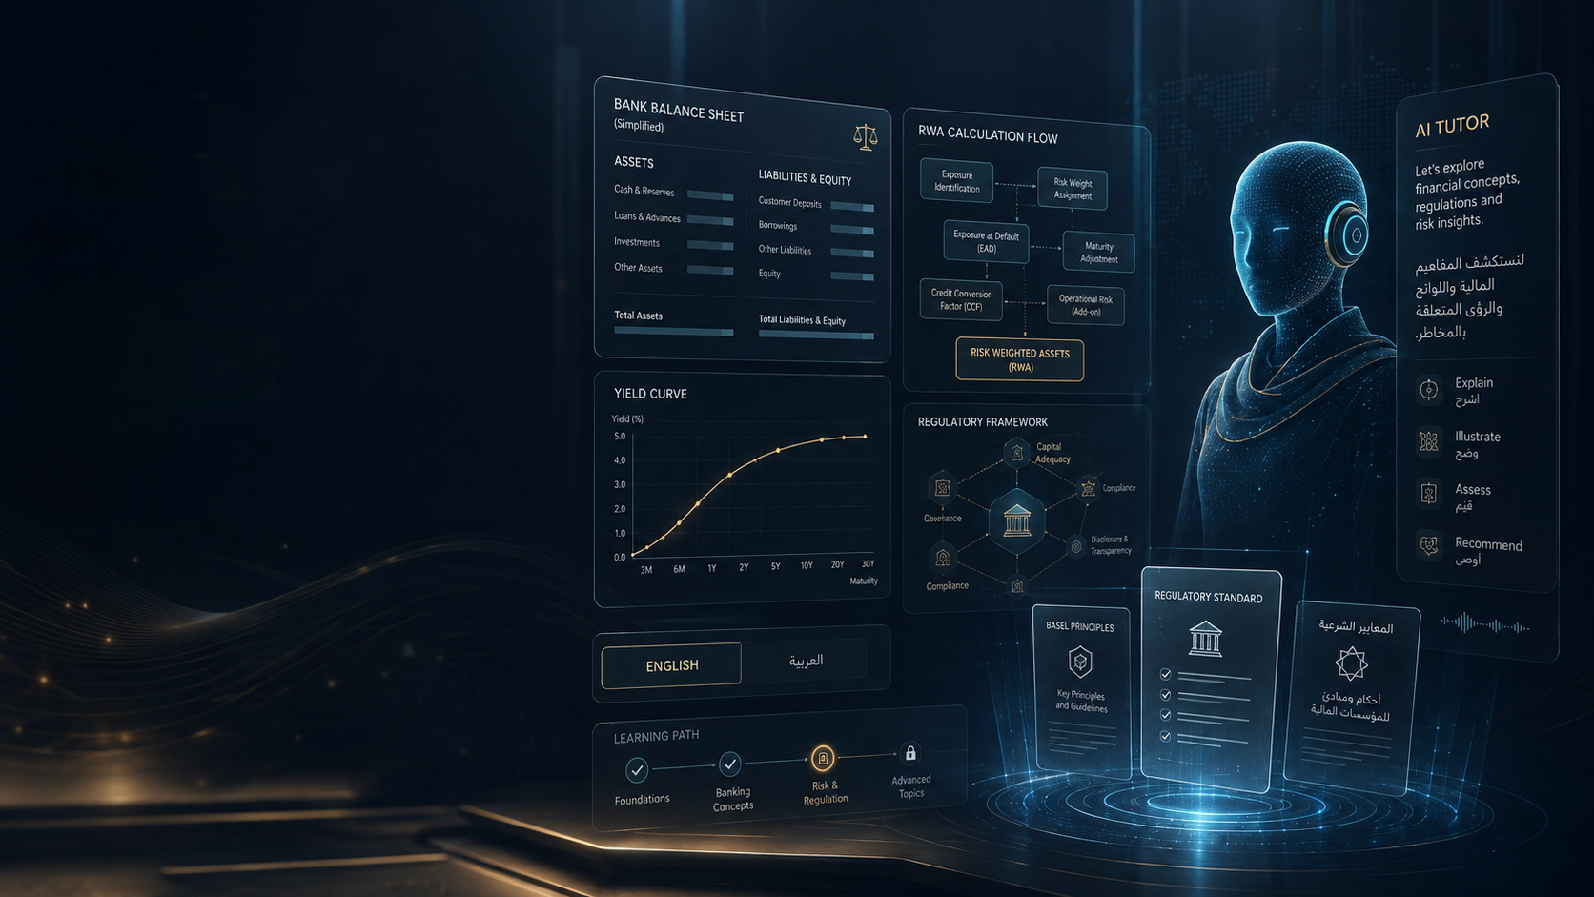
Basel first. Then Regulatory Reporting, ALM, FTP, Profitability, Liquidity and Financial Crime.
Prepared August 16, 2026

Contents
1. Executive Summary
2. Strategic Context and Research Findings
3. Product Vision: Financial Pods
4. Competitive Landscape and White Space
5. Basel Pod — First Commercial Wedge
6. Golden Lesson 001
7. Adaptive AI Tutor and Mastery Engine
8. Multilingual, Voice and Digital Instructor Strategy
9. FinBank Digital Twin and Hands-On Labs
10. Knowledge Architecture and Regulatory Grounding
11. AI Video and Content Production Factory
12. Technology Stack and Infrastructure
13. SME / Banker Partnership and Content Governance
14. Monetization and Go-to-Market
15. Risks and Mitigations
16. 12-Month Implementation Roadmap
17. Detailed 30/60/90-Day Plan
18. Immediate Build Backlog and Decision Gates
19. Strategic Synergy with Capital Change Assurance
20. Research Sources

1. Executive Summary
The opportunity is not “AI videos for finance.” It is a reusable AI learning operating system for regulated banking roles.
Core thesis
Financial Pods should teach a user to understand a financial rule, see it applied to a realistic bank product, manipulate the data, run a deterministic calculation, compare jurisdictions, question an AI tutor by chat or voice, and prove mastery through practice and a voice viva.

The initial product should be Basel Regulatory Capital, focused first on BCBS concepts and the U.S., Saudi Arabia (SAMA), and UAE (CBUAE) implementations. Basel is a strong wedge because it is technically difficult, calculation-heavy, jurisdiction-specific, continuously evolving, and directly connected to real banking roles. Existing providers validate demand for Basel education, while AI-native learning products validate the interaction model. [S1][S2][S3][S4][S5][S7][S9]
The product should not rely on the language model for regulatory calculations. The AI tutor explains, questions, scaffolds and personalizes; deterministic finance engines calculate. Official regulatory sources remain the source of truth, with SME review before regulated content is published.
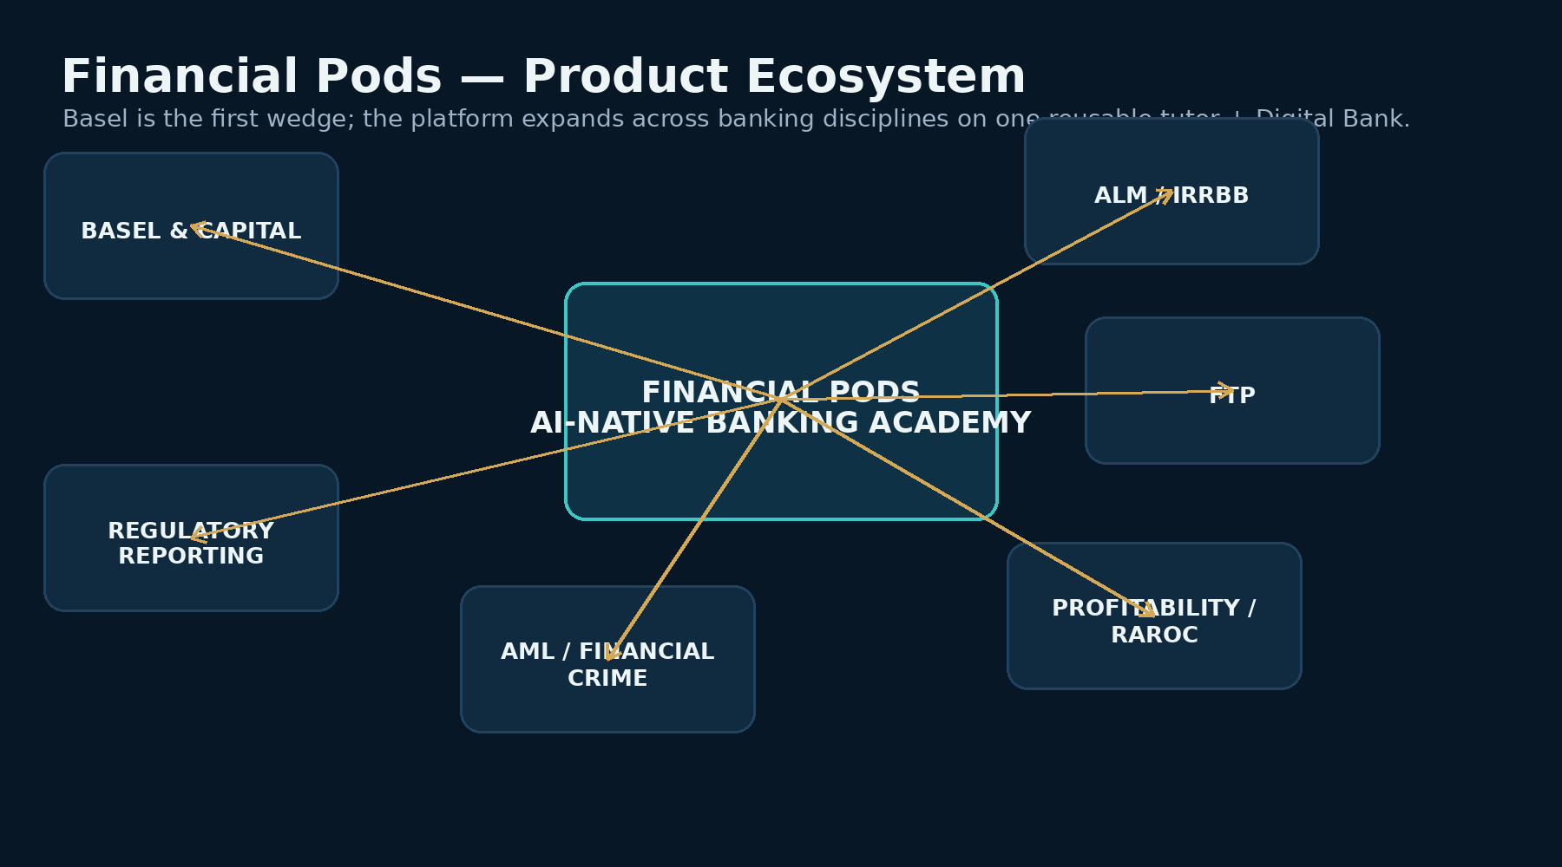
Figure 1 — Basel is the first Pod; the reusable tutor and Digital Bank support the broader Financial Pods roadmap.

What we are building first
- Golden Lesson 001: Corporate Exposure — From a Bank Loan to Regulatory Capital.
- Languages: English and Arabic at launch; additional languages are a localization layer, not a new course build.
- Interaction: pre-produced premium lesson + pause-anywhere chat + realtime voice + interactive calculations + active-learning checks.
- Jurisdictions: BCBS baseline plus U.S. current/proposed treatment, SAMA and CBUAE.
- Differentiator: official-rule grounding + executable calculations + FinBank synthetic bank + adaptive mastery + practitioner-reviewed learning.
- Commercial path: individual subscriptions and practitioner programs first; enterprise bank academy and institution licensing after proof of learning and content quality.

2. Strategic Context and Research Findings

2.1 What the market already proves
Traditional finance education has strong willingness to pay: Fitch sells instructor-led Basel III training; CFI sells annual finance-learning memberships; ACAMS sells globally recognized financial-crime education. AI-native education is also moving quickly: Vizz combines course video with realtime voice, timestamp-aware Q&A, multilingual interaction, adaptive tutor personalities and an Active Mode that pauses video to question learners. CFI now embeds an AI Tutor that uses course context and learning history. [S5][S7][S8][S9][S18]
Evidence | What it proves | Implication for Financial Pods
Vizz / Vizuara | Users value interruption, realtime voice, timestamp-aware tutoring and active questioning. | Interaction pattern is validated; finance specialization must add deeper domain infrastructure.
CFI AI Tutor | Large finance-learning platforms are adding contextual AI support. | “Video + chatbot” is not a moat.
Fitch Basel course | Basel remains a premium professional training topic. | There is willingness to pay for serious regulatory-capital education.
ACAMS | Financial-crime certifications and enterprise academies are established categories. | Future AML/Financial Crime Pod has a proven training market.
2025 AI tutor study | Carefully designed AI tutoring can outperform active classroom instruction in a controlled setting. | Pedagogy and scaffolding matter more than unrestricted chat.

2.2 What is still missing
- An integrated experience that connects official prudential rules to real banking products, required data and deterministic calculations.
- A persistent simulated bank where the same mortgage, deposit or corporate loan reappears across Basel, ALM, FTP and profitability.
- Jurisdiction-aware training that compares BCBS principles with domestic implementation rather than teaching Basel as a single global rulebook.
- Regulatory-reporting labs where learners construct and validate real schedules from synthetic data.
- Adaptive mastery at the concept and misconception level, not just course-completion tracking.
- A tutor that can open the relevant rule, alter an exposure, run a calculation, draw a whiteboard explanation and then test the learner verbally.

3. Product Vision: Financial Pods
Financial Pods should be positioned as an AI-native professional learning platform for banking rather than a collection of courses. The product promise is practical competence: “Learn the rule. See the bank. Run the numbers. Ask the expert. Do the job.”
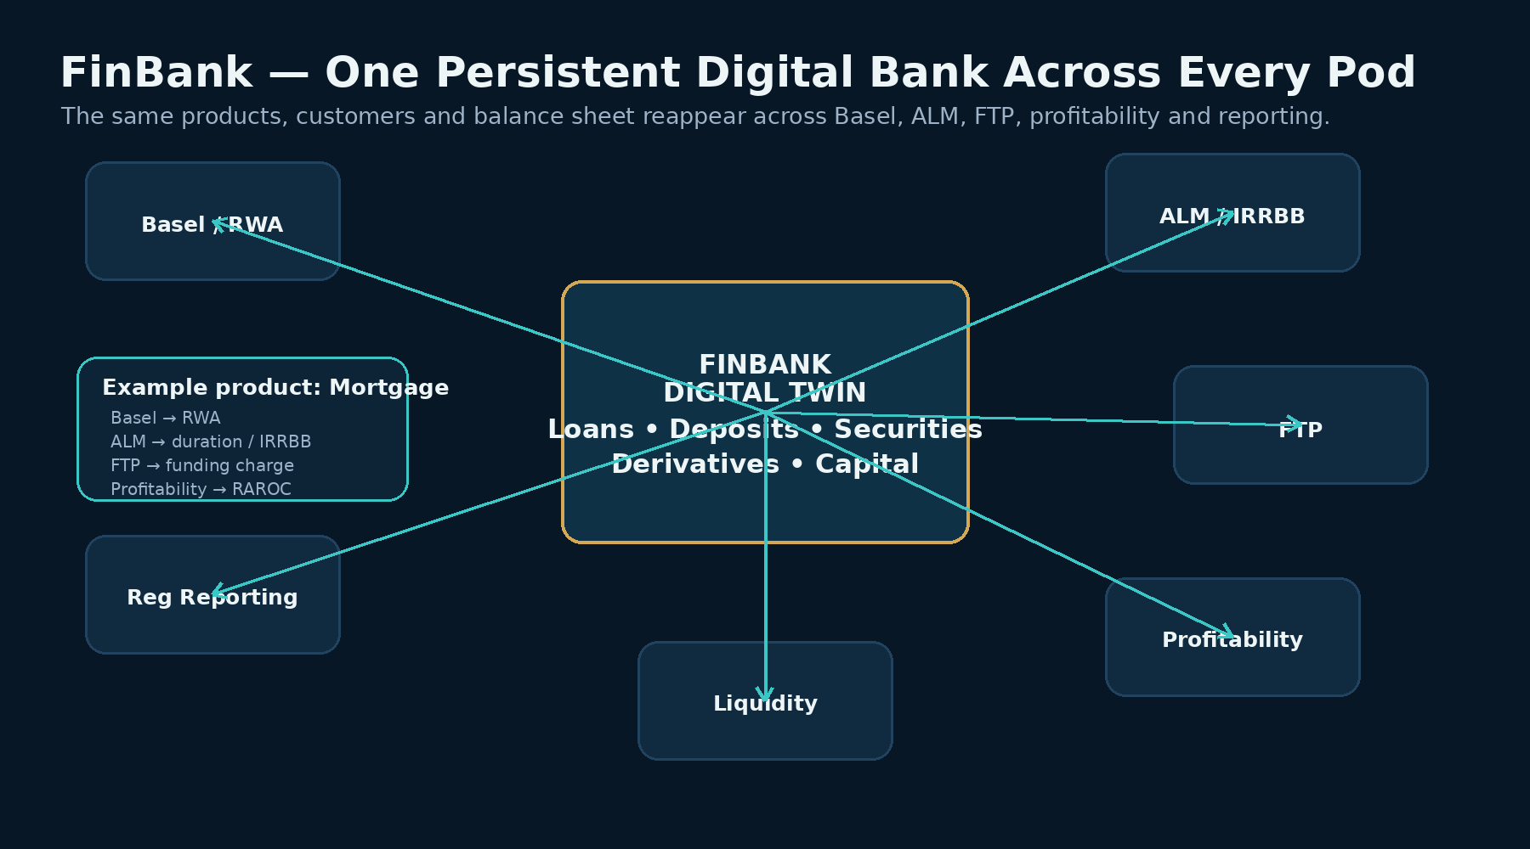
Figure 2 — FinBank lets one product be studied through multiple banking disciplines.

3.1 Planned Pod roadmap
Pod | Initial themes | Why it fits the platform
Basel Regulatory Capital | Capital, credit risk, RWA, CRM, leverage, liquidity introduction, jurisdiction comparisons | Strong first wedge; deterministic calculations and official rules create defensibility.
Regulatory Reporting | FFIEC 101/102, FR Y-9C, FR Y-14, Call Reports, SAMA Q17, UAE reporting/disclosures | Turns data and rule knowledge into job-oriented labs.
ALM / IRRBB | Balance-sheet behavior, duration, NII/EVE, repricing, yield curves | Same FinBank assets/liabilities can be reused.
Fund Transfer Pricing | Matched maturity, liquidity premiums, business-line charges/credits | Connects Treasury decisions to product economics.
Profitability / RAROC | NIM, product/customer profitability, capital allocation, RAROC | Connects regulatory capital and funding costs to management decisions.
Liquidity | LCR, NSFR, funding structure, stress scenarios | Natural bridge from Basel to Treasury.
Financial Crime / AML | KYC/CDD, transaction monitoring, sanctions, investigations; potential CAMS-oriented preparation | Large professional-learning market; requires separate SME governance and IP discipline.

4. Competitive Landscape and White Space
Provider | Strengths observed | Gap relative to our target
Vizz / Vizuara | Realtime voice, video-timeline Q&A, Active Mode, multilingual support, memory, adaptive tutor personality. | Not finance-specific; no prudential rule graph, deterministic capital engine, jurisdiction mapping or Digital Bank.
CFI | Large finance course library, certifications, AI Tutor, personalized learning context and multilingual features. | Broad finance learning; our wedge is deeply executable regulatory/prudential training.
Fitch Learning | Strong professional Basel course, practical examples, enterprise credibility. | Instructor-led / course model rather than always-on interactive simulator with persistent learner state.
ACAMS | Recognized AML credential and enterprise training ecosystem. | A future competitor/benchmark for financial-crime education, not a Basel simulator.
Generic LLM + PDFs | Fast Q&A and summarization. | No trusted curriculum, deterministic tools, mastery model, content governance or structured progression.

White-space statement
Financial Pods is strongest where AI-native interaction meets finance-specific infrastructure: official-rule grounding, executable calculators, a persistent Digital Bank, jurisdiction crosswalks, reporting labs, adaptive mastery and practitioner-reviewed content.

5. Basel Pod — First Commercial Wedge

5.1 Canonical curriculum architecture
The BCBS Basel Framework is the canonical baseline. Jurisdictions are mapped as overlays rather than separate disconnected curricula. Basel CRE20, for example, defines the standardized approach to individual credit exposures and makes RWA the product of the standardized risk weight and exposure amount, while national supervisors implement and modify the framework domestically. [S1]
Track | Initial content
Foundations | Bank balance sheet; why capital exists; Basel I/II/III; Pillars; exposure, EAD, RW and RWA.
Capital | CET1, AT1, Tier 2, deductions, buffers, capital ratios.
Credit Risk SA | Sovereigns, banks, corporates, SMEs, retail, residential RE, commercial RE, defaulted exposures, off-balance-sheet, CRM basics.
Jurisdiction comparison | BCBS baseline vs U.S. rules/proposals, SAMA and CBUAE.
Reporting introduction | How calculated exposures aggregate into regulatory capital and reporting schedules.

5.2 Jurisdiction design principles
- BCBS: canonical conceptual and regulatory baseline. [S1]
- United States: teach current requirements separately from the March 2026 proposals. As of August 2026, the Fed still presents the March package as proposed rulemaking; the UI must visibly label “PROPOSED.” [S2][S19]
- Saudi Arabia: SAMA has an in-force Basel III credit-risk framework and prudential reporting requirements; Q17 is a practical learning target. [S3]
- UAE: CBUAE capital standards and guidance are closely based on Basel but contain UAE-specific requirements. [S4]

6. Golden Lesson 001 — Corporate Exposure: From Loan to Regulatory Capital
The Golden Lesson is the product-development benchmark. We should not scale course production until one lesson proves the complete experience end to end.
Stage | Learner experience
1. Context | A $10m term loan to Alpha Manufacturing appears in FinBank.
2. Classify | Learner decides the regulatory exposure class before seeing the answer.
3. Source | Relevant BCBS/SAMA/CBUAE/U.S. provisions are shown with plain-language explanation.
4. Calculate | Learner sees EAD, risk weight, RWA and basic capital relationship using the deterministic engine.
5. Manipulate | Change rating, revenue, collateral or jurisdiction and recalculate.
6. Interrupt | Pause the lesson at any moment and ask by text or voice; tutor receives timestamp + example + rule context.
7. Compare | Switch BCBS, SAMA, CBUAE and U.S. treatments and explain why they differ.
8. Active check | Video auto-pauses and asks a conceptual question.
9. Practice | Generate new corporate exposure cases.
10. Voice viva | Tutor tests the learner verbally and updates mastery.

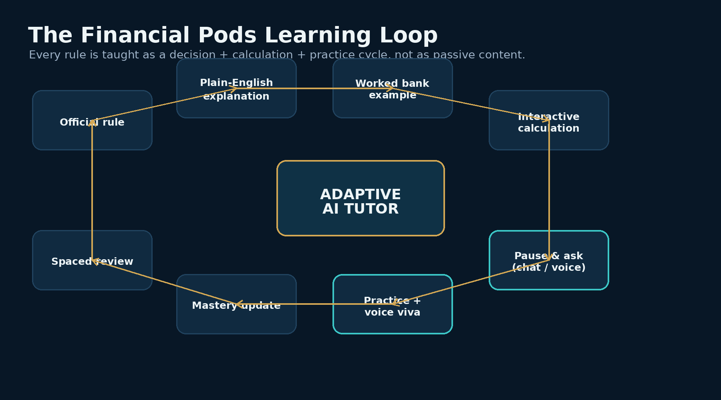
Figure 3 — Standard learning loop that every future Financial Pod can reuse.

6.1 Golden Lesson acceptance criteria
Capability | Gate
English lesson | Required
Arabic lesson | Required
Your cloned English voice | Prototype
Native Arabic voice comparison | Required
Pause-anywhere chat | Required
Realtime voice interruption | Required
Timestamp-aware tutor | Required
Official source citations | Required
Interactive calculator | Required
Jurisdiction switch | Required
Active Mode question | Required
Generated practice cases | Required
Voice viva | Required
Mastery update | Required

7. Adaptive AI Tutor and Mastery Engine
The tutor should not assign simplistic permanent labels such as “visual learner.” It should adapt from observed evidence: concept mastery, misconceptions, preferred explanation depth, response latency, confidence, language, chat/voice behavior and retention over time. Research on intelligent tutoring suggests benefits are strongest when the interaction is deliberately designed around pedagogy and feedback rather than left as unrestricted chat. [S10]

7.1 Learner state
Dimension | Example signal | Tutor adaptation
Mastery | CRE classification 62% | Return to prerequisite and generate targeted cases.
Misconception | “EAD always equals outstanding balance” | Deliberately introduce off-balance-sheet examples.
Explanation preference | Worked examples produce higher subsequent accuracy | Lead with example before abstract text.
Language | Arabic preferred; English terms retained | Use MSA explanation with English banking abbreviations.
Confidence vs correctness | High confidence / wrong answer | Use Socratic challenge and request reasoning.
Retention | Concept decays after 7 days | Schedule spaced review.
Interaction mode | Voice used heavily | Offer voice-first practice and viva.

7.2 Tutor modes
- Teacher
- Socratic Tutor
- Calculation Coach
- Practitioner
- Examiner / Voice Viva
- Interview Simulator
- Jurisdiction Expert
- Whiteboard Explainer

8. Multilingual, Voice and Digital Instructor Strategy
Launch languages should be English and Arabic. Additional languages should be added from demand data, with likely candidates including Hindi, French, Spanish and Portuguese. The regulatory and calculation layers remain language-neutral; only teaching, narration and UI localization change.
Layer | Launch design
Formal Arabic | Modern Standard Arabic for professional/regulatory instruction.
Terminology | Preserve major English abbreviations and optionally show Arabic + English financial terms.
Conversation | Support Arabic, English and mixed Arabic-English questions.
Regulatory source | Show original source text where relevant and local-language explanation separately.
Voice choice | Founder cloned voice for English; test multilingual clone; offer native Arabic professional voice.
Subtitles / transcript | English and Arabic always available at launch.

Current voice platforms can clone a user’s own voice and generate multilingual speech; ElevenLabs markets Arabic TTS, multilingual voice cloning and 70+ language voice generation. HeyGen markets multilingual avatar/digital-twin workflows and realtime avatar interaction. These are implementation accelerators, not strategic moats. [S11][S12][S13]
Brand option
A consistent founder tutor persona can create continuity across Basel, ALM, FTP and future Pods, but the platform should also provide native-language professional voices when that improves pronunciation and learner trust.

9. FinBank Digital Twin and Hands-On Labs
FinBank should be a persistent synthetic universal bank whose products and customers reappear across the platform. This is more valuable than disconnected case studies because the learner develops a mental model of how the bank works end-to-end.
- A mortgage can be used for Basel RWA, ALM duration/IRRBB, FTP funding cost, profitability/RAROC and liquidity analysis.
- A corporate customer can appear in Basel, profitability, regulatory reporting and AML/KYC casework.
- A deposit can appear in ALM, FTP, liquidity and customer-profitability modules.
- The same synthetic regulatory data can power reporting exercises, reconciliation and validation labs.

9.1 FinBank data layers
Layer | Representative entities
Party | Customer, counterparty, legal entity, guarantor, issuer.
Product | Loan, mortgage, credit card, deposit, security, derivative, commitment.
Risk | Rating, collateral, LTV, default status, maturity, CCF, EAD.
Treasury | Rate, repricing date, tenor, transfer price, liquidity spread.
Finance | Revenue, interest, funding cost, expenses, allocated capital.
Regulatory | Exposure class, risk weight, RWA, capital, report mapping.
AML | Customer risk, KYC attributes, transactions, alerts, sanctions flags.

10. Knowledge Architecture and Regulatory Grounding
The same regulated knowledge foundation can support both learning and the separate Capital Change Assurance concept. The knowledge graph should capture relationships; the rule/calculation engines should produce numbers; the AI tutor should interpret and teach.
Layer | Responsibility
Regulatory Knowledge Graph | Rule, concept, jurisdiction, effective date, product, data field, calculation component, reporting mapping, source citation.
Learning Graph | Prerequisites, lesson, example, misconception, exercise, difficulty, mastery objective.
Rule Engine | Determine which rule applies under a versioned jurisdiction/ruleset.
Finance Engine | Perform deterministic EAD, RW, RWA, capital and later ALM/FTP/profitability calculations.
Tutor Orchestrator | Use context and tools to teach, not to invent regulated outputs.
Content CMS | Version lessons with their source rules and SME approvals.

Architectural rule
Do not put capital calculations inside the LLM. Do not treat the knowledge graph as the calculator. The tutor calls deterministic tools and cites the authoritative source.

11. AI Video and Content Production Factory
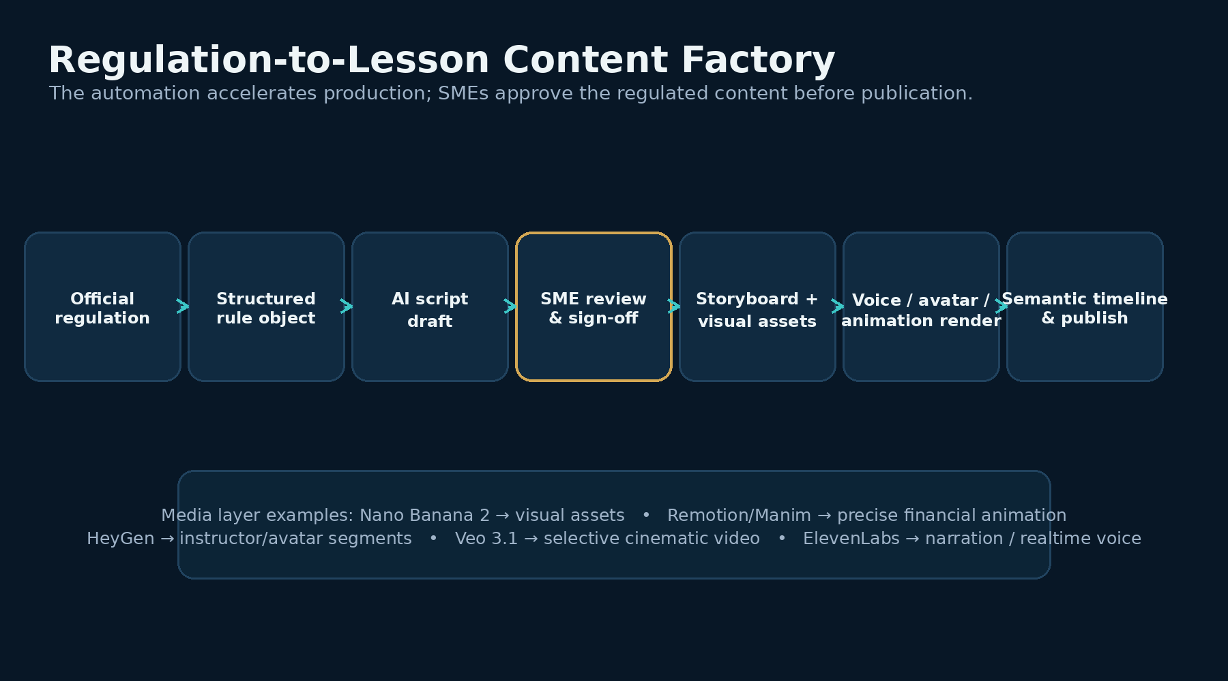
Figure 4 — Reusable regulation-to-lesson production workflow.

11.1 Video design principle
World-class financial training should not be a talking avatar for ten minutes. The lesson should mix a small amount of instructor presence with precise diagrams, programmatic calculation animation, interactive whiteboards, regulatory-source walkthroughs and active questions.
Media component | Recommended role
Nano Banana 2 / image generation | Concept art, infographics, course thumbnails, stylized bank/product visuals. Google describes Nano Banana 2 as an image-generation/editing model. [S14]
Remotion / SVG / Manim | Authoritative financial formulas, tables, charts, animated decision trees and exact numbers.
HeyGen / avatar tool | Instructor introductions, transitions, summarized teaching moments and optional digital twin. [S13]
Veo 3.1 / video generation | Selective cinematic scenes, intros and visual storytelling—not authoritative calculations. Google positions Veo 3.1 as a video-generation model. [S15]
ElevenLabs / voice layer | Narration, multilingual cloned voice, realtime voice tutor. [S11][S12]
FFmpeg / composition | Assemble final rendered scenes, captions and audio.

11.2 Semantic timeline
Every lesson scene should carry machine-readable metadata: start/end timestamp, concept ID, rule IDs, example ID, jurisdiction, calculator/tool and on-screen visual. This is what lets a learner pause at 06:42 and ask “why did the tutor use that risk weight?” without forcing the AI to guess from the entire video.

12. Technology Stack and Infrastructure
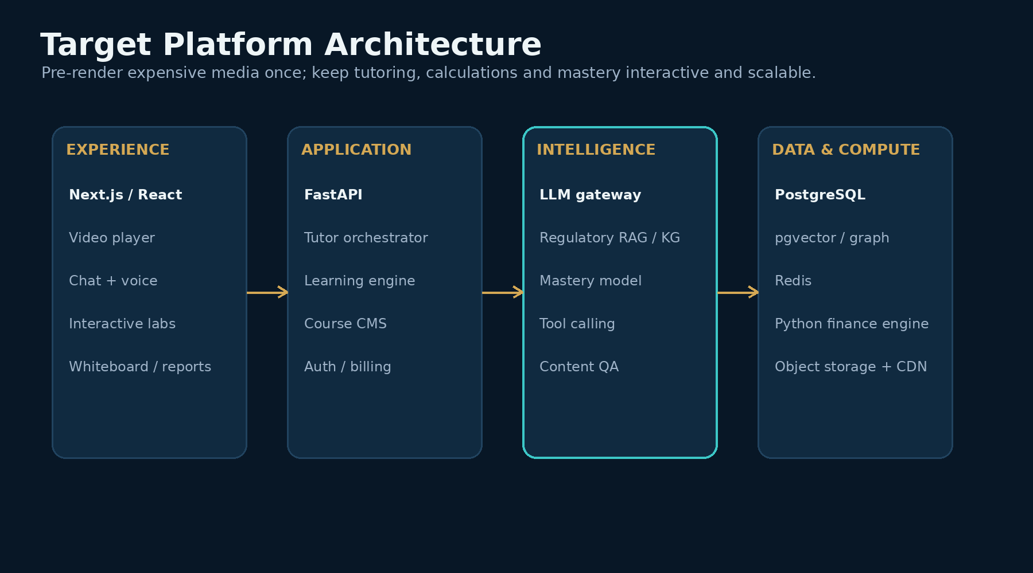
Figure 5 — Proposed platform architecture for the MVP and scalable production platform.

12.1 Recommended V1 stack
Layer | Recommendation | Reason
Web | Next.js + React + TypeScript + Tailwind | Fast product iteration; strong interactive-video and lab UX.
Backend | Python + FastAPI | Matches existing finance-engine work and AI ecosystem.
Primary DB | PostgreSQL | Course, learner, transaction and governance data.
Retrieval | pgvector initially | Avoid unnecessary platform sprawl during MVP.
Graph | Neo4j or graph abstraction later | Add when multi-jurisdiction rule relationships justify it.
Cache / sessions | Redis | Realtime session state, rate limits and tutor context.
Async / workflow | Celery initially; Temporal when workflows become complex | Content generation and background processing.
Finance calculations | Python; optionally Polars for vectorized labs | Deterministic and reuse existing capital engine.
Large compute | Spark only if enterprise simulations require it | Not needed for ordinary learner portfolios.
Media | Object storage + CDN/HLS | Pre-render once, serve cheaply at scale.
Observability | OpenTelemetry + managed monitoring | Tutor latency, errors, cost and learning-event tracing.
AI | Model-agnostic gateway | Avoid hard coupling to one LLM or media provider.

12.2 Infrastructure strategy
- Pre-render once: lesson video, diagrams, captions and localized media should be generated offline and cached/CDN-delivered.
- Realtime only where it adds value: chat, voice, whiteboard, calculations, mastery updates and optional live avatar.
- Control unit economics: text should be inexpensive; voice and live-avatar usage can be quota-based or premium.
- Avoid premature cluster complexity: Python/Polars/Postgres are sufficient for synthetic learning portfolios; Spark becomes relevant only for very large enterprise portfolio simulations.

13. SME / Banker Partnership and Content Governance
Bankers and practitioners are important, but they do not need to be co-founders. Financial Pods should build a structured reviewer and advisory network that separates regulatory accuracy from practical workflow relevance.
Group | Role | Initial target
Regulatory Content Council | Validate BCBS, U.S., SAMA and CBUAE interpretations, examples and calculations. | US capital SME; Saudi/SAMA SME; UAE/CBUAE SME; validation/reporting practitioner.
Industry Learning Council | Ensure the course feels like real bank work and identify skill gaps. | Capital manager/analyst; consulting practitioner; bank L&D/training buyer.
Beta practitioner panel | Use the Golden Lesson and expose confusion, UX gaps and willingness to pay. | 10–20 practitioners across regions.

13.1 Content governance workflow
1. Ingest and version the official regulation.
2. Create a structured rule object with citations and jurisdiction metadata.
3. Generate a first lesson/script/exercise draft.
4. Run deterministic examples and automated validation checks.
5. SME reviews rule interpretation and expected outputs.
6. Second QA pass confirms terminology, jurisdiction and pedagogical clarity.
7. Generate media and semantic timeline.
8. Publish with rule version, reviewer status and effective-date metadata.
9. When the regulation changes, flag affected lessons, calculators, quizzes and practice cases for review.

14. Monetization and Go-to-Market
The product can monetize through both individuals and institutions. The fastest validation path is likely B2C/professional learners and paid practitioner programs; enterprise bank training becomes more attractive after the platform proves content accuracy, learning outcomes and engagement.
Offer | Pricing hypothesis to test | Buyer / objective
Free Foundations | $0 | Acquire learners and demonstrate product experience.
Individual | $29–49/month | Learners who want core content + chat.
Professional | $59–79/month | Voice, labs, jurisdictions, practice.
Professional+ | $99/month | Heavy voice/viva and premium career features.
Annual membership | $499–799/year | Cross-Pod professional access.
Jurisdiction / practitioner program | $199–399 | Focused SAMA/UAE/U.S. specialization.
Bank team pilot | $10K–25K | Validate L&D value with a cohort.
Bank academy | $25K–100K+/year | Enterprise training, dashboards and assignments.
Enterprise/custom | Custom | Private curriculum, SSO, analytics, institution content.

These are hypotheses, not validated prices. Market anchors span low-cost AI tutoring, annual finance-learning memberships and multi-thousand-dollar instructor-led Basel training. [S5][S8][S9]

14.1 Launch channels
- LinkedIn practitioner content and live Basel demos.
- Partnerships with boutique regulatory/treasury consultancies.
- University finance/risk programs.
- Bank L&D and graduate programs after practitioner proof.
- Jurisdiction-specific webinars: “Learn SAMA Corporate Exposures interactively,” etc.
- Career paths and interview/viva modes for individual learners.

15. Risks and Mitigations
Risk | Why it matters | Mitigation
Content inaccuracy | One wrong regulatory lesson can damage trust. | Official sources, versioned rules, deterministic engines, SME sign-off, correction workflow.
Generic AI-video feel | Users may prefer established courses. | Financial diagrams, labs and simulations should dominate; avatar is a supporting element.
Overbuilding | Basel + ALM + FTP + AML at once delays product-market learning. | Golden Lesson gate; Basel Credit Risk MVP first.
AI tutor hallucination | Incorrect explanations in a regulated domain. | Grounded retrieval, tool calling, citation requirements, scoped answer policy and abstention.
Regulation changes | Lessons can become stale quickly. | Versioned content graph and change-detection workflow.
Voice/avatar cost | Realtime media can hurt unit economics. | Quota/premium tiers; pre-render media; voice-first before live avatar.
Distribution | Excellent product can still fail without learners. | SME network, practitioner beta, content-led acquisition and enterprise pilots.
SME availability / conflicts | Working bankers may face employer restrictions. | Use multiple independent SMEs; clear contracts; avoid confidential bank information.

16. 12-Month Implementation Roadmap
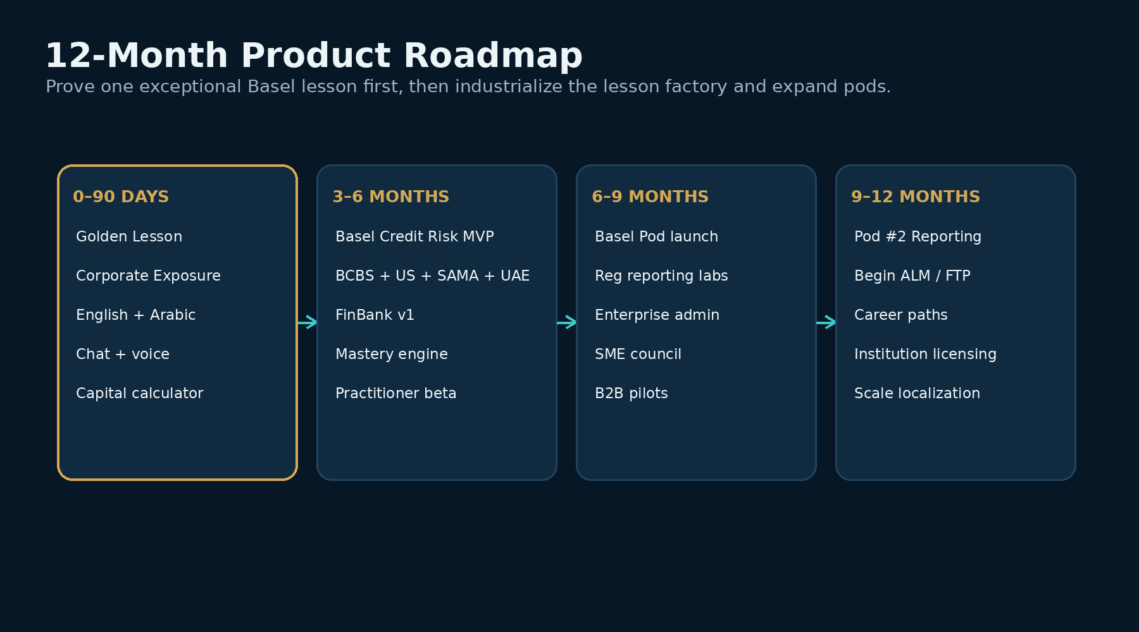
Figure 6 — Recommended 12-month sequencing.
Phase | Product outcome | Exit gate
0–90 days | Golden Lesson: English + Arabic; chat/voice interruption; deterministic calculator; BCBS/U.S./SAMA/UAE sources; basic mastery. | 10–20 practitioner tests; no material calculation/source defects; strong qualitative willingness to continue.
3–6 months | Basel Credit Risk MVP; FinBank v1; core curriculum; practice generator; mastery dashboard. | Paid beta users; repeat usage; measurable learning gains.
6–9 months | Commercial Basel Pod; regulatory reporting labs; enterprise admin; formal SME council. | First bank/consulting pilots and scalable content operations.
9–12 months | Reporting Pod; ALM/FTP prototypes; career paths; expanded localization. | Evidence that platform architecture transfers beyond Basel.

17. Detailed 30 / 60 / 90-Day Plan

Days 0–30 — Prove the content and calculation spine
1. Freeze Golden Lesson scope: Corporate Exposure — From Loan to Regulatory Capital.
2. Create the canonical lesson-content schema: concept, prerequisites, rule sources, jurisdictions, example, data fields, expected calculation, exercises and misconceptions.
3. Build source mappings for BCBS, U.S. current/proposed treatment, SAMA and CBUAE for the Golden Lesson only.
4. Create the Alpha Manufacturing synthetic exposure and variants.
5. Wrap the existing Python capital engine behind clean APIs for classification, risk weight and RWA calculation.
6. Write the English lesson script and SME review checklist.
7. Define Arabic controlled glossary and MSA localization rules.
8. Recruit at least 3 core SME reviewers: one U.S./BCBS, one SAMA, one CBUAE or GCC practitioner.

Days 31–60 — Build the interactive Golden Lesson
1. Build Next.js lesson player with chapter/timestamp metadata.
2. Add grounded chat tutor that receives current timestamp, concept, exposure and jurisdiction.
3. Add interactive calculator and jurisdiction switch.
4. Create premium diagrams and programmatic calculation animations.
5. Generate English video/narration and Arabic localized version.
6. Prototype your cloned English voice; compare native Arabic vs multilingual cloned voice.
7. Implement pause-anywhere Q&A and transcript.
8. Add Active Mode question checkpoints and basic concept mastery state.

Days 61–90 — Realtime voice, beta and commercial proof
1. Add realtime voice interruption and resume flow.
2. Add voice viva and adaptive follow-up questions.
3. Add practice-case generator using structured constraints + deterministic expected outputs.
4. Instrument learning events, latency and AI cost.
5. Run 10–20 practitioner beta sessions in the U.S./Saudi/UAE-oriented target audience.
6. Measure pre/post knowledge, question success, completion, voice usage, trust, NPS-style feedback and willingness to pay.
7. Fix every content/calculation defect and repeat tests.
8. Choose Go / Refine / Stop for the wider Basel curriculum using explicit decision gates.

18. Immediate Build Backlog and Decision Gates

18.1 Must-build backlog
Priority | Epic | Definition of done
P0 | Regulatory content model | One structured corporate-exposure lesson object maps sources, rules, example, expected outputs and jurisdictions.
P0 | Deterministic calculation API | Same sample exposure produces reproducible expected values and explanation payload.
P0 | Lesson player + semantic timeline | Tutor can always identify what the learner is seeing.
P0 | Grounded chat tutor | Answers cite sources and use tools instead of calculating from memory.
P0 | Interactive calculator | Learner can change inputs and jurisdiction and rerun.
P1 | English/Arabic localization | One lesson fully localized with controlled terminology.
P1 | Realtime voice | Pause → ask → answer → resume works reliably.
P1 | Mastery engine | Tracks concepts, misconceptions and targeted practice.
P1 | Voice viva | Scores structured reasoning rather than keywords.
P2 | Digital avatar | Add only after tutor/voice and finance visuals work well.
P2 | Enterprise admin | Build after individual/practitioner proof.

18.2 Decision gates
- Accuracy gate: no unresolved material regulatory or calculation errors in the Golden Lesson.
- Learning gate: practitioner testers can explain and calculate the target concept better after the experience.
- Engagement gate: learners actively use pause-and-ask, labs or voice rather than only watching the video.
- Willingness-to-pay gate: a meaningful subset would personally pay or recommend a team/bank pilot.
- Scalability gate: we can produce Lesson 002 materially faster using the same content and media factory.
- Transferability gate: the platform design can support a second domain (reg reporting or ALM) without rearchitecting the core.

19. Strategic Synergy with Capital Change Assurance
Financial Pods and the separate prudential Capital Change Assurance concept can share regulated intellectual property without becoming the same product. The assurance platform uses the rules to validate bank calculations; Financial Pods uses the same rules to teach people. The shared foundation can include the canonical regulatory model, jurisdiction mappings, calculation engine, test cases, synthetic portfolios and change/version metadata.
Shared asset | Capital Assurance use | Financial Pods use
Regulatory Knowledge Graph | Impact / lineage / change analysis | Grounded teaching and jurisdiction comparison
Python capital engine | Independent RWA calculation and reconciliation | Interactive labs and worked examples
Synthetic portfolios | Regression and validation tests | Practice cases and FinBank
Rule versions | Old/new impact testing | “What changed?” micro-lessons
Reporting mappings | Report impact / validation | Regulatory reporting labs

Strategic advantage
If built carefully, every verified rule, test and synthetic case can increase the value of both products. The learning platform can therefore become a lower-friction commercial channel while the assurance platform targets higher-value institutional workflows.

20. Research Sources
Selected current sources used in the research synthesis. Product and pricing details can change; re-verify before commercial commitments.
S1 Bank for International Settlements — Basel Framework, CRE20 Standardised Approach
https://www.bis.org/basel_framework/chapter/CRE/20.htm
S2 Federal Reserve — March 19, 2026 capital proposals
https://www.federalreserve.gov/newsevents/pressreleases/bcreg20260319a.htm
S3 Saudi Central Bank (SAMA) — Minimum Capital Requirements for Credit Risk
https://rulebook.sama.gov.sa/en/minimum-capital-requirements-credit-risk
S4 Central Bank of the UAE — Standards for Capital Adequacy of Banks in the UAE
https://rulebook.centralbank.ae/en/rulebook/standards-capital-adequacy-banks-uae
S5 Vizz AI — Pricing and feature set
https://vizz.vizuara.ai/pricing
S6 Vizz AI — Terms / service description
https://vizz.vizuara.ai/terms-and-conditions
S7 Corporate Finance Institute — AI Tutor launch
https://corporatefinanceinstitute.com/news/ai-tutor/
S8 Corporate Finance Institute — Membership pricing
https://corporatefinanceinstitute.com/pricing/
S9 Fitch Learning — Bank Capital Adequacy Under Basel III
https://fitchlearning.com/course/risk-and-regulatory/bank-capital-adequacy-under-basel-iii/
S10 Scientific Reports — AI tutoring outperforms in-class active learning (2025)
https://www.nature.com/articles/s41598-025-97652-6
S11 ElevenLabs — Voice cloning
https://elevenlabs.io/voice-cloning
S12 ElevenLabs — Arabic text to speech
https://elevenlabs.io/text-to-speech/arabic
S13 HeyGen — LiveAvatar / realtime avatar workflows
https://www.heygen.com/blog/how-to-activate-your-audience-with-personalization-and-interactivity
S14 Google — Nano Banana 2 image generation
https://blog.google/innovation-and-ai/technology/ai/nano-banana-2/
S15 Google DeepMind — Veo 3.1 video generation
https://deepmind.google/models/veo/
S16 FFIEC — Reporting forms and FFIEC 101 resources
https://www.ffiec.gov/resources/reporting-forms
S17 Federal Reserve — FR Y-14Q reporting form
https://www.federalreserve.gov/apps/reportingforms/Report/Index/FR_Y-14Q
S18 ACAMS — CAMS Certification
https://www.acams.org/en/certifications/cams-certification
S19 Federal Reserve — 2026 proposal details
https://www.federalreserve.gov/apps/proposals/FR-2026-0008-01/details
S20 CBUAE — Guidance for Capital Adequacy of Banks in the UAE
https://rulebook.centralbank.ae/en/rulebook/guidance-capital-adequacy-banks-uae
End of document.

