FINANCIAL PODS
V1 Technical & Functional Specification
Golden Lesson architecture • Product behavior • Domain model • Agent design • Non-functional requirements • Acceptance criteria
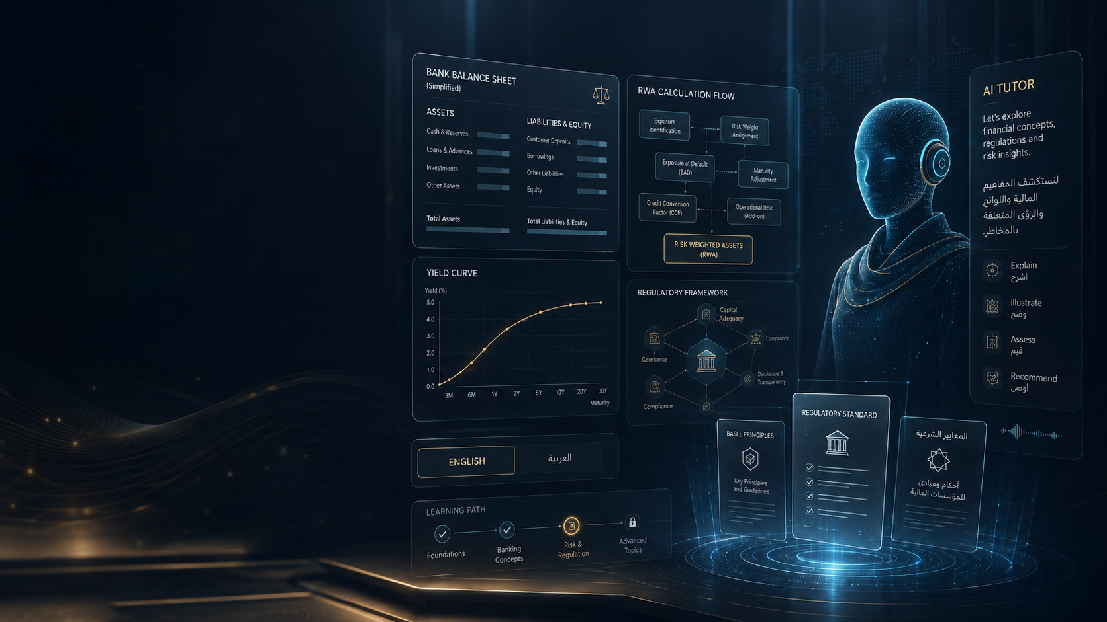
Document status
Architecture Lock Draft v0.9. This is intentionally detailed so product, engineering and SME reviewers can challenge it. Move to v1.0 only after the lock checklist at the end is accepted.

Prepared August 16, 2026

Contents
1. Document Control & Architecture Lock
2. Product Definition and Scope
3. Users, Roles and Journeys
4. Information Architecture and UI States
5. Golden Lesson 001 Functional Specification
6. AI Tutor and Adaptive Learning
7. Regulatory Knowledge and Content Model
8. FinBank and Deterministic Calculation Layer
9. Data Model
10. API, Events and Integration Contracts
11. Video, Voice and Media Architecture
12. Localization and Arabic
13. Security, Privacy and Governance
14. Non-Functional Requirements
15. Testing and AI Evaluation
16. Deployment Architecture
17. Implementation Sprints
18. Architecture Lock Checklist
19. Research Basis

1. Document Control & Architecture Lock
Field | Value
Document | Financial Pods V1 Technical & Functional Specification
Version | 0.9 — architecture lock draft
Initial product | Basel Regulatory Capital Pod
Golden Lesson | Corporate Exposure — From Bank Loan to Regulatory Capital
Launch jurisdictions | BCBS baseline, United States, Saudi Arabia/SAMA, UAE/CBUAE
Launch languages | English + Arabic
Primary review groups | Product, engineering, regulatory SMEs, design/UX, security/privacy
Lock rule | No major V1 build starts until P0 decisions in Section 18 are accepted

Architecture principle
Build a modular monolith with clean boundaries first. Use managed infrastructure and provider adapters. Invest early in domain contracts, auditability, testing and AI evaluations; defer microservices, Kubernetes, Spark and a dedicated graph database until measured requirements justify them.

2. Product Definition and Scope

2.1 V1 outcome
A learner can complete one premium Basel lesson end-to-end, interrupt at any point by text or voice, receive a grounded answer tied to the current lesson segment, manipulate a synthetic corporate exposure, calculate and compare regulatory outcomes across the supported jurisdictions, practice with new cases, complete a voice viva, and see a concept-level mastery result.

2.2 V1 in scope
- Authentication, learner profile and entitlement checks.
- Basel Pod landing page and Golden Lesson 001.
- Chaptered video player with semantic timeline metadata.
- English and Arabic content, captions, RTL UI and terminology glossary.
- Pause-anywhere grounded chat tutor.
- Realtime voice tutor with interruption/barge-in, transcript and resume behavior.
- Official-source panel that distinguishes BCBS, U.S., SAMA and CBUAE; proposed rules are visually distinct from effective rules.
- Interactive corporate-exposure calculator backed by deterministic Python functions.
- Jurisdiction comparison view.
- Active-learning checkpoints and misconception capture.
- Practice case generation within reviewed templates.
- Voice viva with scoring rubric.
- Learner mastery dashboard.
- Content admin workflow with SME approval and immutable publication versions.
- Provider usage/cost telemetry and kill switches.

2.3 Explicitly out of scope
- Full Basel curriculum at initial release; Golden Lesson proves the platform pattern first.
- Native iOS/Android apps.
- Mandatory live avatar; avatar is an optional presentation layer behind a feature flag.
- Production processing of confidential bank portfolios.
- Kubernetes, Spark, multi-region active-active, self-hosted LLMs, or a dedicated graph database without measured need.
- Unreviewed autonomous publication of regulatory content.

3. Users, Roles and Journeys
Persona | Primary goal | Critical V1 experience
Individual learner | Understand Basel concepts and gain job-ready competence | Guided lesson, ask questions, calculations, practice, viva, mastery
Experienced banker | Refresh/compare jurisdictions quickly | Jump to rule, compare treatment, test edge cases, cite source
SME reviewer | Validate accuracy before publication | Rule/citation/calculation review, comments, approve/reject
Content editor | Create consistent learning experiences | Structured lesson template, localization, media/version workflow
Platform admin | Operate product safely | Roles, entitlements, provider flags, usage/cost, audit
Enterprise L&D (phase 2) | Assign and track skill development | Team assignments, proficiency dashboard, SSO later

3.1 Golden learner journey
1. Learner signs in, selects Basel Pod and chooses English or Arabic.
2. Learner starts Golden Lesson; the player loads the immutable lesson version and semantic timeline.
3. At a concept boundary the lesson can automatically pause for an Active Mode checkpoint.
4. At any moment the learner can manually pause and ask a text or voice question. Tutor receives exact segment/jurisdiction/example state.
5. When a question requires a calculation or comparison, the tutor calls an approved deterministic tool and explains the returned result.
6. Learner opens the calculator, changes rating/revenue/jurisdiction and sees the recalculated result with rule references.
7. Learner completes generated-but-constrained practice cases and a scored voice viva.
8. Mastery is updated from multiple evidence events; remediation recommendations are generated.
9. On return, the learner resumes from exact content/version state and sees retained mastery/misconceptions.

4. Information Architecture and UI States

4.1 Primary navigation
Area | Purpose | V1
Home / My Learning | Resume, mastery, recommended review | Yes
Pods | Browse Basel and future Pods | Yes
Lesson | Video + timeline + tutor + tools | Yes
Practice | Cases, quizzes, viva | Yes
Mastery | Concept graph/proficiency | Yes
Sources | Approved rule references | Embedded + optional library
Admin Studio | Rules, lessons, review, localization, publication | Internal V1
Enterprise | Team/admin analytics | Phase 2

4.2 Lesson player desktop layout
Recommended desktop layout uses a dominant learning canvas on the left and an always-available Tutor panel on the right. The bottom tool rail exposes Rule, Calculate, Compare and Practice. Mobile collapses the tutor to a bottom sheet and preserves the video/timeline as the primary surface.
State | Left learning canvas | Right tutor panel | Bottom/secondary actions
Playing | Video / diagrams / chapter progress | Context summary + Ask button | Rule, Calculate, Compare, Practice
Paused by learner | Frozen exact timestamp | Chat/voice input active | Resume
Tutor answer | Video stays paused; may swap to whiteboard/calculation | Streaming grounded answer + citations | Show source / run example / resume
Active checkpoint | Question card replaces/overlays video | Coach waits for answer | Hint according to mode
Compare | Jurisdiction comparison grid + highlighted differences | Comparator explanation | Switch rule/status
Viva | Minimal prompt surface | Examiner voice/transcript | No coaching until scoring completes

5. Golden Lesson 001 Functional Specification

5.1 Learning objective
By the end of the lesson, a learner should be able to identify a corporate exposure, describe the data required for standardized regulatory-capital treatment, determine or explain the appropriate risk-weighting path for supported examples, calculate RWA using the approved tool, distinguish BCBS baseline from jurisdiction implementation, and defend reasoning verbally.

5.2 Chapter structure
Chapter | Approx. purpose | Interactive element
1. Why bank capital exists | Connect credit risk to loss-absorbing capital | Quick diagnostic question
2. Classify the exposure | Corporate vs retail/other exposure class | Decision tree + learner choice
3. Read the rule | Show official source and simplified explanation | Open citation
4. Required data | Rating, borrower type, revenue, exposure, default/collateral fields | FinBank record inspector
5. Calculate | EAD/RW/RWA relationship | Deterministic calculator
6. What-if | Change inputs and observe result | Interactive sliders/selectors
7. Jurisdiction compare | BCBS/U.S./SAMA/UAE | Comparison matrix
8. Practice | Near-boundary cases and misconceptions | Generated constrained cases
9. Viva | Explain and calculate verbally | Scored realtime voice
10. Mastery | Feedback and remediation | Concept mastery summary

5.3 Semantic timeline contract
Every video segment has machine-readable context. The player sends current segment state to tutor sessions rather than forcing retrieval to infer what the learner is seeing.
Field | Example | Requirement
lesson_version_id | GL001-en-v1.0 | Immutable after publish
segment_id | corp-classification-03 | Stable semantic identifier
start_ms / end_ms | 402000 / 447000 | Exact media location
concept_ids | corporate_exposure, exposure_class | One or more
jurisdiction_context | SAMA | Can be neutral/multiple
rule_ids | SAMA-CR-7.37 | Approved structured IDs
example_id | FINBANK-CORP-001 | Synthetic fixture
tool_context | credit_rwa_calculator | Optional
visual_context | classification-decision-tree | Allows tutor to refer to current visual

5.4 Pause-and-ask acceptance behavior
1. Pause action freezes current timestamp and writes a learner event.
2. Question request carries lesson version, segment, current example, selected jurisdiction, tutor mode and language.
3. Tutor must retrieve approved sources for regulatory claims; citations are rendered as structured UI objects.
4. If calculation is requested, tutor must call the deterministic calculator and quote the result returned by the tool.
5. If source coverage is insufficient, tutor says what is missing rather than inventing an answer.
6. Learner can ask a follow-up without losing segment context.
7. On “resume”, playback returns to the same or an explicitly chosen timestamp.
8. Tutor conversation is summarized into learning events/misconceptions; raw transcript retention follows privacy settings.
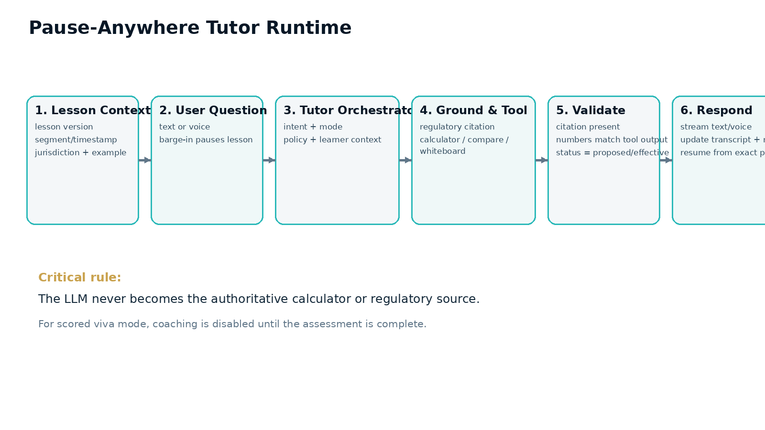
Figure 1 — Runtime path for pause-anywhere text/voice tutoring.

6. AI Tutor and Adaptive Learning

6.1 Tutor modes
Mode | Behavior | Answer policy
Teacher | Explain progressively using lesson context | Can answer directly with citations/tools
Socratic coach | Ask learner to reason before revealing | Do not immediately give final answer
Calculation coach | Guide inputs/formula and invoke tool | Tool output is authoritative
Practitioner | Connect rule to real bank workflow/data | Use approved workflow examples
Jurisdiction comparator | Explain common principle vs local implementation | Must label rule status/version
Examiner / Viva | Ask and score against rubric | No coaching during scored portion

6.2 Grounding hierarchy
1. Approved structured regulatory sources and rule citations.
2. Approved lesson content and jurisdiction explanations.
3. Deterministic calculation and comparison tools.
4. Reviewed FinBank synthetic examples and workflow mappings.
5. General model knowledge only for explanatory analogy or non-authoritative context.

6.3 Adaptive learning model
Do not classify a person as a fixed visual/auditory learner. Adapt from evidence: mastery, repeated misconceptions, response quality, latency, confidence, successful explanation format, practice transfer, preferred language, voice/text preference and spaced-retention checks.
Signal | Example | Adaptive action
Repeated error | Treats outstanding amount as EAD in all cases | Insert off-balance-sheet counterexample later
High success after worked examples | Abstract explanation fails; worked example succeeds | Prefer worked example before independent task
Fast correct answers | Three consecutive high-confidence correct cases | Increase difficulty / reduce scaffolding
Low retention | Concept mastered then fails 7-day review | Schedule spaced retrieval practice
Arabic chosen for questions | Learner studies English video but asks in Arabic | Answer Arabic while retaining English banking terminology mode
Viva reasoning weak | Correct numeric answer without rule reasoning | Recommend jurisdiction/rule interpretation practice

6.4 AI safety/correctness gates
- No fabricated paragraph numbers, citations, effective dates, report fields or numerical results.
- No conversion of proposal/consultation into effective rule status.
- No authoritative numerical response if required calculator fails.
- Retrieved documents are untrusted input for prompt injection; only structured approved content is authoritative.
- All provider/model/prompt versions are logged for reproducibility and evaluations.
- Tutor must have a feature-level kill switch and fallback to text-only/source-only experience.

7. Regulatory Knowledge and Content Model

7.1 Canonical model
Use the consolidated BCBS Basel Framework as the canonical prudential concept layer, then map U.S., SAMA and CBUAE jurisdiction implementations. The Basel Committee describes the consolidated Framework as the integrated home for current and forthcoming Basel standards. The March 19, 2026 U.S. capital package is a proposal and must therefore remain explicitly versioned/status-labelled in the learning product. [R9][R12]
Entity | Purpose | Key fields
RegulatorySource | Authority/source registry | authority, jurisdiction, canonical URL
RegulatoryDocument | Versioned publication | status, publication/effective dates, hash
Rule | Canonical concept/rule | canonical ID, module, concept
JurisdictionRule | Local implementation | jurisdiction, status, effective range, source mapping
RuleCitation | Exact evidence locator | document, locator, excerpt metadata
Concept | Learning graph node | prerequisites, glossary, mastery rubric
LessonVersion | Published learning object | locale, rule versions, review state
LessonSegment | Video/tutor context | timestamps, concepts, rules, example/tool context

7.2 Publication state machine
Draft -> automated validation -> primary SME review -> calculation/test verification -> editorial/localization review -> approved -> published -> superseded/withdrawn. Published versions are immutable. Corrections create new versions so learner history remains reproducible.
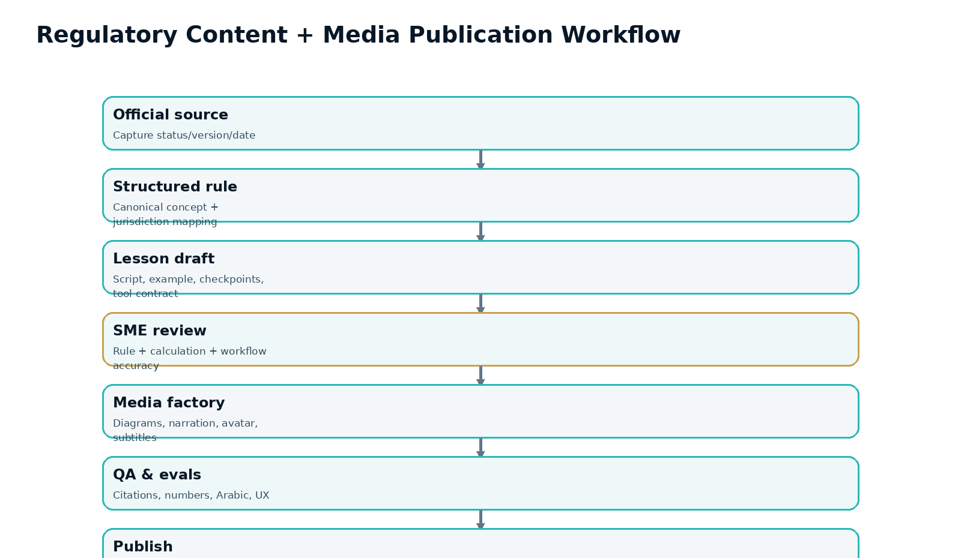
Figure 2 — Regulatory and media content publication workflow.

8. FinBank and Deterministic Calculation Layer

8.1 FinBank purpose
FinBank is a reusable synthetic digital bank. The same corporate loan can later appear in Basel, profitability, FTP, ALM, reporting and AML learning contexts. V1 includes a small deterministic corporate-loan universe; future Pods enrich the same canonical product/customer/account model.

8.2 Calculation service contract
Input | Output | Required metadata
Exposure fixture or learner-modified values | classification, EAD, RW, RWA, capital teaching outputs | jurisdiction, ruleset version, input hash, rule IDs
Two jurisdictions/rulesets | side-by-side results + structured delta | both ruleset versions, reasons/citations
Invalid/incomplete input | typed validation errors and missing-data requirements | no guessed defaults unless rule explicitly defines one

8.3 Precision rule
Authoritative monetary/risk calculations use Decimal/fixed-point policies and deterministic code. UI may format values, but it must never recompute authoritative results with floating-point JavaScript logic.

9. Data Model
Domain | Core tables / aggregates | Notes
Identity/tenant | tenant, user, role, entitlement, subscription | Design tenant-ready from V1; enterprise features later
Content | source, document, rule, jurisdiction_rule, citation, concept, lesson, lesson_version, segment | Published content immutable
Media | asset, rendition, caption_track, voice_asset, provenance | Store provider/provenance and rights metadata
FinBank | legal_entity, counterparty, product, facility, exposure, collateral, rating, fixture_version | Synthetic and reproducible
Learning | enrollment, learning_event, mastery, misconception, assessment_attempt, answer_evidence | Learning events append-only
Tutor | conversation, turn, tool_call, citation_used, tutor_mode, prompt_version | Retention configurable
Operations | provider_usage, cost_event, audit_event, feature_flag, job_run | Supports unit economics and audit

9.1 Mastery event examples
- video_segment_completed
- checkpoint_answered
- calculation_attempted
- rule_source_opened
- practice_case_completed
- viva_question_scored
- misconception_detected
- misconception_resolved
- spaced_review_passed

10. API, Events and Integration Contracts

10.1 API style
- REST/JSON for resource and deterministic-tool APIs; generated OpenAPI contract.
- Server-Sent Events for streamed text tutor responses.
- WebRTC for low-latency browser voice; server issues only short-lived/ephemeral authorization where provider supports it.
- Idempotency keys for billable content/media and state-changing async operations.
- Every response includes trace/request ID; calculation response includes rule/version/input-hash metadata.

10.2 Proposed endpoint families
Endpoint family | Examples
Identity/learning | /api/v1/me, /enrollments, /mastery
Catalog/content | /pods, /lessons/{id}, /lessons/{id}/timeline
Tutor | /tutor/sessions, /tutor/sessions/{id}/messages, /tutor/realtime-token
Tools | /calculations/credit-rwa, /comparisons/jurisdictions
Assessments | /practice, /viva/sessions, /attempts
Sources | /rules/{id}, /citations/{id}
Admin | /admin/rules, /admin/lessons, /admin/reviews, /admin/publications
Operations | /health, /ready, internal usage/cost endpoints

10.3 Domain events
Use an internal event vocabulary from day one even inside a modular monolith. Examples: LessonStarted, SegmentCompleted, TutorQuestionAsked, ToolExecuted, MasteryChanged, ContentApproved, LessonPublished, RegulatoryChangeCandidateCreated, ProviderCostRecorded.

11. Video, Voice and Media Architecture

11.1 Pre-render vs realtime
Pre-render / offline | Realtime
Core lesson video, authoritative diagrams/tables, captions, translations, reusable illustrative media | Tutor text, voice, whiteboard, deterministic calculations, live assessment
Can be reviewed once and served cheaply through CDN | Must be instrumented for latency/cost and have fallback paths

11.2 Media provider strategy
Keep generation behind adapters. Google describes Gemini 2.5 Flash Image (“nano-banana”) as an image generation/editing model suitable for maintaining character consistency and targeted edits; use such models for illustrative assets, not authoritative formulas. [R4] HeyGen LiveAvatar exposes embeddable realtime avatar sessions; treat avatar as optional presentation, not a core dependency. [R2]

11.3 Voice strategy
Support both direct speech-to-speech and chained STT -> text tutor -> TTS behind a common interface. Current OpenAI voice-agent guidance describes speech-to-speech as the low-latency path for barge-in and natural turn taking, while chained pipelines give tighter control over intermediate text. [R1] ElevenLabs documents multimodal agents with configurable turn-taking/interruptions and bring-your-own-model options. [R3]

11.4 Voice-session context
- lesson/version/segment
- language and jurisdiction
- current FinBank example
- current calculator state
- tutor mode
- learner mastery summary
- approved tool catalog
- citation scope

12. Localization and Arabic

12.1 Architecture
- Concept/rule IDs are language-neutral.
- Original regulatory source language is preserved; explanation language is separate.
- English and Modern Standard Arabic launch content; optional Arabic + English financial-term mode.
- Central glossary controls RWA, EAD, CCF, CET1 and other recurring terms across scripts, tutor and UI.
- RTL support is a first-class design-system requirement, not post-launch translation work.
- Arabic tutor/voice quality has its own evaluation set and human linguistic review.

12.2 Localization objects
Object | Localization rule
Lesson | Locale-specific immutable lesson version
Segment/captions | Aligned to semantic segment ID
Rule explanation | Localized explanation mapped to same jurisdiction rule
Glossary | Approved terminology, acronym behavior and notes
Voice asset | Locale/persona/provider/version metadata
Assessment rubric | Meaning preserved; not blindly translated

13. Security, Privacy and Governance
Area | V1 requirement
Authentication | OIDC-compatible provider; MFA mandatory for admin/SME
Authorization | RBAC and tenant-aware access; server-enforced
Secrets | Managed secret store; never browser/static config
Encryption | TLS in transit; managed encryption at rest
AI data minimization | Send only context needed for answer; provider calls tracked
Transcript retention | Explicit policy/consent; configurable later for enterprise
Admin audit | Append-only audit for publication, roles, entitlements, provider flags
Content integrity | Hash/version source and published lesson assets
Abuse protection | WAF/rate limits/quota and provider-cost guardrails
Enterprise path | SSO/SCIM, data residency, dedicated tenant/VPC, retention controls in phase 2

14. Non-Functional Requirements
Category | V1 target / design requirement
Availability | Target 99.9% learner API/web availability after public launch; graceful tutor degradation
Latency | Core page/API p95 < 500 ms excluding provider streams; text tutor first output target < ~2.5 s; voice target tuned separately
Video | Adaptive streaming/CDN; lesson start monitored as SLI
Correctness | Zero known critical golden-calculation failures; no uncited authoritative regulatory claim in approved test set
Accessibility | Keyboard navigation, captions, transcript, semantic controls, RTL and responsive layout
Scalability | Stateless web/API horizontal scaling; async workers independent; CDN carries media load
Auditability | Version every source, lesson, tool ruleset, prompt/model and assessment rubric
Cost | Per-user provider cost ledger; quota and premium gating for voice/avatar
Recovery | Managed DB backups/PITR; tested restore and immutable deployment rollback
Observability | End-to-end trace IDs and AI/provider/tool telemetry

Latency figures above are architecture targets to validate during prototype load testing, not guarantees.

15. Testing and AI Evaluation

15.1 Engineering test layers
1. Domain unit tests.
2. Golden deterministic calculation tests and boundary cases.
3. Database/repository integration tests.
4. API contract tests.
5. Frontend unit/component tests.
6. Playwright Golden Lesson end-to-end tests.
7. AI eval suite.
8. Arabic/RTL/terminology QA.
9. Load tests for tutor/API/lesson start.
10. Failure/chaos tests for provider unavailability and worker retry behavior.

15.2 AI evaluation set
Eval category | Must prove
Grounding | Regulatory claim resolves to approved source/citation
Status | Proposed vs final/effective is never confused
Tool use | Numeric/RWA question invokes required calculator
Numerical fidelity | Narrative values exactly match tool result
Pedagogy | Socratic mode gives learner opportunity before answer
Assessment integrity | Viva does not coach during scored portion
Arabic | Terminology and meaning consistent with approved glossary
Injection resistance | Retrieved text cannot override tutor policy/tool permissions
Failure handling | Missing source/tool error produces transparent limitation

16. Deployment Architecture
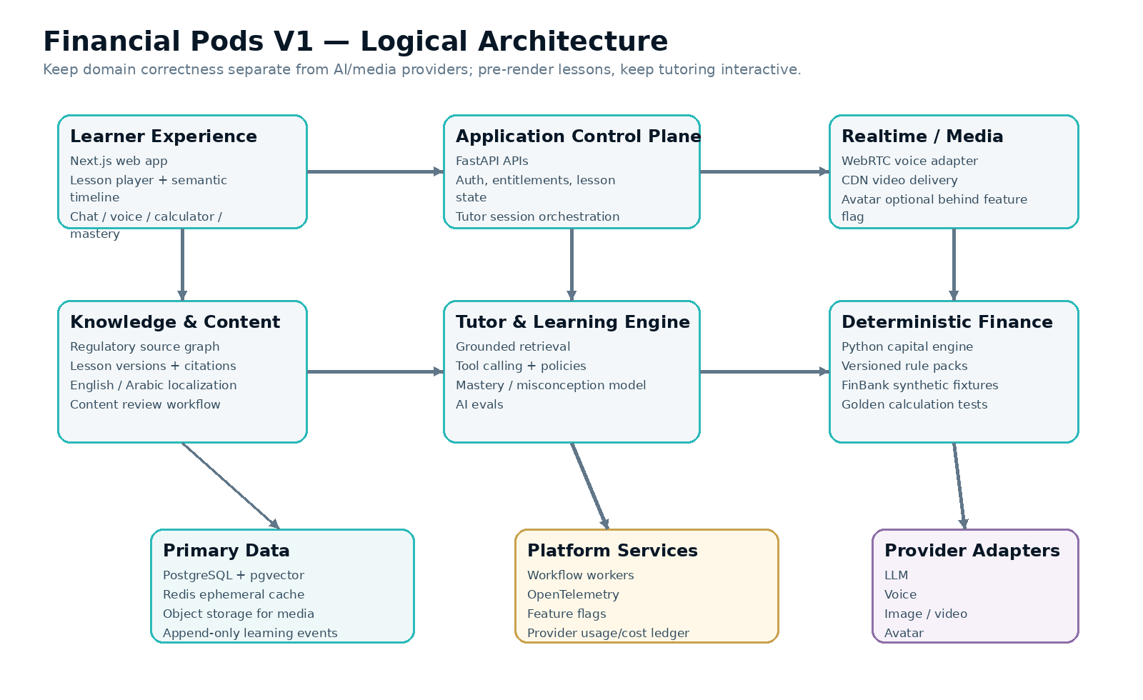
Figure 3 — Logical application architecture.
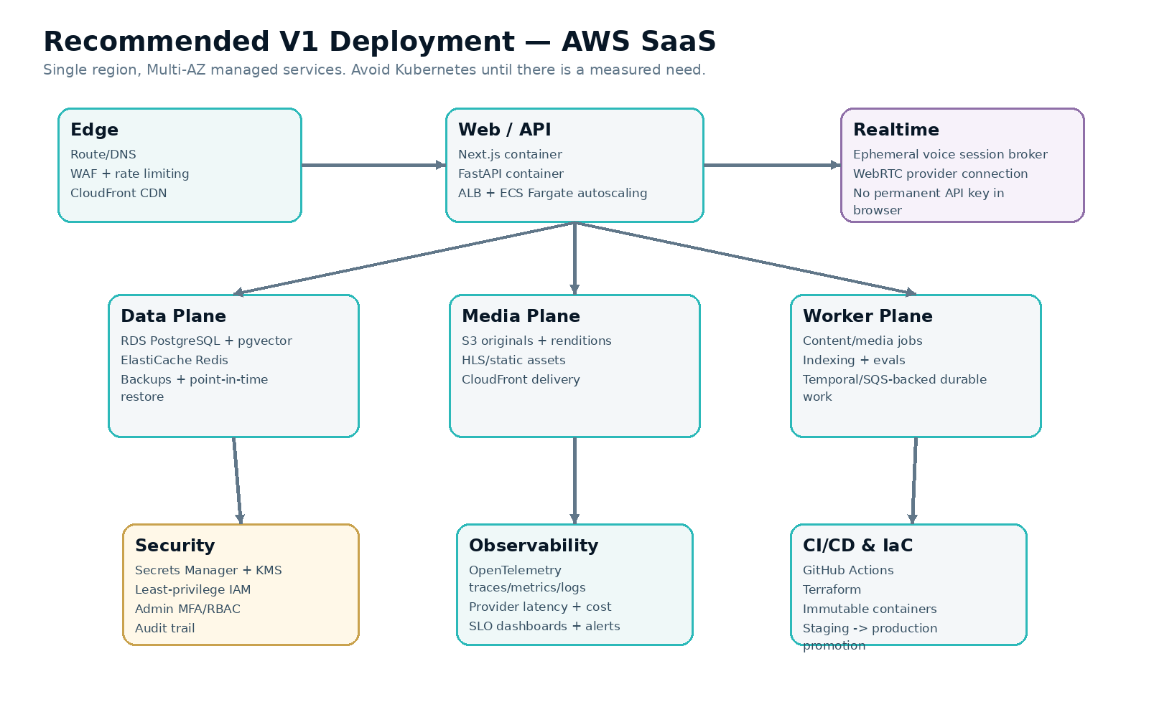
Figure 4 — Recommended initial SaaS deployment.

16.1 V1 deployment recommendation
Use a managed-container strategy rather than Kubernetes. AWS Fargate runs ECS containers without requiring the team to provision or manage underlying server clusters and supports load balancing and service scaling; this fits the V1 need for stateless web/API/worker components. [R5]
- CloudFront + S3 for lesson/video/static media; browser never streams large media through FastAPI.
- ECS Fargate services for web/API/realtime broker and worker processes.
- RDS PostgreSQL as system of record; pgvector keeps V1 retrieval in the same operational data platform. pgvector supports vector similarity search within PostgreSQL. [R7]
- ElastiCache Redis for ephemeral cache/rate/session coordination only.
- Durable workflows for media publication, indexing, evals and notifications. Temporal documents durable workflows that resume after failures; use it when workflow reliability warrants the dependency. [R6]
- OpenTelemetry instrumentation so traces/metrics/logs are vendor-neutral and correlated. [R8]
- Terraform for infrastructure-as-code and GitHub Actions for CI/CD.
- Defer EKS/Kubernetes until enterprise deployment or scale requirements make it beneficial.

17. Implementation Sprints
Sprint | Primary deliverables | Exit criteria
0 — Architecture lock | Repo skeleton, ADRs, CI, local Compose, base telemetry, domain contracts | Lock checklist accepted; CI green; dev environment reproducible
1 — Content/domain | Rule/concept/lesson/version schemas; Golden Lesson seed; review state machine | Reviewed data model; seed loads reproducibly
2 — Learner/player | Auth, dashboard, lesson player, semantic timeline, progress events | Resume and timestamp context work end-to-end
3 — Finance lab | FinBank fixture, corporate classifier/calculator, jurisdiction adapters | Golden calculation suite passes
4 — Text tutor | Grounding, citations, tool calling, streamed chat, tutor modes | Eval suite passes agreed threshold
5 — Mastery | Checkpoints, events, mastery/misconceptions, recommendations | Deterministic mastery updates from test journeys
6 — Voice | Realtime session, barge-in, transcript, resume, cost telemetry | Voice interruption works across supported browsers
7 — Arabic | RTL, glossary, Arabic lesson/tutor/voice QA | Arabic E2E and SME language review pass
8 — Practice/viva | Case templates, scoring rubric, voice viva, mastery feedback | Assessment integrity evals pass
9 — Content factory | Admin review, media pipeline, publication/versioning | New lesson version can be produced without code change
10 — Pilot | 10–20 practitioners, quality analytics, pricing feedback | Go/no-go decision for curriculum scale-out

18. Architecture Lock Checklist
How we lock v1.0
Review these decisions together. “Locked” means the choice is stable for V1 unless an ADR records evidence requiring change. It does not mean the choice can never evolve.

Decision | Recommended lock | Status
Product wedge | Golden Lesson 001 before full Basel curriculum | PROPOSED
Frontend | Next.js + React + TypeScript + Tailwind | PROPOSED
Backend | Python + FastAPI; reuse/refactor deterministic capital engine | PROPOSED
Architecture | Modular monolith + separate deployable web/API/worker/realtime processes | PROPOSED
Database | PostgreSQL; pgvector for V1 retrieval | PROPOSED
Graph | Relational graph semantics first; Neo4j deferred | PROPOSED
Runtime compute | No Spark for learning V1 | PROPOSED
Cloud | AWS single-region SaaS, Multi-AZ managed data plane | PROPOSED
Containers | ECS Fargate V1; Kubernetes deferred | PROPOSED
IaC/CI | Terraform + GitHub Actions | PROPOSED
Voice | Provider adapter; support realtime S2S and chained fallback | PROPOSED
Avatar | Optional feature flag; never core dependency | PROPOSED
Media | Pre-render lessons; realtime tutor/tools only | PROPOSED
AI calculations | LLM never authoritative calculator | PROPOSED
Content governance | SME-approved immutable versions | PROPOSED
Launch languages | English + Arabic | PROPOSED
Jurisdictions | BCBS, U.S., SAMA, CBUAE | PROPOSED

18.1 Questions to resolve during our lock review
- Identity provider for V1: Auth0 vs AWS Cognito vs another OIDC provider.
- Which realtime voice provider is primary for prototype; which is fallback.
- Whether founder cloned voice is required for Golden Lesson beta or follows after text/voice correctness.
- Whether to introduce Temporal in Sprint 0 or begin with a simpler managed queue and adopt Temporal in Content Factory sprint.
- Whether the U.S. Golden Lesson teaches current rule + both March 2026 proposal paths immediately or adds the non-ERBA standardized proposal after first prototype.
- Which Saudi/UAE SME reviewers are available before publication.
- Initial subscription/billing model and whether payments are included in V1 beta.

19. Research Basis
[R1] OpenAI Voice agents documentation
https://developers.openai.com/api/docs/guides/voice-agents
[R2] HeyGen / LiveAvatar developer documentation
https://docs.liveavatar.com/
[R3] ElevenLabs ElevenAgents documentation
https://elevenlabs.io/docs/eleven-agents/overview
[R4] Google Developers — Gemini 2.5 Flash Image / nano-banana
https://developers.googleblog.com/introducing-gemini-2-5-flash-image/
[R5] AWS — Architect for AWS Fargate for Amazon ECS
https://docs.aws.amazon.com/AmazonECS/latest/developerguide/AWS_Fargate.html
[R6] Temporal documentation — durable execution
https://docs.temporal.io/temporal
[R7] pgvector official repository/documentation
https://github.com/pgvector/pgvector
[R8] OpenTelemetry documentation
https://opentelemetry.io/docs/
[R9] BIS — Basel Framework
https://www.bis.org/basel_framework/
[R10] SAMA — Minimum Capital Requirements for Credit Risk
https://rulebook.sama.gov.sa/en/minimum-capital-requirements-credit-risk
[R11] CBUAE — Standards for Capital Adequacy of Banks in the UAE
https://rulebook.centralbank.ae/en/rulebook/standards-capital-adequacy-banks-uae
[R12] Federal Reserve — March 19, 2026 capital proposals
https://www.federalreserve.gov/newsevents/pressreleases/bcreg20260319a.htm

