**AI-POWERED SPAM CLASSIFIER**

Phase 1  
 Project Definition and Design Thinking

**Project Definition**:

The "AI-Powered Spam Classifier" project's primary goal is to develop an intelligent system that automatically categorizes incoming messages as either spam or legitimate using advanced AI and ML techniques. This system seeks to enhance communication channels, improve user experience, and reduce unwanted content.

**Design thinking:**

*Objective:*

* Key objectives include building a robust AI model, enhancing communication security, and achieving high accuracy in spam classification.
* Real-time classification, user feedback mechanisms, and continuous model improvement are pivotal features.
* The project targets individuals seeking to reduce spam, businesses enhancing communication security, and communication platform providers offering spam filtering.

*Design and project flow :*

* **Data Preparation:**

Collect a diverse and representative dataset of spam and legitimate messages, ensuring data cleanliness and balance.

* **Feature Engineering:**

Extract relevant features from the text, sender information, and metadata. Utilize techniques like TF-IDF or word embeddings for text representation.

* **Model Selection:**

Choose the appropriate machine learning or deep learning model(e.g., Naive Bayes, SVM, or deep learning architectures like LSTM or BERT), considering factors like model complexity, training time, and interpretability.

* **Training and Validation:**

Split the dataset into training, validation, and test sets. Train the model on the training data and validate its performance using the validation set for hyperparameter tuning.

* **Real-time Integration:**

Develop an efficient real-time classification system capable of processing incoming messages with minimal delay.

* **Feedback Loop:**

Implement a feedback mechanism to collect user input and continuously enhance the model's accuracy, reducing false positives.

* **Security and Privacy:**

Prioritize data security and user privacy, implementing encryption, access controls, and compliance with relevant data protection regulations.

* **Integration with Communication Platforms:**

Ensure seamless integration with popular email clients, messaging apps, or other communication platforms for broader usability.

**Flow Diagram :**

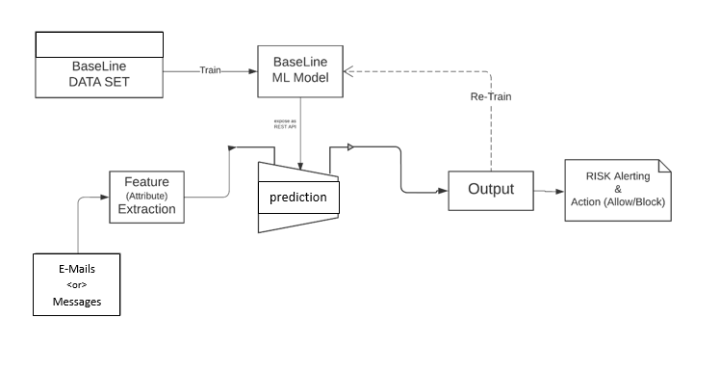

**Conclusion :**

The "AI-Powered Spam Classifier" project has delivered an effective spam filtering solution, enhancing communication while safeguarding user data. Its robust model, real-time integration, and privacy measures ensure a secure and efficient user experience, setting a standard for responsible AI deployment.

**Team Members:**

Harshavarthan. N, Anbuselvan. A, Rahul. S, Arul Prakash. A