**EXERCISE NUMER:** 01

**DATE:** 12/10/2020

**Aim**:

To write a Python program to print the calendar of a given month and year

**Program**:

import calendar

year=int(input())

month=int(input())

if(year<10000 and year>999 and month<13 and month>0):

print(calendar.month(year,month))

else:

print("Invalid Input")

**Link**:

http://103.53.53.18/mod/vpl/forms/edit.php?id=229&userid=1710

**Output**:

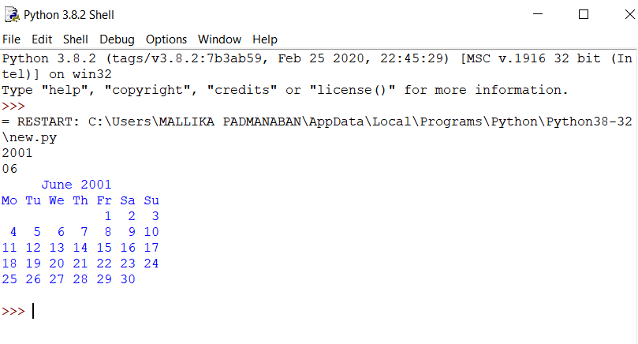

**Result**:

The expected output is obtained successfully.