**EXERCISE NUMER:** 11

**DATE:** 21/11/2020

**Aim**:

To Write a Python function to count the Number of Uppercase and LowerCase.

**Program**:

def string_test(s):

d={"upper":0,"lower":0}

for i in s:

if i.islower():

d["lower"]+=1

elif i.isupper():

d["upper"]+=1

print("No. of Upper case characters : ",d["upper"])

print("No. of Lower case characters : ",d["lower"])

s=input()

string_test(s)

**Output:**

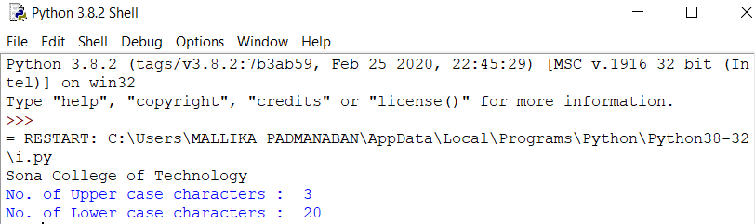

**Link**:

http://103.53.53.18/mod/vpl/forms/submissionview.php?id=325&userid=1710

**Result**:

The output for the given program is obtained.