**EXERCISE NUMER:** 11

**DATE:** 21/11/2020

**Aim**:

To Write a Python function to find GCD of two number.

**Program**:

def gcd(a,b):

if b==0:

return a

return gcd(b,a%b)

a=int(input("Enter first number:"))

b=int(input("Enter second number:"))

GCD=gcd(a,b)

print("GCD is: ")

print(GCD)

**Output:**

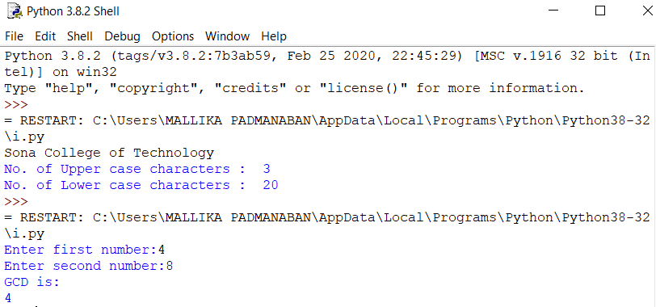

**Link**:

http://103.53.53.18/mod/vpl/forms/submissionview.php?id=326&userid=1710

**Result**:

The output for the given program is obtained.