**EXERCISE NUMER:** 02

**DATE:** 12/10/2020

**Aim**:

To write a Python function countX(lst, x) to count the number x in a given list of numbers.

**Program**:

def countX(lst,x):

count=0

for i in range(0,len(lst)):

if(lst[i]==x):

count=count+1

print(count)

lst=[]

n=int(input())

for i in range(0,n):

lst.append(int(input()))

x=int(input())

countX(lst,x)

**Link**:

http://103.53.53.18/mod/vpl/forms/edit.php?id=230&userid=1710

**Output**:

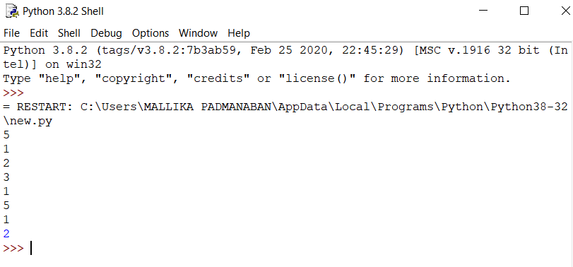

**Result**:

The expected output is obtained successfully.