**EXERCISE NUMER:** 03

**DATE:** 12/10/2020

**Aim**:

To write a Python program to remove and print every second number from a list of numbers until the list becomes empty.

**Program**:

def removeThirdNumber(lst):

temp=[]

p=1

s=0

for i in range(0,len(lst)):

s=(p+s)%len(lst)

re=lst.pop(s)

temp.append(re)

return temp

n=int(input())

lst=[]

for i in range(0,n):

lst.append(int(input()))

p=removeThirdNumber(lst)

print(p)

**Link**:

<http://103.53.53.18/mod/vpl/forms/edit.php?id=231&userid=1710>

**Output**:

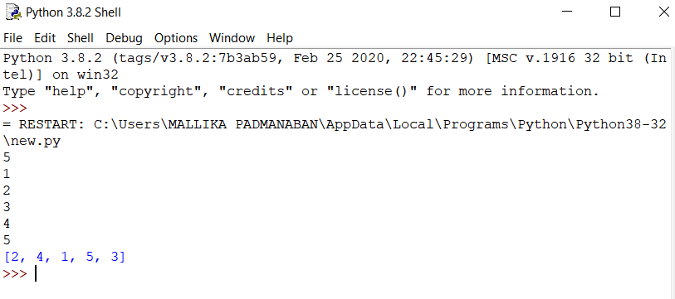

**Result**:

The expected output is obtained successfully.