**EXERCISE NUMER:** 04

**DATE:** 14/10/2020

**Aim**:

To Write a Python function to print missing characters to make string pangram.

**Program**:

sentence = input()

sentence = sentence.replace(" ","")

alpha_flag = [0]*26

for char in sentence:

asci = ord(char)-97

alpha_flag[asci]=1

asci=0

for i in range(0, len(alpha_flag)):

if(alpha_flag[i]==0):

asci=i+97

print(chr(asci),end="")

**Link**:

<http://103.53.53.18/mod/vpl/forms/edit.php?id=235&userid=1710#>

**Output**:

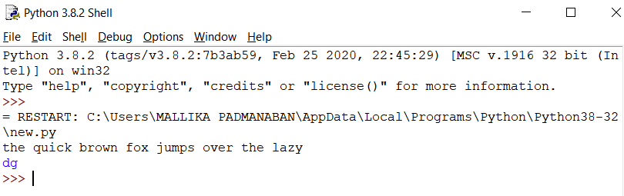

**Result**:

The expected output is obtained successfully.