1) Find the maximum between three numbers

C code:

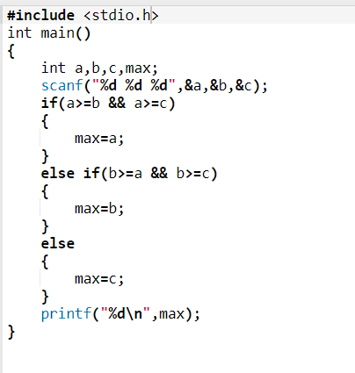

Wp derivation:

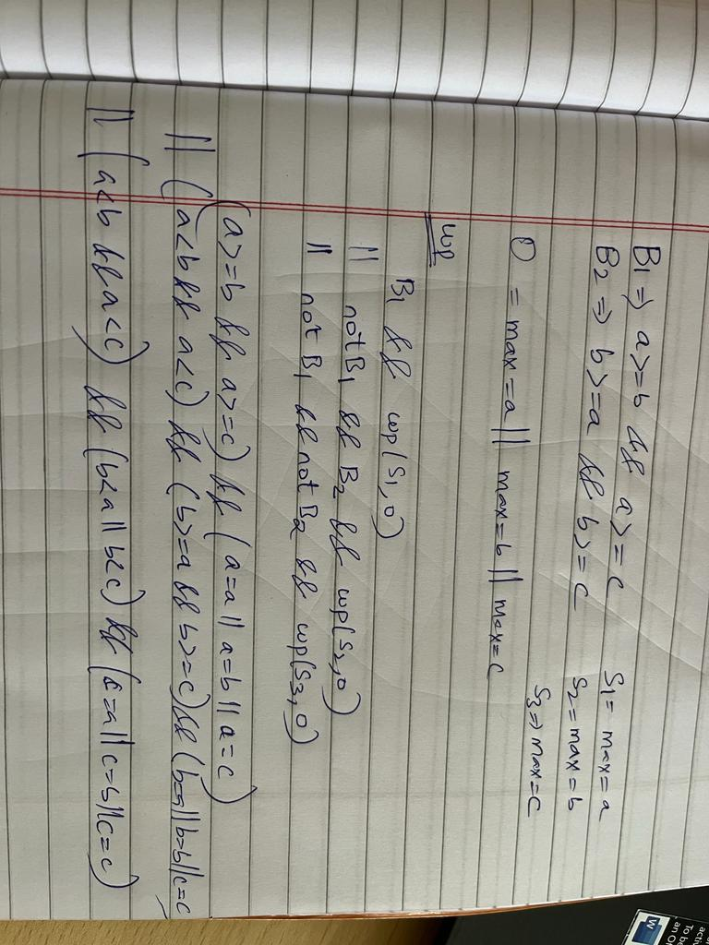

Alt ergo:  
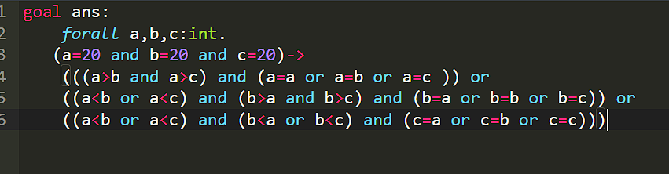

2) Check whether a number is negative, positive or zero.

C code:

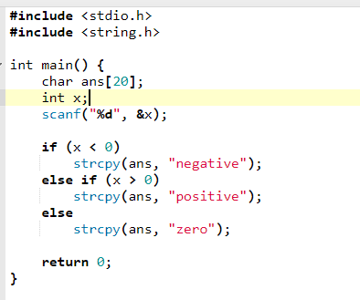

Wp derivation:

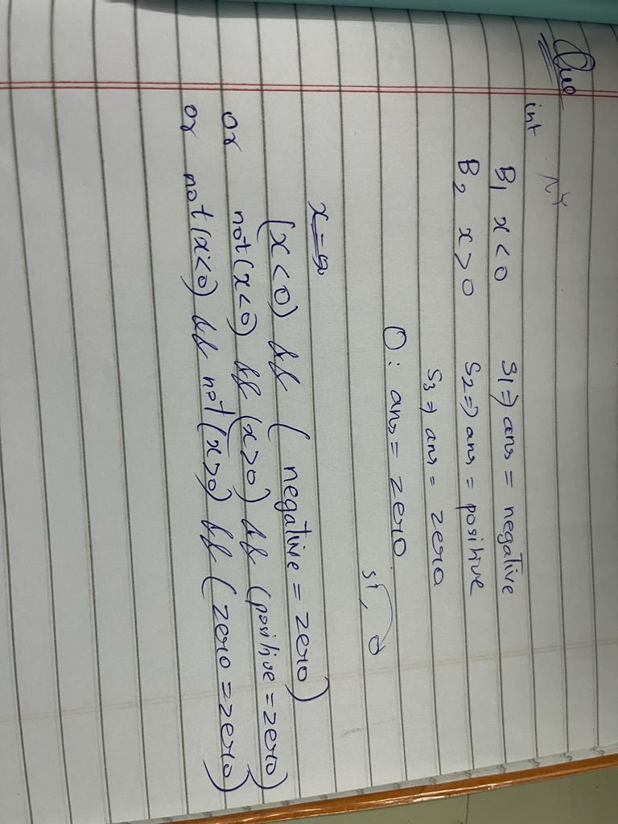

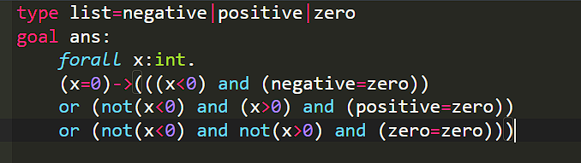\

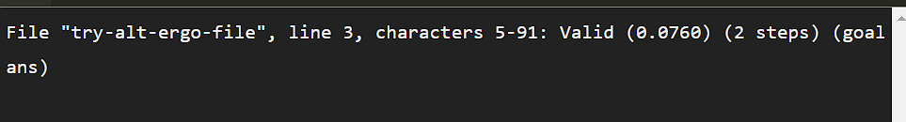

3)Check whether a number is even or odd

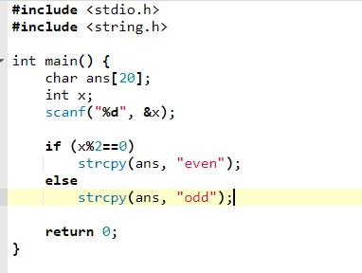

Wp derivation:

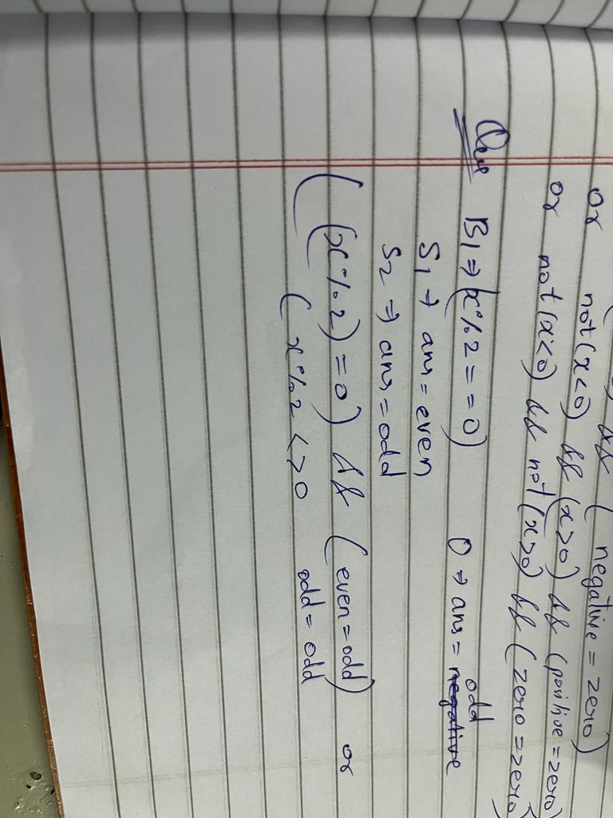

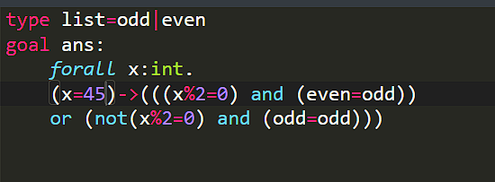



5) Input the basic salary of an employee and calculate its Gross salary according to following:

a) Basic Salary <= 10000 : HRA = 20%, DA = 80%

b) Basic Salary <= 20000 : HRA = 25%, DA = 90%

c) Basic Salary > 20000 : HRA = 30%, DA = 95%

C code:

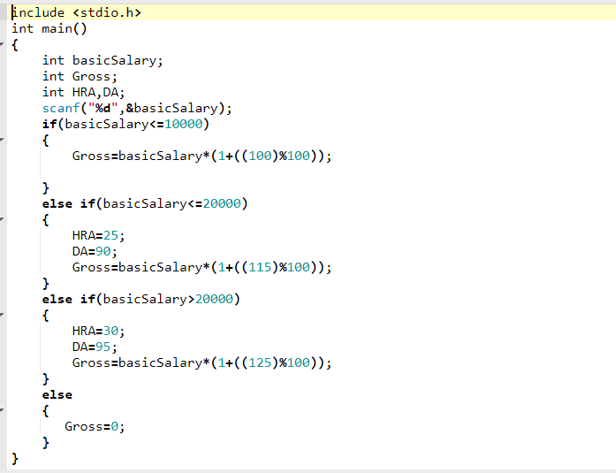

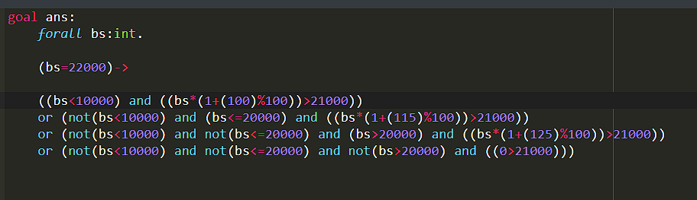



4) Input week number and print week day.

