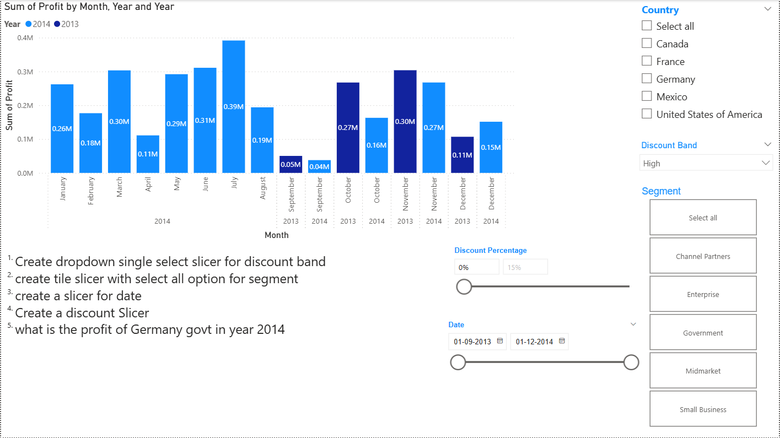Slicer

**Steps:**

* **In Report View Tab**

1. Visualizations tab ->Build Visual
2. Click on **Stacked Column Chart**

* **Data Tab**

1. **Financials** -> Select Column name according to the given question

* **Build Visual**

1. X-axis -> Month, Year
2. Y-axis -> Sum of Profit
3. Legends -> Year

* **Format Visual**

1. Legends -> ON
2. Data Label -> ON

* **To Add Slicer**

1. Visualizations tab ->Build Visual
2. Click on **Slicer**

* **Build Visual**

1. Field -> **Country**

* **Format Visual**

1. **Slicer Settings**

* Style -> Vertical List

1. **Selection**

* Multi-select with CTRL **(ON)**

1. Field -> **Discount Band**

* **Format Visual**

1. **Slicer Settings**

* Style -> Drop Down

1. **Selection**

* Single Select

1. Field -> **Segment**

* **Format Visual**

1. **Slicer Settings**

* Style -> Title

1. **Selection**

* Multi-Select with CTR
* Show "Select all Option” – **ON**

1. Field -> **Discount Percentage**

* **Format Visual**

1. **Slicer Settings**

* Style -> Greater than or equal to

1. Field -> **Date**

* **Format Visual**

1. **Slicer Settings**

* Style -> Between
* **Slicer Header ->ON (For all Slicer)**
* Font -> Arial
* Size ->12, Bold
* Font Color -> Blue