AI FITTRACK API - Personalized Fitness ecommendations Powered by AI

1. Description
FitTrack AI is a backend service that helps people log their workouts and receive AI-driven fitness guidance through a clean set of REST endpoints. It is built on the Node.js and Express.js stack, with MongoDB (via Mongoose) handling persistence, and it covers everything from account creation to workout record-keeping and AI-based coaching.
The codebase is organized around the MVC pattern, which keeps routing, business rules, and data access in separate layers so the project stays easy to extend. Account security relies on JSON Web Tokens for session handling and bcrypt.js for one-way password hashing — nothing is ever stored or compared in plain text. A dedicated middleware layer checks the token on every protected route before a request is allowed to reach its controller.
What sets this backend apart is its connection to Google Gemini through the official @google/genai SDK. Given a user's age, fitness goal, and experience level, the AI layer produces a tailored workout plan, and given a user's workout statistics (session count, average duration, calories burned) it produces a short, practical fitness insight.
Every response follows a consistent JSON shape, so the API can be consumed equally well by a web client, a mobile app, or a tool like Postman. A single error-handling middleware, combined with Mongoose-level validation and JWT-based route protection, keeps failure responses predictable and the codebase easy to reason about.

2. Scenario-Based Case Study

2.1 Background
Priya works out on a regular basis but keeps track of her sessions in a mix of phone notes and a physical diary. She stays disciplined about exercising, yet piecing together her workout history from scattered notes is tedious, and she has no easy way to tell whether her routine is actually moving her toward her fitness goal. She also has nobody to check whether the exercises she picks suit her current fitness level.

2.2 Problem
- Workout history is scattered across notebooks and phone notes instead of one place.
- Hand-written logs are error-prone and hard to trust over time.
- There is no login system, so fitness data isn't protected or tied to a specific person.
- Looking up a past workout by name, type, or date takes real effort.
- There is no guidance on which workouts fit her current goal or experience.
- She has no summary that tells her whether her overall progress is on track.
- Adding up duration and calories by hand for every session wastes time.

2.3 Solution
FitTrack AI replaces the notebook with a backend service where a user signs up once and then manages every workout through a small set of REST endpoints — create, list, fetch one, edit, delete, and search. Rather than leaving the user to guess at a routine, the service forwards the user's profile details and workout numbers to Google Gemini, which returns a personalized plan and a short read on how the user is progressing.
Underneath, the same protections you'd expect from any production API are in place: JWT-based sessions, bcrypt password hashing, middleware that gate-keeps every protected route, one error-handling layer for consistent failure responses, and Mongoose schemas that reject bad input before it reaches the database.

3. Usage

3.1 User Usage
A new user signs up through the registration endpoint and then logs in with their email and password. A successful login returns a JWT that must be attached to every subsequent request as a Bearer token. Once logged in, a user is able to:
- Log a new workout session.
- Pull up every workout they've logged, newest first.
- Open a single workout record using its ID.
- Edit the details of a workout already logged.
- Remove a workout record they no longer need.
- Look up past workouts by name, category, or date.
- Ask the AI layer for a personalized workout plan.
- Ask the AI layer for an insight based on their workout stats.

3.2 AI Usage
All AI-related calls pass through a single service module, geminiService.js, which is the only part of the codebase that talks to Google Gemini. For a workout plan, the user supplies their age, fitness goal, and experience level, and Gemini replies with a short, no-nonsense plan with concrete steps. For an insight, the user supplies their workout count, average session length, and total calories burned, and Gemini replies with two or three sentences of direct, practical feedback.

4. Outcome
With FitTrack AI in place, a user no longer needs to keep a manual log — every session is stored centrally and can be recalled, searched, or edited on demand, and the Gemini integration turns raw activity numbers into recommendations the user can actually act on. Because every workout route sits behind JWT verification, one person's data stays isolated from everyone else's account.
The layered MVC structure also means the project isn't a dead end — features like nutrition logging, BMI tracking, wearable-device sync, reminder notifications, or a full analytics dashboard could be bolted on later without reworking the existing modules.

5. Software and Hardware Requirements

5.1 Software Requirements
- Operating System: Windows 10/11, macOS, or Linux.
- Node.js (v20 or above) — JavaScript runtime for the server.
- npm (v8 or above) — Node package manager.
- Express.js — lightweight web framework for building REST APIs.
- MongoDB (Local or MongoDB Atlas) — NoSQL document database.
- Postman — API testing and verification tool.
- Google Gemini API Key (from Google AI Studio) — for AI-powered features.
- Code Editor — Visual Studio Code (recommended).

5.2 Hardware Requirements
- Processor: Intel Core i5 (8th Gen or above) / AMD Ryzen 5 or equivalent.
- RAM: 8 GB minimum (16 GB recommended).
- Storage: 1 GB of available disk space.

6. Epic 1: Project Architecture

Fig 1: FitTrack AI System Architecture
The backend is arranged in layers rather than as one large file — an MVC-style split keeps routing, business logic, persistence, middleware, and the AI integration each in their own place, which makes the codebase easier to navigate and to grow.
A typical request starts at the Express server, which hands it off to the matching route. If that route is protected, the JWT middleware checks the token first and rejects the request early if it's missing or invalid. From there, the controller takes over — running validation, calling a Mongoose model or the Gemini service as needed — and finally sends back a JSON response.

Building Blocks of the Architecture
- Client Application (Postman / React / Mobile App)
- Express Server (app.js, server.js)
- API Routes (routes/index.js, authRoutes, workoutRoutes, aiRoutes)
- Authentication Middleware (middleware/auth.js)
- Controllers (authController, workoutController, aiController)
- Service Layer (geminiService.js)
- MongoDB Database
- Mongoose Models (User.js, Workout.js)

7. Components Definition

7.1 Client Layer
This is whatever is making the API calls — Postman during development, or eventually a React front end or mobile app. Its job is to fire requests, hang on to the JWT once a user logs in, and render whatever JSON comes back.

7.2 Express Server Gateway (app.js)
app.js wires up the shared middleware — cors() so browsers can call the API from another origin, express.json() to parse request bodies, and morgan('dev') to log each incoming request — then mounts every route under /api and passes anything unmatched or any thrown error down to the error handler.

7.3 Authentication Middleware (middleware/auth.js)
The exported protect function pulls the Bearer token out of the Authorization header, checks its signature against JWT_SECRET, and looks up the matching user (password field excluded) to attach as req.user. If the header is missing, malformed, or the token doesn't verify, the request is stopped with a 401 before it ever reaches a controller.

7.4 Route Layer (routes/)
Each route file maps a URL pattern to a controller function; routes/index.js then wires all three groups together under the shared /api prefix.
Route Group | Base Path | Protected
Authentication Routes | /api/auth | Partial (profile only)
Workout Routes | /api/workouts | Yes — all routes
AI Routes | /api/ai | Yes — all routes

7.5 Controller Layer
- authController.js handles signing up, logging in, and returning the logged-in user's profile.
- workoutController.js covers the full CRUD set for workouts plus the search endpoint.
- aiController.js checks the request body is complete, then hands off to geminiService for the actual AI call.

7.6 Service Layer (services/geminiService.js)
This is the only file that imports the @google/genai SDK. It assembles a short, direct prompt from whatever the caller supplied, sends it to ai.models.generateContent() using the model named in GEMINI_MODEL, and hands back the trimmed text — or raises an error that flows to the shared error handler if the call fails.

7.7 Database Layer (config/db.js, models/)
Persistence is handled by MongoDB, with Mongoose sitting on top to define schemas and run queries. config/db.js opens the connection when the server boots and logs whether it succeeded, while User.js and Workout.js describe the two collections the app actually uses.

8. Entity Relationship (ER) Diagram Description

Fig 2: Entity Relationship Diagram — Users and Workouts
Data is split across two MongoDB collections — Users and Workouts — linked to each other in a one-to-many arrangement.

8.1 User Entity (models/User.js)
Field | Type | Description
_id | ObjectId | Primary key
name | String | Required, trimmed user name
email | String | Required, unique, lowercase, regex-validated
password | String | Required, min. 6 characters, hashed with bcrypt before save
createdAt / updatedAt | Date | Automatic timestamps

8.2 Workout Entity (models/Workout.js)
Field | Type | Description
_id | ObjectId | Primary key
workoutName | String | Required, trimmed
category | String | Required; enum: Cardio, Strength Training, Yoga, Running, Cycling, Walking
duration | Number | Required, minimum 1 minute
caloriesBurned | Number | Required, minimum 0
workoutDate | Date | Defaults to current timestamp
user | ObjectId (ref: User) | References the owning user
createdAt / updatedAt | Date | Automatic timestamps

8.3 Relationship — User → Workout
One user can own any number of workouts, but a given workout always traces back to exactly one user. This is enforced two ways: the Workout document keeps an ObjectId reference to its owner in the user field, and the protect middleware ensures every query is automatically filtered to req.user.id, so no request can leak another user's records.

9. Key Features

9.1 Secure Authentication
- User registration with duplicate-email protection.
- Secure login with bcrypt password comparison.
- Password hashing via a Mongoose pre('save') hook.
- JWT generation and verification.
- Route-level protection via middleware.

9.2 Workout Management (CRUD)
Once logged in, a user can create a workout, list all of them, fetch one by its ID, update its fields, or remove it entirely. Ownership is tied to the user field on each record, so nobody can read or modify a workout that isn't theirs.

9.3 Workout Search
Hitting GET /api/workouts/search?q=<term> runs a case-insensitive pattern match against the workout name and category fields, and separately checks whether the query looks like a date (say, 2026-06-26) to match against workoutDate. Note that /search is declared ahead of the /:id route in workoutRoutes.js — otherwise Express would treat "search" as an ID.

9.4 Google Gemini Workout Recommendation
The caller sends age, fitness goal, and experience level; geminiService.js turns that into a prompt and returns a concrete, step-by-step plan generated by Google Gemini through the @google/genai SDK.

9.5 AI Fitness Insights
The caller sends their total workout count, average session duration, and total calories burned, and gets back a short, practical read on their progress along with what to adjust.

9.6 Centralized Error Handling (middleware/errorHandler.js)
Error Type | HTTP Status | Handling
Invalid ObjectId (CastError) | 404 | "Resource not found with id of ..."
Duplicate email (code 11000) | 400 | "Duplicate field value entered. User with this email already exists."
Mongoose ValidationError | 400 | Combined list of field validation messages
Unhandled route | 404 | "Endpoint Not Found - <url>"
Other server errors | 500 | "Server Error"

9.7 RESTful API Design
Every endpoint sticks to standard HTTP verbs (GET, POST, PUT, DELETE) and always answers with the same JSON shape, which makes the API predictable regardless of which client is calling it.

9.8 Modular Architecture
Config, controllers, middleware, models, routes, and services each live in their own folder, so a change in one area rarely ripples into another — that keeps testing and future changes manageable.

10. Roles and Responsibilities

10.1 Authenticated User
- Register an account and log in securely.
- View profile information.
- Add, view, update, delete, and search workout records.
- Request AI-powered workout recommendations.
- Request AI-generated fitness insights.
Operation | Permission
Register / Login | Yes
View Profile | Yes
Add / Get / Update / Delete Workout | Yes
Search Workouts | Yes
AI Recommendation | Yes
Fitness Insights | Yes

11. User Flow

Fig 3: End-to-End User Flow

12. MVC Architecture Pattern

Fig 4: Model-View-Controller Pattern used in FitTrack AI

12.1 Model Layer
Handled by the two Mongoose schemas, User and Workout, which define what a valid document looks like and talk to MongoDB directly for reads and writes.

12.2 View Layer
Since this is a pure API with no server-rendered pages, the "view" is really whatever client is consuming the JSON — Postman during testing, or a React/mobile front end in production.

12.3 Controller Layer
Sits between the incoming request and the data layer: it checks the input, calls the right model or service, and shapes the final JSON that goes back to the caller.

13. Epic 2: Project Setup and Configuration

13.1 Creating the Project

Fig 5: Project folder structure
mkdir AI-FitTrack-API && cd AI-FitTrack-API
npm init -y

13.2 Installing Dependencies
The actual dependencies configured in package.json are:
Package | Version | Purpose
express | ^4.19.2 | Web framework / routing
mongoose | ^8.4.1 | MongoDB ODM
dotenv | ^16.6.1 | Environment variable loading
bcryptjs | ^2.4.3 | Password hashing
jsonwebtoken | ^9.0.2 | JWT auth
cors | ^2.8.5 | Cross-Origin Resource Sharing
morgan | ^1.10.0 | HTTP request logging
@google/genai | ^2.10.0 | Google Gemini AI SDK
nodemon (dev) | ^3.1.2 | Auto-restart during development

13.3 Environment Variables (.env)
PORT=5000
MONGO_URI=mongodb://localhost:27017/fittrack
JWT_SECRET=your_jwt_secret_key_here
GEMINI_API_KEY=your_google_gemini_api_key_here
GEMINI_MODEL=gemini-3.8-flash
Keeping these values in .env rather than hard-coded means secrets never end up committed to source control, and each environment (local, staging, production) can point at its own database and keys.

14. Epic 3: Backend Development
This phase is where the actual API endpoints get built — everything a logged-in user needs to manage workouts and talk to Gemini. The work breaks down into these modules:
- Server Configuration (server.js, app.js)
- Database Configuration (config/db.js)
- Authentication (authController.js, authRoutes.js)
- Workout Management (workoutController.js, workoutRoutes.js)
- AI Recommendation (aiController.js, aiRoutes.js, geminiService.js)
- Middleware (auth.js, errorHandler.js)
- Error Handling (errorHandler.js)

15. Epic 4: Database Configuration
All persistent data lives in MongoDB, split into the Users and Workouts collections described earlier. Mongoose sits between the app and the database, taking care of schema validation and hooks like the password-hashing step that runs before a user is saved.

15.1 MongoDB Connection (config/db.js)
This file opens the connection the moment the server starts, prints whether it connected successfully, catches any connection failure, and exposes the connection object for the rest of the app to use.

15.2 Mongoose Schemas
Two schemas back the whole app — User for login/profile data and Workout for the fitness records — with the exact fields and validation rules already listed in Section 8.

16. Epic 5: Project Execution and API Testing

16.1 Running the Project
npm install
npm run dev # development, with nodemon
npm start # production
Once running, a plain GET request to / returns a simple JSON message confirming the API is up, together with the port it's listening on.

16.2 API Reference
Feature | Method | Endpoint | Auth
Register User | POST | /api/auth/register | No
Login User | POST | /api/auth/login | No
Get Profile | GET | /api/auth/profile | Yes
Add Workout | POST | /api/workouts | Yes
Get All Workouts | GET | /api/workouts | Yes
Search Workouts | GET | /api/workouts/search?q= | Yes
Get Workout by ID | GET | /api/workouts/:id | Yes
Update Workout | PUT | /api/workouts/:id | Yes
Delete Workout | DELETE | /api/workouts/:id | Yes
Workout Recommendation | POST | /api/ai/workout-recommendation | Yes
Fitness Insights | POST | /api/ai/fitness-insights | Yes

16.3 API Testing
Testing relied on the Postman collection shipped with the project (FitTrack.postman_collection.json). Its scripts automatically capture the JWT returned by Register/Login into a jwt_token variable, and the ID of a newly created workout into workout_id, so the rest of the calls in the collection don't need to be authorized by hand. Endpoints were exercised in this order:
- Authentication APIs — Register, Login, Get Profile.
- Workout APIs — Add, Get All, Get by ID, Update, Delete, Search.
- AI APIs — Workout Recommendation, Fitness Insights.

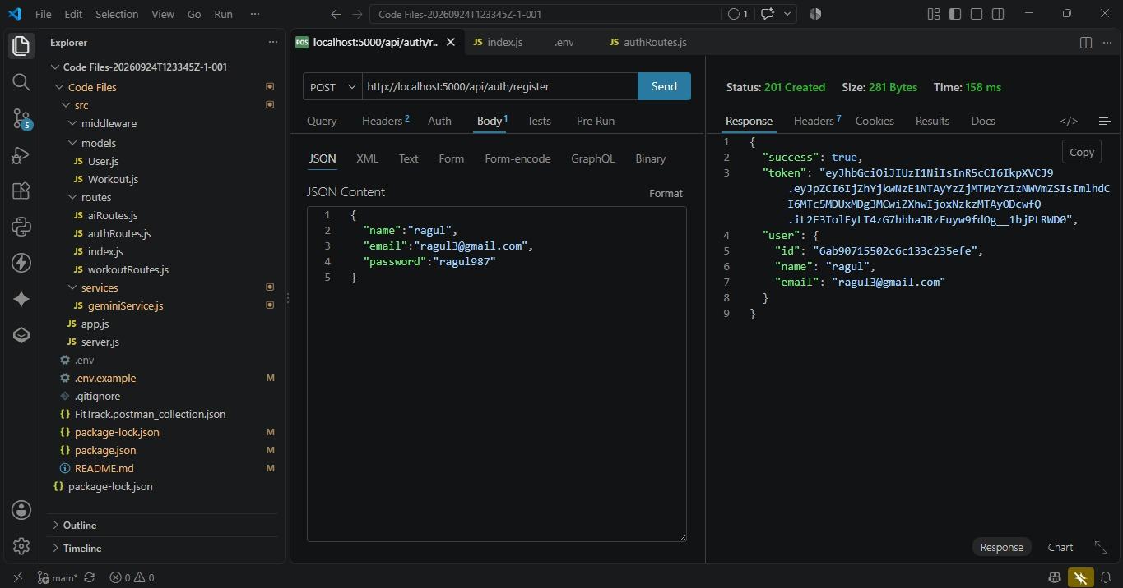

Figure 16.1: POST /api/auth/register — new user registration

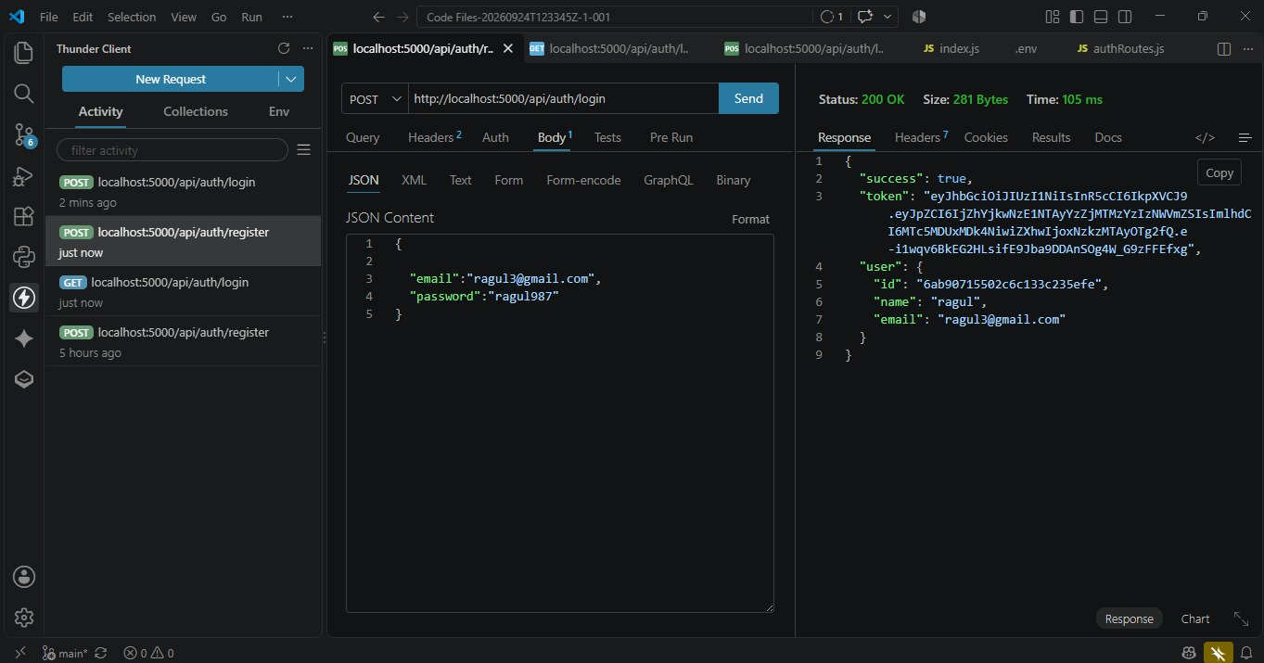

Figure 16.2: POST /api/auth/login — successful login

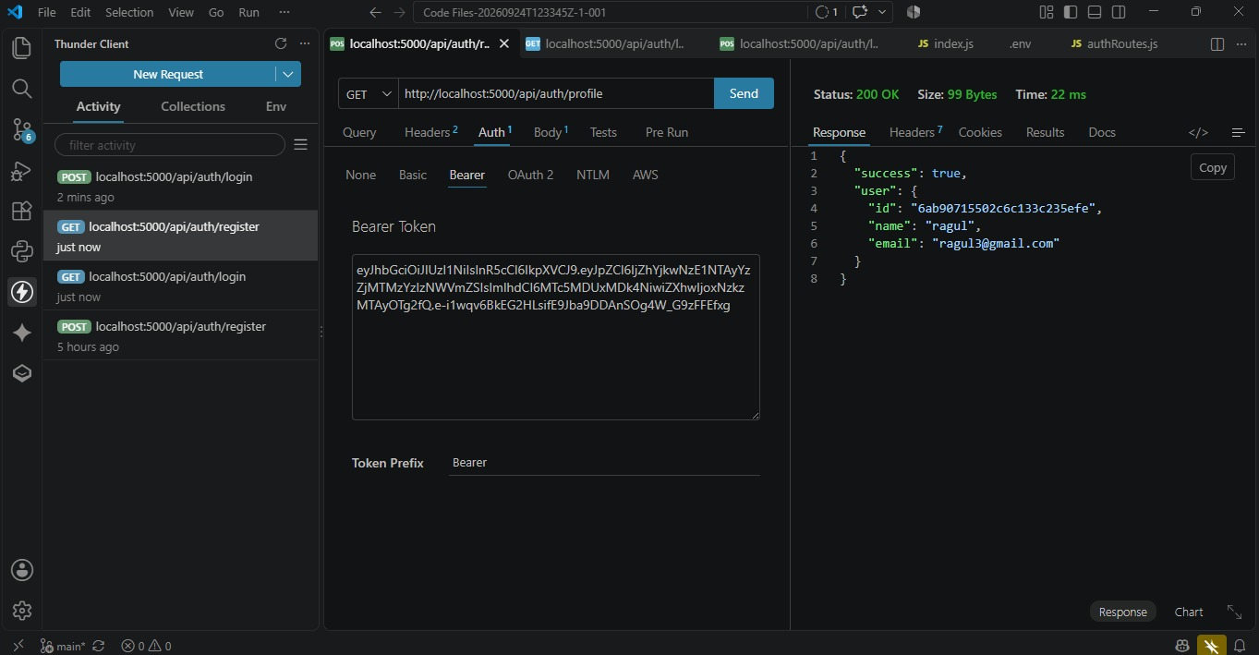

Figure 16.3: GET /api/auth/profile — authenticated request (Bearer token) returning the logged-in user’s profile.

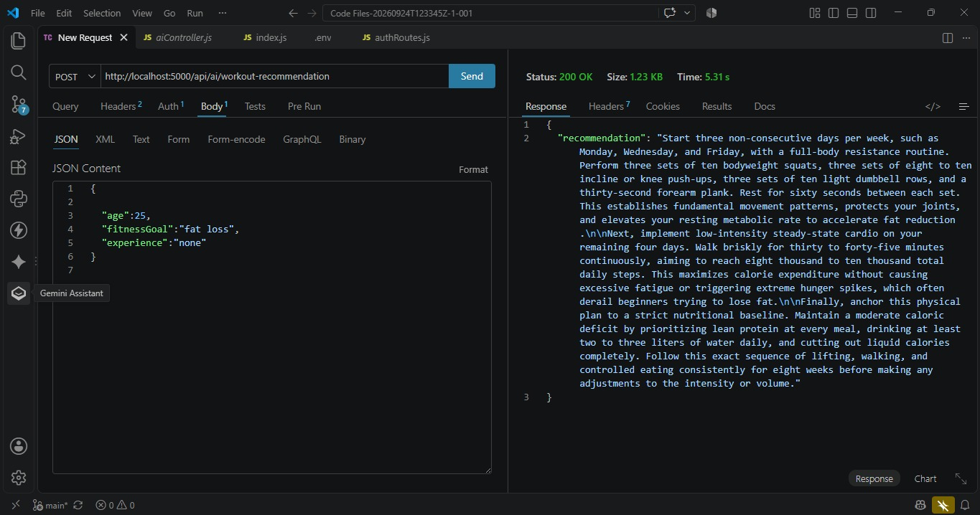

Figure 16.4: POST /api/ai/workout-recommendation — AI-generated personalized workout plan
based on age, fitness goal, and experience.

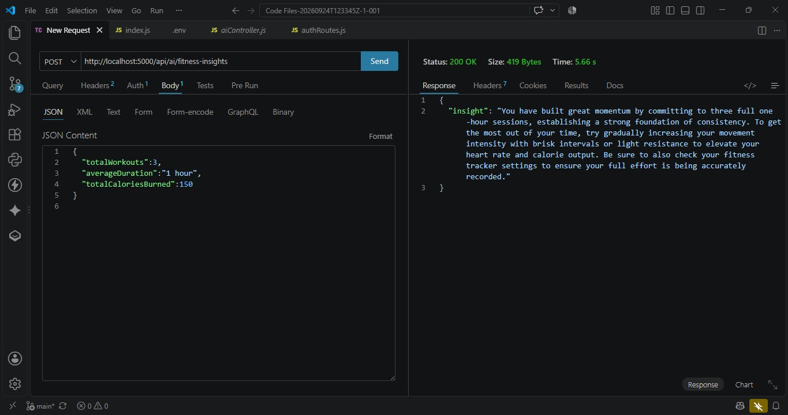

Figure 16.5: POST /api/ai/fitness-insights — AI-generated fitness insight based on aggregated workout statistics.

17. Project Links

- Demo Video Link: https://drive.google.com/file/d/1dZ0mINOwP4GYAFw9Jw2wszctHB8j7JWM/view?usp=drivesdk

- API Testing Video Link:
https://drive.google.com/file/d/1H8CJBxPg-j0ogOp1eKRihGW501O2qOCJ/view?usp=drivesdk

- Source Code / Drive Link:
https://drive.google.com/drive/folders/1ajR7fiJrDXxIn4wjUtCAVniekjv94Pm1

