PHASE 4

PROJECT DEVELOPMENT 2

EXPLAIN:

* In this part you will continue building your project.
* Perform the air quality analysis and create visualizations.
* Calculate average SO2,NO2,and RSPM/PM10 levels across different monitoring stations, cities, or areas with high pollution levels
* Create visualizations using data visualization libraries(e.g.,Matplotlib,Seaborn).

CODE:

import pandas as pd

import matplotlib.pyplot as plt

import numpy as np

import seaborn as sns

df = pd.read_csv("N:\cpcb_dly_aq_meghalaya-2014.csv")

#df = df.dropna()

print(df)

average_levels_of_state = df.groupby('State')[['SO2', 'NO2', 'RSPM/PM10',]].mean()

|  |  |  |  |
| --- | --- | --- | --- |
| print(average_levels_of_state) |  |  |  |
|  | | |

#finding the maximum and minimum  pollution of the city/town/village/area

print('Maximum of the data')

max_levels = df.groupby('City/Town/Village/Area')[['SO2', 'NO2', 'RSPM/PM10',]].max()

print(max_levels, '\n')

print('Minimum of the data \n')

min_levels = df.groupby('City/Town/Village/Area')[['SO2', 'NO2', 'RSPM/PM10',]].min()

print(min_levels, '\n \n')

#finding the average pollution of the city/town/village/area

print("Average of the data ")

average_levels_of_city = df.groupby('City/Town/Village/Area')[['SO2', 'NO2', 'RSPM/PM10',]].mean().sort_values(by='SO2', ascending = False)

print(average_levels_of_city, '\n')

OUTPUT:

Maximum of the data

SO2 NO2 RSPM/PM10

City/Town/Village/Area

Byrnihat 42 30 178.0

Dawki 5 17 181.0

Khliehriat 2 6 68.0

Nongstoin 2 11 49.0

Shillong 2 26 96.0

Tura 2 5 53.0

Minimum of the data

SO2 NO2 RSPM/PM10

City/Town/Village/Area

Byrnihat 20 14 105.0

Dawki 2 5 21.0

Khliehriat 2 5 13.0

Nongstoin 2 5 12.0

Shillong 2 5 32.0

Tura 2 5 22.0

Average of the data

SO2 NO2 RSPM/PM10

City/Town/Village/Area

Byrnihat 26.328571 20.314286 136.342857

Dawki 2.527473 12.340659 45.428571

Khliehriat 2.000000 5.011765 41.511905

Nongstoin 2.000000 9.782609 28.043478

Shillong 2.000000 10.328125 61.536458

Tura 2.000000 5.000000 38.088608

VISUALIZATION OF NO2:

plt.figure(figsize=(10, 6))

sns.lineplot(data=df, x='City/Town/Village/Area', y='SO2')

plt.title('SO2 levels across different cities at Meghalaya')

plt.show()

# Create visualizations for citys and NO2

plt.figure(figsize=(10, 6))

sns.lineplot(data=df, x='City/Town/Village/Area', y='NO2')

plt.title('NO2 levels across different cities at Meghalaya')

plt.show()

# Create visualizations for citys and RSPM/PM10

plt.figure(figsize=(10, 6))

sns.lineplot(data=df, x='City/Town/Village/Area', y='RSPM/PM10')

plt.title('RSPM/PM10 levels across different cities at Meghalaya')

plt.show()

OUTPUT:

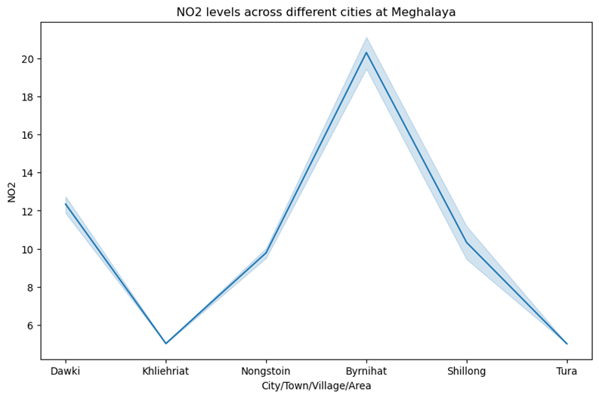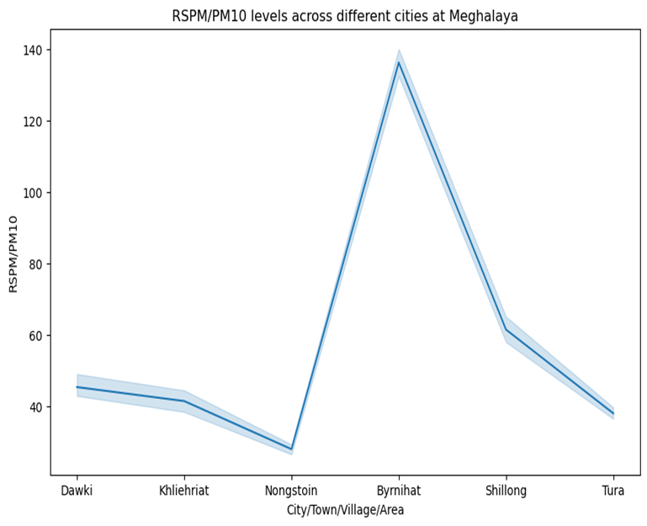

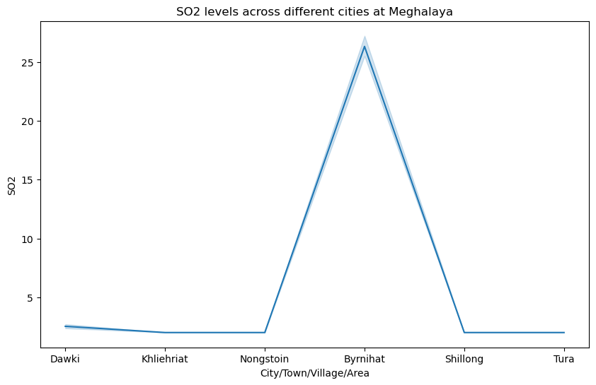

MAXIMUM LEVELS OF SO2 AND NO2:

plt.figure(figsize=(10, 6))

sns.lineplot(data=max_levels, x=max_levels.index, y='SO2')

plt.title('maximum SO2 Levels in Each City')

plt.show()

plt.figure(figsize=(10, 6))

sns.lineplot(data=max_levels, x=max_levels.index, y='NO2')

plt.title('maximum NO2 Levels in Each City')

plt.show()

plt.figure(figsize=(10, 6))

sns.lineplot(data=max_levels, x=max_levels.index, y='RSPM/PM10')

plt.title('maximum RSPM/PM10 Levels in Each City')

plt.show()

OUTPUT:

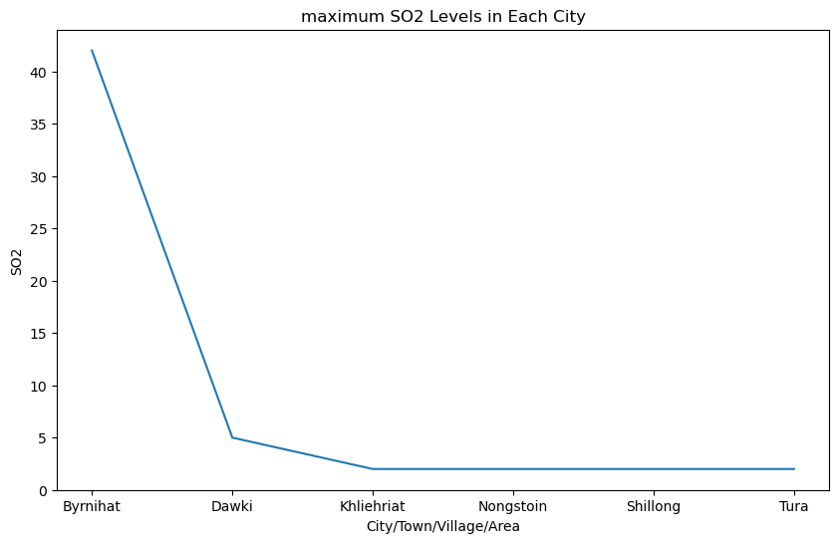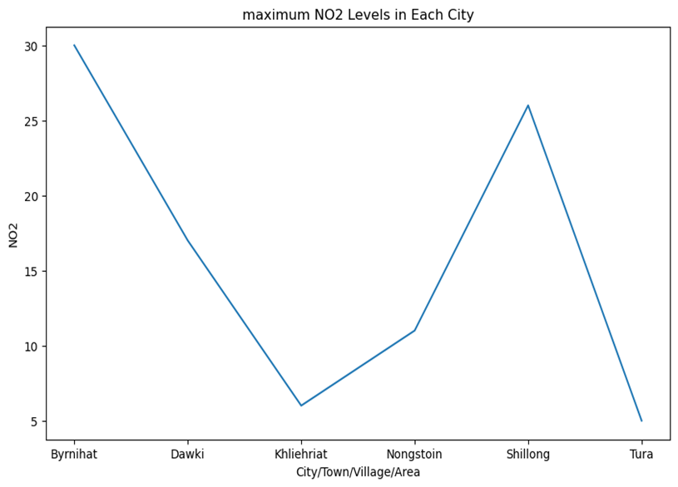

AVERAGE OF SO2 AND NO2:

plt.figure(figsize=(10, 6))

sns.lineplot(data=average_levels_of_city, x=average_levels_of_city.index, y='SO2')

plt.title('Average SO2 Levels in Each City')

plt.show()

plt.figure(figsize=(10, 6))

sns.lineplot(data=average_levels_of_city, x=average_levels_of_city.index, y='NO2')

plt.title('Average NO2 Levels in Each City')

plt.show()

plt.figure(figsize=(10, 6))

sns.lineplot(data=average_levels_of_city, x=average_levels_of_city.index, y='RSPM/PM10')

plt.title('Average RSPM/PM10 Levels in Each City')

plt.show()

OUTPUT:

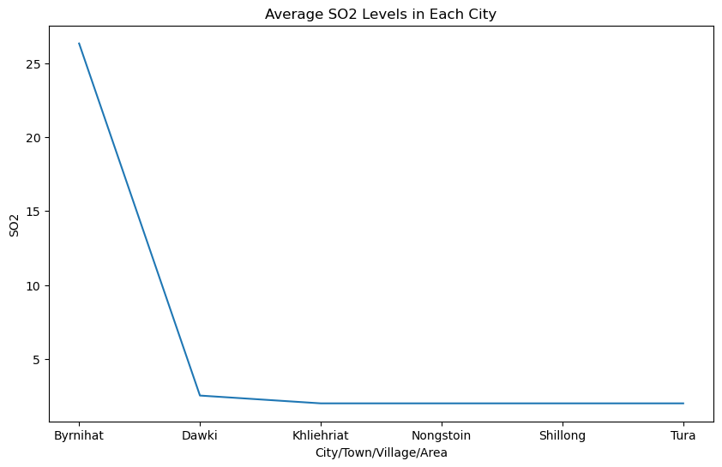

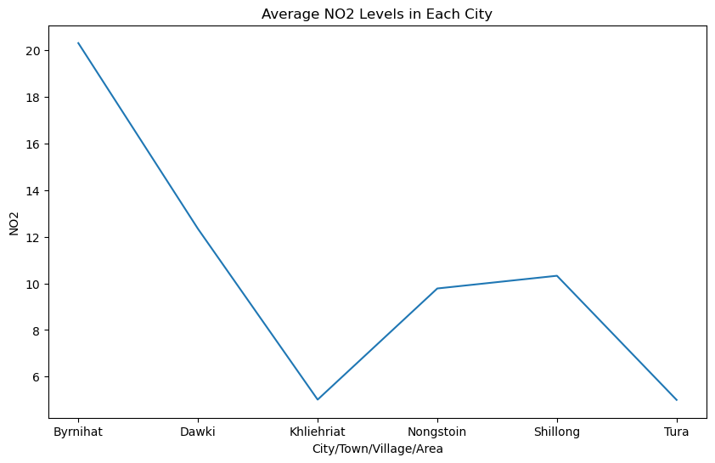

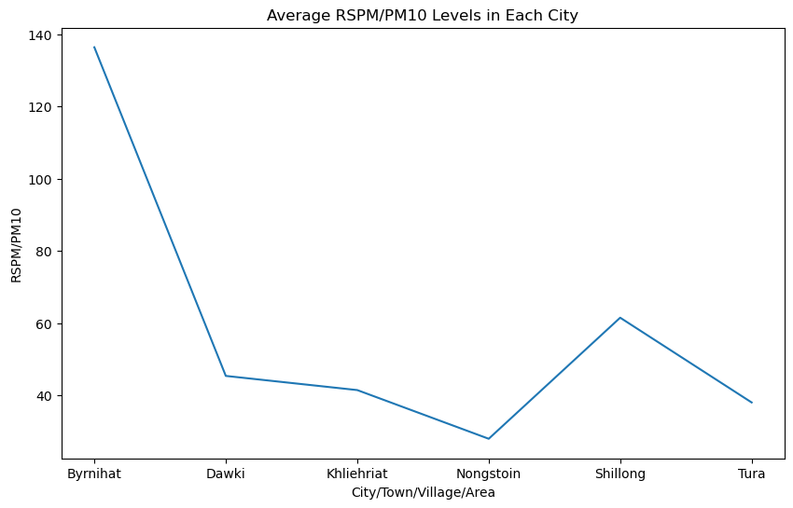

MINIMUM LEVELS OF S02 AND NO2:

plt.figure(figsize=(10, 6))

sns.lineplot(data=min_levels_of_citys, x=min_levels.index, y='SO2')

plt.title('Minimum  SO2 Levels in Each City')

plt.show()

plt.figure(figsize=(10, 6))

sns.lineplot(data=min_levels_of_citys, x=min_levels.index, y='NO2')

plt.title('Minimum  NO2 Levels in Each City')

plt.show()

plt.figure(figsize=(10, 6))

sns.lineplot(data=min_levels_of_citys, x=min_levels.index, y='RSPM/PM10')

plt.title('Minimum  RSPM/PM10 Levels in Each City')

plt.show()

OUTPUT:

