1. RPI_main_code
   1. This folder contains the scripts for Raspberry Pi
   2. The folder includes:
      1. Light.py: Test the function of light tower
      2. Sftp.py: Test the file transmission function between RPi and Server based on sftp
      3. Twocam.py: Test the cameras with visualization.
      4. Main_general_scangun.py: the main program of the RPi.
      5. Config.json: the config of the main script, need to edit it to match the specific information. (Refer to the following image below)

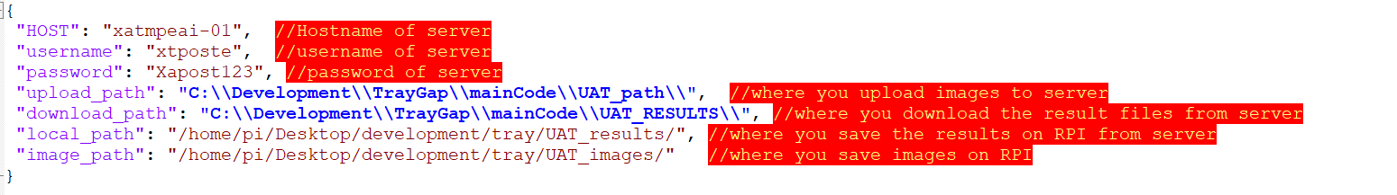

1. Server_main_code:
   1. This folder contains the scripts for server.
   2. The folder includes:
      1. Best.pt: the model weights file of YOLOv7
      2. Main_tray_20221201.py: the main program of server.
      3. Setting.json: the config of the main script, need to edit it to match the specific information. (Refer to the following image below)

1. Conda environment for Server.7z
   1. This one is the conda environment for server, includes all packages needed for the project, please unzip it and put it into the Anaconda/env folder, then you could use ***‘conda activate xxxxx’*** to activate this environment.
2. Traygap_ult
   1. This folder contains the scripts to auto copy the ult files from Scanner, which includes:
      1. Ult_copy.py: main code to copy ult files
      2. Ult_path.json: the network path for each Scanner
      3. Target_path.json: the location of copied ult files
3. Raspberrypi.img: the img file for RPi-4B OS, the img including all needed packages (python and linux packages) for running the RPI scripts.
4. The data transmission rely on SFTP protocol. For enabling SFTP server in Windows, please refer this [link.](https://winscp.net/eng/docs/guide_windows_openssh_server)