Setup Ansible Lab:-
Base OS --> CentOS 7.5
Install & Enable Networking on KVM to create multiple Virtual machines
https://www.linuxtechi.com/install-kvm-hypervisor-on-centos-7-and-rhel-7/

Control Node --> Centos 7.5
Install ansible --> #yum install ansible
Create & Copy ssh keys to managed nodes (ssh-keygen, ssh-copy-id)

Manage Node --> 3 (2-web, 1-db) (All are CentOS 7.5) {mnode1 / mnode2 / mnode3 are host-names }
Create ansible user on all the managed nodes and give sudo access without password
Disable SELinux

Basic Ansible Lab Setup --> 1-Control Node & 1-Manage Node is more than enough
############################################################################################

Ansible Ad-Hoc Commands:-

// Add all your managed nodes to /etc/ansible/hosts file for Inventory management. //

// Simple Lab Setup//

[web]
mnode1
mnode2

[db]
mnode3

Ansible Module checking commands:-

$ ansible-doc -l
$ ansible-doc <Module Name> → ansible-doc file

Use your own inventory file & Config files:-

$ ansible all –list-hosts - to list all hosts in inventory file
$ ansible web –list-hosts - to list only web host group hosts list-host
$ ansible localhost -m debug -a 'var=groups.keys()' - to list only group names in inventory file
$ ansible localhost -m debug -a 'var=groups' - to list groups and its host lists

// Create hosts file & ansible.cfg file //
$ vim ansible.cfg
inventory = <Current Working Directory>/hosts
$ vim hosts
mnode2
$ ansible --version → to check its version and configurations details

// Usage of ansible-inventory file for better understanding in a easy way //

$ ansible-inventory –list – to list all the hosts where its group & ungrouped list
$ ansible-inventory –graph - to view it in a Graph Mode
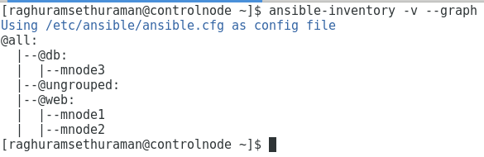

$ ansible-inventory --host=mnode3 - to list only the variables of specific host

// After entering user-name & password in hosts file & ansible command without user details //

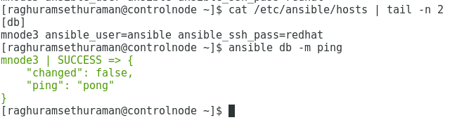
###################################################################################

To check the connectivity using ping:-

$ ansible web -m ping -u ansible - ping only “web” hostgroup
$ ansible web,db -m ping -u ansible - ping web & db hostgroup
$ ansible all -i mnode2, -m ping -u ansible - ping only mnode2
$ ansible all -m ping -u ansible --limit 'all:!mnode2' - ping all except mnode2
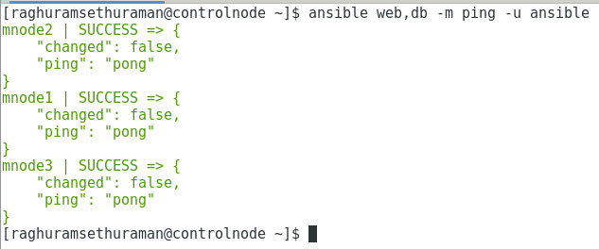
How to use adhoc command without SSH Pass-wordless login:-

$ ansible web -m shell -a “uptime” -k -u ansible → It will prompt for a SSH Password
$ ansible web -m shell -a “uptime” -K -u ansible → Prompt for a SSH Password with SUDO
$ ansible db -m shell -a "fdisk -l" -u ansible -b → run as ansible and become as root, also “s” option can be used but it should be executed without password.

Ansible Facts:-

OHAI – Chef based plugins || FACTER – Puppet based plugins

Possible Values: all, min, hardware, network, virtual, ohai & facter

// Store the collected facts in a temporary directory with hostname as a file //
$ ansible all -m setup -u ansible --tree /tmp/facts

// Only collect minimum value //
$ ansible all -m setup -a 'gather_subset=!all' -u ansible

// Display only distribution related factors from db hostgroup servers. //
$ ansible db -m setup -a "filter=ansible_distribution*" -u ansible

Playbook Execution Commands:-

// To check the Syntax is perfect //
$ ansible-playbook package.yaml -u ansible --syntax-check

// Pre-Filght check before actual installation //
$ ansible-playbook package.yaml -u ansible –check

To Install the httpd package:-

Privilege Escalation options:-

// Create sudoers file in /etc/sudoers.d/sudoers → ansible ALL=(ALL) NOPASSWD: ALL //

Option 1:- $ ansible-playbook package.yaml → common to whole playbook

---
- name: Package Install
hosts: web
gather_facts: no
remote_user: ansible
become: yes
tasks:
- name: Insall httpd Package
yum: name=httpd state=latest
...

Option 2:- ansible-playbook package.yaml -u ansible → for individual play

---
- name: Package Install
hosts: web
gather_facts: no
tasks:
- name: Insall httpd Package
yum: name=httpd state=latest
become: yes
...

Option 3:- ansible-playbook package.yaml -u ansible → for individual play

---
- name: Package Install
hosts: web
gather_facts: no
tasks:
- name: Insall httpd Package
yum: name=httpd state=latest
become: yes
become_method: sudo → based on how you access sudo as root.
...

Usage of Multiple Modules for Apache httpd server configuration:-

$ ansible-playbook httpd_server.yaml -u ansible
---
- name: Package Install
hosts: web
become: yes
gather_facts: no
tasks:

- name: Open Firewall Port
firewalld: port=80/tcp zone=public permanent=true state=enabled immediate=yes

- name: Insall httpd Package
yum: name=httpd state=latest

- name: Sample index.html is present
copy: src=index.html dest=/var/www/html/index.html owner=apache group=apache mode=0644

- name: Start & Enable httpd service
service: name=httpd state=started enabled=true
...

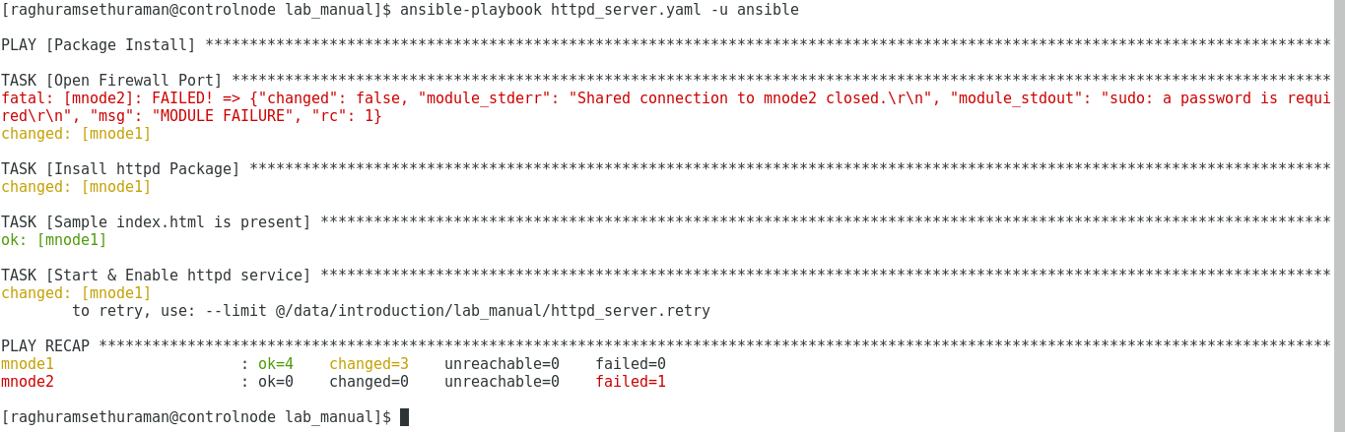
Actually it succeed for mnode1 and failed mnode2, after fixing sudo issue with mnode2 server then wen can try with --limit @/data/introduction/lab_manual/httpd_server.retry option.

Nothing to be modified on playbook hosts section, It will install only on failed node.

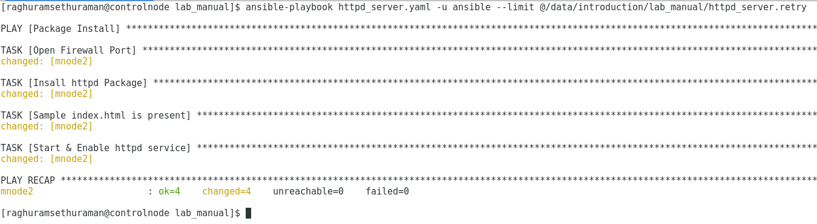

Conditions & Templates:

$ ansible-playbook cond_template.yaml -u ansible
---
- name: Package Install
hosts: web
become: yes
gather_facts: yes
tasks:
- name: Template sample playbook
template: src=index.j2 dest=/var/www/html/index.html
when:
- ansible_distribution == "CentOS" → if any-other OS it will skip the play.

- name: Start & Enable httpd service
service: name=httpd state=started enabled=true
…
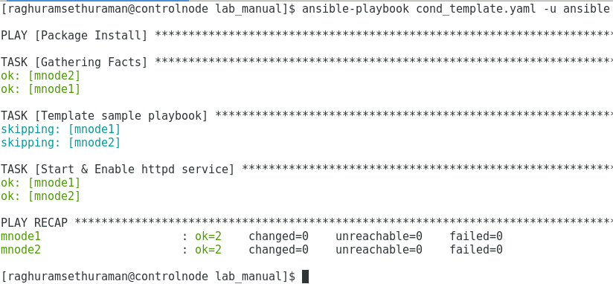

Loops & Variables:-

$ ansible-playbook loops_variables.yaml -u ansible

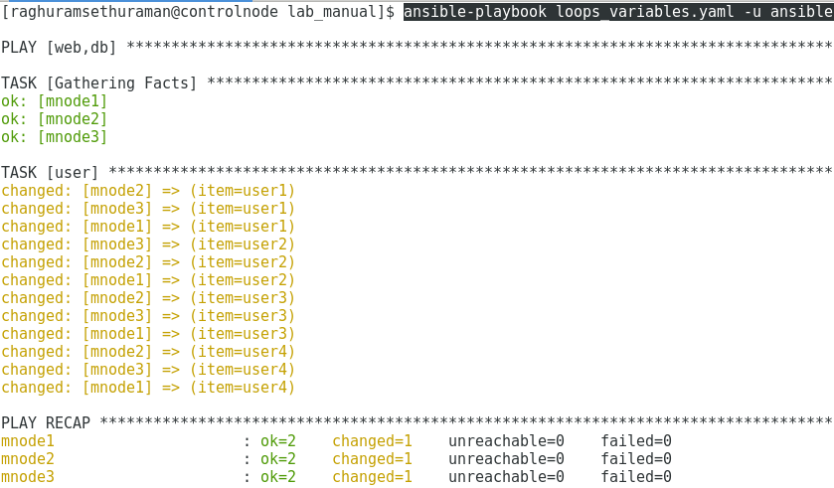

Tags:

Multiple options to use tags:
Option 1: ansible-playbook tags.yaml -t t2 -u ansible → use only one tag
Option 2: ansible-playbook tags.yaml -t t1,t2 -u ansible → use t1 & t2 tags
Option 3: ansible-playbook tags.yaml --tags=t1,t2 -u ansible → use t1 & t2 tags
Option 4: ansible-playbook tags.yaml --skip-tags=t1 -u ansible → will skip t1 tag

Debug & Ignore_Errors:

$ ansible-playbook debug_ignore.yaml -u ansible

Roles:-

$ ansible-playbook motd_roles.yml

